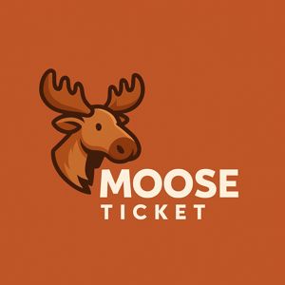

# MooseTicket Inc.

## MooseTicket InApp Consent Texts

# 1. DATA CONSENT

You authorize MooseTicket to collect personal and vehicle data to operate the app.

# 2. LOCATION

You may enable location tracking for regional enforcement data. We do not track continuously.

# 3. THIRD-PARTY ACCESS

You agree to allow access to public ticket APIs and payment processors.

# 4. PAYMENT CONSENT

You authorize payments through linked accounts. MooseTicket is not liable for payment issues.

# 5. NOTIFICATIONS

You consent to receive updates via email or push unless opted out.

# 6. AI USE

Any automated assistance is not legal advice. Always verify submissions before sending.