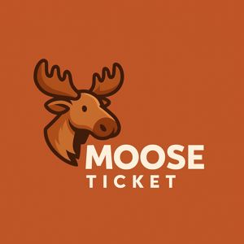

# MooseTicket Inc.

## MooseTicket Subscription Terms

# 1. OVERVIEW

MooseTicket offers paid plans. By subscribing, you agree to these terms.

# 2. FEES

Recurring unless canceled. Fees are final after the trial period.

# 3. AUTO-RENEWAL

Your card is charged unless you cancel before renewal.

# 4. TRIAL LIMITATIONS

One trial per user/vehicle/IP. Abuse may lead to blocking.

# 5. NON-REFUNDABLE

All payments are final unless required by law or platform terms.

# 6. VIOLATIONS

We reserve the right to revoke access for fraud or abuse.

# 7. CONTACT

support@mooseticket.com