MSSQL Job Monitoring

1. INTRODUCTION

a) Purpose

The MSSQL Job Monitoring is designed to monitor sql jobs. The main
reason for doing this, this plugin pulls information on Job Details such as Job Name, step name, Current Status, Last Run Status, server, message. This information about Jobs Details allows DBAs to identify if automated tasks are executed properly as planned. This saves DBAs a lot of time and effort instead of monitoring them manually.

b) Design Overview

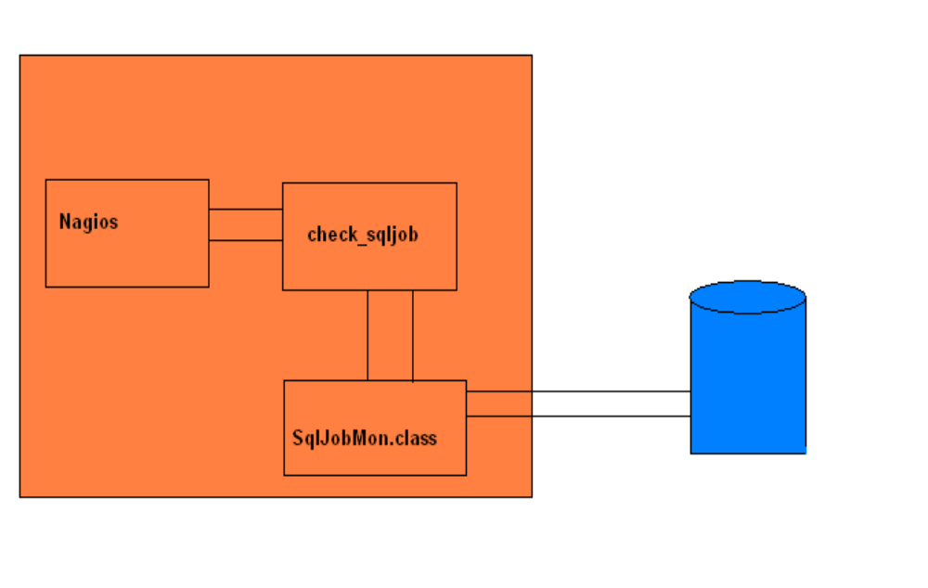

The MSSQL Job Monitoring Plugin consists of four files

- check_sqljob.sh script file.
- SqlJobMon.class java class file.
- url.properties properties file.
- Sqljdbc.jar library fule.

These four files should reside on nagios libexec path.

When Nagios needs to monitor a mssql job service for remote machine

- Nagios will execute the check_sqljob.sh and this script internally execute java class file SqlJobMon.class.
- The SqlJobMon.class make connection with MSSQL server running on the remote host using java JDBC API. The JDBC API provides a call-level API for SQL-based database access. Once connection made it will return the result set. Then the result set are written to a html file(serveraddress-date.html). Html file consists of both recent and history of failed jobs in seperate table.
- The results from the service check are passed to the Nagios process. This plugin internally will create a directory sqllog and put html file in the sqllog directory(/usr/local/nagios/share/sqllog/).

Note: The plugin requires credential to MSSQL database running on the remote host.

3. Installation

In order to use the plugin, you'll need to perform some tasks on both the monitoring host and the remote monitored host.

a) Prerequisites

In order to complete these installation instructions, you'll need:
- Administrative privilege on the monitored host as well as administrative privilege on MSSQL server.
- Access to the nagios user account on the monitoring host.
- JDK 1.6.0or JRE 1.6.0 on monitoring host(Nagios).
- Nagios user privilege to execute java commands(/usr/local/bin/java).

b)Monitoring Host Setup

- Install and configure the check_sqljob plugin
- Create a Nagios command definition for using the check_sqljob plugin
- Create Nagios service definitions for monitoring the MSSQL server failed jobs.
- Nagios cgi.cfg configuration.

1)Install and configure the check_sqllog plugin

Download and copy SqlJobMon.class, url.properties, check_sqljob.sh and sqljdbc.jar files libexec directory(eg /usr/local/nagios/libexec).

Edit the check_sqljob.sh file and set the JAVA_HOME path and CLASSPATH corresponding to your machine.

Edit url.properties file and set HTML_DIR and HTML_LINK corresponding to you machine.
(eg: HTML_DIR=/usr/local/nagios/share HTML_LINK=/nagios/sqllog)

sample usage of the plugin

sh check_sqljob.sh -H 10.25.5.115 -u Nagios -p Fefr6dre
plugin output will be
<a href=/nagios/sqllog/10.25.5.115-2010-07-25.html target=main> CRITICAL: Number of Jobs Failed:9|count=9</a>

sh check_sqljob.sh -h
Usage: check_sqljob.sh -H hostaddress -u {username} -p {password}
-h for help
-H (hostaddress)
-u (username)
-p (password)
Example command
check_sqljob -H 10.70.5.45 -u sa -p s22css

2)Create a command definition

You'll need to create a command definition in one of your Nagios object configuration files in order to use the check_sqllog plugin. Open the sample commands.cfg file for editing...
vi /usr/local/nagios/etc/commands.cfg
and add the following definition to the file:
define command{
command_name check_sqllog
command_line $USER1$/check_sqllog -H $HOSTADDRESS$ -u $ARG1$ -p $ARG2$
}

(ARG1 – username ARG2 – password credential for MSSQL server).

3)Create service definitions

You'll need to create service object definition in order to monitor MSSQL server jobs. These definition
can be placed in their own file or added to an already exiting object configuration file.

define service{
use generic-service
host_name mssql-server
service_description Failed_Jobs
check_command check_sqllog!sa!s22css
}

4)Nagios cgi.cfg configuration

In nagios cgi.cfg there is an option whether HTML tags in host and service status output is escaped in the web interface. If enabled, your plugin output will not be able to contain clickable links. This option should be 0, because out plugin output contain clickable link.

escape_html_tags=0

Restart/Reload Nagios

4. Restart

At this point you've installed the check_sqllog plugin and service definitions for monitoring the
remote MSSQL windows machine.
Verify your Nagios configuration files.

/usr/local/nagios/bin/nagios -v /usr/local/nagios/etc/nagios.cfg

If there are errors, fix them. If everything is fine, restart Nagios.

service nagios restart

Once you configured service reload/restart nagios service successfully. In the nagios screen you will see output like if jobs get failed (“CRITICAL: Number of Jobs Failed:25 “) unless (“OK: Number of Jobs Failed:0”). The check_sqllog plugin output is a clickable html link. If you click on the link you will get into a html page which consists of list of jobs failed currently and history of job failed for current date in a separate table.

