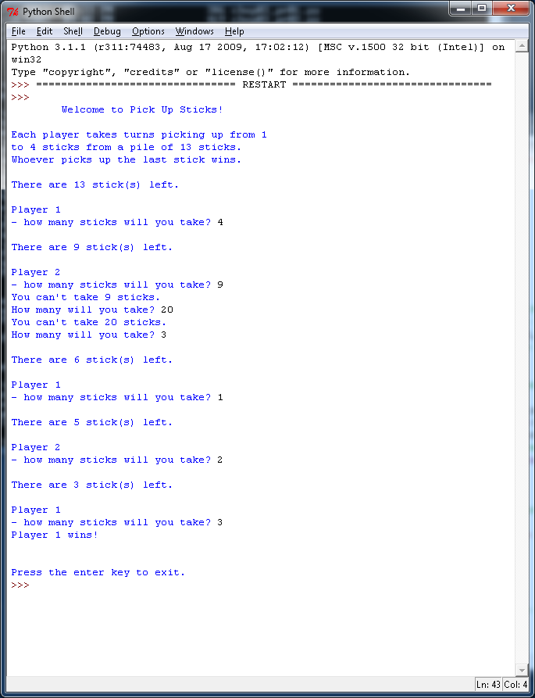

Here is a possible “Pick Up Sticks” Game occurred with my version of the problem.

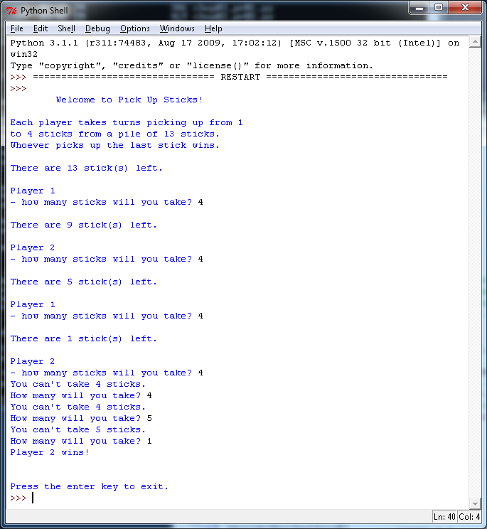

Example of the game which requires the last player to pick up the exact number of sticks.