TASK 1

1. 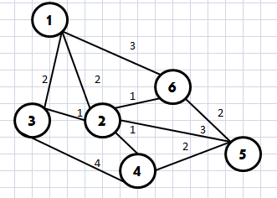 2.

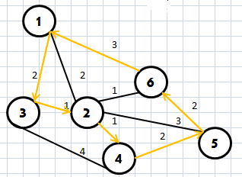3.

Total = 11km ([2] is our starting point)

4. The greedy algorithm was used to create the shortest route; first, pick the branch with the smallest length adjacent to the starting point (if there are multiple branches that have the same smallest value, pick one for now), then travel on that branch until the node is reached. At that node, the branch with the smallest value would be chosen again; this keeps happening until:

a) A cyclic path is created, but not all of the nodes are connected

b) All the nodes are connected

If case A happens, then the path would backtrack to the last node where it hasn’t formed a cyclic path and choose the next smallest branch that will not form a cyclic group. If case B occurs, then the algorithm terminates.

TASK 2

1.

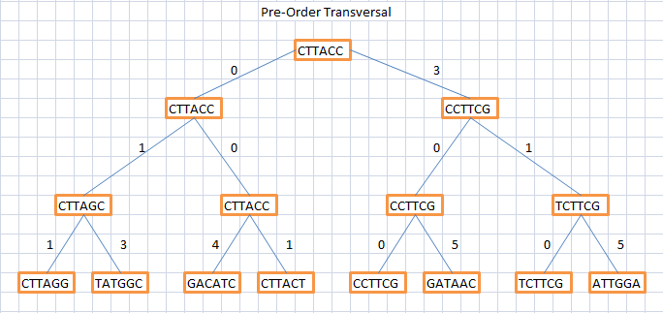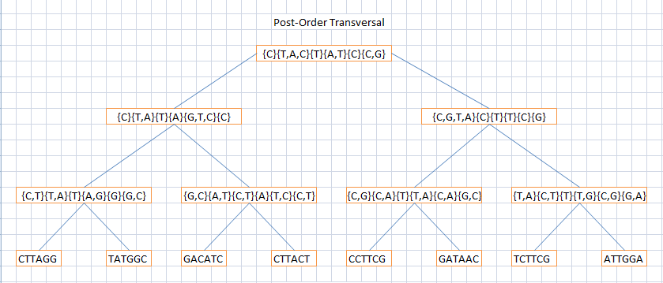2.

3.The parsimony score of the tree is 24.