CSC 106 Assignment #4: The game’s the thing!

Wesley Chow

Sebastian Cabrera

Due: Dec. 3 (11:55 pm)

TASK 1

**Part 1**

From a player’s perspective “Quidditch” is a relatively simple game to play. Since Quidditch resembles “Pong”, a well-known game, no instructions are needed. The only two keys needed to play the game are the up and down keys. Also, the game’s name is catchy and if you’re a Harry Potter enthusiast you know exactly what the game is going to be about. The simplicity of Quidditch is a good feature for those players who don’t want or have the desire to learn complex instructions.

**Part 2**

From a developer’s point of view, two features of Quidditch that need improvement are what happens after a point is scored and when pausing and restarting takes place. As it is, when a point is scored, the ball continues on its path and a small blurb says, “GOAL”. From a player’s perspective, a goal could be more explicit when a point is scored. This could be accomplished by resetting the goalkeeper and the quaffle positions to the initial parameters. In other words, after the point is scored, the goalkeeper should be placed at the center of the ring nets and the quaffle at the center of the pitch. Also, when the game scripts are initiated, the quaffle doesn’t return to the center of the pitch.

**Part 3**

After discussing the implementation needed to improve Quidditch, the group decided that it would be best to combine the work on the two easiest game tasks (the goalkeeper and ball position after a goal). In this way, each group member felt the amount work and responsibilities is fairly divided in terms of time and challenge. The following table summarizes the work plan to improve the features mentioned in Task 1, part 2:

Table 1: Work plan to deploy improvements to Quidditch

|  |  |  |  |  |  |
| --- | --- | --- | --- | --- | --- |
| Order | Task | Time estimated | Actual time spent | Responsibility | Status |
| 1 | Modify the position of the goalkeeper to return to center of the goalpost after each a goal is scored | 10 min | 80 | Wesley | Done |
| 2 | Modify the quaffle’s position to return to center half of the field after a goal is scored | 10 min | 60 | Sebastian | Done |
| 3 | Place the quaffle to the center half every time the game is reset | 10 in | 5 | Wesley | Done |

The group agreed to have their assigned tasks completed by the next meeting which was scheduled 6 days later. In the next meeting, all the tasks would be implemented to make sure they functioned correctly.

TASK 2

**PART 1**

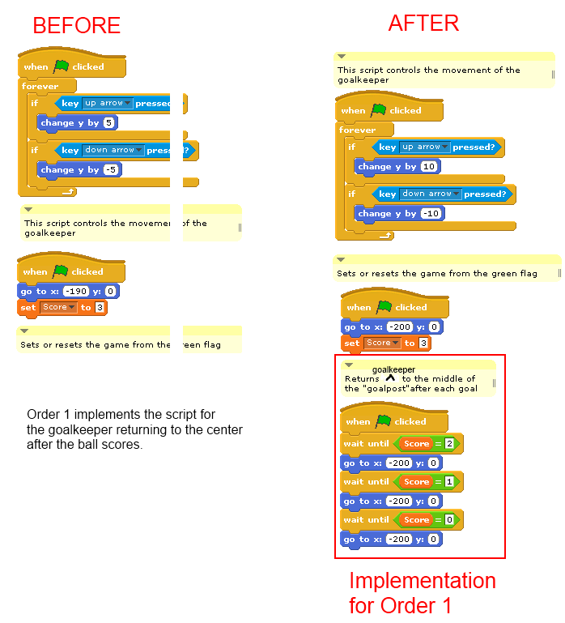Work Order 1: Implementation of the goalkeeper returning to the middle of the goalpost after Slytherin scores

Table 3: Difficulty Rating for the goalkeeper returning to the center of the goalpost

|  |  |  |  |  |
| --- | --- | --- | --- | --- |
| Very easy | Easy | Medium | Hard | Very Hard |
|  |  | x |  |  |

Reason: The implementation took a long time to figure out as the developer was not familiar with the syntax used in Scratch. He was thinking of referencing the quaffle in the goalkeeper’s scripts but was not within Scratch’s programming parameters. Instead, the ‘wait until’ function was used.

Work Order 2: Implementation of the quaffle returning to the center ring of the field.

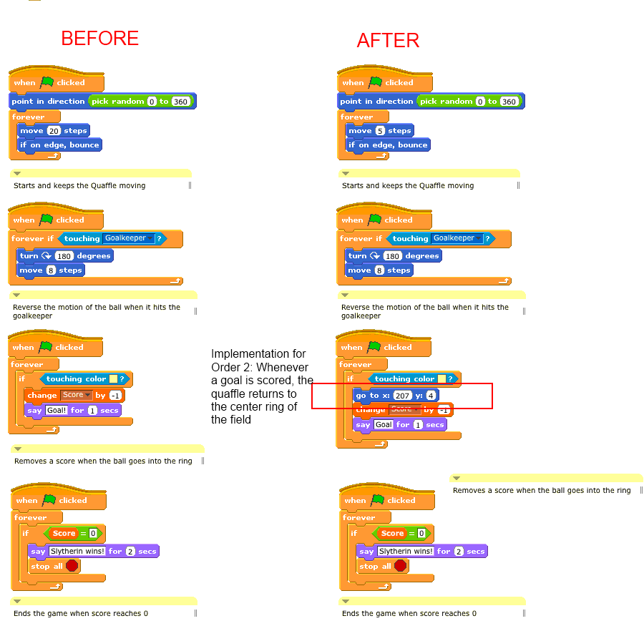

Table 4: Difficulty Rating for the quaffle to return to the center ring of the field

|  |  |  |  |  |
| --- | --- | --- | --- | --- |
| Very easy | Easy | Medium | Hard | Very Hard |
|  |  | x |  |  |

Reason: The developer working on this implementation was not familiar with Scratch, which made things slightly more complicated. After trying multiple implementations, this one worked.

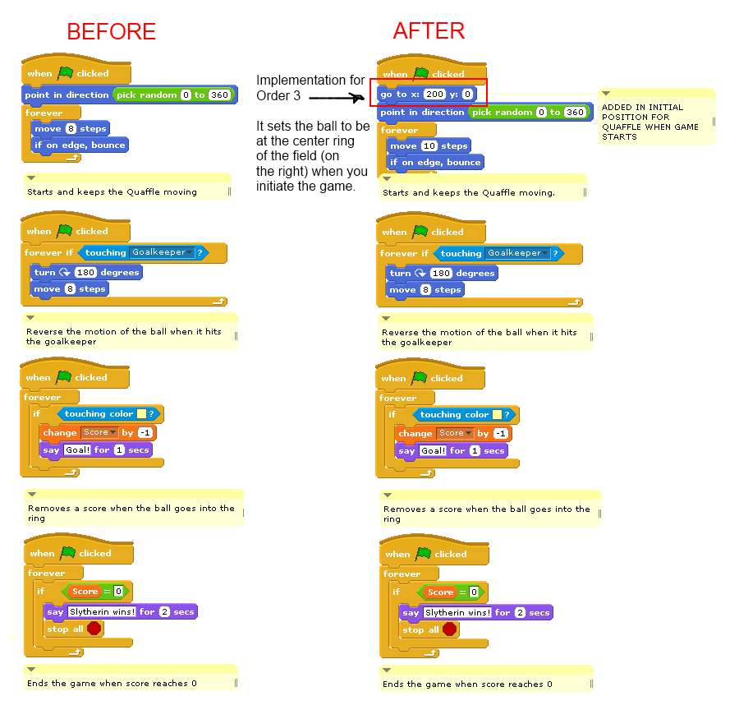Work Order 3: Implementation of the quaffle to return to the center ring of the field when the game restarts

Table 5: Difficulty Rating for placing the quaffle to center ring of the field when the

field starts.

|  |  |  |  |  |
| --- | --- | --- | --- | --- |
| Very easy | Easy | Medium | Hard | Very Hard |
| x |  |  |  |  |

Reason: Putting the starting location for the goal keeper was very simple.

**PART 2**

The modified game file is attached to the connex submission.