Group 10- Interim Report

In this project, we will be creating a GUI chat app in java. This will include a main page with all existing chats with the option to start a new chat, a keyword search feature and buttons to view and edit the users profile and contacts. Each individual chat will have a list of all to and from messages, with options to add a message, or delete the chat. The user will also be able to load and save their chat history to a file.

We have considered several data structures for storing different parts of the chat application. The user profile will be stored as a class, as it groups related attributes such as the username and profile information together. Contacts will be stored in a set of class objects to prevent duplicate contacts being added. Individual chats will use a queue of objects because messages are processed in the order they are sent and received which is the same as a queue (first in and first out). The list of chats will be stored in a set of objects so that each conversation is unique and can be easily accessed without duplicates.

As an initial design for our program, we have considered which classes are necessary as well as the fields and methods they might contain. Additionally, we have created some basic designs for our user interface.

Here are some proposed classes:

- The user profile will be stored in a class: ‘Profile’. This will contain the user’s contactID, name and phoneNumber as fields. Each field will be stored as a String. This may include methods such as editProfile() and displayProfile().

- Each of the contacts in the user’s contact list will be stored as an object in the class: ‘Contact’. This will also include their contactID, name and phoneNumber as fields. These will each be stored as Strings. Potential methods include: editContact() and getRecentChats().

- Each message sent or received in a chat must also be stored as an object in the ‘Message’ class. This will include fields such as its own messageID, chatID, the contactID of who sent it, the content of the message as message, its readStatus and the timestamp of when it was sent. messageID, chatID, contactID, and message will be stored as Strings. The readStatus will be stored as a Boolean and the timestamp can be stored as LocalDateTime. A potential method for this class is markAsRead to calculate and display when a message has been read and when.

We have also chosen to implement GUI to enhance the design and usability of our system. We have focused on creating clear, and understandable designs that meet all program requirements. Here are some initial designs for each of the necessary pages:

- The Landing Page – including placeholders for different chats, each with their name, readStatus and the timestamp displayed.
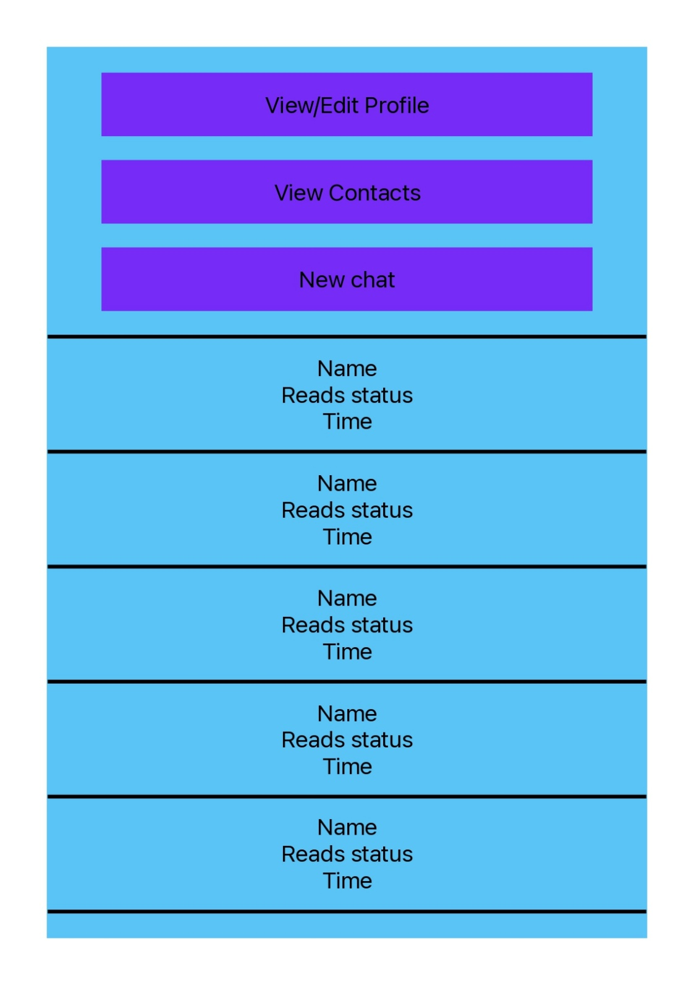

- The chat page – with dark blue boxes representing messages between the user and one of their contacts.

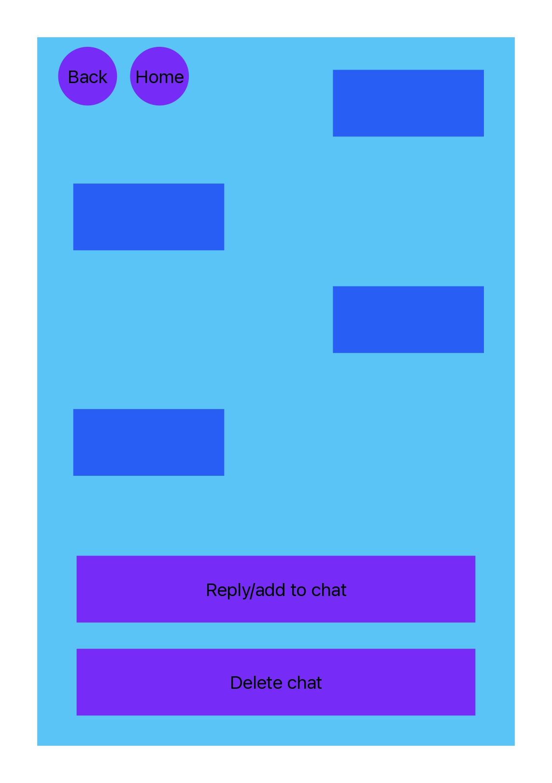
- The Profile Page – displaying the user details and allowing the user to edit them.

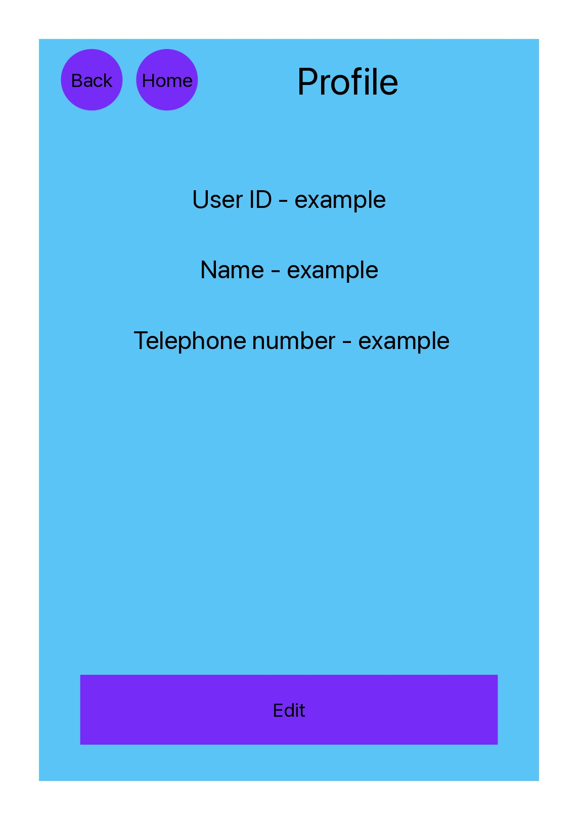

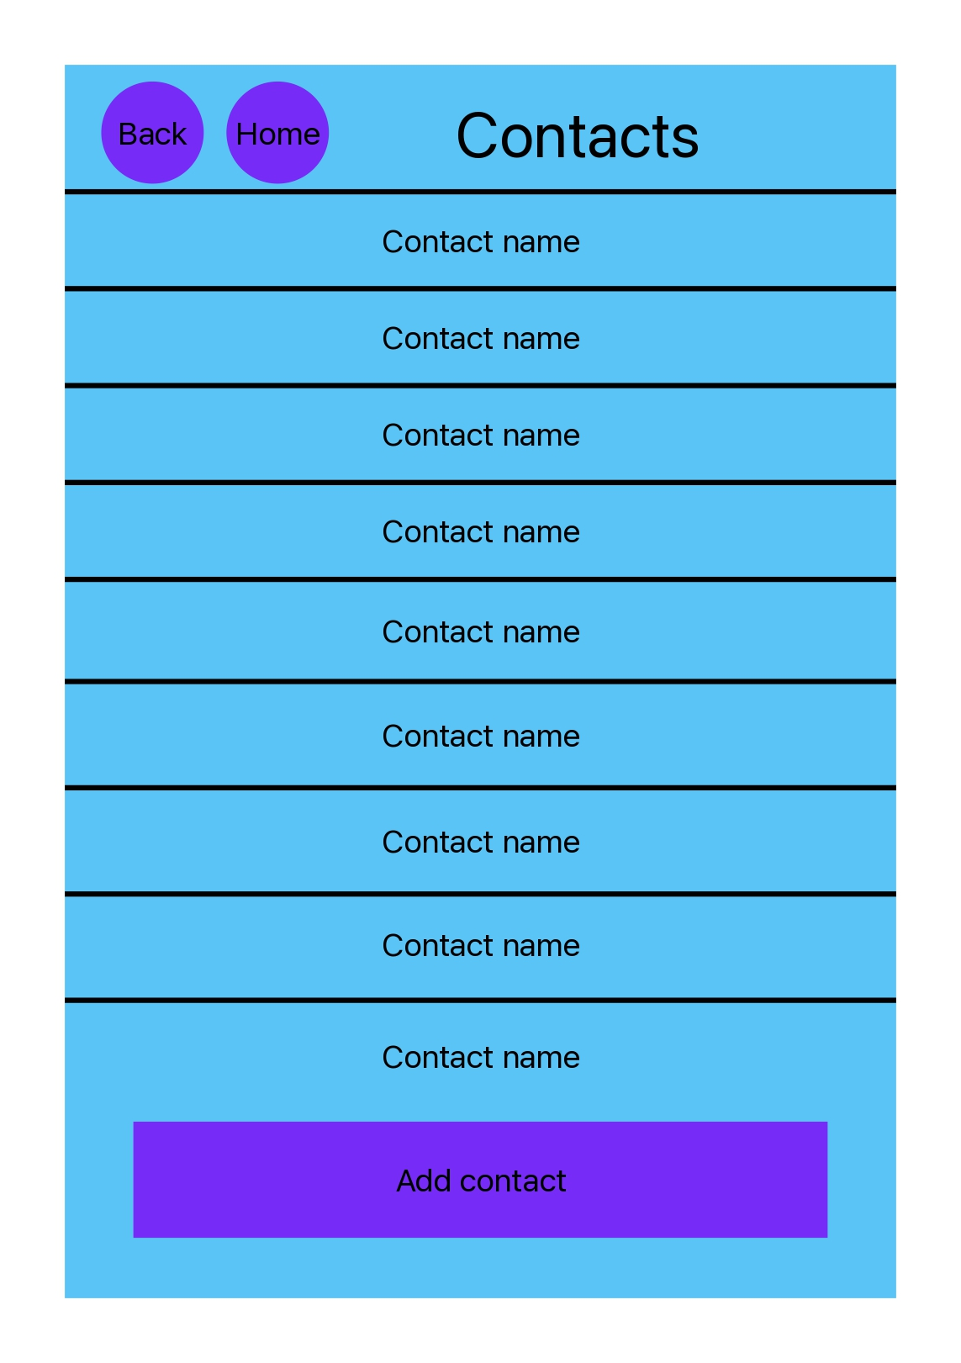
- The Contacts Page – showing a list of contacts through their contact names.

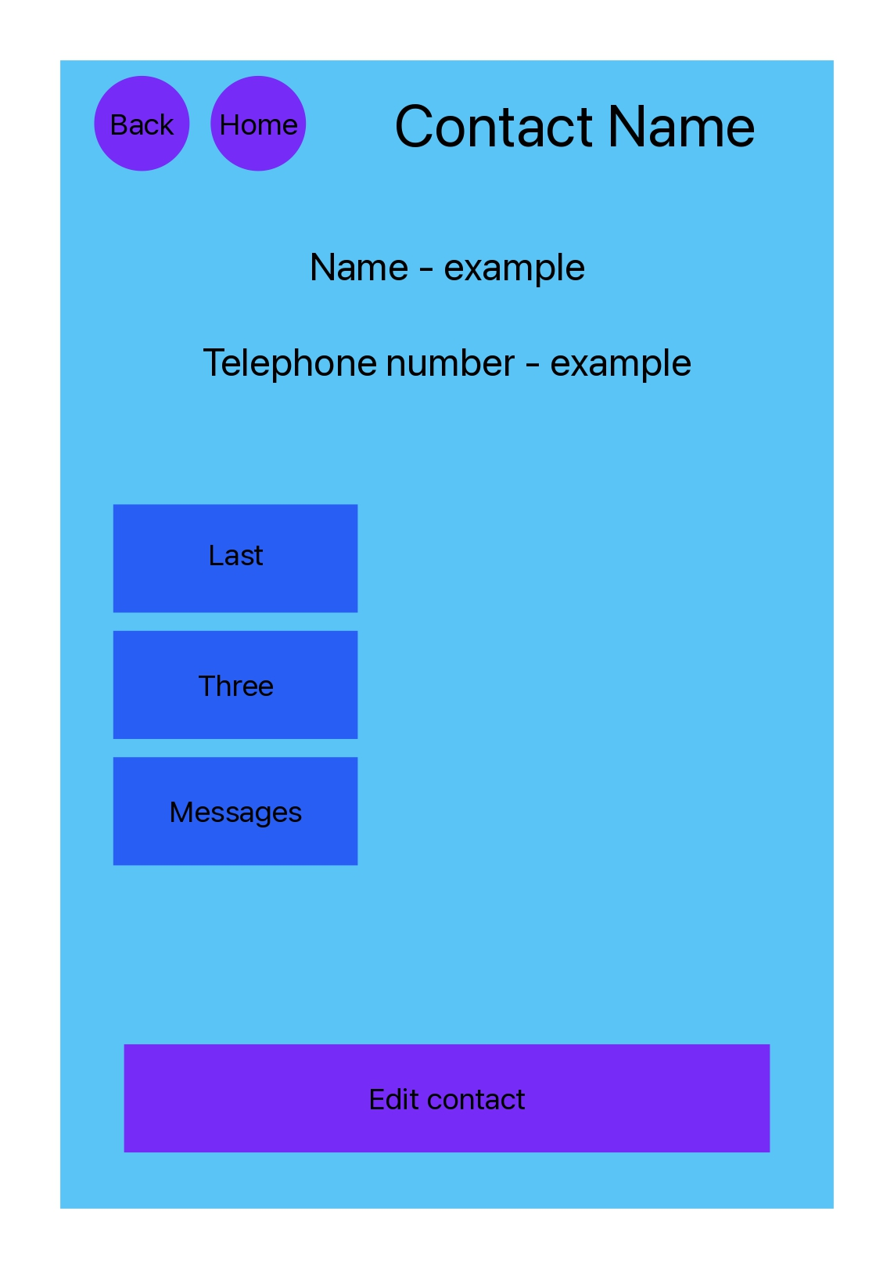
- The Contact Page for each individual contact, displaying the contact’s details and allowing the user to edit them.

Here is our list of task allocations to each team member:

Coding - Everyone
Secretary – Zara
Test plan – Amelie
Video Demo - Millie
Final report – Hannah
Submit - Millie

