- Degrees of Separation

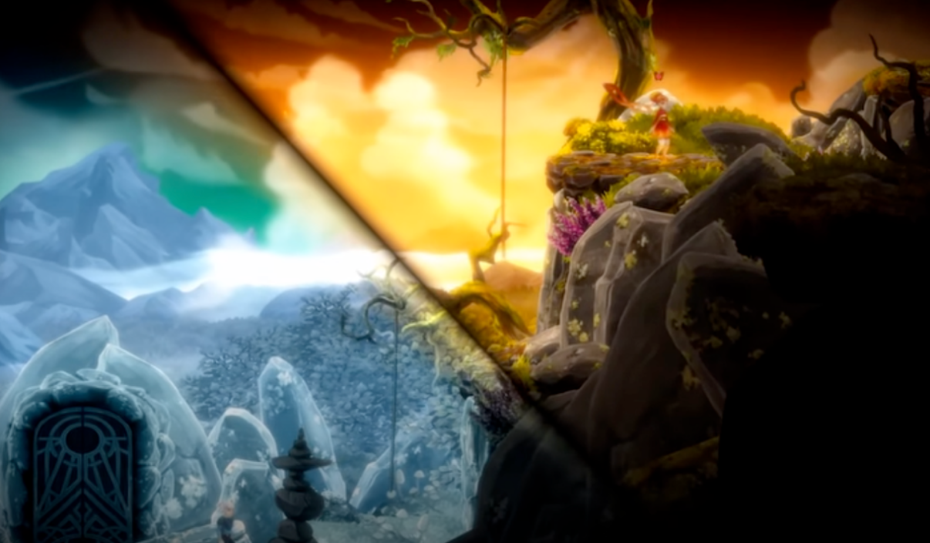

Core Details & Mechanics
1. Worldview: Two parallel "fire-ice" worlds – the Sunlit World (warm, lush, fire-powered) and the Frosted World (cold, snowy, ice-powered) – sharing the same geographical outline but opposing ecosystems.
2. Core Mechanics: Split-screen dual-character control. Players manipulate Eya (Sunlit) and Kai (Frosted), with abilities complementing each other (fire melts ice walls, ice freezes lava). Actions in one world alter the other’s terrain. Both characters must reach their portals simultaneously to clear the level.
3. Features: Minimal controls, no death mechanics or complex stats, focusing on co-op.

Inspiration & Adaptation
1. Adopt split-screen dual-world visualization, replacing fire-ice with "Normal World/Upside Down".
2. Adapt the "action affects the other world" logic to design interactive gameplay between bulb collection (Normal) and monster fighting (Upside Down).
3. Reference the "dual simultaneous goals" clearance rule to emphasize co-op necessity.

2. Stranger Things: Upside Down (Official Board Game)

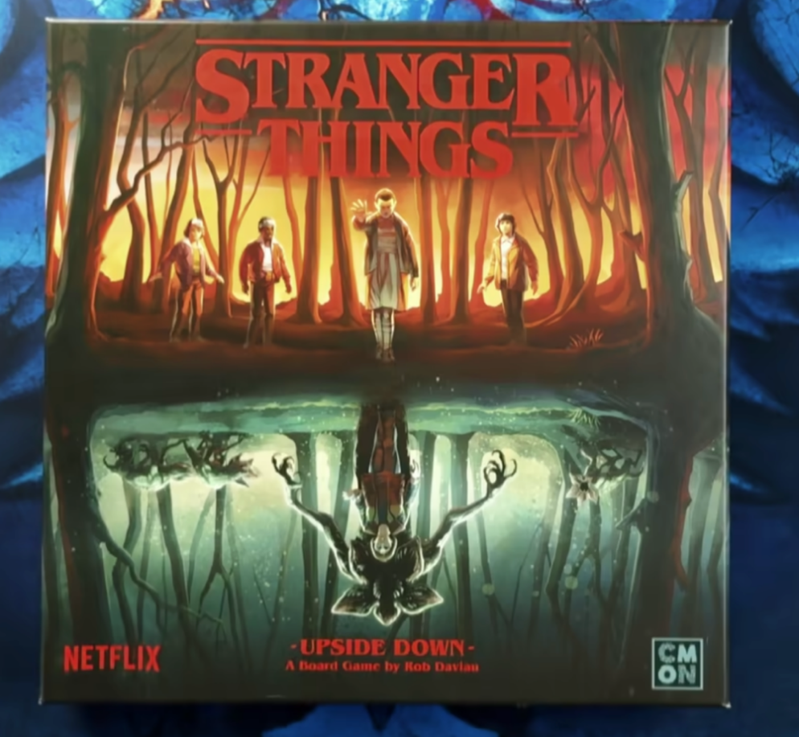

Core Details & Mechanics
1. Worldview: Restores Hawkins from the show, divided into two factions – the Normal World Team (find missing persons, collect clues) and the Upside Down Team (fight Demogorgons, Demodogs) – operating in the same physical space.
2. Core Mechanics: Mirrored scene linkage. Clues from the Normal World become weapons for the Upside Down Team; eliminating monsters unlocks Normal World areas. The final boss (Demogorgon) spawns only after collecting 3 key clues and clearing all mobs. Co-op to defeat the boss is the sole victory condition.
3. Features: Faction failure leads to global defeat, emphasizing resource sharing and division of labor.

Inspiration & Adaptation
1. Extract the "collect in Normal, fight in Upside Down" logic, turning bulbs into buffs for combat.
2. Reference the "key collectibles trigger boss" setting, linking bulb collection to boss unlocking.
3. Adopt the "single character failure = level restart" rule to highlight co-op importance.

3. Stranger Things: The Game (Pixel Mobile Game)

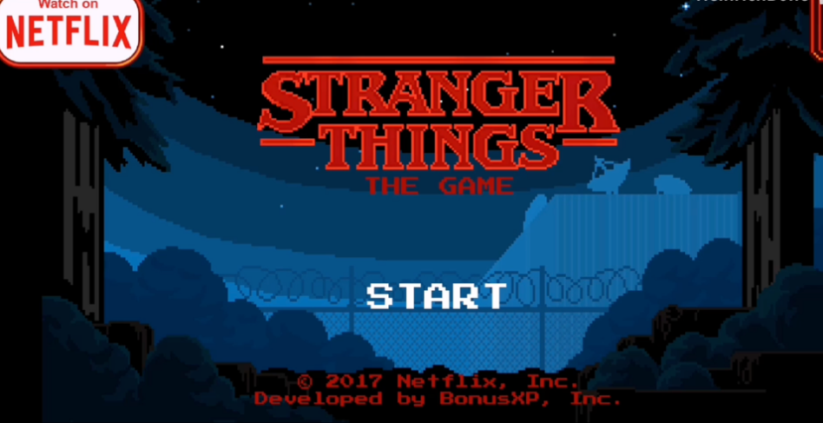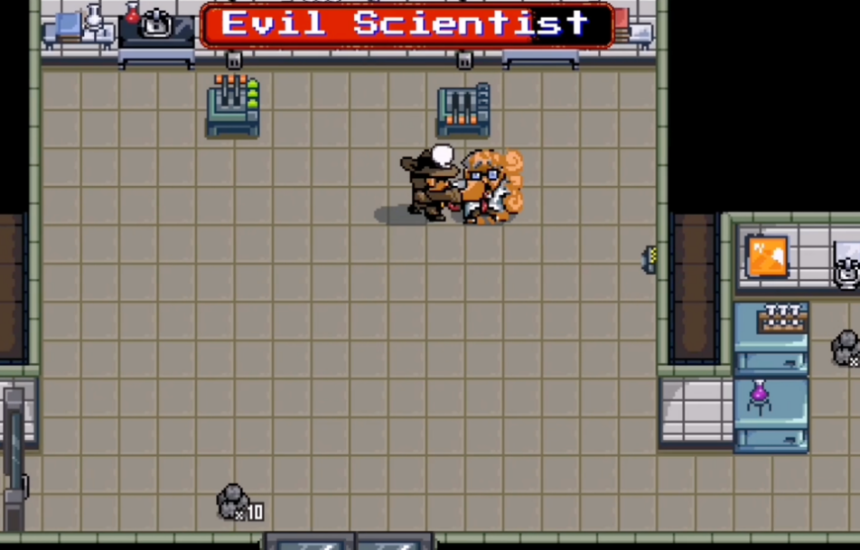

Core Details & Mechanics
1. Worldview: Based on Season 1, 16-bit retro pixel art. Warm tones for the Normal World, dark purple/blue eerie tones for the Upside Down.
2. Core Mechanics: Explore and collect items (unlock plots/skins/key tools) in the Normal World; real-time action combat triggers in the Upside Down. Monster drops unlock Normal World mechanisms.
3. Features: No complex progression, simple controls, mild death penalties.

Inspiration & Adaptation
1. Use retro pixel art (suitable for p5.js) and color contrast to build dual-world atmosphere.
2. Adapt collectible buffs, setting golden bulbs as combat enhancement items.
3. Simplify combat to "attack + dodge" for browser-based playability.

