

Report on social media tweets



**About Dataset**

The dataset is social media posts that are generated by different users, each has a specific id related to the platform.

**Analysis Of the Data**

**1 – Number of examples per class**

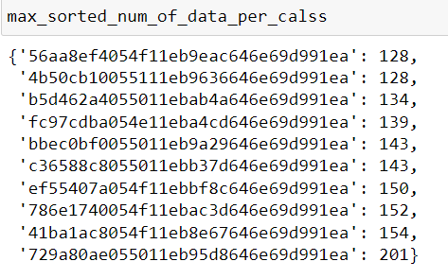

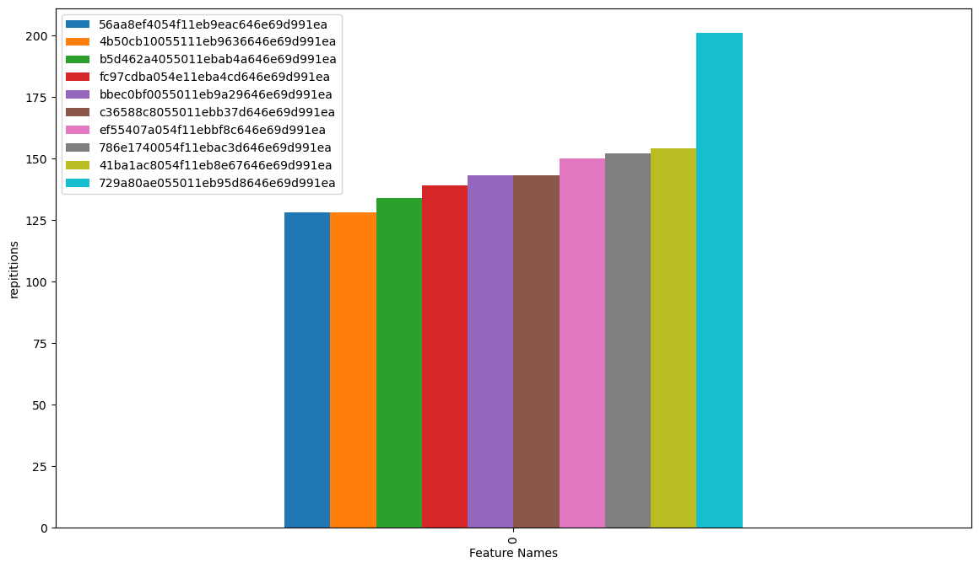

**Number of tweets per user**

The data and the bar plot above show the most active postId(s) (persons tweets on social media), as each Id corresponds to one of the application users.

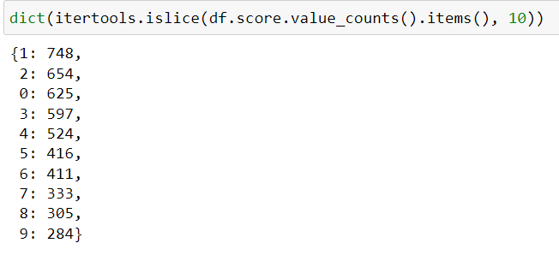

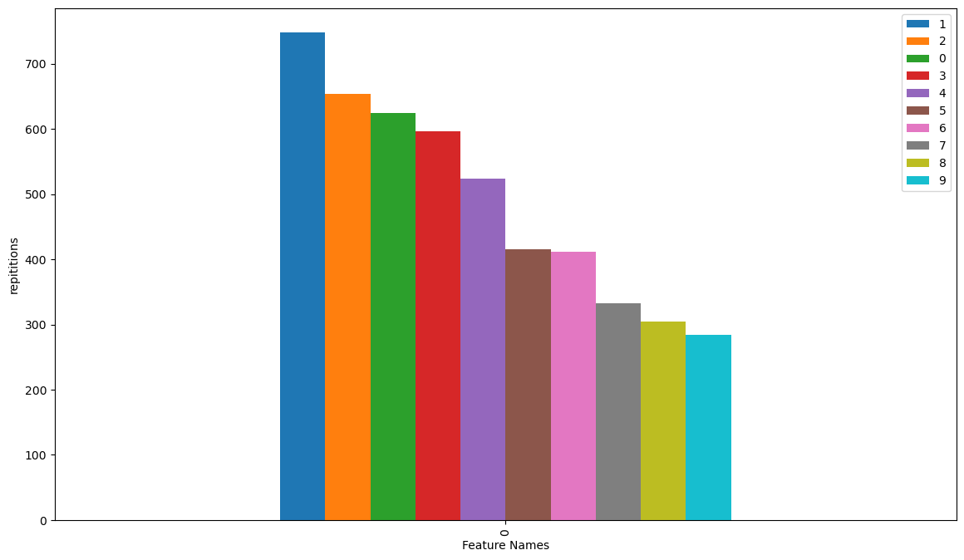

**Number of tweets per score value**

The plot and the data above show the number of tweets for the top 10 scores

**2 – Top frequent n-grams generally and per class**

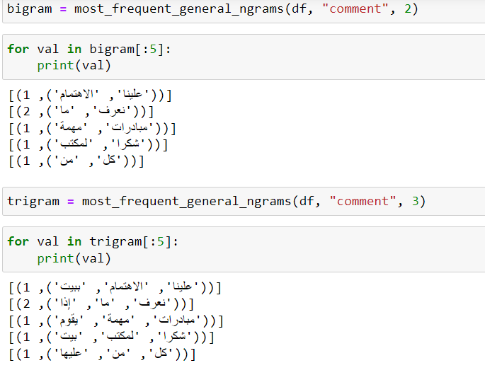

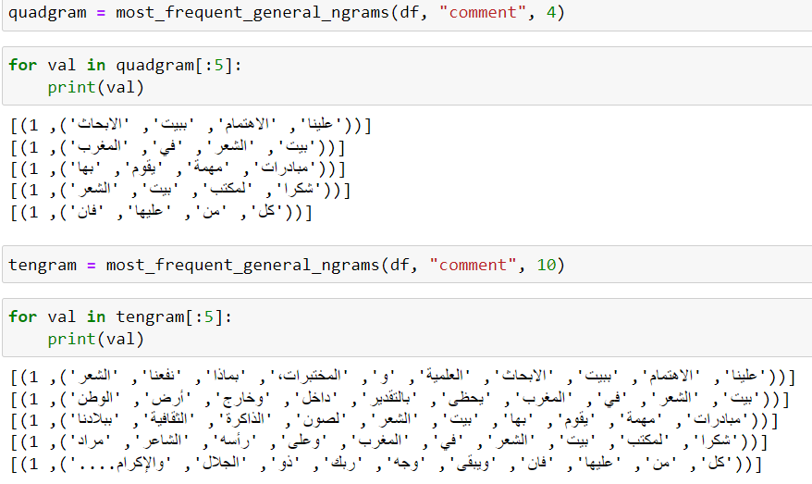

**Top frequent n-grams generally**

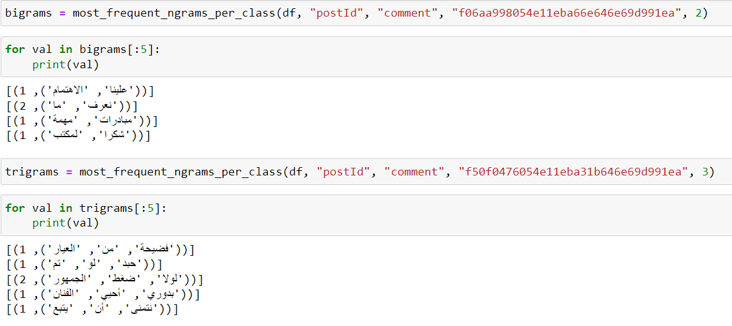

**Top frequent n-grams per specific class**

**3 – Lengths of examples in words and in letters**

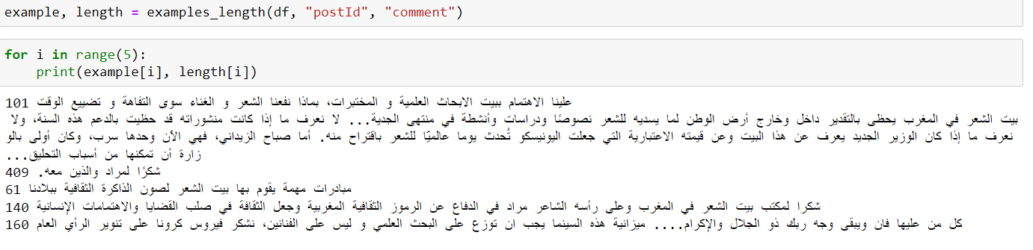

**Lengths of general examples in letters**

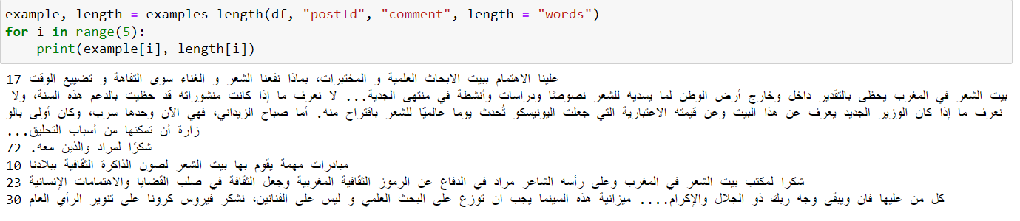

**Lengths of general examples in words**

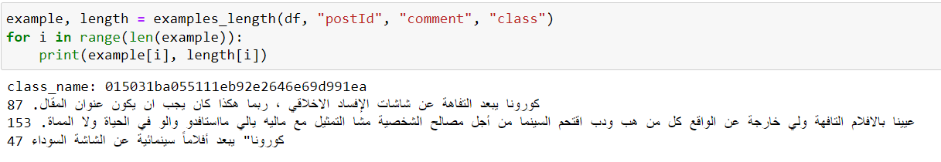

**Lengths of randomly selected class examples in letters**

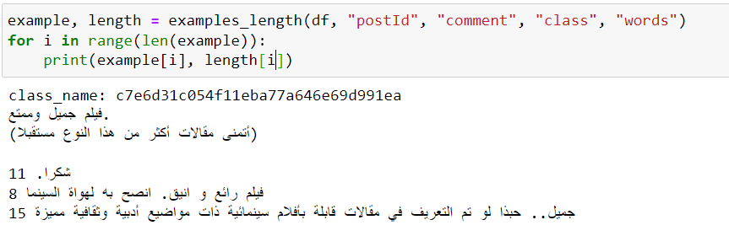

**Lengths of randomly selected class examples in words**