Testing table
Input | Expected output | Actual output | Passed?
17, 61, 51, 28, 76 | Average 49.6%  Minimum 18%  Maximum 81%  Number recorded 5  Sorted list/array contents: 18%, 30%, 54%, 65%, 81%. | 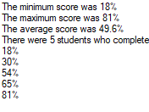 | ☒
0, 94, 47, 23, 71 | Average: 50%  Minimum: 0%  Maximum: 100%  Number recorded 5  Sorted list/array contents: 0%, 24%, 50%, 76%, 100%. | 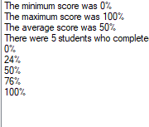 | ☒
Clicking display with no scores added | No results to show | 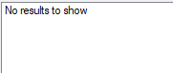 | ☒
-1 | Invalid input. Number must be in the range {MIN_SCORE}-{MAX_SCORE} inclusive | 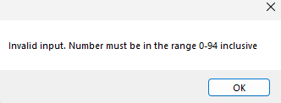 | ☒
0 | Nothing (number is added without issue) | 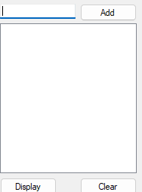 | ☒
1 | Nothing (number is added without issue) |  | ☒
93 | Nothing (number is added without issue) |  | ☒
94 | Nothing (number is added without issue) |  | ☒
95 | Invalid input. Number must be in the range {MIN_SCORE}-{MAX_SCORE} inclusive | 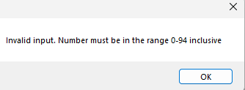 | ☒
Ten | Invalid input. Please enter a whole number in the range {MIN_SCORE}-{MAX_SCORE} inclusive, e.g. 64. | 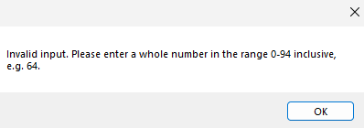 | ☒
12.5 | Invalid input. Please enter a whole number in the range {MIN_SCORE}-{MAX_SCORE} inclusive, e.g. 64. |  | ☒
“” (empty string) | Invalid input. Please enter a whole number in the range {MIN_SCORE}-{MAX_SCORE} inclusive, e.g. 64. |  | ☒
Clicking display after clicking clear | No results to show |  | ☒

