Testing Version 1
Input | Expected Output | Actual Output | Working?
292, 83, 261, 108, 97, 331, 62 | -9  12  26  37  190  221  260  The average net score of all golfers was 105.2857143  The minimum net score of all golfers was -9  The maximum ne score of all golfers was 260  The sum of all scores was 737  7 golfer’s scores were recorded | 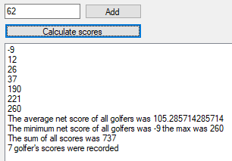 | Y
17 | Number out of bounds | Number in bounds and accepted | N
18 | Number in bounds and accepted | Number in bounds and accepted | Y
400 | Number in bounds and accepted | Number in bounds and accepted | Y
401 | Number out of bounds | Number in bounds and accepted | N
hello | Error message | 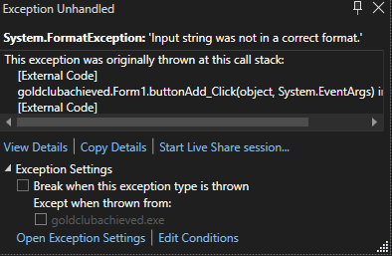 | N

