Testing Version 1
Input | Expected Output | Actual Output | Working?
292, 83, 261, 108, 97, 331, 62 | -9  12  26  37  190  221  260  The average net score of all golfers was 105.2857143  The minimum net score of all golfers was -9  The maximum ne score of all golfers was 260  The sum of all scores was 737  7 golfer’s scores were recorded | 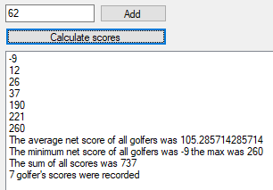 | Y
17 | Number out of bounds | Number out of bounds and denied | Y
18 | Number in bounds and accepted | Number in bounds and accepted, text clears | Y
19 | Number in bounds and accepted, text clears | Number in bounds and accepted, text clears | Y
400 | Number in bounds and accepted, text clears | Number in bounds and accepted, text clears | Y
401 | Number out of bounds | Number out of bounds and denied | Y
hello | Invalid input. Please make sure raw score is a whole number e.g. 64. | 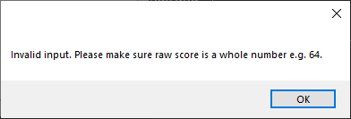 | Y
Empty string | Invalid input. Please make sure raw score is a whole number e.g. 64. | 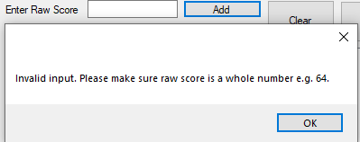 | Y
19.5 | Invalid input. Please make sure raw score is a whole number e.g. 64 | 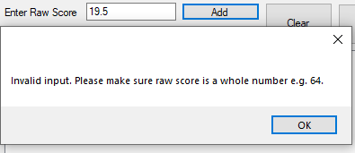 | Y
Pressing calculate with no data added | No data has been entered. | 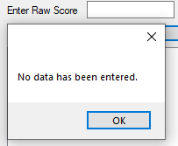 | Y
Clear button | The form clears and the old numbers aren’t included in new calculation. | 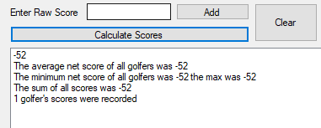  After pressing clear and entering 20:  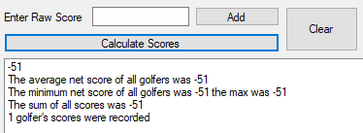 | Y
Exit button | Closes form. | Closes the form | Y

