Golf program v1
Input value(s) | Expected output | Actual output | Passed?
67, 98, 77, 153, 110 – In valid range | The net scores were:  -4  6  27  39  82  There were 5 scores added. The average net score was 30.  The highest score was 82 and the lowest score was -4. | 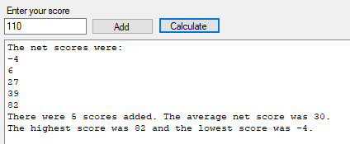 | ☒
Adding value 17 and calculating – Score out of range. | Message box error saying, “That is not in the valid range”. | 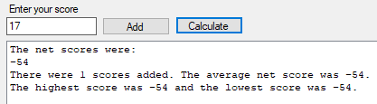 | ☐
Adding value 18 and calculating – Lowest possible score. | The net scores were:  -53  There were 1 scores added. The average net score was -53.  The highest score was -53 and the lowest score was -53. | 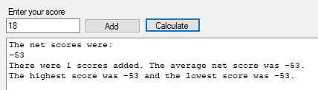 | ☒
Adding value 401 and calculating – Score out of range. | Message box error saying, “That is not in the valid range”. | 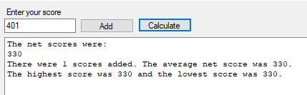 | ☐
Adding value 400 and calculating – Highest possible score. | Your net scores were:  329  There were 1 scores added. The average net score was 329.  The highest score was 329 and the lowest score was 329. | 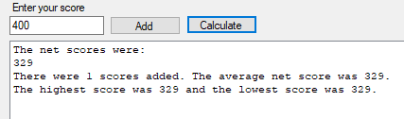 | ☒
Adding non int value. | Message box error saying “Please enter a whole number” | 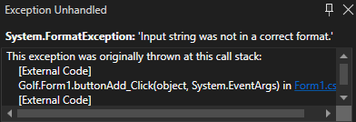 | ☐
Calculating without adding any data. | Message box error saying, “Please add some values before calculating!” and the program doesn’t crash. | 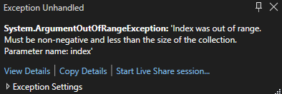 | ☐

Golf program v2
Changes made: Adding checking for range as well as for if the textbox had an int inside as well as adding functions for calculations. I also put the average to 2dp and made sure the list wasn’t empty before calculating.

Input value(s) | Expected output | Actual output | Passed?
67, 98, 77, 153, 110 – In valid range | The net scores were:  -4  6  27  39  82  There were 5 scores added. The average net score was 30.00.  The highest score was 82 and the lowest score was -4. | 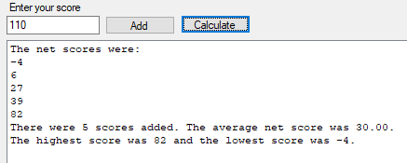 | ☒
Adding value 17 and calculating – Out of range. | Message box error saying “Out of range! Please enter a number greater than 17 and smaller than 401.” and for the number to not be added to the list. | 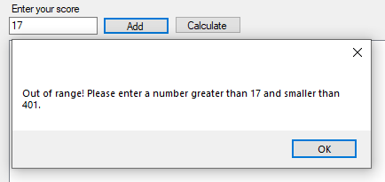 | ☒
Adding value 18 and calculating – Lowest possible score. | The net scores were:  -53  There were 1 scores added. The average net score was -53.00.  The highest score was -53 and the lowest score was -53. | 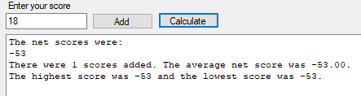 | ☒
Adding value 18.5 – Non int value | Message box error saying, “Please enter a whole number!” and for the number to not be added to the list. | 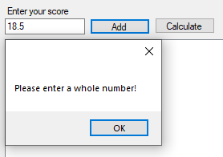 | ☒
Adding value 401 – Out of range. | Message box error saying, “Out of range! Please enter a number greater than 17 and smaller than 401.” and for the number to not be added to the list. | 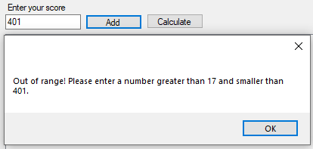 | ☒
Calculating without adding any data. | Message box error saying, “Please add some values before calculating!” and the program doesn’t crash. | 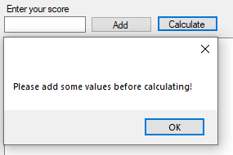 | ☒
Adding value 400 and calculating – Highest possible score. | The net scores were:  329  There were 1 scores added. The average net score was 329.00.  The highest score was 329 and the lowest score was 329. | 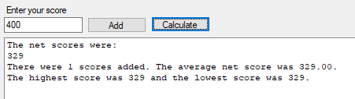 | ☒
Adding non int value. | Message box error saying “Please enter a whole number” | 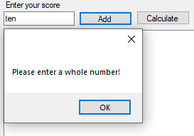 | ☒

Golf program v3:
Changes made: Made some quality-of-life additions like a button the reset everything (textbox, list, listbox). Made an exit button as well as making the cursor refocus onto the textbox after each addition for faster data entry. Made the listbox reset after every calculation. Fixed the button’s tab index. Gave the form a title. Removed redundant code that found total as well as biggest and smallest numbers, as index 0 will be the smallest and the last item in the list will be the largest, the total can be found with the inbuilt .Sum() method. No modifications to logic which is reflected in the practically unchanged testing table.

Input value(s) | Expected output | Actual output | Passed?
67, 98, 77, 153, 110 – In valid range | The net scores were:  -4  6  27  39  82  There were 5 scores added. The average net score was 30.00.  The highest score was 82 and the lowest score was -4. | 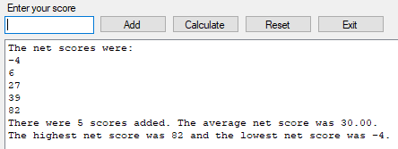 | ☒
Adding value 17 – Out of range. | Message box error saying “Out of range! Please enter a number greater than 17 and smaller than 401.” and for the number to not be added to the list. | 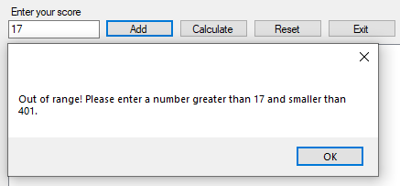 | ☒
Adding value 18 and calculating – Lowest possible score. | The net scores were:  -53  There were 1 scores added. The average net score was -53.00.  The highest net score was -53 and the lowest net score was -53. | 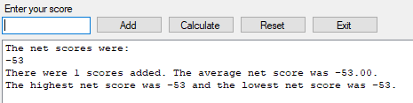 | ☒
Adding value 18.5 – Non int value | Message box error saying, “Please enter a whole number!” and for the number to not be added to the list. | 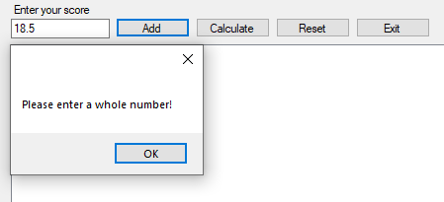 | ☒
Adding value 401 – Out of range. | Message box error saying “Out of range! Please enter a number greater than 17 and smaller than 401.” and for the number to not be added to the list. | 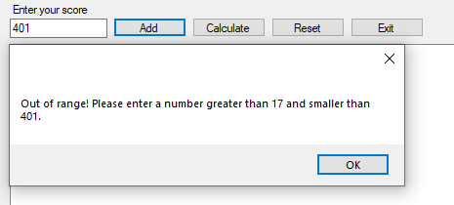 | ☒
Calculating without adding any data. | Message box error saying, “Please add some values before calculating!” and the program doesn’t crash. | 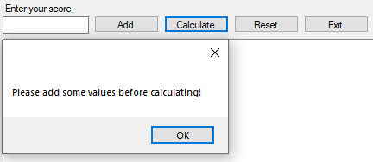 | ☒
Adding value 400 and calculating – Highest possible score. | The net scores were:  329  There were 1 scores added. The average net score was 329.00.  The highest net score was 329 and the lowest net score was 329. | 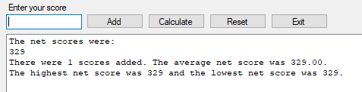 | ☒
Adding non int value. | Message box error saying, “Please enter a whole number” |   

