Homework 4

M1522.000900 Data Structure (2019 Fall)

2013-12815 Dongjoo Lee

**Question 1.**

For a binary tree that has n leaves, the number of 2-degree nodes be $n-1$.

In the tree that has k nodes, let the number of leaves be $L(k)$ and of 2-degree nodes be $T(k)$.

Let the proposition $P$ for the binary tree that has $k$ nodes, $P(k): L(k)-T(k)=1$.

Proof. $∀k P(k)$

[Base case] At $k=1, L(k)=1$ and $T(k)=0$.

$L(k)-T(k)=1$, thus, $P(k)$ holds for $k=1$.

[Inductive Steps] Assume that $P(k)$ holds for $k=n$.

When tree grows by 1 node, there are 3 cases by the degree.

(Case 1) The new node cannot be attached to existing node if it is 2-degree node.

(Case 2) The new node can be attached to existing node if it is 1-degree node.

In this case, this node becomes 2-degree node by new node.

$T(n+1)=T(n)+1 and L(n+1)=L(n)+1$

$L(n+1)-T(n+1)=L(n)-T(n)=1$

(Case 3) The new node can be attached to existing node if it is leaf.

In this case, there is no change in $T(n+1)$ and $L(n+1)$ from $k=n$.

$L(n+1)-T(n+1)=L(n)-T(n)=1$

In all cases, $L(n+1)-T(n+1) = 1$.

∴ $P(n+1)$ holds for $k=(n+1)$.

**QED**.

**Question 2.**

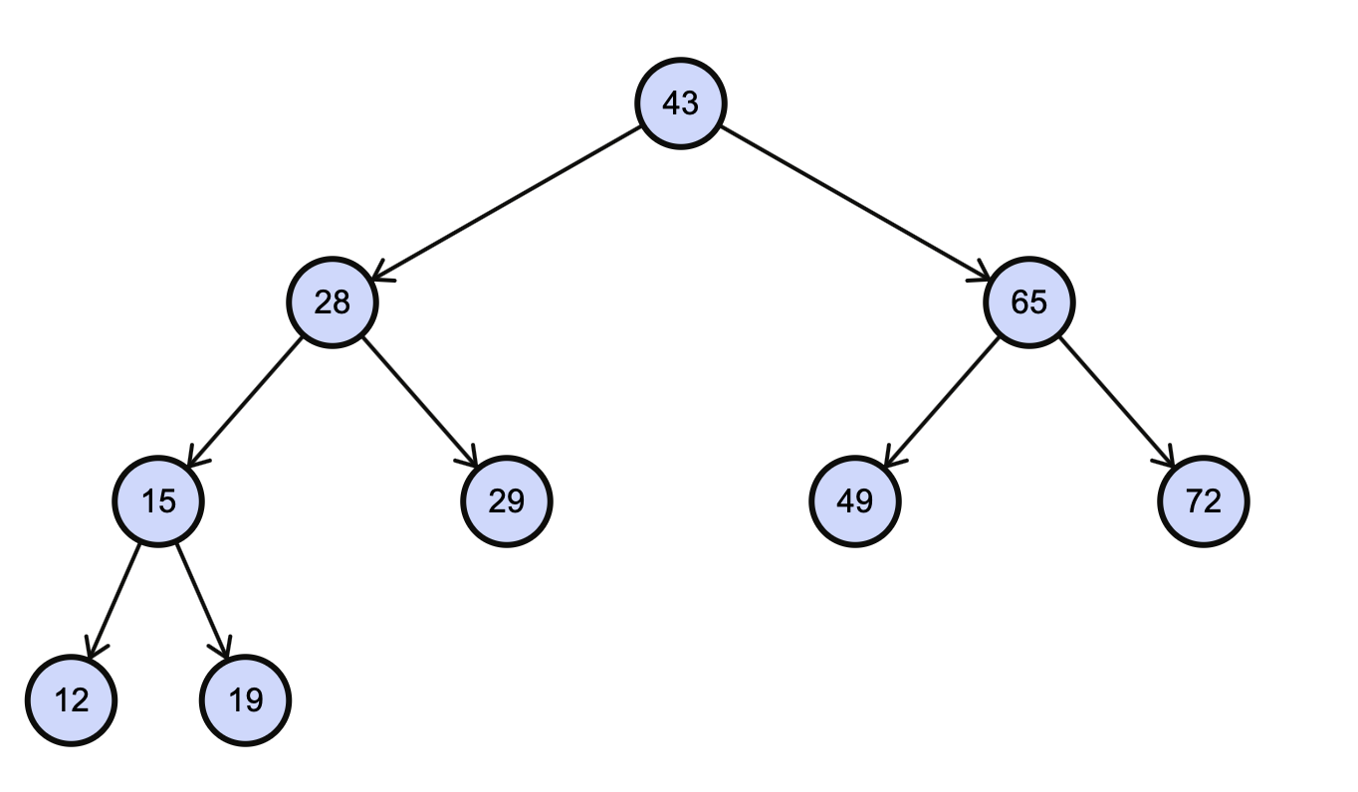 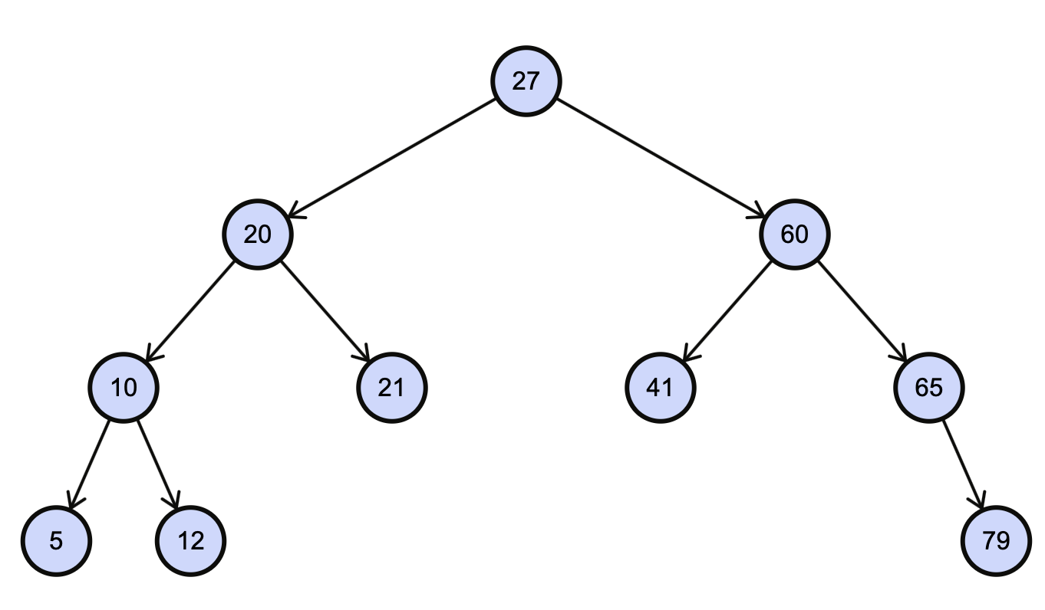

**(a) (b)**

**Question 3.**

(a) 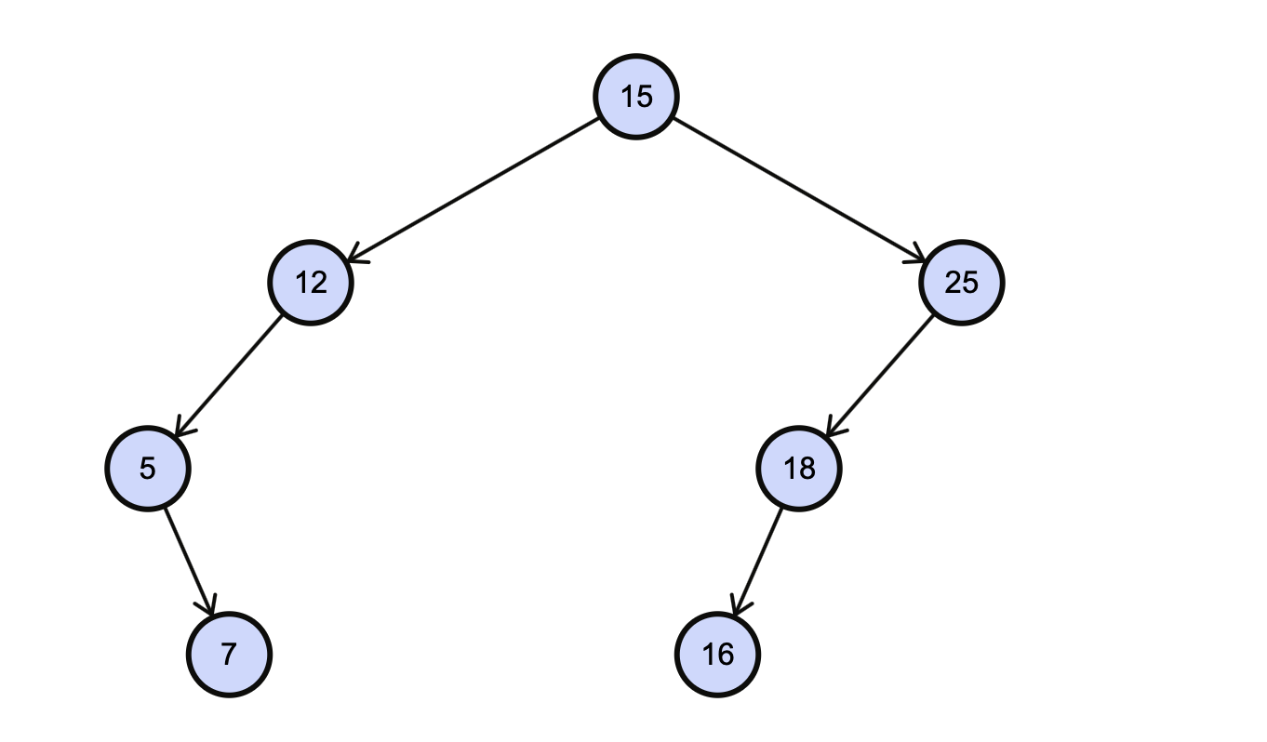

(b) A. 15-12-5-7-25-18-16

B. 5-7-12-15-16-18-25

C. 7-5-12-16-18-25-15

**Question 4.**

(1) (c), (d)

(2)

**Question 5.**

Let $S(h)$ be $(h-2)(2^h-1)+h$.

And let a perfect binary tree of height h be $T_{h}$.

Proof. The sum of depth of each node in $T_{h}$ is $S(h)$.

[Base case] In $T_{1}$, sum of depth of each node is $0$.

$S(1)=-1⋅0+1=1$

$∴ S(h)$ holds for $h=1$.

[Inductive Steps] Assume that $S(h)$ holds for $h=n$, then, sum of depth of each node is $S(n)$.

When $T_{n}$ grows to $T_{n+1}$, new leaves are attached at existing leaves.  
This procedure is like below,

1) has leaves from its definition.  
2) Each leaves in $T_{n}$ became $T_{n+1}$’s nodes that have 2 children.

3) ’s leaves are 2 times of $T_{n}$’s leaves.

From these, sum of depth of each node in $T_{n+1}$ is

$= S(n)+2^(n-1)⋅2⋅n$

$= S(n)+2^n⋅n$

$= (n-2)⋅2^n+2+2^n⋅n$

$= (2n-2)⋅2^n+2$

$= (n-1)⋅2⋅2^n-(n-1)+(n+1)$

$= (n-1)⋅(2⋅2^n-1)+(n+1)$

$= (n-1)⋅(2^(n+1)-1)+(n+1)$

$= S(n+1)$

**∴ S(h) also holds for h=(n+1).**

**QED.**