Report 109550039 楊富翔

Case 1 : Run –filter icmp

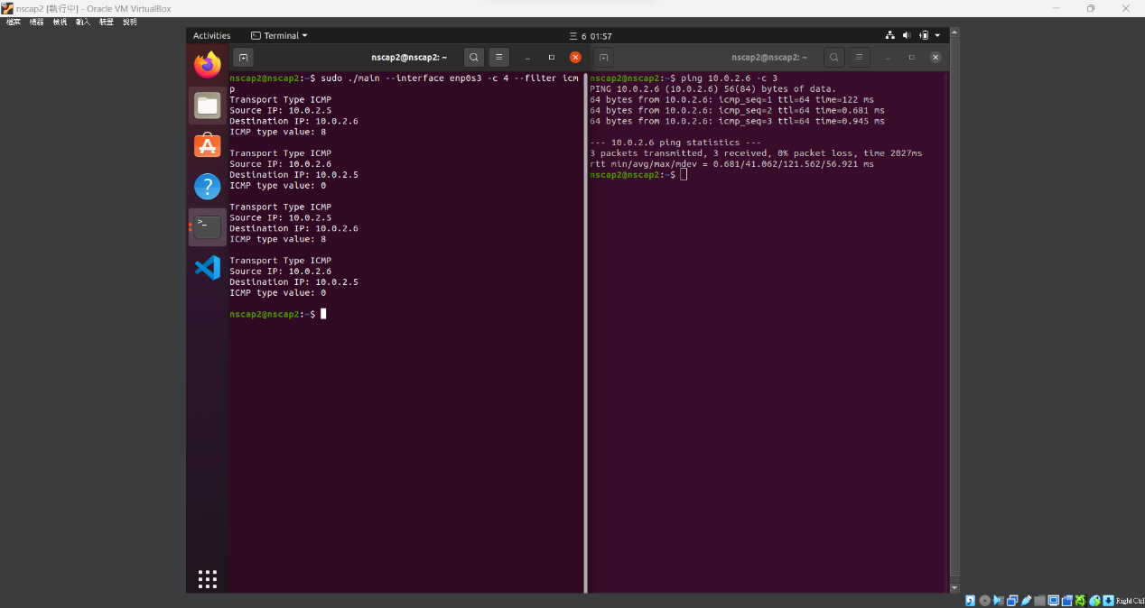

Case 2: Run –filter all (ping &UDP)

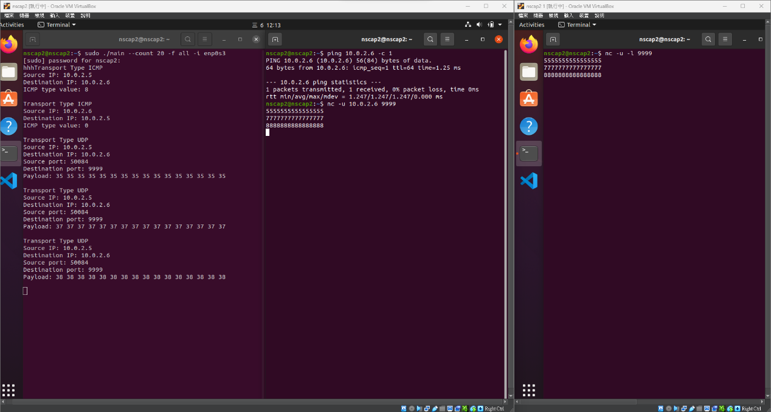

Run TCP pkt1

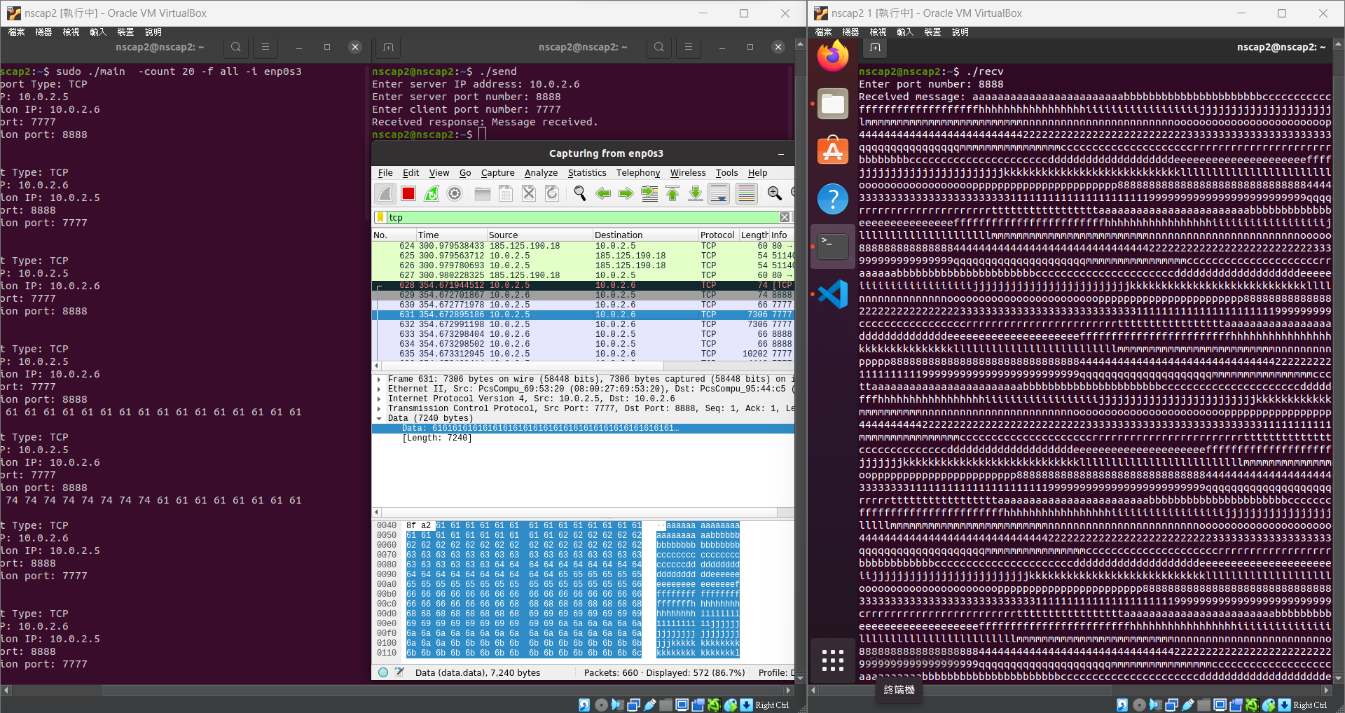

Run TCP pkt1

