NSCAP HW7 Report 109550039 楊富翔

1. **When h1 ping h2, what will happen?**

ARP:

h1 sent request

h2 received and replied

h1 received the reply

ICMP:

h1 sent request

h2 received and replied

h1 received the reply

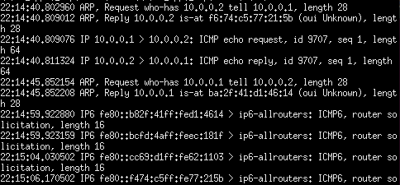

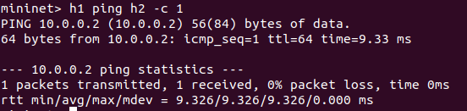

1. **When h1 ping h3, what will happen?**

ARP:

h1 sent request

h3 received and replied

h1 received the reply

ICMP:

h1 sent request

h3 received and reply

h1 cannot received since controller dropped it

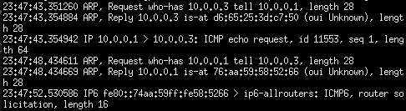

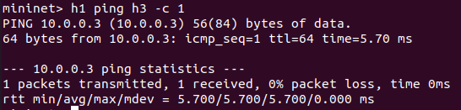

1. **When h3 ping h2, what will happen?**

ARP:

h3 sent request

h2 received and replied

h3 received the reply

ICMP:

h3 sent request

h2 cannot received since controller dropped it

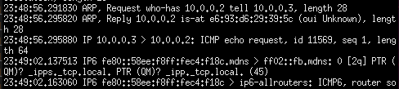

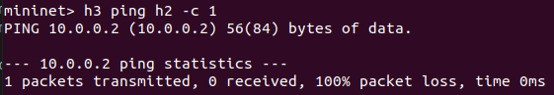

1. **When h1 ping h5, what will happen?**

ARP:

h1 sent request 3 times and no reply

ICMP:

h1 couldn’t send request

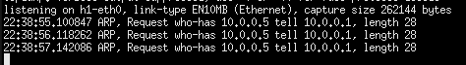

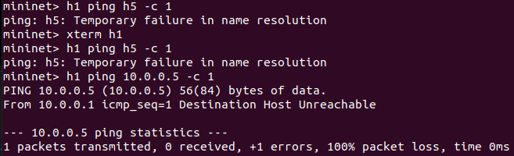

1. **When h1 ping h5, what will happen?**

It is similar to Q1

ARP:

h1 sent request

h5 received and replied

h1 received the reply

ICMP:

h1 sent request

h5 received and replied

h1 received the reply

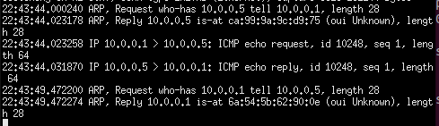

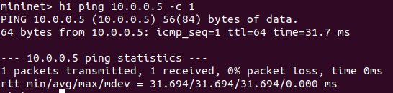

1. **When h1 ping h7, what will happen?**

It is similar to Q2

ARP:

h1 sent request

h7 received and replied

h1 received the reply

ICMP:

h1 sent request

h7 received and reply

h1 cannot received since controller dropped it

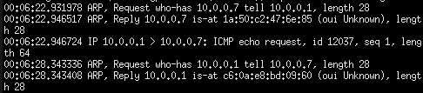

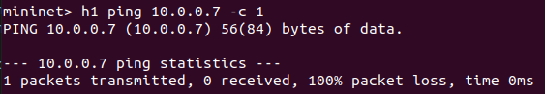

1. **When h7 ping h1, what will happen?**

It is similar to Q3

ARP:

h7 sent request

h1 received and replied

h7 received the reply

ICMP:

h7 sent request

h1 cannot received since controller dropped it

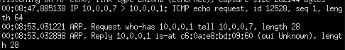

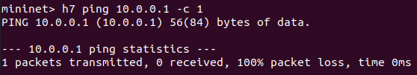

1. **If the packet in question 6 or 7 is dropped in some part of the network, are the outcome and explanation the same as that of question 4?**

No, Q4 is because controller can’t handle this packet since these 2 switches aren't connected, but in Q6 and Q7, controller filter it by flow table.

We know it by observing tcpdump in Q5 since even ARP can’t be replyed. However, in Q6 and Q7, ARP can be replyed.  






1. **Change filter_table2 rule**

**Will the outcome of questions 5, 6, and 7 differ? (no need to print screenshot)**

**explain why or why not.**

No, they are the same. Since “from port_3 or port_4 will be dropped” equals to “from port_1 or port_2 will be allowed to pass” logically, controller dropped port3 and port4 mean let port1 and port2 pass.