**AT01 Production Diary**

**1.1.1 Depth First Search Algorithm Research**

**Algorithm Summary**

A Depth First Search Algorithm is a type of pathfinding algorithm that uses the backtracking principle. It discovers the best path by moving forward if possible and backtracking if necessary to find the quickest route.

**DFS Terminology Definitions**

**Pathfinding:**

Pathfinding is when the computer/AI tries to find the quickest path from point A to point B.

**Tree:**

A tree is a group of linked nodes that form the path that can be traversed through.

**Parent:**

A parent object is and object which has other objects inside of it, a parent object can influence the values of the object inside of it, such as position, size, and other parameters and special values.

**Child:**

A child object is an object inside of a parent object, the child object inherits certain values from the parent object.

**1.1.3 AI Behaviour Chart**

**1.1.4 AI Design Reflection**

The current AI design does fill out all requirements and I believe it is technically feasible to create with my skill level and time available, to create a simple AI like the one required it will not affect budget or other teams in the studio.

**1.2.1 Planned HCI Device Integration Summary**

the HCI devices will include a keyboard and mouse. The required interactions are W, A, S, D for directional controls and the mouse needs to be able to click on North, South, East, West arrows for directional controls.

**1.2.2 C# Event System Summary**

The built in unity event system is up to industry standards, it can be used to implement events for input detection, object detection and more.

**1.2.2 Unity GUI Library Review**

IMGUI is a code-based GUI system made for programmers, IMGUI is more difficult to use than other GUI system due to it all be written and not being able to position UI elements easily.

uGUI is the unity Game Object-based system, uGUI is the main system people use for making a games UI because it has an extensive toolkit and is easy to modify and position UI elements.

**1.2.3 UI Widget Example Overviews**

In the game Destiny, there is a HUD widget that corresponds to the left and right bumper on a controller, when pressed the player will you an item and the widget will flash then show a cooldown bar. This works in a similar way to the required UI widget with that it responds to input by flashing. It does work a little different because it uses an item rather than show directional input.

Mobiles racing games such as Asphalt 9 display directional controls on the screen that when pressed move the car, this is similar to the required widget because when the widget is pressed the player will move but it is not quite the same because the buttons do not flash when pressed and they control the player in different ways.

**1.2.4 UI Widget Paper Prototype**

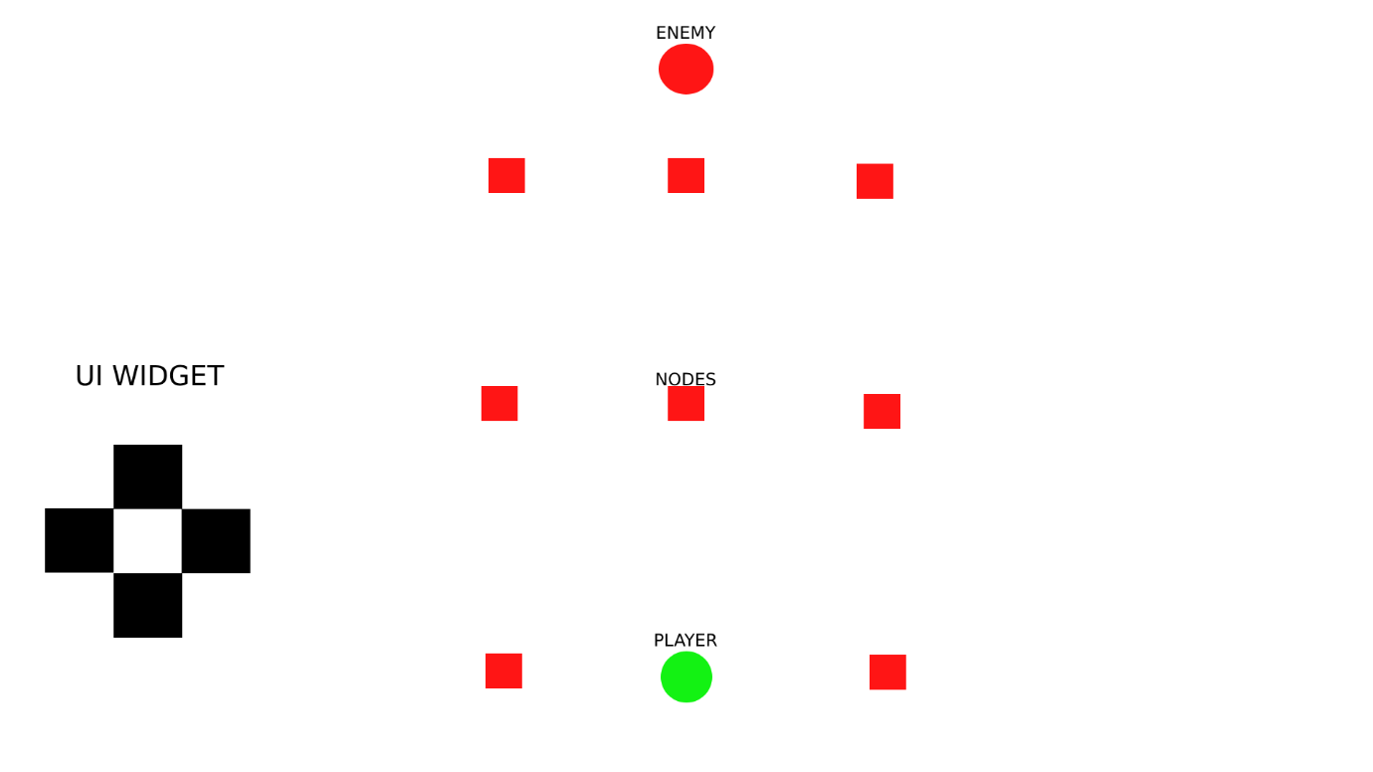

The UI widget will be displayed to the left of the screen, when you either use your keyboard, gamepad or press the UI widget the button widget that you pressed will flash green if you can move in that direction and flash red if you cannot move in that direction.

I will implement this functionality through code and the Unity event system.

**2.1.1/2.2.2 Testing Log**

*Please add rows as required.*

|  |  |  |  |
| --- | --- | --- | --- |
| Test Case Description | Expected Results | Actual Results | Success? |
|  |  |  |  |
|  |  |  |  |
|  |  |  |  |
|  |  |  |  |
|  |  |  |  |
|  |  |  |  |
|  |  |  |  |
|  |  |  |  |
|  |  |  |  |
|  |  |  |  |
|  |  |  |  |

**3.1 Final Checks**

|  |  |
| --- | --- |
| **Final Checks** | **Confirmed** |
| * AI pathfinding (using the DFS algorithm) has been successfully integrated |  |
| * Game over conditions have been successfully implemented |  |
| * Appropriately compatible with Google Chrome web browser |  |
| * Appropriately compatible with Mozilla Firefox web browser |  |
| * Appropriately compatible with Windows |  |
| * UI widget responds to relevant keyboard inputs |  |
| * UI widget responds to relevant mouse inputs |  |
| * UI widget responds to relevant controller inputs |  |
| * UI set to scale with a full HD resolution (1920x1080) |  |

**3.1 AI Evaluation**

**3.2 Required Amendments**

**3.3 Final Client Sign-Off**

*Insert a screenshot of your email communications with the client, providing evidence of their endorsement to finish the production of the project.*