VLC Controller
VLC Controller is a simple controller for the popular VLC Media Player using face detection and finger recognition with your PC's/notebook's webcam.

Programmers: Patrick Morczinietz, David Retzer

Face Detection
- pause video when no face is detected after two seconds
- play when face is detected again
- activate by adding “face” as argument when starting the application

Finger Recognition
Finger Recognition in the appropriate rectangle on the right of the opening webcam window:
- three fingers: volume down
- four fingers: volume up
- five fingers: play/pause

Prerequisites
- Install uinput: https://github.com/tuomasjjrasanen/python-uinput
- install Tkinter: sudo apt-get install python python-tk idle python-pmw python-imaging
- install selfspy: https://github.com/gurgeh/selfspy
- install OpenCV: sudo apt-get install libopencv-dev python-opencv

Screenshots
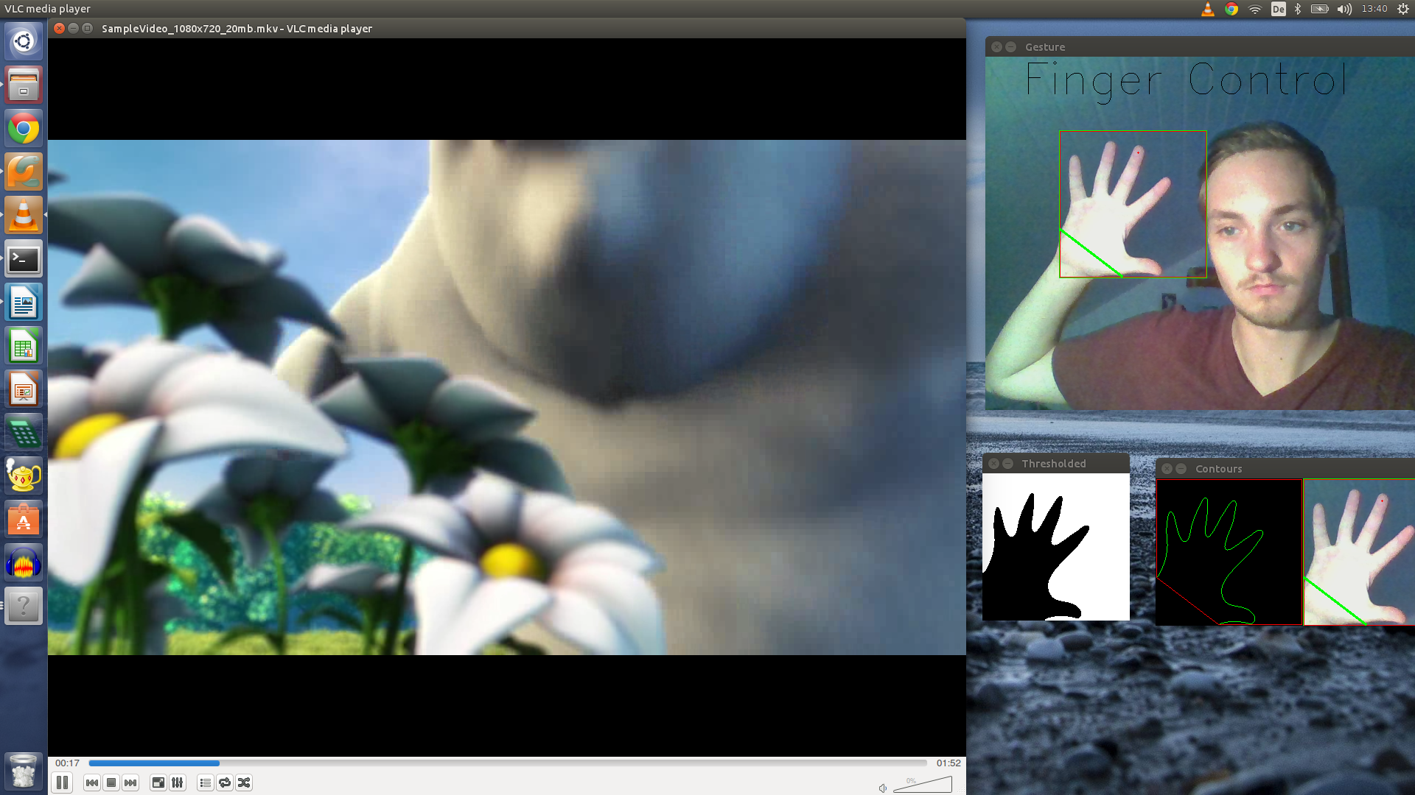

Usage
- start script ubicomp.py with sudo python ubicomp.py or sudo python ubicomp.py faces to activate face detection (due to performance issues)
- open VLC Media Player
- Drag and Drop Video in VLC
- play Video using moouse or space key
- use rectangle box to recognize finger count
- use face detection
CLOSE INSTRUCTIONS TO START! Have fun!

Implementation
VLC Controller is using following modules:
- OpenCV: detect number of fingers and faces
- selfspy (Sniffer class): check if the current window is VLC
- uinput: simulate keystrokes (and combinations)
- multiprocessing for start and kill timers and the actions
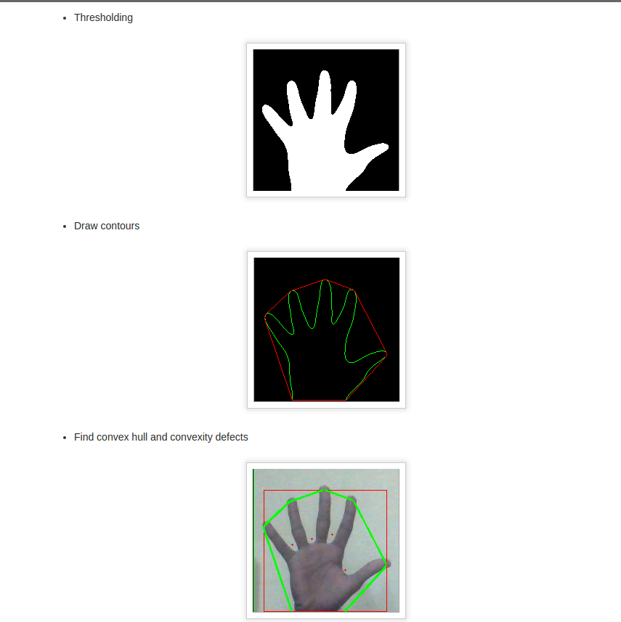

Usage Scenario
The notebook is connected to a TV with a HDMI Cable and the user wants to watch a video. Instead of moving to the mouse or to to notebook's mousepad and taking long and uncomfortable ways the user now has the possibility to control the VLC Media Player's most often used settings play/pause, volume down and volume up via simple hand gestures in the appropriate rectangle displayed in the application. Additionally, the video is paused when no face is detected by the webcam for two seconds, for example when the user leaves the room. When a face is detected again by the application and the webcam, the video is played back. The application can also be used when the user is watching a video on his notebook or pc (using a webcam).
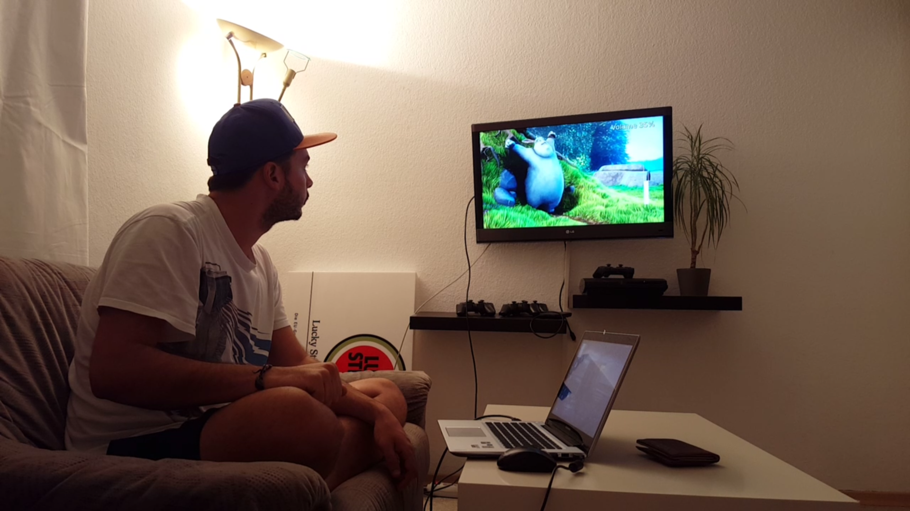

Limitations
- Finger recognition only works well when the background is white and bright enough
- only works in VLC Media Player
- smooth running only on good computers
- user must be in front of the webcam to use face detection

Testing
Setup
For our study we always used the same room, background and light. The participant sits on the couch and controls VLC via number of fingers. The notebook is connected to the TV using a HDMI Cable. The VLC window is shown on a second screen on TV, so the application and the webcam frames are displayed on the notebook. For comparison between the status quo and the novel interaction technique the user does all tasks with both approaches using the notebook's keyboard. The participant is pleased to do the tasks as fast as possible. Before starting the tasks, the participant has three minutes to get warm with the novel technique. The test is started by testing the status quo first.
Tasks
- pause VLC (using hand gestures)
- volume up VLC 50 percent (using hand gestures)
- volume down VLC 50 percent (using hand gestures)
- play back VLC (using hand gestures)

Variables
Independent variables:
user, interaction technique
dependent variables:
time difference
controlled variables:
keyboard, wireless mouse, sitting height, table height, notebook, fatigue, latency, index finger, forearm on the table
condounding variables:
CPU-workload (minimize by killing all processes except the applications)
Participants
- Four students
- Participants often use keyboard for gaming or school
Participant Selection
- three male participants, one female
Logging
For measuring the times between old and new interaction technique a simple stopwatch on smartphone is used. The results are stored in CSV-spreadsheet for further calculations of the new approach.
• a description of study setup and results, including statistical analysis and discussion of results

