Magic Wand Report
With magic_wand.py you can draw simple gestures (including circle, triangle and rectangle) using the wii mote to spawn the drawn objects on the screen. Furthermore you can drag and drop these objects on the screen using the wii mote. Objects will be created at a random position and with a random color.
Functions
- Hold down the “1” button to start recognizing a gesture
- Best experience for drawing gestures: start at the left top and perform the gesture anti-clockwise
- according to the gesture either a circle, a triangle or a rectangle will be placed on the screen
- while holding down the “B” button, the mouse cursor can be fully operated using the wii mote
- the “A” button works similar to the left click of a mouse, objects can be selected and dragged pressing “A” and “B” at the same time
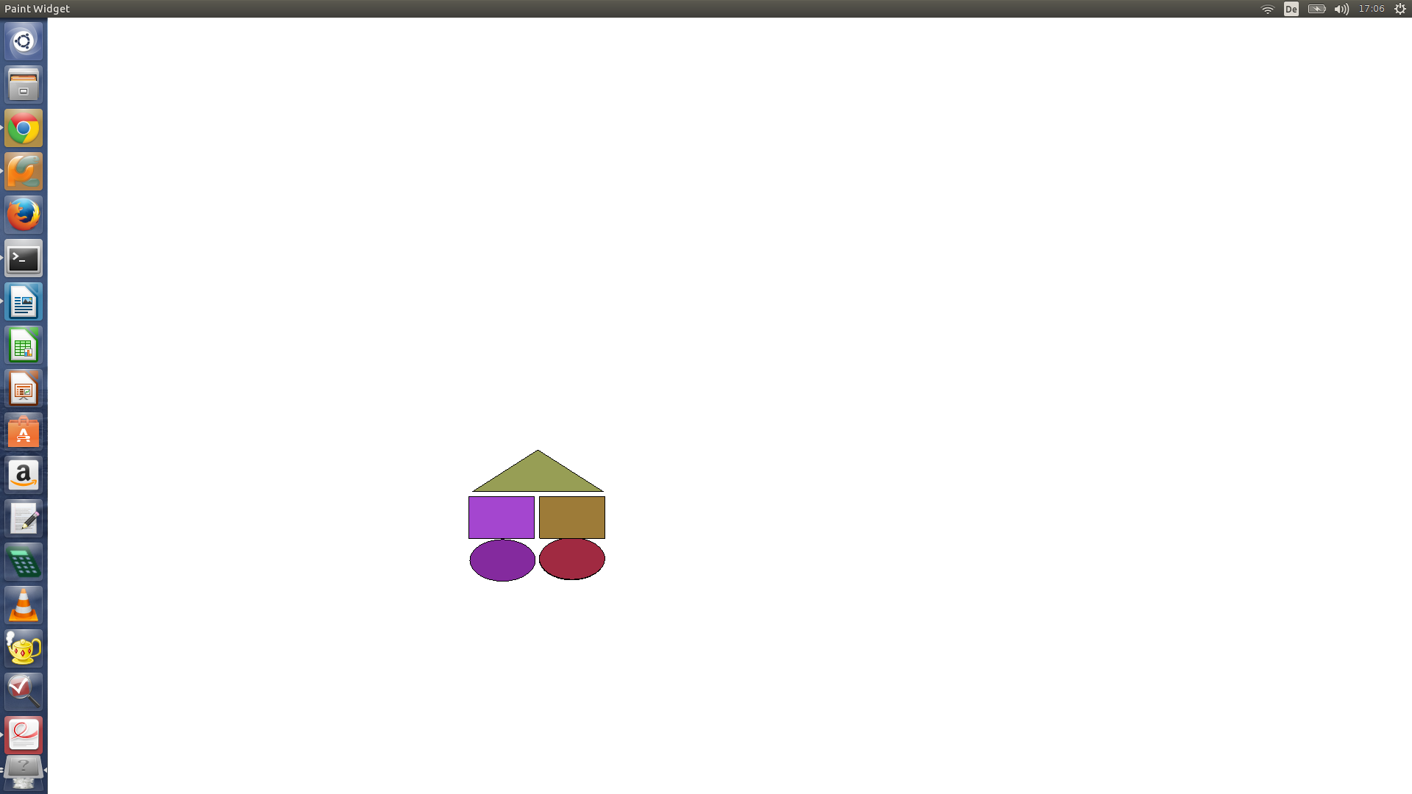
Prerequisites
For the usage of Magic Wand these prerequisites are essential:
- Install PyUserInput: pip install PyUserInput
- Install Xlib: pip3 install python3-xlib
- Install PyQt5
- unix.py from https://github.com/pepijndevos/PyMouse/tree/master/pymouse
- wiimote.py from https://github.com/RaphaelWimmer/wiimote.py
- $1 recognizer from https://depts.washington.edu/aimgroup/proj/dollar/others/python.cvm.zip
- of course: magic_wand.py
Implementation
The python file wiimote_node.py was extended with these features:
- output of ir data of x,y and as tuple
- button press outputs of '1', 'A' and 'B'
Two additive nodes were implemented:
- RecognizerNode
The RecognizerNode gets ir x and y data as input and uses the dollar.py module to recognize the gestures square, triangle and circle and draws the appropriate elements on a canvas.
2. PointerNode
The PointerNode gets ir x and y data as input and moves the mouse using PyMouse depending on the x and y position. The node scales the ir data up to the screen size because the maximum infrared values are: 1024 (x-axis), 760 (y-axis)
xScreen = self.screenSize[0] - int((self.screenSize[0] / 1024) * self.irX)
yScreen = int((self.screenSize[1] / 760) * self.irY)
Further Usage Scenario
- Playing “Connect Four” with a wii mote
- Simple drawing with a wii mote

