
Maven Market — Power BI Sales & Returns Dashboard
README & Usage Guide
Graduation Project — Retail Analytics
Data coverage: Jan 1997 – Dec 1998 | Countries: USA, Canada, Mexico
1. Project Overview
Maven Market is a multi-national grocery chain operating in the United States, Canada, and Mexico. This Power BI report gives the sales team a single, decision-ready view of revenue, profit, margins, and returns — with drill-down capability across countries, regions, stores, products, and customers.
The report is built on a star-schema data model with two fact tables (Sales and Returns) and five conformed dimensions (Products, Customers, Stores, Regions, Calendar), covering transactions from January 1997 through December 1998.

Data Model Summary
Table | Type | Row Count (approx.) | Key Columns
Sales_Fact | Fact | 269,722 | transaction_date, product_id, customer_id, store_id, quantity
Returns_1997-1998 | Fact | 7,088 | return_date, product_id, store_id, quantity
Products | Dimension | 1,560 | product_brand, product_name, product_cost, product_retail_price
Customers | Dimension | 10,281 | gender, member_card, yearly_income, homeowner
Stores | Dimension | 24 | store_name, store_country, region_id
Regions | Dimension | 109 | sales_region, sales_district
Calendar | Dimension | 730 | Date, Month Name, Month Number, Quarter, Year

2. Core KPIs & DAX Measures
All measures are centralized in a dedicated _Measures table, following consistent naming and formatting conventions.

Revenue & Profitability
Total Revenue
Total Revenue = SUMX(Sales_Fact, Sales_Fact[quantity] * RELATED(Products[product_retail_price]))
Total Cost
Total Cost = SUMX(Sales_Fact, Sales_Fact[quantity] * RELATED(Products[product_cost]))
Total Profit
Total Profit = [Total Revenue] - [Total Cost]
Profit Margin
Profit Margin = DIVIDE([Total Profit], [Total Revenue])

Volume & Orders
Total Orders
Total Orders = COUNTROWS(Sales_Fact)
Total Qty Sold
Total Qty Sold = SUM(Sales_Fact[quantity])
Avg Revenue per Order
Avg Revenue per Order = DIVIDE([Total Revenue], [Total Orders])

Returns
Total Returns
Total Returns = COUNTROWS('Returns_1997-1998')
Qty Returned
Qty Returned = SUM('Returns_1997-1998'[quantity])
Return Rate
Return Rate = DIVIDE([Qty Returned], [Total Qty Sold])
Total Return Cost
Total Return Cost = SUMX('Returns_1997-1998', 'Returns_1997-1998'[quantity] * RELATED(Products[product_cost]))

Customers
Active Customers
Active Customers = DISTINCTCOUNT(Sales_Fact[customer_id])
Avg Revenue per Customer
Avg Revenue per Customer = DIVIDE([Total Revenue], [Active Customers])

3. Report Pages
The report contains four pages, each answering a specific set of business questions defined in the project brief.

3.1 Executive Overview
A high-level summary for leadership: overall performance, monthly trends, and geographic breakdown.
- 6 KPI cards: Total Revenue, Total Profit, Profit Margin, Total Orders, Total Qty Sold, Return Rate
- Monthly Trend Line — Revenue & Profit across Jan 1997 – Dec 1998, highlighting seasonal peaks (Nov–Dec) and dips (summer months)
- Revenue by Country Map — filled map showing revenue concentration by country
- Revenue by Country donut — USA, Canada, Mexico split
- Filters: Date range, Country, Region, Store
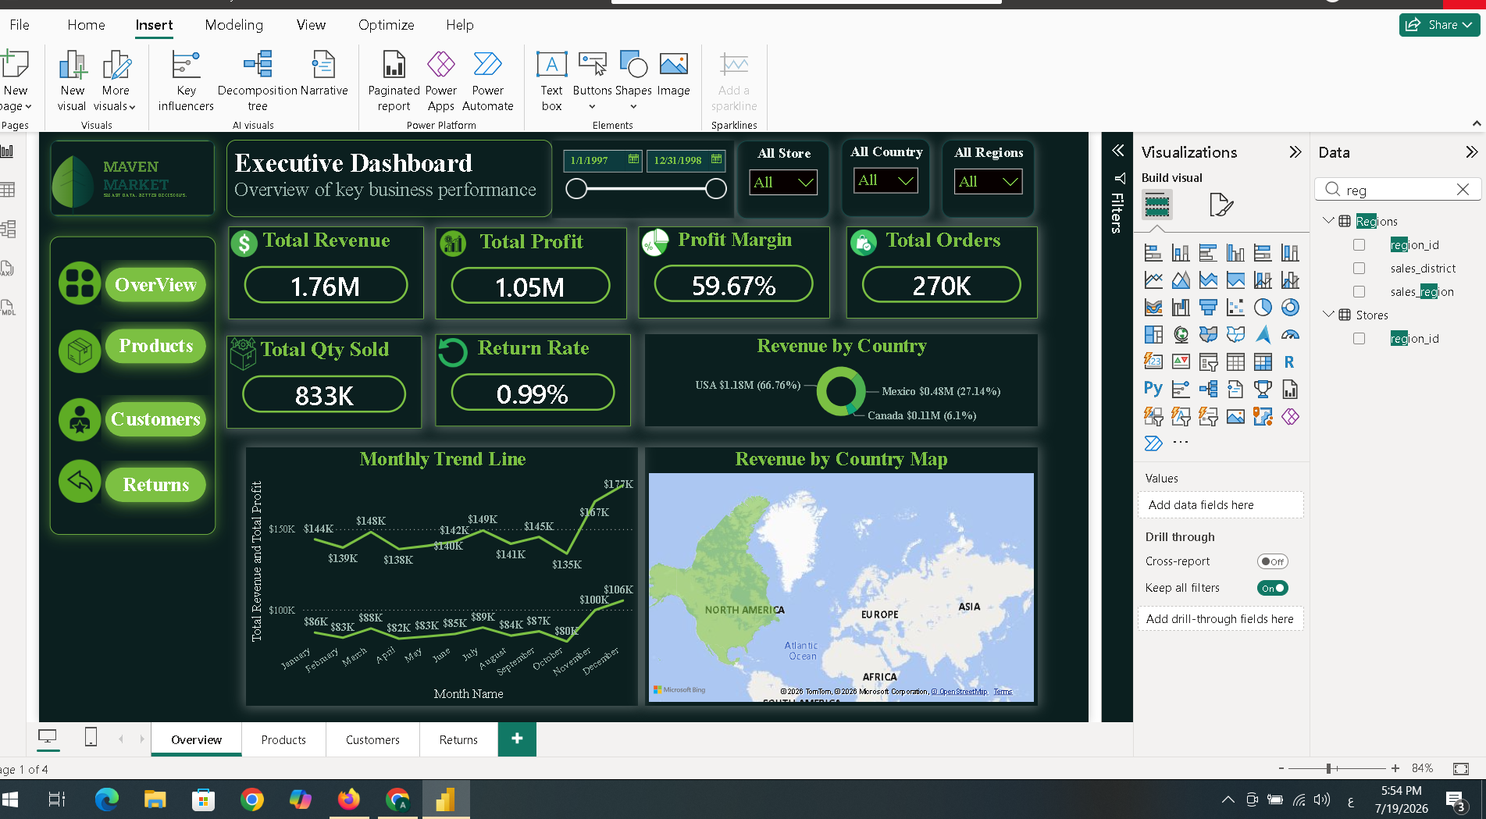

3.2 Products
Analyzes product and brand performance to identify what drives profit and where return issues are concentrated.
- Profit by Brand — treemap (Top N filtered) showing which brands generate the most profit
- Product Profitability Breakdown — matrix with Revenue, Cost, Profit and Margin % per product, with conditional formatting
- Top 10 Products by Return Rate — bar chart isolating the highest-return items for investigation
- Supporting cards: Return Rate, Total Products
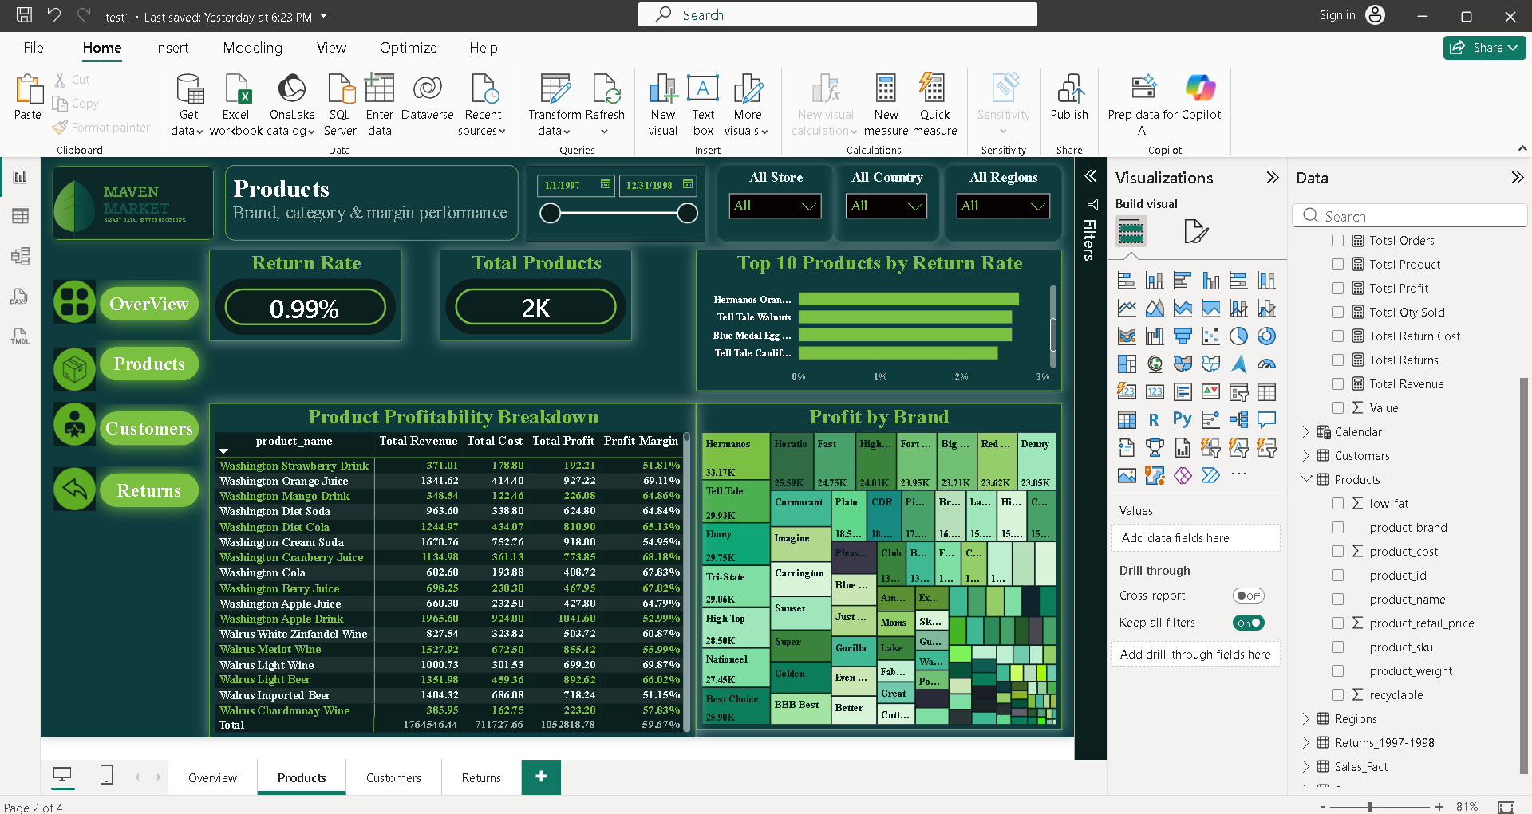

3.3 Customers
Identifies the highest-value customers and profiles the customer base by simple demographic segments.
- Top 10 Customers by Revenue — bar chart
- Revenue by Gender — donut segmentation
- Revenue by Membership Type — bar chart (Bronze / Silver / Golden / Normal)
- Customers by Home Ownership — donut segmentation
- Supporting cards: Active Customers, Avg Revenue per Customer
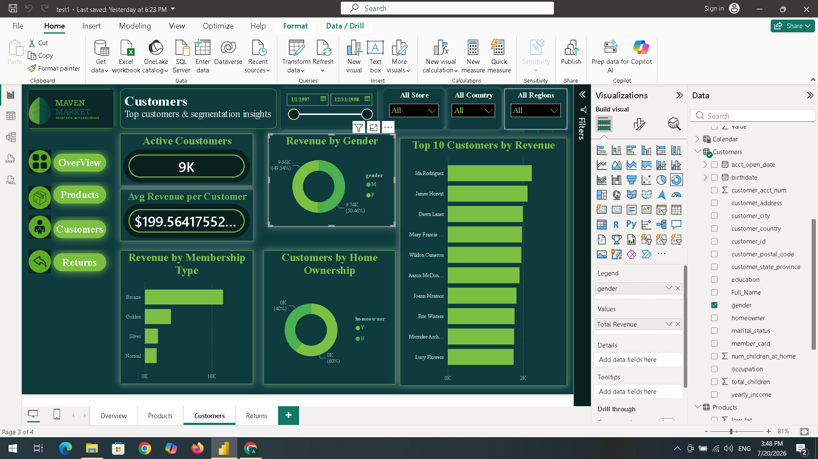

3.4 Returns
Tracks return trends over time and surfaces operational hotspots by region, store, and brand.
- Return Rate Trend Over Time — monthly line chart
- Return Rate by Region, by Store (Top 5), and by Brand (Top 10) — bar charts
- Supporting visuals: Total Returns card, Return Rate gauge
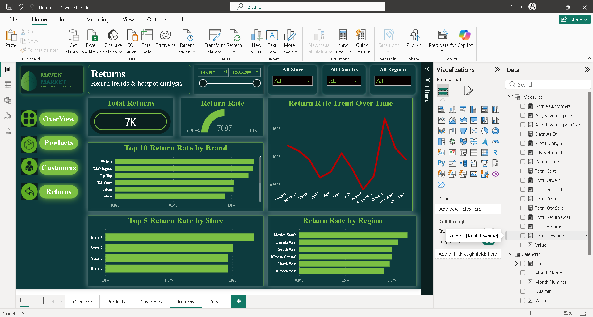

4. Filters & Navigation

Global Filters (all pages)
Filter | Field | Type
Date Range | Calendar[Date] | Between slider
Country | Stores[store_country] | Dropdown
Region | Regions[sales_region] | Dropdown
Store | Stores[store_name] | Dropdown

Navigation
A custom sidebar (left) replaces the default Power BI page tabs. Each button uses a Page Navigation action to jump directly to Executive Overview, Products, Customers, or Returns, keeping all applied filters intact (Keep all filters = On).
All visuals respect cross-filtering: clicking any bar, brand, or region on any page filters related visuals on the same page.

5. Visual Identity
The report follows a dark, brand-consistent theme derived from the Maven Market logo.
Color | Hex | Usage
Bright Green | #7BC043 | Primary accent, positive values, active nav
Medium Green | #4CAF50 | Secondary data series
Teal | #0FA678 | Tertiary data series, links
Dark Teal | #0D3B3E | Card & panel backgrounds
Near-Black Teal | #0B1F1F | Page background
Off-White | #E6F2ED | Primary text on dark backgrounds

6. Implementation Notes
- Star schema: Sales_Fact and Returns are the two fact tables; Products, Customers, Stores, Regions, and Calendar are conformed dimensions related to both facts.
- Calendar table built with DAX (CALENDAR + ADDCOLUMNS); Month Name sorted by Month Number for correct chronological ordering in all charts.
- Stores → Regions relationship enables geographic roll-ups (country / region / store).
- Surrogate keys and non-additive numeric fields (e.g. product_sku, customer_postal_code) are set to 'Don't Summarize' to prevent invalid aggregation.
- All core measures are centralized in the _Measures table for maintainability.
- Map visuals (Filled Map) were initially blocked by Power BI's Global Security setting for Map/Filled Map visuals; enabled via File > Options and settings > Options > Global > Security > 'Use Map and Filled Map visuals', followed by a full application restart.

7. Deliverables
- Maven_Market_Dashboard.pbix — full Power BI file with data model, measures, and 4 report pages
- This README — KPI reference, filter guide, and page-by-page screenshots

