**Terraform AWS Project Documentation**



**Project Name**: Terraform AWS Infrastructure Automation  
**Author**s:

Ahmed Khamis Hassan

Amr Hatem

Ziad Tarak

Omar Ahmed

**Table of Contents**

1. Project Overview
2. Objectives
3. Terraform Architecture (Diagram)
4. Components Explanation
5. Terraform Workflow (Flowchart)
6. AWS Services Used
7. Best Practices
8. Security Considerations
9. Setup Instructions
10. Conclusion

**1. Project Overview**

This project automates AWS infrastructure deployment using Terraform, including creation of a custom VPC, Subnet, Internet Gateway, Route Table, Security Group, and EC2 Instance.

**2. Objectives**

* Automate AWS resource provisioning.
* Enable reusable and modular infrastructure design.
* Ensure security, scalability, and maintainability.

**3. Terraform Architecture**

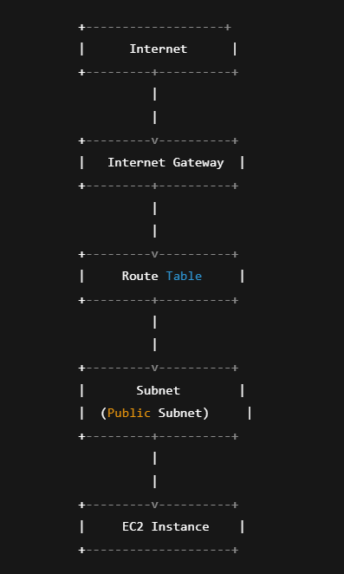

**4. Components Explanation**

**main.tf**

* **VPC**: 10.0.0.0/16 network
* **Subnet**: Public subnet inside VPC
* **Internet Gateway**: Enables internet access
* **Route Table**: Routes traffic to the gateway
* **Security Group**: Opens ports 22 (SSH) and 80 (HTTP)
* **EC2 Instance**: t2.micro server

**variables.tf**

Defines variables like:

* AWS region
* AMI ID
* Key pair name
* VPC/Subnet CIDR blocks

**outputs.tf**

Outputs:

* VPC ID
* Subnet ID
* EC2 Public IP Address

**5. Terraform Workflow**

**6. AWS Services Used**

* **VPC**: Isolated cloud network
* **Subnet**: Public network inside VPC
* **Internet Gateway**: Internet connectivity
* **Route Table**: Traffic routing
* **Security Group**: Network firewall
* **EC2 Instance**: Cloud virtual server

**7. Best Practices**

* Modularize code with variables and outputs.
* Secure state files (terraform.tfstate).
* Use consistent resource naming conventions.
* Limit access through Security Group rules.

**8. Security Considerations**

* Restrict SSH access to known IPs.
* Minimize open ports to prevent vulnerabilities.
* Protect access key and secret key credentials.

**9. Setup Instructions**

Configure AWS credentials first via CLI or environment variables.

**10. Conclusion**

This project provides a clean, secure foundation for AWS deployments, demonstrating effective use of Terraform for Infrastructure as Code (IaC) with an emphasis on modularity and security.