NavSight

Software Engineering B.Sc. Final Project

Software Design Document
Authors:**
- Roey Ben Harush (315676163)
- Tamir Sobuh (206029084)
- Morad Zubidat (208156828)
Supervisor:**
- Mr. Amit Dunsky
Date:** 15/01/2026
---

1. Introduction

a. System Overview
NavSight is a self-contained, real-time mobile navigation system designed for Android devices. It leverages Visual-Inertial Odometry (VIO) combined with Dead Reckoning (DR) to provide continuous position tracking without dependence on Global Navigation Satellite Systems (GNSS). The system is engineered to operate entirely offline, processing sensor data locally on the device to deliver a responsive and private navigation experience. Its primary use case is urban micromobility, enabling users to navigate environments where GPS signals are unreliable or unavailable, such as dense urban canyons, tunnels, and indoor spaces.

b. Purpose
The purpose of the NavSight system is to overcome the limitations of traditional satellite-based navigation in challenging environments. GNSS signals are often blocked, reflected, or degraded in urban canyons created by tall buildings, inside tunnels and underground passages, and within indoor environments. NavSight provides a reliable navigation alternative by using the device's own camera and motion sensors to track movement relative to a starting point, ensuring users can navigate confidently regardless of satellite signal availability.

c. Scope
In-Scope:**
- **Visual Odometry (VO):** Real-time motion estimation derived from analyzing sequential camera frames using sparse feature tracking (Optical Flow).
- **Inertial Preintegration:** On-manifold integration of high-frequency accelerometer and gyroscope data between video frames to reduce drift and computational load.
- **Sensor Fusion Logic:** A tightly-coupled algorithm that combines VO pose estimates with preintegrated inertial measurements. This includes automatic scale estimation to resolve monocular scale ambiguity and gravity alignment for robust initialization.
- **Native Android Application:** A mobile application (Kotlin/Jetpack Compose) that provides a user interface for controlling tracking sessions, visualizing the 3D path in real-time, and managing sensor permissions.
- **Offline Operation:** The entire system runs locally on the device without any network dependency for positioning.
Out-of-Scope:**
- Full 3D Simultaneous Localization and Mapping (SLAM) with loop closure and global bundle adjustment.
- Cloud-based processing or data storage.
- Integration with external hardware sensors beyond the smartphone's built-in suite.
- Voice guidance features.

d. Definitions and Acronyms
- **VIO (Visual-Inertial Odometry):** A technique that estimates device motion by fusing visual information from a camera with inertial measurements from an IMU.
- **VO (Visual Odometry):** The process of determining a device's position and orientation by analyzing sequential camera images.
- **DR (Dead Reckoning):** A method of calculating current position by using a previously known position and advancing it based on estimated speed and direction from inertial sensors.
- **IMU (Inertial Measurement Unit):** A sensor package typically containing accelerometers and gyroscopes that measures linear acceleration and angular velocity.
- **JNI (Java Native Interface):** A framework that enables Java/Kotlin code running in the Android Runtime (ART) to call and be called by native applications and libraries written in C++.
- **RANSAC (Random Sample Consensus):** An iterative method to estimate parameters of a mathematical model from a set of observed data that contains outliers.

e. Constraints
- **Hardware Dependency:** System performance relies on the quality of the smartphone's camera (rolling shutter artifacts) and IMU (bias stability).
- **Environmental Limitations:** Visual tracking requires sufficient lighting and texture. Performance degrades in low-light, low-texture, or high-dynamic-range scenes.
- **Real-Time Processing:** Computations must complete within the inter-frame interval (approx. 33ms for 30fps) to ensure real-time feedback.
- **Power Consumption:** Continuous camera and sensor usage is battery-intensive; the system must be optimized for efficiency.
- **Platform:** Android 10 (API level 29) or higher.
---

2. System Architecture

a. Architectural Description and Design: Roles, Activities and Data
The NavSight system follows a **Layered Architecture** with a strict separation between the managed Android environment (UI/Logic) and the unmanaged Native environment (Performance Core).

Layer 1: Presentation Layer (Android UI)
- **Role:** User Interaction & Visualization.
- **Technology:** Kotlin, Jetpack Compose.
- **Activities:** Renders the camera feed, overlays tracked feature points, draws the estimated 3D trajectory on a 2D map, and displays real-time debug metrics (tracking quality, scale factor, initialization status).

Layer 2: Application Logic Layer (Orchestrator)
- **Role:** System Orchestration & Sensor Management.
- **Technology:** Kotlin, Android SDK.
- **Activities:** Manages the application lifecycle, handles permissions, initializes sensors (`SensorManager`, `CameraX`), synchronizes data streams, and acts as the bridge to the native layer.

Layer 3: Native Interface Layer (JNI Bridge)
- **Role:** Data Marshalling & Thread Management.
- **Technology:** C++, JNI.
- **Activities:** Converts Android sensor data (byte arrays, float arrays) into C++ structures (`cv::Mat`, `std::vector`), manages the background VIO processing thread, and ensures thread-safe communication between Java and C++.

Layer 4: Native Processing Core (C++)
- **Role:** Algorithmic Computation.
- **Technology:** C++, OpenCV.
- **Activities:**
- **VisionModule:** Performs feature detection, optical flow tracking, and essential matrix decomposition to estimate relative pose.
- **IMUPreintegrator:** Integrates raw inertial data to calculate delta-position, delta-velocity, and delta-rotation between video frames.
- **Sensor Fusion:** Combines visual and inertial data to estimate the global 6-DoF pose, scale, and velocity.

b. The Life Cycle of the System
- **Initialization:** App launch -> Permission Request -> Native Library Load -> Sensor Warm-up.
- **Calibration:** The system buffers IMU data to estimate the gravity vector and align the coordinate frame (Z-down). It waits for the device to be stationary (variance check).
- **Active Tracking (VIO Mode):** The primary loop where camera frames and IMU data are fused to update the global pose. The UI is updated at 30-60Hz.
- **Degraded Tracking (DR Mode):** If visual tracking fails (low feature count, degenerate motion), the system falls back to propagating the pose using only the IMU preintegrator (Dead Reckoning).
- **Recovery:** Once visual features are re-acquired, the system re-aligns and resumes full VIO fusion.
- **Termination:** User stops tracking -> Resources released -> Session summary displayed.
---

3. Literature Survey

a. Problem Survey
Estimating the 6-DoF pose of a mobile device without external infrastructure (GNSS) is a classic problem in robotics.
- **Visual Odometry (VO)** suffers from **scale ambiguity** (monocular) and drift over distance.
- **Inertial Navigation (INS)** suffers from rapid drift due to the double integration of sensor noise and bias.
- **Challenge:** The core difficulty lies in fusing these two modalities to correct each other's weaknesses while running in real-time on resource-constrained mobile hardware.

b. Solution Survey
- **Filter-based approaches (e.g., MSCKF):** Use an Extended Kalman Filter (EKF) to fuse measurements. Very fast but can be inconsistent if linearization errors accumulate.
- **Optimization-based approaches (e.g., VINS-Mono, ORB-SLAM3):** minimizing a joint non-linear cost function over a sliding window of keyframes. Higher accuracy but computationally expensive.
- **Loose vs. Tight Coupling:** NavSight employs a **tightly-coupled** approach where IMU preintegration factors are directly used to constrain visual pose estimation, rather than fusing two separate trajectories.

c. Discussion and Conclusion
NavSight adopts a lightweight, tightly-coupled architecture inspired by **VINS-Mono** but simplified for "dead reckoning" survival. By using **IMU Preintegration** (Forster et al.), we avoid re-integrating IMU samples during optimization, significantly saving CPU cycles. The addition of **automatic scale estimation** via accelerometer displacement resolves the critical monocular scale ambiguity problem, making the system practical for real-world navigation.
---

4. Design

a. Data Design

i. Database Description
The system is stateless and offline; no persistent database is used. Ephemeral session data is stored in RAM.

ii. Global Data Structures Design
- **`VioData` (Kotlin):** The primary data transfer object (DTO) from Native to UI.
data class VioData(
val x: Double, val y: Double, val z: Double, // Position (Meters)
val roll: Double, val pitch: Double, val yaw: Double, // Orientation (Radians)
val trackedPoints: FloatArray, // 2D points for visualization
val trackingQuality: Double, // 0.0 - 1.0 confidence score
val estimatedScale: Double, // Current scale factor (meters/unit)
val isInitialized: Boolean // System readiness flag
)
- **`VisionOutput` (C++):** Internal result of a processed frame.
struct VisionOutput {
cv::Mat rotation; // 3x3 Relative Rotation
cv::Mat translation; // 3x1 Relative Translation
int tracked_features; // Count of valid flow points
bool is_valid; // RANSAC success flag
};
- **`PreintegratedIMU` (C++):** Result of IMU integration.
struct PreintegratedIMU {
cv::Vec3d delta_p; // Position change (meters)
cv::Vec3d delta_v; // Velocity change (m/s)
cv::Mat delta_R; // Rotation change (Matrix)
double dt; // Integration interval
};

b. Structural Design

i. Class Diagram
Figure 1: System Architecture Diagram
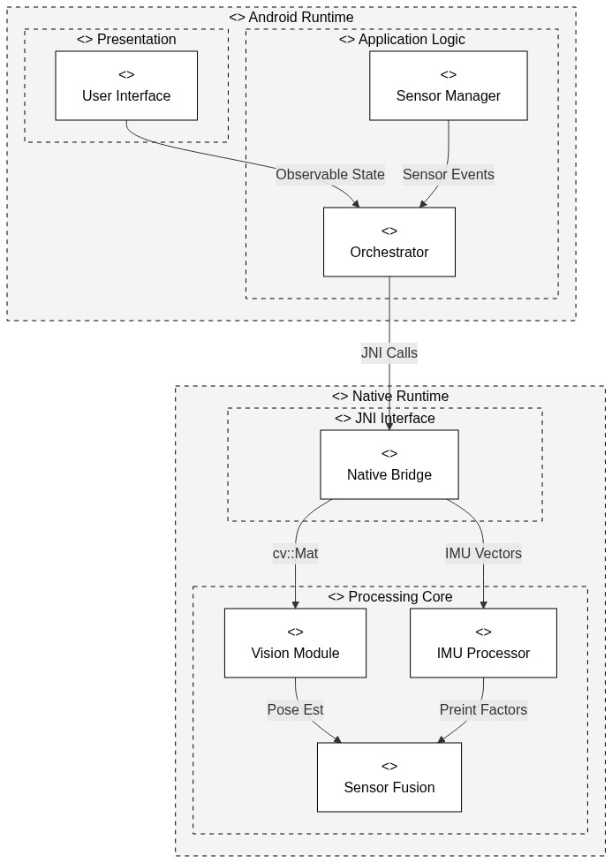

c. Interactions Design

i. Use Cases
- **UC-1: Start Navigation:** User opens app -> System calibrates -> User walks -> Path is drawn.
- **UC-2: Lost Tracking:** User covers camera -> System detects feature loss -> Switches to IMU-only DR -> Alerts user.
- **UC-3: Backgrounding:** User minimizes app -> Sensors stop -> Tracking pauses -> User resumes -> Tracking continues (with potential gap).

ii. Sequence Diagram (Main Processing Loop)
Figure 2: Class Diagram
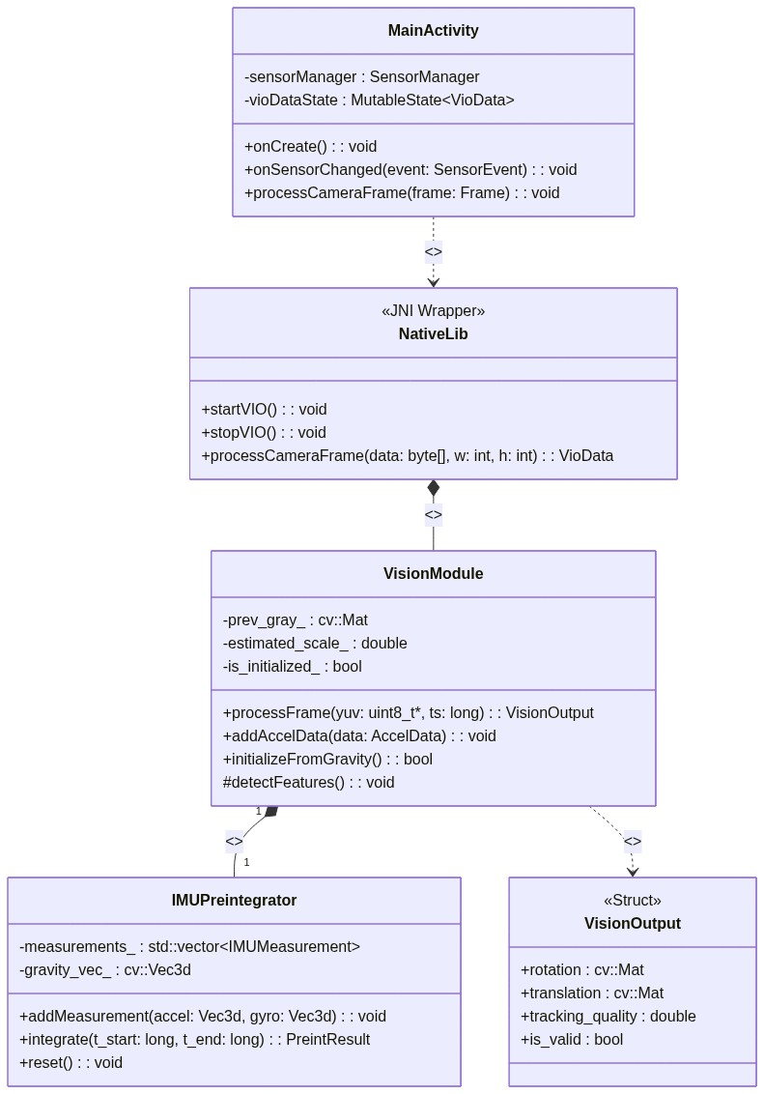

iii. Activity Diagram (System States)
Figure 3: Sequence Diagram
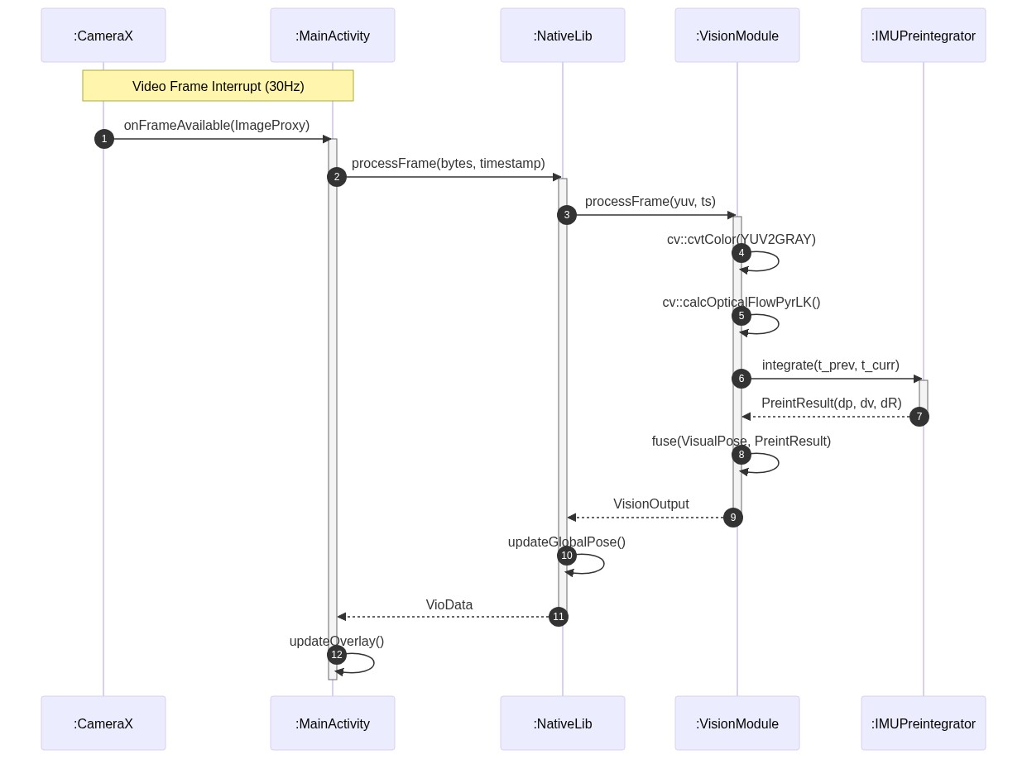

d. Software Architecture Pattern

i. Three-tier
The system adheres to a strict three-tier model:
- **Presentation:** Android Views (XML/Compose).
- **Logic:** Kotlin Orchestrator & NativeLib.
- **Data/Computation:** C++ Native Core (Vision & IMU modules).

ii. MVC
- **Model:** `VioData` (Kotlin) and `VisionOutput`/`GlobalPose` (C++).
- **View:** `MainActivity` UI layout.
- **Controller:** `MainActivity` and `native-lib` logic binding the two.

e. Testing Platform
- **Unit Testing:** GoogleTest (GTest) for C++ modules (VisionModule, IMUPreintegrator).
- **Integration Testing:** Automated instrumentation tests on Android (Espresso).
- **Field Testing:** Manual validation in diverse environments (hallways, outdoors, stairs) comparing computed trajectory against known ground truth (e.g., returning to start point).
---

5. Appendix-A

a. POC discussion
A Proof-of-Concept was conducted demonstrating:
- Successful JNI linking between Kotlin and OpenCV C++.
- Basic optical flow tracking of features on a desk surface.
- Retrieval of high-frequency IMU data at 200Hz.
The POC confirmed that the smartphone hardware is capable of running the VIO pipeline in real-time.

6. Appendix-B

a. Team Roles
- **Student 1:** Vision Module & Sensor Fusion implementation (C++).
- **Student 2:** Navigation Core integration & Path Estimation logic.
- **Student 3:** Android UI, Architecture, and System Integration.

7. Appendix-C

a. Schedule / Gantt
*(Refer to external Gantt chart document)*

8. Appendix-D

a. System Screens
*(Refer to design mockups and screenshots folder)*

