**Web Server Flow**

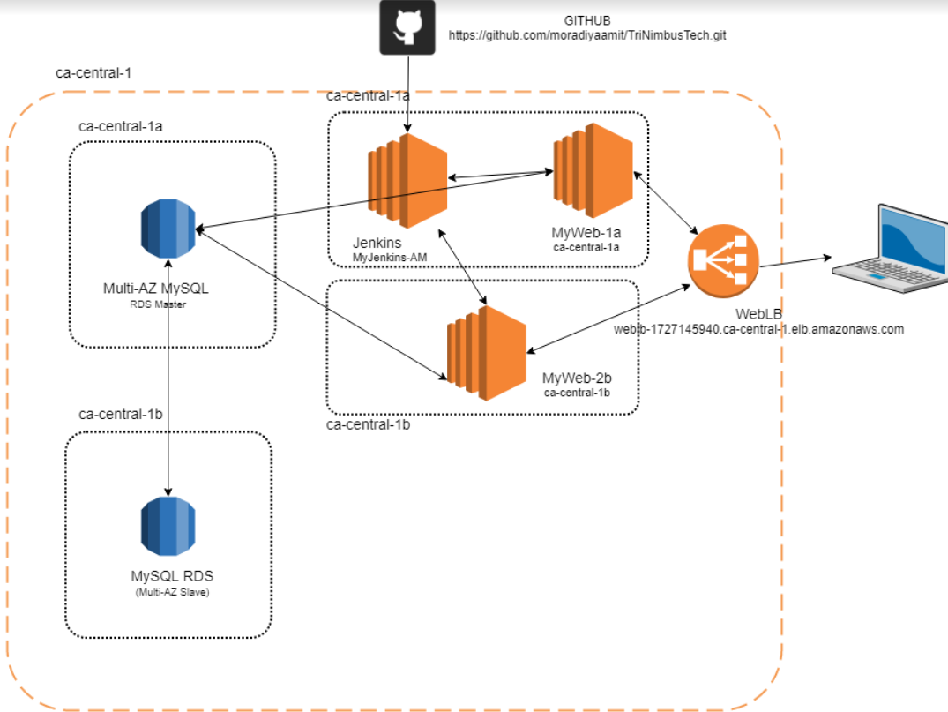

|  |  |  |  |
| --- | --- | --- | --- |
| **ServerName** | **Instance ID/URL** | **Application** | **Availability Zone** |
| MyWeb-1a | i-0ff82ffe5017bce90 | httpd | ca-central-1a |
| MyWeb-1b | i-0aad2c4abd0145313 | httpd | ca-central-1b |
| MyJenkins-am | i-0b656396b18013f38 | Jenkins | ca-central-1a |
| testdb | testdb.chntrgvaknsf.ca-central-1.rds.amazonaws.com | MySQL | ca-central-1b |
| WebLB | WebLB-1727145940.ca-central-1.elb.amazonaws.com |  |  |

* En

**Deployment of web Server MyWeb-1a and MyWeb-2b:**

* Run the following command to deploy webserver and self-signed certificate on your ec2 instance
  + sudo yum update -y
  + sudo yum install –y httpd php php-mysql mod_ssl
  + Installed httpd and start the service
  + sudo chkconfig httpd on
  + sudo service httpd start
  + sudo openssl genrsa -out cert.key 2048
  + sudo openssl req -new -key cert.key -out cert.csr
  + sudo openssl x509 -req -days 365 -in cert.csr -signkey cert.key -out cert.crt
  + sudo cp cert.crt /etc/pki/tls/certs/
  + sudo cp cert.csr cert.key /etc/pki/tls/private/
  + Make certificate related changes to /etc/https/conf.d/ssl.conf file and restart the webserver

**Deployment of Jenkins and build a job to get the file from github and deploy to webserver**

* Run the following command to deploy Jenkins and build a job
  + sudo yum -y update
  + sudo yum install java-1.8.0  
    sudo yum remove java-1.7.0-openjdk
  + sudo wget -O /etc/yum.repos.d/jenkins.repo <http://pkg.jenkins-ci.org/redhat/jenkins.repo>
  + sudo rpm --import <http://pkg.jenkins-ci.org/redhat/jenkins-ci.org.key>
  + sudo yum install jenkins
  + sudo service jenkins start
  + sudo chkconfig --add Jenkins
  + Open the browser and build a job which can get the index.php file from git and deploy it to the web server

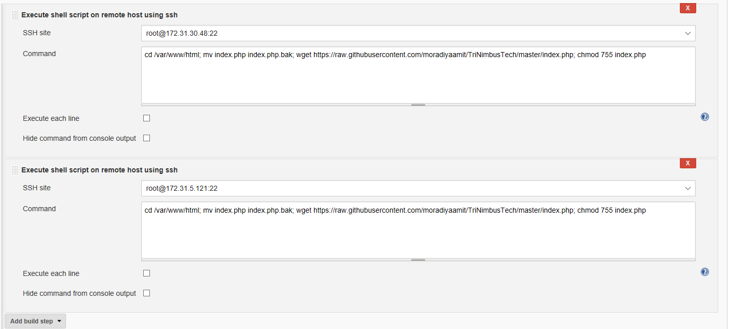

Deploy RDS instance