CS296N Lab 05 Screenshots - Aubrey Morales

Graph:

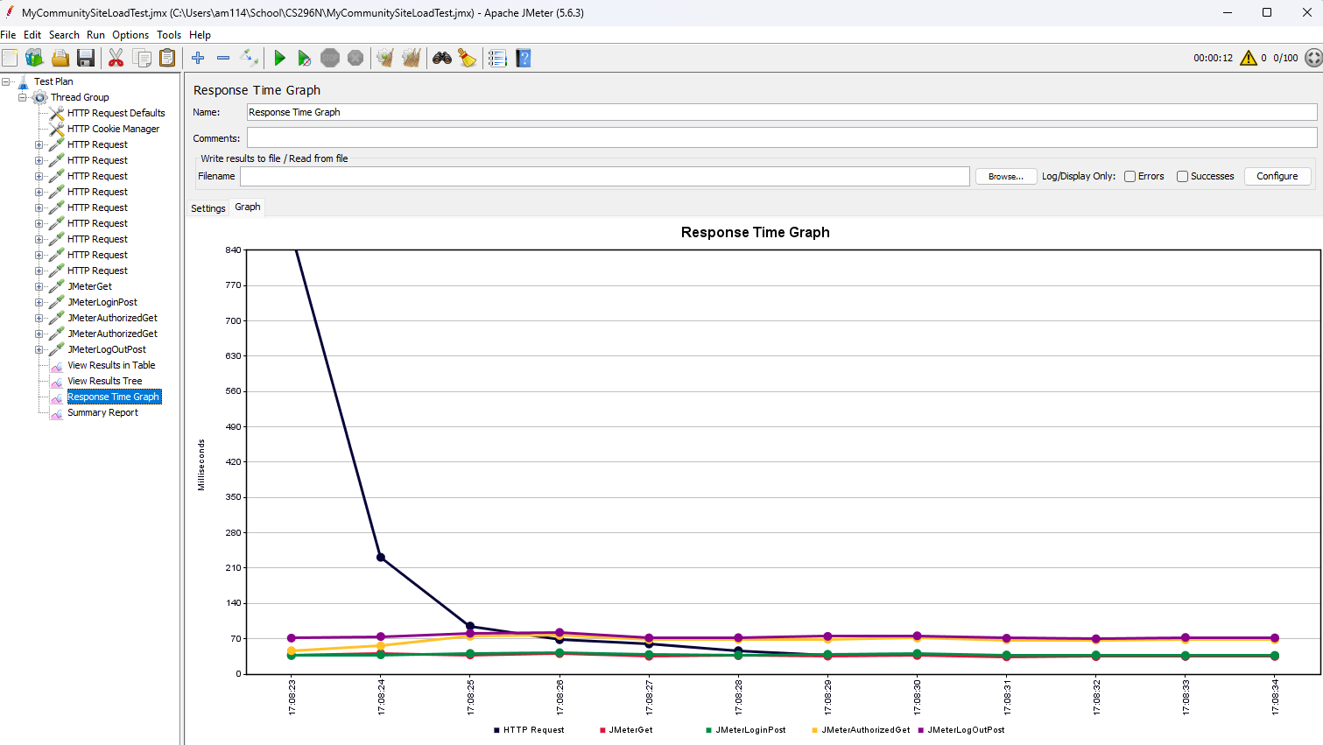

Summary:

