Software Requirements Specification
for
<UniSched>
Version <X.X>

Prepared by
Group Name: <place your group name here>
<Rishika> | <Se22uari143> | <Se22uari143@mahindrauniversity.edu.in>
<Likhitha> | <Se22uari099> | <Se22uari099@mahindrauniversity.edu.in>
<Rashmitha> | <Se22uari141> | <Se22uari1412mahindrauniversity.edu.in>
<Joshika> | <Se22uari193> | <Se22uari193@mahindraunversity.edu.in>
<Bhargavi> | <Se22uari030> | <Se22uari030@mahindrauniversity.edu.in>

Instructor: | <Nartkannai >
Course: | <Software Engineering>
Lab Section: | <AI3 >
Teaching Assistant: | <Surya Teja >
Date: | <\10-3-25>
Contents
Contents ii
Revisions ii
1 Introduction 1
1.1 Document Purpose 1
1.2 Product Scope 1
1.3 Intended Audience and Document Overview 1
1.4 Definitions, Acronyms and Abbreviations 2
1.5 Document Conventions 2
1.6 References and Acknowledgments 2
2 Overall Description 4
2.1 Product Overview 4
2.2 Product Functionality 4
2.3 Design and Implementation Constraints 5
2.4 Assumptions and Dependencies 5
3 Specific Requirements 6
3.1 External Interface Requirements 6
3.2 Functional Requirements 7
3.3 Use Case Model 8
4 Other Non-functional Requirements 9
4.1 Performance Requirements 9
4.2 Safety and Security Requirements 10
4.3 Software Quality Attributes 10
5 Other Requirements 10
Appendix A – Data Dictionary 11
Appendix B - Group Log 12

Revisions
Version | Primary Author(s) | Description of Version | Date Completed
V 2.0 | Rishika  Likhitha  Rashmitha  Bhargavi  Joshika | Prepared draft for software engineering UNISCHED project | 10-3-25

Introduction
This document provides a comprehensive Software Requirements Specification (SRS) for UniSched, a web-based Smart Timetable Management System designed to automate the process of academic timetable generation for educational institutions. The system addresses the challenges faced by administrators in manually organizing class schedules, allocating faculty, and avoiding time conflicts.

This section outlines the purpose, scope, audience, and conventions used in this document. It also introduces key definitions and references that will help stakeholders understand the technical and functional details of the system. Readers can expect a clear overview of the UniSched system’s objectives, intended users, and foundational assumptions, setting the stage for the more detailed system requirements in later sections.

Document Purpose
This Software Requirements Specification (SRS) document outlines the functional and non-functional requirements for the UniSched system.UniSched is a web-based timetable generation system developed for academic institutions to streamline the creation of class schedules by automatically assigning subjects, timeslots, and faculty based on institutional constraints and availability.

The primary purpose of this document is to serve as a reference for developers, testers, clients, and academic administrators involved in the development and deployment of UniSched. It captures the system's behavior, design constraints, and interaction with users and external systems. This SRS specifically focuses on the core scheduling functionalities of the platform, including faculty and student management, timetable generation, and admin controls, and does not cover mobile app interfaces or long-term data analytics at this stage.

Product Scope
UniSched is a web-based academic scheduling system designed to automate the process of timetable generation for educational institutions. The system dynamically generates timetables by assigning subjects, faculty members, and classrooms based on predefined constraints such as faculty availability, subject requirements, and course overlaps. The platform provides different user roles—admin, faculty, and student—each with specific access and functionality.

The main goals of UniSched are to eliminate manual scheduling errors, reduce administrative workload, and ensure optimal utilization of institutional resources. By automating timetable generation, the system significantly improves efficiency and consistency, while also allowing easy updates in case of changes in faculty or class availability. This centralized platform ensures transparency, quick access to schedules for all users, and adaptability for future enhancements such as elective subject support or mobile integration.

Intended Audience and Document Overview
This document is intended for the client, professor, developers, and testers involved in the UniSched project. It helps each stakeholder understand what the system is expected to do and how it should behave.

The SRS includes an introduction to the system, overall product description, detailed functional and non-functional requirements, use cases, and any additional requirements. Readers should start with the overview in Section 1, then move to technical details in Sections 2 and 3, followed by performance and quality aspects in Section 4.

Definitions, Acronyms and Abbreviations
Term Definition
Admin Administrator responsible for managing faculty, students, and timetables.
CSS Cascading Style Sheets – used for designing the UI layout and styling.
HTML HyperText Markup Language – used to structure the web pages.
JS JavaScript – used to provide dynamic functionality in the frontend.
SRS Software Requirements Specification – this document.
UI User Interface – the visual part of the application that users interact with.
UniSched The timetable generation software system being developed.
Jinja2 A templating engine for Python used in Flask to render HTML templates.
Flask A lightweight Python web framework used for backend development.

Document Conventions
This Software Requirements Specification (SRS) document follows the IEEE standard format and uses the following conventions:

Formatting Conventions
The document is written using Arial font, size 11 for the main body text.

Section and subsection titles follow the IEEE SRS template numbering format (e.g., 1.1, 2.3.1).

Text is single spaced with 1-inch margins on all sides.

Italics are used for template instructions or placeholder comments.

Naming Conventions
Functional requirements are labeled as F1, F2, F3, etc.

Use cases are labeled as U1, U2, U3, etc.

Diagrams and figures are referenced as Figure 1, Figure 2, etc.

References and Acknowledgments
The following references were used in the preparation of this Software Requirements Specification (SRS) document:

IEEE Std 830-1998: IEEE Recommended Practice for Software Requirements Specifications

Flask Documentation: https://flask.palletsprojects.com/

HTML/CSS/JavaScript References: https://developer.mozilla.org/

Jinja2 Templating Engine: https://jinja.palletsprojects.com/

Unisched Project Guidelines and Requirements (as provided by the course instructor)

Acknowledgments:
We would like to thank our professor and project mentor for providing valuable guidance and feedback throughout the development of the Unisched system

Overall Description

Product Overview
Unisched is an automated academic timetable generation system designed to optimize the scheduling of subjects, faculty, and classrooms in educational institutions. The system reduces human error, enhances efficiency, and saves administrative time by automatically generating conflict-free timetables based on user inputs.

Unisched consists of a backend built using Flask and Jinja2, which communicates with a frontend created using HTML, CSS, and JavaScript. Faculty and administrators can input data such as course availability and constraints, and the system generates an optimized schedule. The backend processes this data and sends the results to the frontend for user display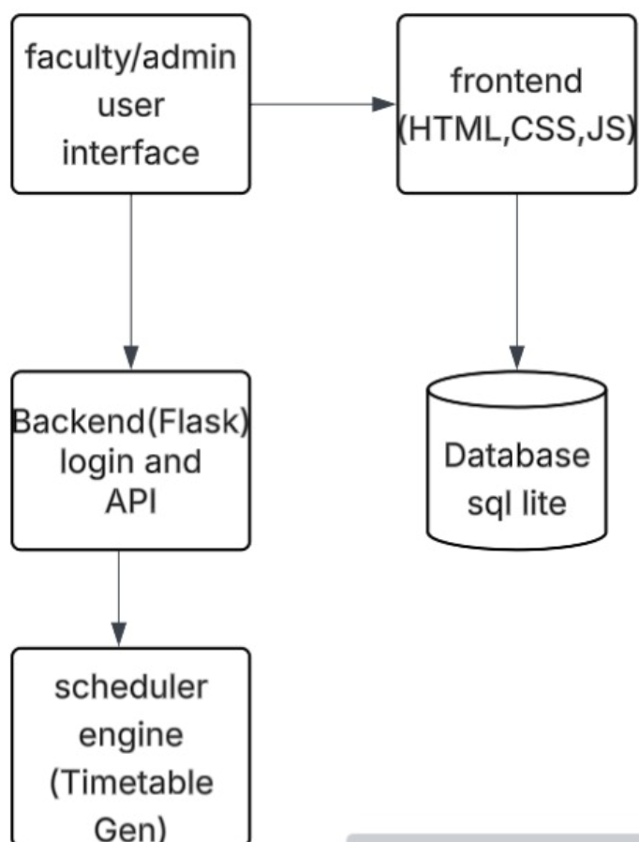

Product Functionality
The major functions of the Unisched system include:

Automated Timetable Generation: The system automatically generates conflict-free timetables based on user input.

Faculty Management: Faculty members can input their available times and courses they can teach.

Course Management: Admins can define courses, allocate classrooms, and set constraints (e.g., maximum class size, room type).

Conflict Resolution: The system ensures there are no conflicts in terms of room allocation, faculty availability, or student scheduling.

User Interface for Admin and Faculty: A web interface allows easy interaction with the system, where faculty and admins can manage data.

Data Storage and Retrieval: The system stores all course, faculty, and timetable data in a database and retrieves it as needed.

Timetable Viewing: Faculty and students can view generated timetables in a user-friendly format.

Customizable Timetable Settings: Admins can adjust rules or preferences for timetable generation (e.g., preferred time slots for certain courses).

These functionalities are designed to simplify and automate the process of timetable creation, offering efficiency and reducing human errors.

Design and Implementation Constraints
The system must be designed using the COMET (Collaborative Object Modeling and Architectural Design Method), which supports component-based software engineering and modular design.

UML (Unified Modeling Language) diagrams must be used to model the system architecture and behavior.

The backend must be implemented using Flask with Python, and the frontend will use HTML, CSS, JavaScript, and Jinja2 templates.

The application must be compatible with standard modern web browsers (Chrome, Firefox).

The system will store data using SQLite (or optionally MySQL for deployment), requiring optimization for moderate-sized datasets.

The timetable generation logic should run within a reasonable time limit (e.g., under 10 seconds for normal use cases).

User authentication and role-based access control must be implemented to secure admin, faculty, and student data.

Limited hardware resources on student/developer machines mean the system should be lightweight and efficient.

Assumptions and Dependencies
It is assumed that users (students, faculty, admin) will access the system through a modern web browser with stable internet connectivity.

The system depends on the availability and proper functioning of the Flask web framework and the SQLite/MySQL database.

It is assumed that input data such as subject names, faculty availability, and classroom details will be provided correctly by the admin.

The timetable generation logic assumes that no major conflicts exist in faculty schedules or room assignments that cannot be resolved automatically.

The project assumes continuous access to development tools such as Python, Jinja2, and supporting libraries without licensing issues.

The system assumes basic hardware capability from client devices, such as a desktop or laptop with at least 4GB RAM and a modern browser.

Specific Requirements

External Interface Requirements

User Interfaces
The UniSched system features a web-based user interface designed to be intuitive and accessible for all types of users—students, faculty, and admins. The interface is built using HTML, CSS, and JavaScript for responsiveness and interactivity, while Flask and Jinja2 are used to render dynamic content from the backend.

Students can log in to view their class schedules and receive updates.

Faculty can log in to view assigned lectures and update availability.

Admins can input data such as subjects, faculty, and available rooms, then generate and manage the timetable.

Interaction is done through standard web elements like dropdowns, buttons, and forms—no special hardware like a touchscreen is required.

Hardware Interfaces
The UniSched system is a web-based software solution and does not require direct interaction with specialized hardware components. However, it interacts with general-purpose computing devices used by different types of users. These include:

Desktop and Laptop Computers: Used by administrators, faculty, and students to access the web application through a browser.

Smartphones and Tablets: Optional devices for users who prefer accessing schedules and updates on the go.

Web Server: Hosts the backend application (Flask-based), processes requests, and stores scheduling data.

Database Server: Used to store user data, subject information, room availability, and generated timetables.

All hardware interfaces are limited to basic I/O and standard network communication for accessing the web application.

Software Interfaces
The UniSched system interacts with the following software components:

Web Browser Interface: The frontend is accessible through any modern web browser (e.g., Chrome, Firefox, Edge), allowing users to interact with the system via HTML, CSS, JavaScript, and Jinja2 templates rendered through Flask.

Flask Backend: Acts as the core application server, handling routing, user authentication, data processing, and interaction with the database.

Relational Database (e.g., SQLite/MySQL): Stores all relevant data including users, subjects, faculty, classroom availability, and generated timetables. The backend uses SQL queries to interact with the database.

Mobile Compatibility (via Responsive Design): Though not a standalone mobile app, the system’s responsive frontend ensures usability on mobile devices through adaptive HTML/CSS layout.

Functional Requirements
The following are the detailed functional requirements for the UniSched system:
- User Registration and Authentication
  - The system shall allow users (admin and faculty) to register using a unique ID and password.
  - The system shall authenticate users at login and provide access based on user roles.
- Subject and Faculty Management
  - The system shall allow the admin to add, update, and delete subjects.
  - The system shall allow the admin to add, update, and delete faculty profiles.
  - The system shall enable assigning faculty members to specific subjects.
- Classroom and Timeslot Management
  - The system shall allow the admin to define classrooms and their capacities.
  - The system shall allow the admin to configure available time slots per day and week.
- Timetable Generation
  - The system shall generate a conflict-free timetable based on faculty availability, subject requirements, and classroom capacity.
  - The system shall support generating timetables for different departments or sections.
- Faculty Preferences
  - The system shall allow faculty members to input their available time slots or preferences.
  - The system shall consider these preferences during timetable generation.
- Timetable Display and Export
  - The system shall display generated timetables in a readable tabular format.
  - The system shall allow users to export the timetable as a PDF or image.
- Editing and Regeneration
  - The system shall allow admins to modify the generated timetable manually.
  - The system shall allow re-generating the timetable with updated constraints.
- Conflict Detection and Alerts
  - The system shall detect and notify users of scheduling conflicts such as faculty double-booking or classroom overlaps

F1: The system shall …
Description:
The system shall allow users (e.g., administrators, faculty) to create accounts with a username and password. Once registered, users shall be able to log in securely to access system functionalities based on their role.
Rationale:
User authentication is required to ensure secure access and data protection.
Fit Criterion:
- Users can successfully create an account and log in.
- Unauthorized users are denied access.

<Functional Requirement or Feature #2>
Description:
The thermostat system shall display the current temperature readings and allow users to set or modify the desired temperature via the main user interface.
Rationale:
This functionality ensures that users can monitor and control the indoor environment effectively.
Fit Criterion:
- Users can view live temperature data on the interface.
- Users can change the desired temperature, and the system updates accordingly.

Use Case Model
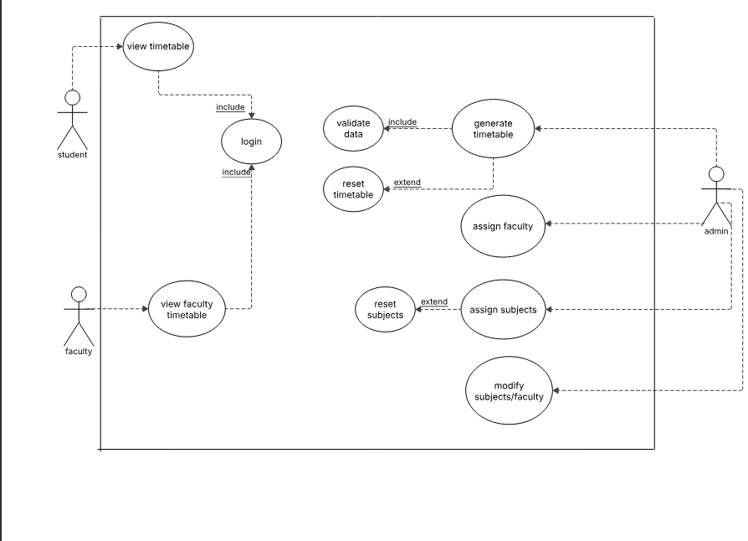

Use Case 1 -- View Timetable
Author: Rishika Takkellapati

Purpose: To allow students and faculty to view their respective schedules.

Requirements Traceability: R1, R2

Priority: High

Preconditions: User must be logged in; timetable must be available.

Postconditions: Timetable is displayed.
Actors: Student, Faculty

Extends: None

Flow of Events:
- Basic Flow: User logs in → Navigates to "View Timetable" → System fetches and displays data.
- Alternative Flow: If timetable not available, show placeholder message.
Exceptions: Database down, session expired.

Includes: Login System

Notes: Access may vary based on role.

Use Case 2 Create/Modify Table
Author: Rishika Takkelapatti
Purpose: Allow admin to generate or update the timetable.
Requirements Traceability: R3, R4
• Priority: High
• Preconditions: Data on subjects, faculty, classrooms, and time slots must exist.
• Postconditions: Valid timetable is generated and stored.
• Actors: Admin
• Extends: None
• Flow of Events:
- Basic Flow: Admin logs in → Navigates to timetable module → Initiates generation → Valid timetable is saved.
- Alternative Flow: Conflicts are resolved manually.
- Exceptions: Incomplete data, scheduling algorithm errors.
• Includes: Assign class
• Notes: Conflict resolution logic needs to be robust.

3.3.3 Use Case 3 Add Classes/Subjects

• Author: Rishika Takkelapatti
• Purpose: To add class sections and their associated subjects into the system.
• Requirements Traceability: R5
• Priority: Medium
• Preconditions: Admin must be authenticated.
• Postconditions: Classes and subjects are stored in the database.
• Actors: Admin
• Extends: U2
• Flow of Events:
- Basic Flow: Admin logs in → Navigates to “Add Class” → Inputs section/subject info → Saves to database.
- Alternative Flow: Admin imports bulk data using file upload.
- Exceptions: Duplicate class name or subject code.
• Includes: None
Notes: Format validation is required.

Other Non-functional Requirements

Performance Requirements
P1. The system shall update and display the current room temperature within 1 second of receiving new sensor data.

P2. The secondary heater shall be engaged if the desired temperature is not reached within 10 seconds of activating the primary heater.

P3. The mobile app must reflect changes made on the thermostat interface within 2 seconds of an update.

P4. User inputs on the thermostat touchscreen must receive feedback (e.g., visual or audio confirmation) within 0.5 seconds.

P5. Energy usage data must be updated and logged every 5 minutes.

Safety and Security Requirements
S1. The system shall include an automatic shutdown feature if temperatures exceed a safe threshold (e.g., above 95°F/35°C) to prevent overheating and potential damage to hardware components.

S2. All communication between the thermostat and the mobile app shall be encrypted using SSL/TLS protocols to ensure data privacy and prevent unauthorized access.

S3. The thermostat shall have a password protection mechanism for access to administrative features (e.g., temperature settings, schedules) to prevent unauthorized modifications.

S4. The system shall comply with CE Marking and UL Safety Standards to ensure the product meets European and North American safety certifications for electrical appliances.

S5. The mobile app shall require user authentication (via PIN or fingerprint/face recognition) before accessing sensitive functionalities (e.g., remote control, temperature override).

S6. User data (e.g., temperature preferences, schedules) shall be stored securely on the cloud and comply with GDPR for privacy and data protection.

Software Quality Attributes
4.3.1 Reliability
R1. The thermostat system shall maintain 99.9% uptime with scheduled maintenance for updates or system checks.

R2. The system shall handle up to 50 simultaneous mobile app connections without performance degradation, ensuring reliable user interactions.

R3. The system must be able to recover within 5 minutes if it crashes or experiences a failure, maintaining all user settings.

R4. The thermostat shall continuously monitor the hardware components for potential failures (e.g., temperature sensors) and alert the user via the mobile app in case of malfunction.

Achieving Reliability: The reliability of the system will be achieved by implementing a robust exception-handling mechanism in both hardware and software layers, performing regular system health checks, and establishing backup processes for critical system failures.

4.3.2 Usability
U1. The mobile app shall allow users to adjust temperature settings with no more than two taps or interactions.

U2. The user interface (UI) shall be designed to allow users to schedule temperature changes with minimal input, requiring no more than 5 clicks for setting schedules.

U3. The system shall provide clear visual feedback (e.g., temperature change, status updates) on the thermostat display to ensure users understand the current system state.

U4. The thermostat’s display and mobile app shall support multiple languages, ensuring accessibility for non-English speakers.

Achieving Usability: To ensure usability, the system will follow user-centered design principles, emphasizing intuitive navigation, clear visual cues, and quick access to frequently used features. Extensive user testing will be performed, with feedback incorporated to improve the UI/UX.

Other Requirements
5.1 Database Requirements
DB1. The system shall store historical temperature and humidity data in a secure, cloud-based relational database to ensure data persistence and scalability.

DB2. The database must support the storage of user preferences (e.g., temperature schedules) and be able to store up to 10 years of data with minimal latency during retrieval.

DB3. Data backup mechanisms must be in place, ensuring data integrity and availability even in the event of system failures.

5.2 Internationalization Requirements
I1. The user interface shall support multiple languages, with an initial requirement to support English, Spanish, French, and German.

I2. The system shall allow users to select between Celsius and Fahrenheit as units of temperature, depending on the region or preference.

I3. The mobile app shall be adaptable to different time zones and handle daylight saving time (DST) transitions automatically.

5.3 Legal and Regulatory Requirements
L1. The product must comply with the General Data Protection Regulation (GDPR) for handling personal data of users within the European Union.

L2. The system must meet the UL certification standards to ensure it is electrically safe and suitable for home environments in North America.

L3. The product shall include a privacy policy and terms of service that comply with relevant regulations and provide clear information on data collection, usage, and user rights.

5.4 Reuse Objectives
R1. The design of the system should be modular, enabling the easy addition of new hardware (e.g., sensors, actuators) without significant changes to the software.

R2. The system’s software components, such as algorithms for temperature control and scheduling, should be reusable in future home automation projects with minimal modification.

R3. The thermostat's user interface design should follow common UI/UX patterns to enable reuse in similar consumer electronics projects.

5.5 Environmental Requirements
E1. The thermostat and its components should be designed for energy efficiency with an average standby power consumption of less than 2 watts.

E2. The product should be able to operate in temperatures ranging from -10°C to 50°C to cater to various climate conditions and household environments.

5.6 System Upgrade Requirements
U1. The software shall be capable of over-the-air (OTA) updates for future feature improvements and security patches.

U2. The system must notify users when a new software update is available and offer an easy-to-use interface for initiating the update process.

Appendix A – Data Dictionary
This data dictionary defines key variables, inputs, outputs, and system states used in the Web Utility for Timetable Generation system.
Name | Type | Description | Possible Values / Format | Related Operations
faculty_id | String | Unique identifier for a faculty member | Alphanumeric (e.g., FAC001) | Add, Assign class, View schedule
faculty_name | String | Name of the faculty member | Text | Display, Edit
subject_code | String | Unique identifier for a subject | Alphanumeric (e.g., CS101) | Add subject, Assign faculty
subject_name | String | Name of the subject | Text | View, Search
day | Enum | Day of the week when the class occurs | Monday–Saturday | Assign, Filter
time_slot | Time | Specific time period for a class session | HH:MM - HH:MM (e.g., 10:00 - 11:00) | Assign, Detect Conflicts
semester | Integer | Academic semester number | 1–8 | Filter, Assign
department | String | Department offering the course | Text (e.g., CSE, ECE) | Group, Filter
timetable_entry | Object | A single timetable record | Composite (faculty, subject, time...) | Add, Update, Delete
conflict_status | Boolean | Indicates if a conflict exists for a timetable entry | True / False | Conflict Detection Module
user_role | Enum | Type of user accessing the system | Admin, Faculty | Control access to features
login_status | Boolean | Indicates if a user is logged in | True / False | Session management

Appendix B - Group Log
The following log provides a record of the group activities, meetings, and efforts involved in producing the Software Requirements Specification (SRS) document. This log will assist in determining the effort and collaboration put forth by the team during the development of this document.

Item | Type | Description | Operations/Requirements
Temperature (T) | Input Variable | The current temperature in the room, as sensed by the temperature sensor. | Must be updated every 5 seconds. Input to control logic for temperature regulation.
Humidity (H) | Input Variable | The current humidity level in the room, as sensed by the humidity sensor. | Must be updated every 5 seconds. Input to control logic for humidity regulation.
Desired Temperature (T_d) | Input Variable | The temperature that the user has set as the desired target temperature. | Must be updated based on user interaction with the interface.
Heating Mode (H_m) | State Variable | Indicates whether the system is currently in heating mode. | States: ON, OFF. Activated if T < T_d and heating is required.
Cooling Mode (C_m) | State Variable | Indicates whether the system is currently in cooling mode. | States: ON, OFF. Activated if T > T_d and cooling is required.
Power State (P_s) | State Variable | Indicates whether the system is powered on or off. | States: ON, OFF. Power on state is required to operate the system.
Fan Speed (F_s) | Output Variable | The speed of the fan for airflow regulation, determined based on room conditions. | States: LOW, MEDIUM, HIGH. Affects room airflow and temperature regulation.
Secondary Heater (SH) | Output Variable | The secondary heating unit engaged when the primary heater cannot meet T_d. | States: ON, OFF. Activated if the primary heater fails to reach the desired temperature within the specified time.
User Command (U_c) | Input Variable | Command received from the user via the mobile app or physical interface (e.g., increase/decrease temperature). | Must be processed by the control system to adjust heating/cooling parameters.
Schedule (S) | Input Variable | A daily or weekly temperature schedule set by the user to automate temperature adjustments. | Used to adjust the temperature settings based on pre-defined time intervals.
Mobile Command (M_c) | Input Variable | Commands sent from the mobile app for controlling the thermostat settings. | Can include changes to T_d, fan speed, heating/cooling mode, and schedule changes.
Alarm (A) | Output Variable | Alarm notification to alert the user if the temperature or humidity is out of the acceptable range. | States: ACTIVE, INACTIVE. Triggered if the system detects unsafe temperature/humidity conditions.
Battery Level (B) | Input Variable | Indicates the remaining battery power of the mobile device interacting with the thermostat. | Affects the ability of the mobile app to send commands if the battery is low.
System Status (S_st) | State Variable | Represents the overall status of the system (operating normally, error state, etc.). | States: NORMAL, ERROR. Set based on hardware or software failures.
Data Logs (D_l) | Data Output | Historical records of temperature, humidity, and user commands for analysis. | Can be stored in the cloud for future access or analysis.
Time of Day (T_o) | Input Variable | Current time, used for scheduling temperature changes and daily routines. | Affects schedule-based temperature adjustments. Must be synchronized with the mobile app.

