**School of Health and Life Sciences**

**Session: 2024/25**

**Programme: Master of Public Health**

**Module title and code: Applied Statistics and Data Analysis for Public Health**

**(MMB725024)**

**Name and matriculation number:**

**Word count: 2900**

**Submission Date: 13th August 2025**

**Turnitin score (%): 32**

**Declaration:**

***“In submitting this piece of coursework via TurnItIn from my personal GCULearn account, I confirm that it is my own original work and has not been submitted elsewhere in fulfilment of the requirement of this or any other award. I also confirm that I am aware of and have adhered to the GCU Plagiarism Regulations (available on the GCU website).***

**Signed:**

**Date: 11th August 2025**

Statistics plays a highly significant role in public health since it assists in the interpretation and explanation of health facts in various studies (Biostatistics Canada, n.d.). Specifically, it helps researchers to find patterns, make decisions using facts, and check if health programs are working well. As health research collects a lot of data, statistical methods are needed to find out if results are meaningful, like whether a program is successful or not (Biostatistics Canada, n.d.). In this report, statistics are used to check how well a 12-week lifestyle health education program worked to manage body mass index and health knowledge among the students of two universities. The study was done using a randomised control trial, where one group took part in the program (intervention group) and another group did not (control group). The main goal is to see if the program made a big change in BMI and health knowledge.

This report uses the given dataset to answer questions about how the lifestyle health education program affected students. The focus will be on checking if the program changed BMI compared to the control group, if it improved health knowledge, and if results were different for students based on age or if they had asthma. The report follows a step-by-step process. First, the data will be checked for mistakes or missing information. Then descriptive statistics will be used to show averages, standard deviations, and other numbers to describe the data. Then, the independent t-test and ANOVA as statistical tests will be employed to respond to the research questions.

Checking the data first (preliminary screening) means making sure no data is missing, variables are in the right format, and tests like normality and equal variance are done (Qualls et al., 2010). Descriptive statistics will give a summary of the data, like average values and spread of the numbers (Ho and Yu, 2015). Finally, inferential statistics like the t-test and ANOVA will help to see if there are real differences between the groups (Vrbin, 2022). This will give a clear answer about whether the program was effective or not.

**Table 1: Descriptive Statistics**

The sample size involved 81 respondents (67.9 percent female) whose average age was 25.07 years (SD = 6.68). The baseline health literacy scores (M = 58.89, SD = 14.63) were near-normally distributed since the skewness (-0.01) and kurtosis (-0.29) values fell within recommended (pl ranges between +/-1). This was also reaffirmed that the Q-Q plot of baseline health literacy (Figure 2) observed values were very close to the expected normal line, with slight variations in the higher tail. In a similar manner, the scores of the post-intervention health literacy (M = 59.36, SD = 14.78) were skewed normally (skew = 0.03, kurtosis = -0.33), and the Q-Q plot of linearity patterns supported this finding, which suggested that the data was admissible to parametric tests.

Variables associated with weight were more variable. The baseline weight Q-Q plot indicated that there were minor departures of higher values normality, which may be due to outliers or right-skewness, but Normality should be confirmed by skewness statistics (not provided). The same was observed in post-intervention weight, although values fell away from the diagonal beyond the extremes, which will require subsequent work (e.g. outliers are dropped or transformations in case of skew beyond +/-1). All these detailed summaries are as shown in the table and figures below.

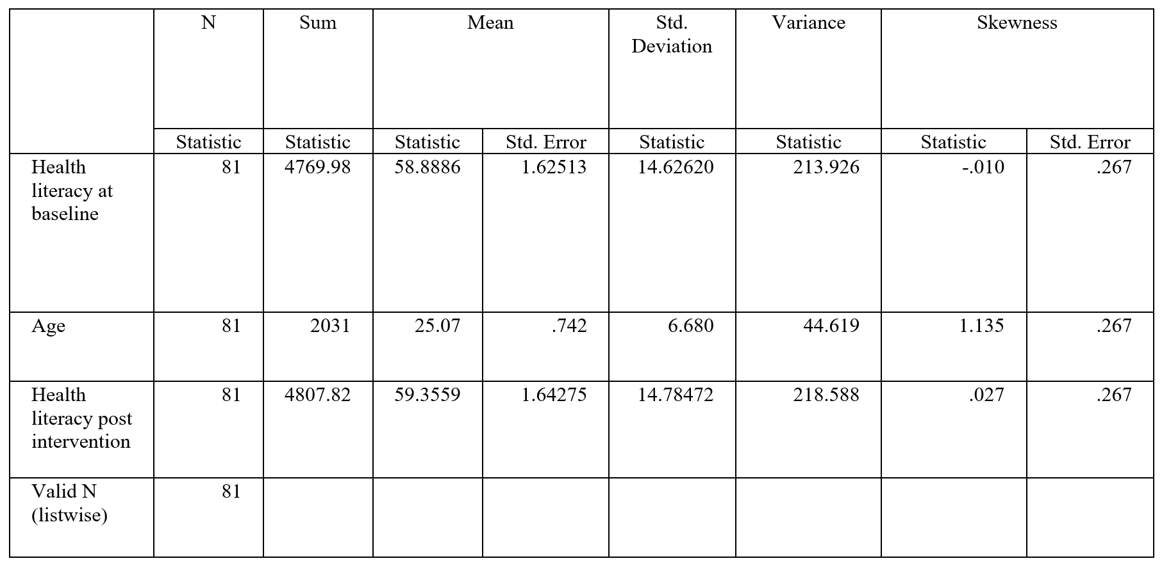

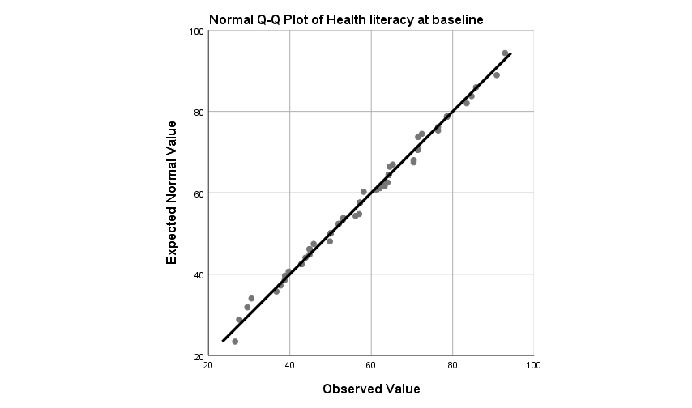

**QUESTION 1: Examining Differences in Post-Intervention Health Literacy Between Campus A and B**

To answer the questions correctly, the selection of the appropriate statistical test depended on understanding the nature of the data (Vrbin, 2022). Since parametric and non-parametric tests are designed to work with either paired or independent data, it was deemed crucial to choose the right one to get accurate results (Qualls et al., 2010).

Following this, question one was determined to be independent because campus A and campus B consist of different individuals, making an independent t-test the most suitable method for comparison (Vrbin, 2022). If the data had been paired, for example, from the same participants before and after an intervention, a different approach would be needed.

However, before performing the t-test, the data must be confirmed whether it meets certain assumptions. One of the key assumptions for the independent t-test is that the data should be normally distributed, which can be checked using both graphical methods and statistical tests (Vrbin, 2022). In this analysis, Q-Q plots, histograms, and Shapiro-Wilk test were used to inspect the data.

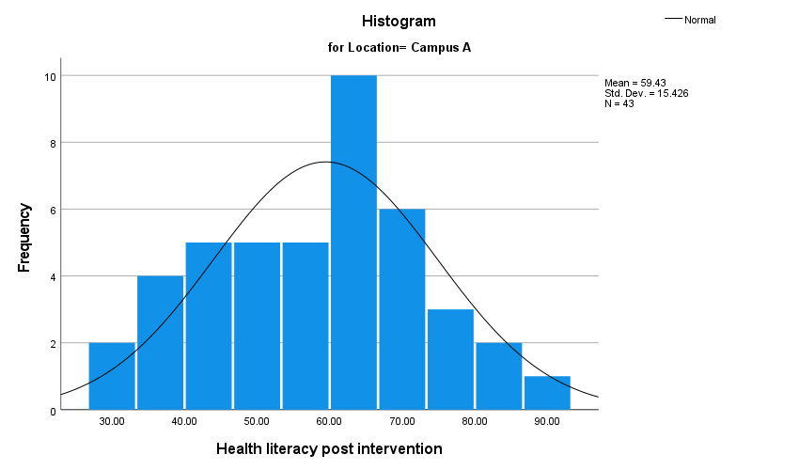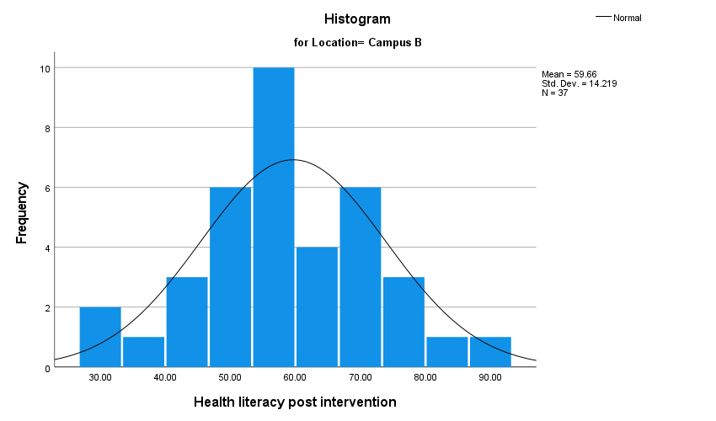

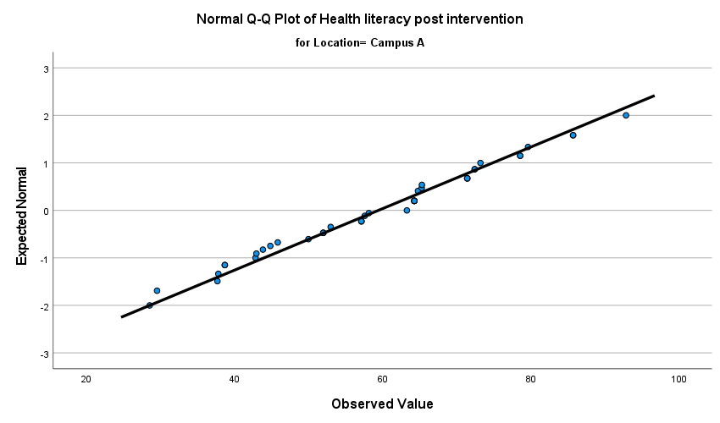 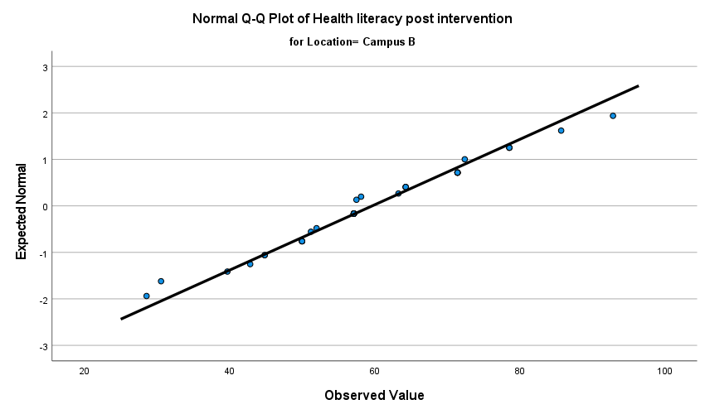

As shown above, the histogram shows a bell-shaped curve for both campuses, suggesting that its normally distributed, while the plot confirms that the data points for both followed a straight line, further supporting the assumption of normality.

Additionally, the Shapiro-Wilk test as shown below confirms the data is normally distributed for both groups, with p-values of 0.667 for institution A and 0.614 for institution B, both greater than 0.05.

**Table 2: Shapiro-Wilk test**

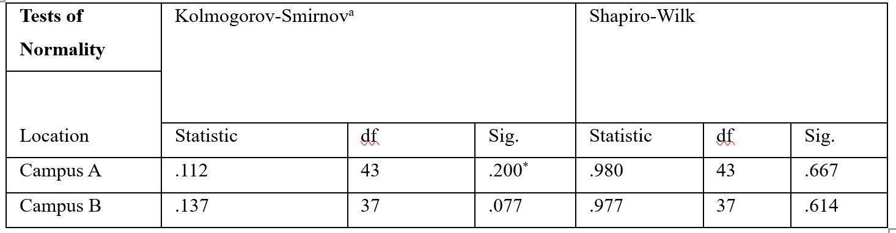

There was also an assumption of the homogeneity variance whereby the Levene test was applied and a p-value of 0.449 was observed. Following this, it was assumed that the variances between the two groups are the same. Since all the assumptions were met, the independent t -test was considered suitable and the results were as shown in the table below.

**Table 3: Levene’s test**

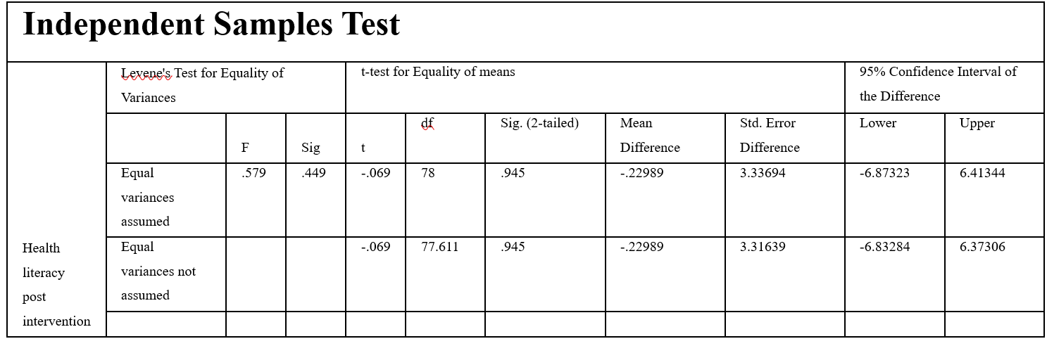

From the above table, the results of the independent t-test revealed a p-value of 0.945, which is greater than the threshold of 0.05, indicating that there is no statistically significant difference between the post-intervention health literacy scores of campus A (M = 59.43, SD = 15.43) and campus B (M = 59.66, SD = 14.22). The difference in means was very small (t(78) = -0.069; p = 0.945; 95% CI, -6.87 to 6.41). Therefore, we fail to reject the null hypothesis and conclude that the health literacy post-intervention was similar for participants in both campuses. Hence, there is no significant difference in post-intervention health literacy between participants in campus A (M = 59.43, SD = 15.43) compared to participants in campus B (M = 59.66, SD = 14.22).

**QUESTION 2: Evaluating the Effect of the Intervention on Body Mass Index (BMI) in the Intervention Group Compared to the Control Group**

For question two, the independent samples t-test was again conducted to determine whether the 12-week lifestyle health education program had a significant effect on reducing body mass index (BMI) in the intervention group compared to the control group. The sample used in the analysis was 81 (Intervention group 34, Control group 47). The outcome variable was post-intervention BM, which was calculated by dividing weight in kilograms by height in meters squared. Despite the expectations, descriptive statistics indicated that the intervention group recorded a higher mean of the BMI (M = 24.68, SD = 4.50) compared to the control group (M = 22.87, SD = 3.20). The t-test was used based on the fulfillment of the assumptions of normality (checked with Shapiro-Wilk test) and homogeneity of variance (Levene’s test: p = 0.064) whose results are in the table below. The results showed a statistically significant difference between two tested groups in BMI (t (79) = -2.120, p = 0.037), a mean difference of -1.81 (95% CI: [-3.51, -0.11]) and small-to-moderate effect size (Cohen d = 0.47).

These findings were against the expected trend. This could be explained by participants not following instructions correctly or a larger standard deviation in the intervention group, implying presence of outliers, which also could be seen when looking at boxplots.

**Table 4: Group Statistics**

**Table 5: Independent Samples Test**

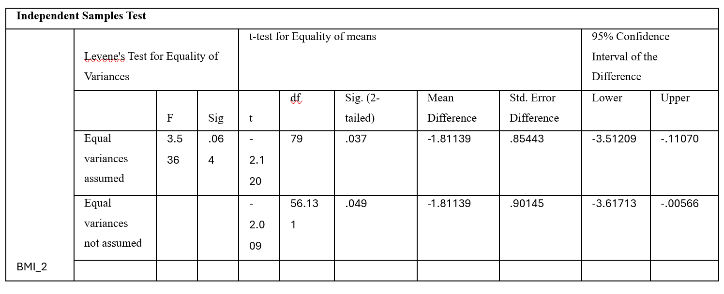

**QUESTION 3: Examining Change in Health Literacy Among Intervention Group Participants**

A paired samples t-test was used to identify whether there is a significant improvement in the health literacy scores of the participants after the 12 weeks of the intervention. The 81 participants had a base health literacy mean of 58.89 (SD = 14.63) and a post-intervention health literacy mean of 59.36 (SD = 14.78). This represents a low average post-intervention of 0.47 points. There was a standard deviation of the paired differences of 0.841 indicating that the differences in the scores were quite consistent between the members. The 95 percent confidence interval for the difference between the means was between 0.281 and 0.653. This indicates that the interval does not include zero, and therefore, at the population level, the observed improvement is statistically significant. The t-test produced a highly significant result, *t*(80) = 5.000, *p* < .001, supporting the rejection of the null hypothesis. The effect size, measured by Cohen’s *d*, was 0.56, which reflects a medium effect. This suggests that the intervention had at least a moderate impact on health literacy. Overall, although it is statistically significant, it seems to have small but statistically significant effects on the increase of health literacy but not much proof of effectiveness in practice.

**Table 6: Paired Samples Statistics**



**Table 7: Paired Samples Test**

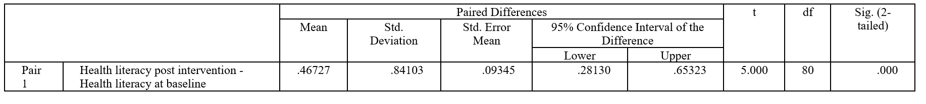

**QUESTION 4: Examining Differences in Asthma Prevalence Between Intervention and Control Groups**

A Chi-square measure of independence was used to get the picture of whether there was a given statistical level of influence of the implementation of the 12-week lifestyle health education on asthma prevalence via the intervention and the control group (Qualls et al., 2010). The rates of asthma were almost equal to 14.9 percent (7/47) in control and 14.7 percent (5/34) in intervention showing the overall prevalence of asthma among the total sample of the respondents to be 14.8 percent. All the values of the expected frequencies in the contingency table were above 5 (minimum = 5.04). Thus, it indicates that Pearson Chi-square test was appropriate. The chi-square test returned a value of 0.001 under the notation (1, N = 81, p = 0.981 not significant) suggesting that there was no significant association between group assignment and asthma status. As a robust check, a Fisher Exact Test was also completed which resulted in a non-significance (p = 1.000). The effect measuring (0.003) was insignificant confirming the fact that there was no significant difference. These results indicate the intervention had no effect on asthma outcomes, probably since the program focused on general health literacy and BMI instead of respiratory health. Also, the study time of only 12 weeks and very few cases of asthma (n = 12) might have restricted the capacity to differentiate any differences that might have occurred. Hence, the null hypothesis is not rejected.

**Table 8: Intervention * Asthma diagnosed Crosstabulation**

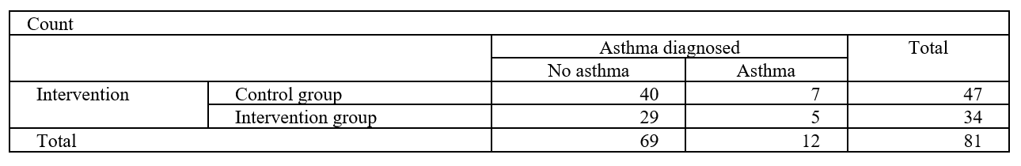

**Table 9: Chi-Square Tests**

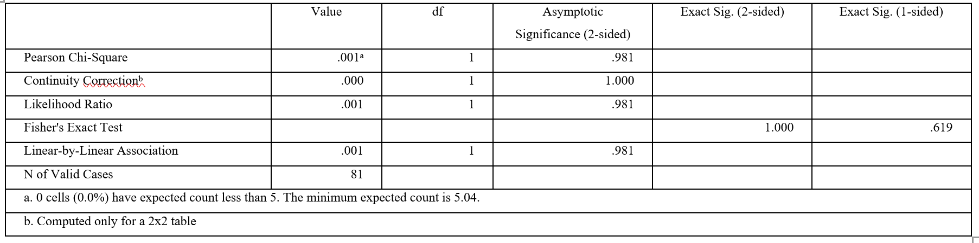

**QUESTION 5: Comparing Baseline Health Literacy Across Age Groups**

One-way ANOVA was employed to examine the significance of the differences in the magnitude of baseline health literacy across three age groups (0-20; n = 29; 21-25; n = 23; and 26-40; n = 26 years). Descriptive data showed very similar scores in all the groups: 0-20 years (M = 59.08, SD = 14.60), 21-25 years (M = 59.21, SD = 14.90) and 26-40 years (M = 57.80, SD = 15.58), which showed little differences between groups. Before ANOVA was done, assumptions were examined. Shapiro-Wilk tests revealed that the data within the health literacy scores were normally distributed in each of the groups (all p >.05), and homogeneity of variances was confirmed using Levene test (p =.978), which permitted the application of parametric analyses (Qualls et al., 2010). The ANOVA outcome was not significant, assuming that there is no real difference between baseline health literacy scores between different age groups, F (2, 75) = 0.069, p = .933. The effect size, 0.002, was negligible, which shows that belonging in the age bracket could be the reason for less than 1 percent of the variance in the scores.

Also, the statistical and practical equivalence can be concluded as supported by the overlapping confidence intervals, small mean differences as well as the less than 1.5 points. As ANOVA gave a non-significant result, there was no need to do post-hoc analysis but in theory the pairwise comparisons would also show no significant differences (Qualls et al., 2010). The results mean that the participants of different ages started the intervention with health literacy at similar levels. It means in practice that there is no gap in disadvantages or advantages based on age without any baseline change, which means there is a chance to approach intervention in these groups in the same way with no stratified adjustment required. This is beneficial to the validity of the subsequent effects of the interventions because any subsequent differences following the interventions are expected not to be a result of baseline differences in health literacy due to age differences. In general, age status of participants did not have any significant influence on the initial level of health literacy.

*Boxplot comparison*

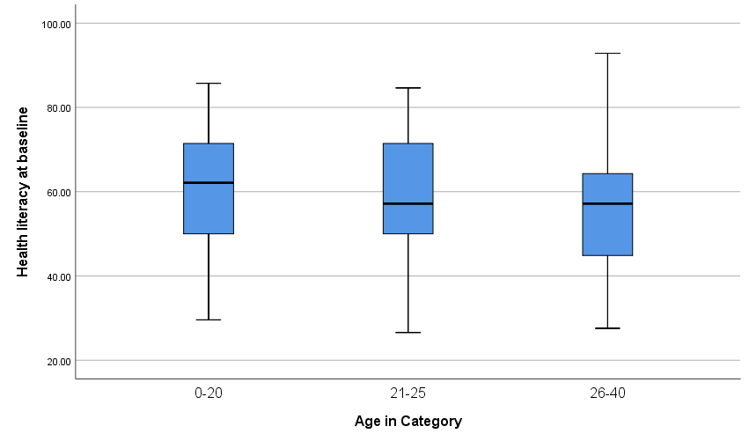

**Table 10: Tests of Normality**

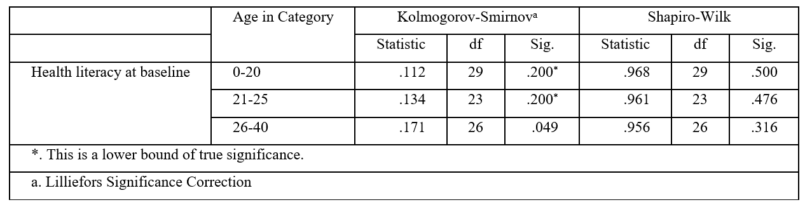

**Table 11:** **Descriptives**

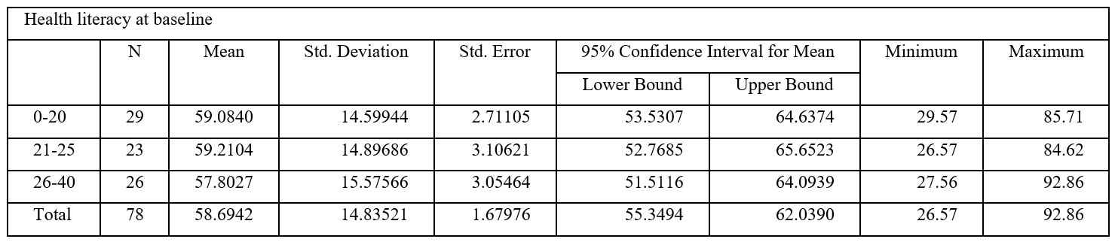

**Table 12: ANOVA**

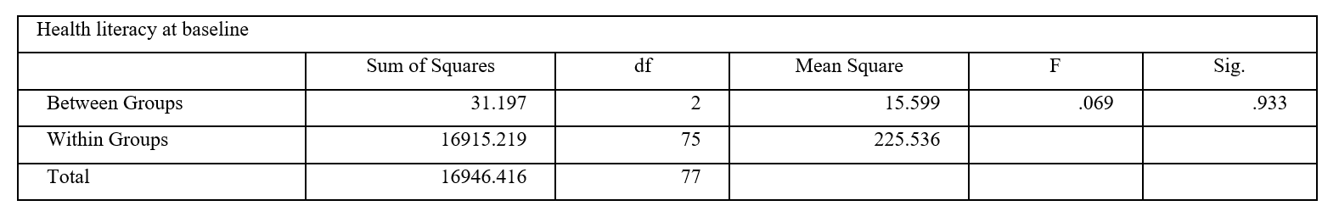

**QUESTION 6: Predicting Post-Intervention BMI Using Age, Sex, and Post-Intervention Health Literacy**

For this question, the goal is to see how several things together can be used to explain one result. A method that studies the link between many predictors and one outcome is a good choice because it can show both individual and combined effects. This method is none other than a multiple linear regression analysis. As such, this analysis was performed to determine the significance of predicting post-intervention BMI of 81 people based on age, sex, and health literacy.

Descriptive statistics revealed the mean BMI = 23.63 (SD = 3.88) and the predictor variables were, age, sex, and health literacy, mean age = 25.07 (SD = 6.68), sex (68 percent female, coded as 2), health literacy, the mean = 59.36 (SD = 14.78). Initial correlations showed that there was a positive correlation between age and BMI (r = .286, p = .005), which implied that older people had high BMI. There was negative correlation between sex and BMI (r = -.254, p = .011), indicating that the male sex (coded as 1) had a greater BMI than the female. Health literacy had no significant relationship with BMI (r = .059, p = .301). The general regression model was found to be significant, F (3, 77) = 3.819, p = .013 and R 2 = .129 showing that the predictors can explain 12.9 percent of the variance in BMI. Age was a powerful predictor (B = 0.148, p = .020), and every year of age was also linked to an increase in the BMI by 0.15 units.

The BMI was also significantly associated with sex (B = -1.792, p = .048), where females had lower BMI as compared to males by almost 1.8 units. Health literacy did not significantly predict (p = .831). The issue of multicollinearity was not a concern (all the VIFs had < 1.05). Normality and homoscedasticity were confirmed using residual analysis; therefore, the model assumptions hold.

Even though the significance of age and sex was high, the explanatory power of the model was not very high (Cohen f 2 = 0.15), which indicates the necessity of additional unmeasured variables, like diet, physical activity, or stress, which may have a greater impact on BMI. Generalizability may also be challenged in terms of overrepresentation of females (68%). Conclusively, age and sex are insignificant and moreover significant predictors of BMI in the sample and health literacy as a factor does not seem to play an influential role in BMI outcomes.

***Figure 6: Regression Scatterplot***

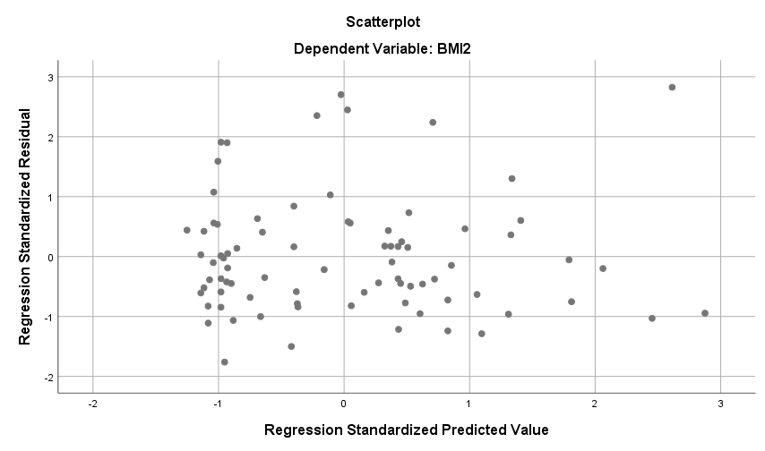

**Table 13:** **Model Summaryb**

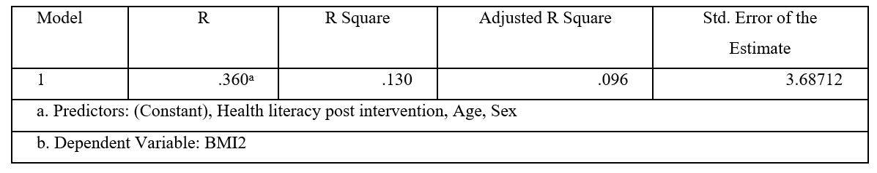

**Table 14: Coefficientsa**

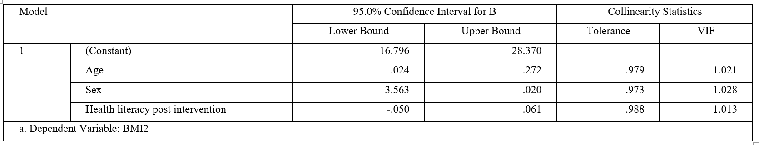

**Table 15: Descriptive Statistics**

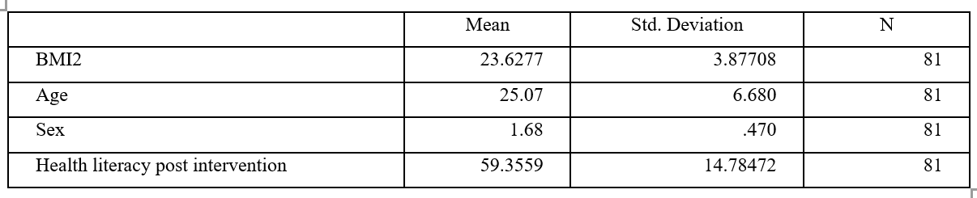

**CONCLUSION**

This evaluation explored the impact of a 12-week lifestyle subjective health education program in students attending university, showing that there were several important outcomes. Though a statistically significant change in post-intervention health literacy was noted, the effectiveness of this level of improvement is questionable as it did not have much practical value. Surprisingly, post-intervention BMI of the intervention group was found to be higher than that of the control group without any probable reason which may include the possible baseline imbalances hypothesis, non-adherence or other confounding variables. The campuses and age groups were not found to significantly differ in their prevalence of asthma and baseline health literacy, which may be taken as an indicator that the variables under consideration did not confide the major results.

In regression analysis, small but significant predictors of BMI were found to be age and sex, and health literacy showed no quantifiable effect. Such outcomes indicate that the design of the study might not be sufficient to eliminate any outside force that can interfere with the effectiveness of the intervention. The study has certain limitations, such as a small sample size (N = 81), self-reported data, and a comparatively short duration of intervention, which may have an impact on generalization and may cover the long-term impacts of the research. Future studies are also needed to consider broader and more dissimilar samples, employ objective health measures and perform more prolonged follow-up tests. Also, qualitative methods can possibly reveal obstacles to adherence and guide more specific subgroup-specific interventions.

**References**

Biostatistics Canada. (n.d.) ‘Biostatistics in Public Health: Principles, Methods, and Case-Studies – A Comprehensive Guide.’ *Biostatistics Canada*. Available at: <https://www.biostatistics.ca/biostatistics-in-public-health-principles-methods-and-case-studies-a-comprehensive-guide/> (Accessed: 10 August 2025).

Ho, A. D. & Yu, C. C. (2015) ‘Descriptive Statistics for Modern Test Score Distributions: Skewness, Kurtosis, Discreteness, and Ceiling Effects.’ *Educational and psychological measurement*. 75 (3), 365–388. Available at: <https://doi.org/10.1177/0013164414548576>

Qualls, M. et al. (2010) ‘Parametric Versus Nonparametric Statistical Tests: The Length of Stay Example.’ *Academic emergency medicine*. 17 (10), 1113–1121. Available at: <https://doi.org/10.1111/j.1553-2712.2010.00874.x>

Vrbin, C. M. (2022) ‘Parametric or nonparametric statistical tests: Considerations when choosing the most appropriate option for your data.’ *Cytopathology (Oxford)*. 33 (6), 663–667. Available at: <https://doi.org/10.1111/cyt.13174>