TrueIWFR v.1.0

mgr inż. Krzysztof Morawiec

September 2017 (version 1.0)

TrueIWFR Manual (version 1.0)

I) Tools required for running TrueIWFR software

In order to run TrueIWFR you will require:
- Windows Vista, 7, 8, 10 (≥ Vista),
- Nvidia graphics card (GPU) with a CUDA architecture and compute capability
cc ≥ 2.0 (you can check compute capability of your GPU on the following site:
https://developer.nvidia.com/cuda-gpus),
- Python language interpreter version 3.5 or later,
- Numba and Accelerate libraries which allow for performing parallel computations on GPU card,
- PyQt5 library supporting the graphical user interface of TrueIWFR.

I.1. Download the Anaconda environment from https://www.continuum.io/downloads. Choose a version compatible with Python 3.5 or later.

I.2. Install the Anaconda environment by running the installation file and following the instructions on the screen. We recommend you to install Anaconda in the default location suggested by the instalator. In Windows it will be C:\Users\user_name\Anaconda3.

I.3. After installation, open Anaconda Prompt. In Windows 7 it can be found under Start menu, in All Programs → Anaconda → Anaconda Prompt.

I.4. Type the following commands in the Anaconda Prompt in order to install required libraries:
conda install numba
conda install accelerate
conda install pyqt

After each command you will be asked for confirmation of the library name which you want to install. You can confirm it by typing 'y' into the Anaconda Prompt and pressing Enter. If the installation of all libraries is successful, you can close the Anaconda Prompt.
II) Running and operating TrueIWFR software

II.1. Download TrueIWFR software from the following site (feature currently unavailable – program files were provided with this manual):

https://github.com/morawatur/PyEWRecRepo

II.2. Extract files from zip archive to a directory on local disk.

(e.g. C:\python_programs\TrueIWFR)

II.3. Open the Python command interpreter. In Windows it can be found under Start menu, in All Programs → Anaconda → IPython.

II.4. From the command interpreter level go to the directory with extracted files. You can do it by typing in the interpreter the following command:

cd path_to_directory
(e.g. cd C:\python_programs\TrueIWFR)

II.5. Run the Main.py script by entering the following command:

%run 'Main.py'

A dialog window should appear. It allows you to point a directory in which a focal series of images is located. In order to read a focal series you need to mark the first image and press Open.

Note 1: Images must be in dm3 format (internal file format of Digital Micrograph software).

Note 2: Image names must obey the following convention:

ser_name1.dm3, ser_name2.dm3, ser_name3.dm3 etc.,

where 'ser_name' is common for all images in a focal series.
Note 3: The model focal series is located in the folder 'seria' in a directory with TrueIWFR files (defocus between two adjacent images in the series is 3 nm).

II.6. Information about the progress in loading images will be displayed in the interpreter window. After all images are loaded, the main window of the TrueIWFR program should appear on the screen (see Fig. 1).

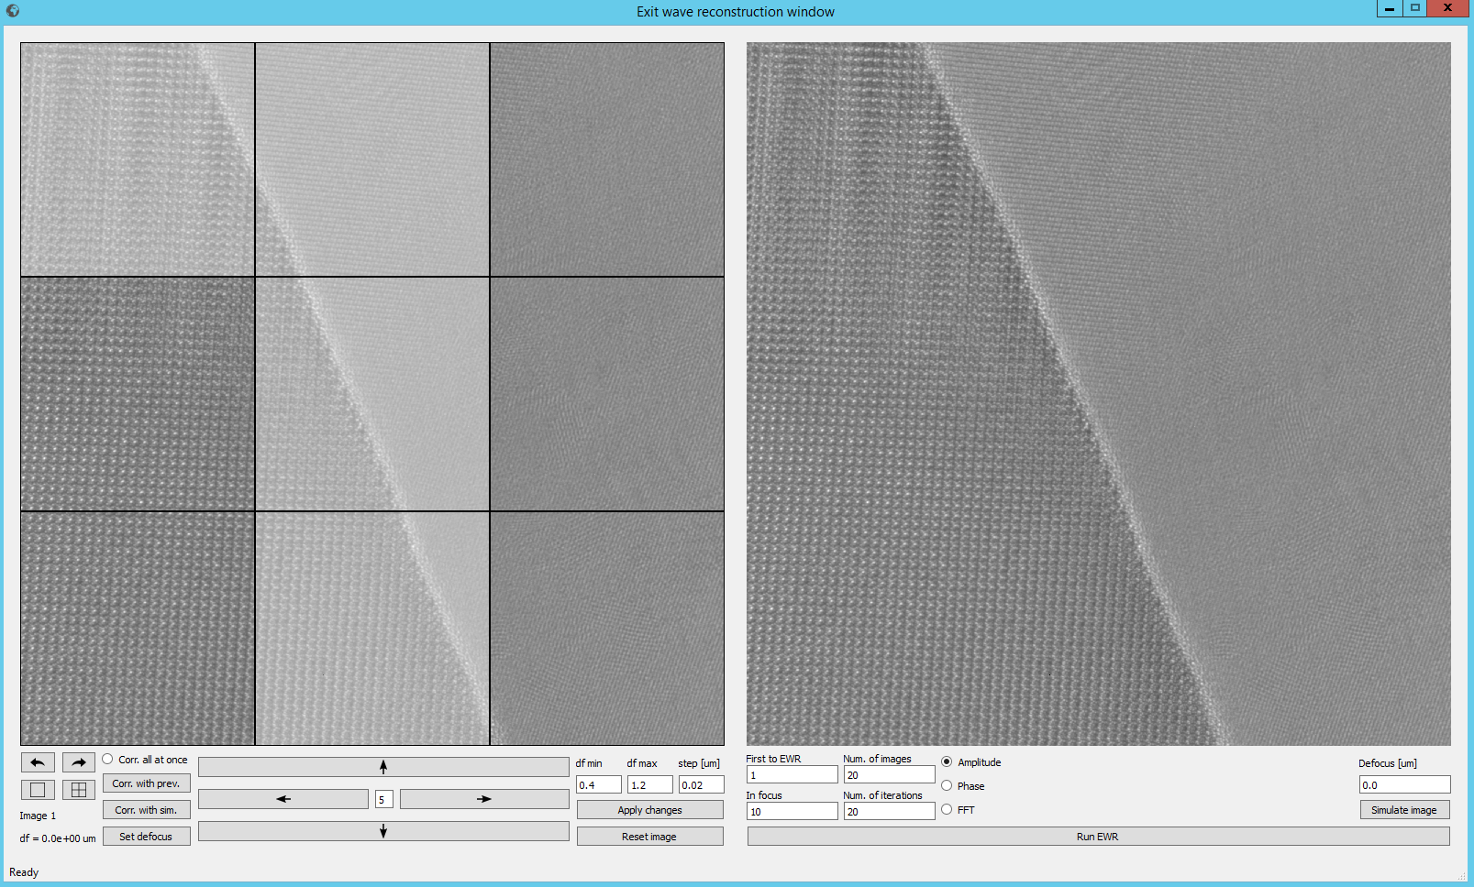
Fig. 1. Graphical user interface of TrueIWFR software.

The left panel displays the loaded focal series. It serves to switch between individual images and move them relative to each other. This allows you to remove the drift effects of the sample during microscopic examination and is usually required for proper wave function reconstruction. The right panel allows you to define reconstruction parameters and display the results.

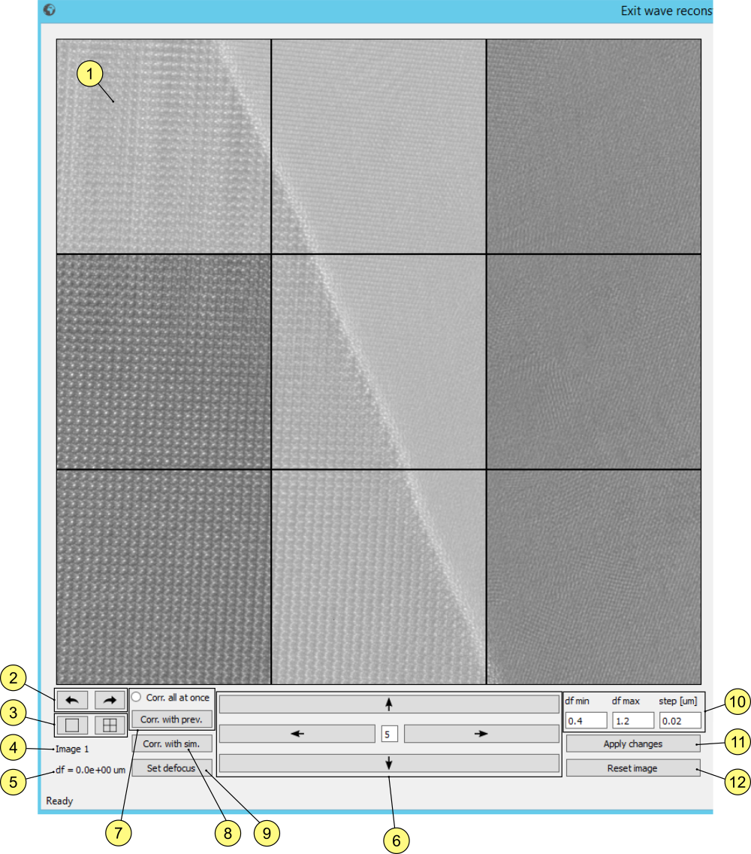
Fig. 2. Left panel functions.

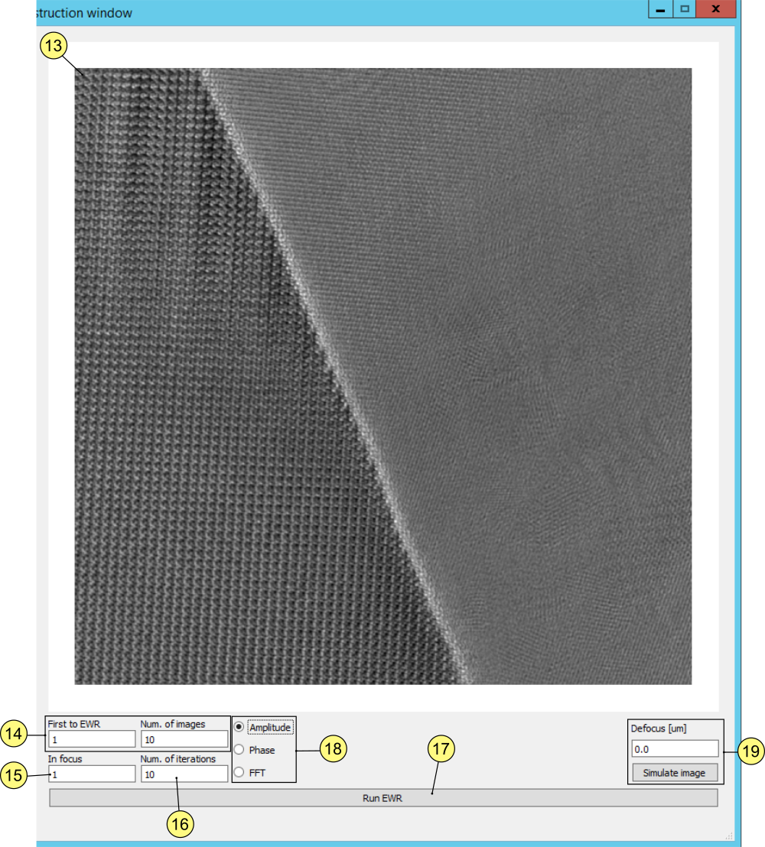
Fig. 3. Right panel functions.

Below there is a description of the program functions marked with numbers on Fig. 2 and Fig. 3.

(1) A window displaying images that belong to the focal series.

(2) Buttons to switch between images included in the focal series.

(3) Buttons to modify the mesh compaction used to select fragments of images that will be utilized to alignment. Click on the squares to select individual fragments. In Fig. 1, the areas that contain the distinctive boundary between the layers are marked.

Note: In order to efficiently align images, selected fragments should represent characteristic areas of the sample, such as precipitates, sample edges, grain boundaries, etc.

(4) Number of the displayed image.

(5) Defocus of the displayed image.

(6) Buttons to move the image by the number of pixels set in the middle text field.

(7) Alignment of the currently displayed image to the previous image. If Corr. all at once is selected, all images will be aligned according to the second-to-first, third-to-second rule, and so on.

(8) Alignment of an image to the result of a reconstruction (not available now).

(9) Defines the defocus of the currently displayed image. Specify the defocus value in the text field df min. This function is useful when the program is not able to determine automatically the defocus of the image.

(10) The defocus parameters. If you are not sure how the neighboring images differ in their defocus values, you may specify a range of values from which the program (by analyzing images) will be able to select the most appropriate value. You must then specify the minimum defocus value between the adjacent images (df min), the maximum value (df max), and the iteration step (df step).
Note: These values are required, so if you do not want the program to check for different defocus values, you can specify values that will determine one specific defocus value, e.g. df min = 10 nm, df max = 11 nm, df step = 2 nm. In this case, df step> (df max - df min), so only one value will be checked (and accepted), df = df min = 10 nm.

(11) Saves the changes made while alignment of images (including defocus values).

(12) Restores the displayed image to its original state (deletes all introduced changes).

(13) Displaying the result of the wave function reconstruction.

(14) Allows you to select the range of images to be reconstructed by specifying the number of the first image and the total number of images to be taken into account during the calculation.

(15) Specifies the image number that the user pertains to zero defocus.

(16) Number of iteration of the wave function reconstruction procedure.

(17) Starts the iterative wave function reconstruction procedure based on the focal series shown in the left panel.

(18) Allows you to switch between wave function reconstruction results, such as: amplitude, phase and Fourier transform.

(19) Allows, on the basis of the reconstruction result, to simulate the microscope image for the defocus value given in the text box.

Further points indicate the correct procedure of the wave function reconstruction based on the focal series.

II.7. First, select the characteristic parts of the image (by clicking on the appropriate squares of the grid), on the basis of which the program will try to align the images together. It is important to select items that appear in the same squares on all pictures.
II.8. Specify the appropriate defocus parameters in fields df min, df max and df step.

Note: The program helps to determine only differences in the defocus between neighboring images in a focal series. The absolute defocus values are determined by the user giving number of the image closest to the focus (see the in-focus text box in the right panel). If you do not want to use this function and you are sure that the defocus between neighboring images is 10 nm, then the values in these three fields may be 10nm, 11nm, and 2nm respectively.

Note: Please note that all defocus values should be given in micrometers.

II.9. Press Corr. all at once, then click on Corr. with prev. As a result, all images will be automatically correlated and aligned as follows: 2 → 1, 3 → 2, 4 → 3, etc. The progress information of the alignment procedure will be displayed in the lower left corner of the program status window. At the same time, information of the defocus difference between the currently displayed image and the previous image will be displayed in field (5).

II.10. If the results of image alignment and the defocus values assigned to the images are acceptable, click Apply changes to save all introduced changes. Otherwise, switch to the images that have not been correctly aligned and press Reset image to restore them to the original state. If the program is not able to correctly and automatically aligned images, it can be done manually by pressing the corresponding arrows in panel (6).

II.11. In the right panel, specify the reconstruction parameters, such as the range of images that will be used for reconstruction, number of the image that corresponds to zero defocus and the number of iterations. To start the reconstruction process press Run EWR. At the beginning, the program will cut out fragments of images that are visible on each of the aligned images in the focal series. At the same time, the program will calculate and assign individual absolute values for the defocus. They will replace the values previously given in field (5). The program will then begin to reconstruct the wave function. Information about executing subsequent iterations will be displayed in the Python interpreter window. At the end of the last iteration, the result, in the form of a wave function amplitude, is displayed in the right panel. You can display the phase image by selecting Phase button (18).

II.12. The alignment and reconstruction results are saved on disk in the 'results' directory in the TrueIWFR files folder. The results of the alignment of series are in the 'crop' directory, while the reconstruction results in 'ewf' (abbreviation for exit wave function). Files with names 'am' contain amplitudes, while 'ph' files contain phases determined after next iterations of the procedure.

TrueIWFR can be referenced. The following paper describes TrueIWFR version 1.0:

tu-będzie- odnośnik-do-pracy-Krzysia-na-temat-programu-TrueIWFR :)

