Grope: Devops

Student: Mor Bargig

Data: 16/06/2020

e-mail: [morbarig@gmail.com](mailto:morbarig@gmail.com)

**Cloud : Aws Final Project**

1. **Peering;**

Test1: Virginia vpc2: Frankfurt

web1: public: 3.235.98.78 web3: public: 18.156.162.171

privet: 10.0.0.153 privet: 192.168.0.186

web2: privet: 10.0.1.247 web4: privet: 192.168.30.161

1. connecting from wm1 to web3: c) Connecting from wm4 to web2:

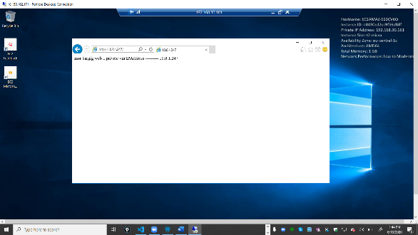

­­­­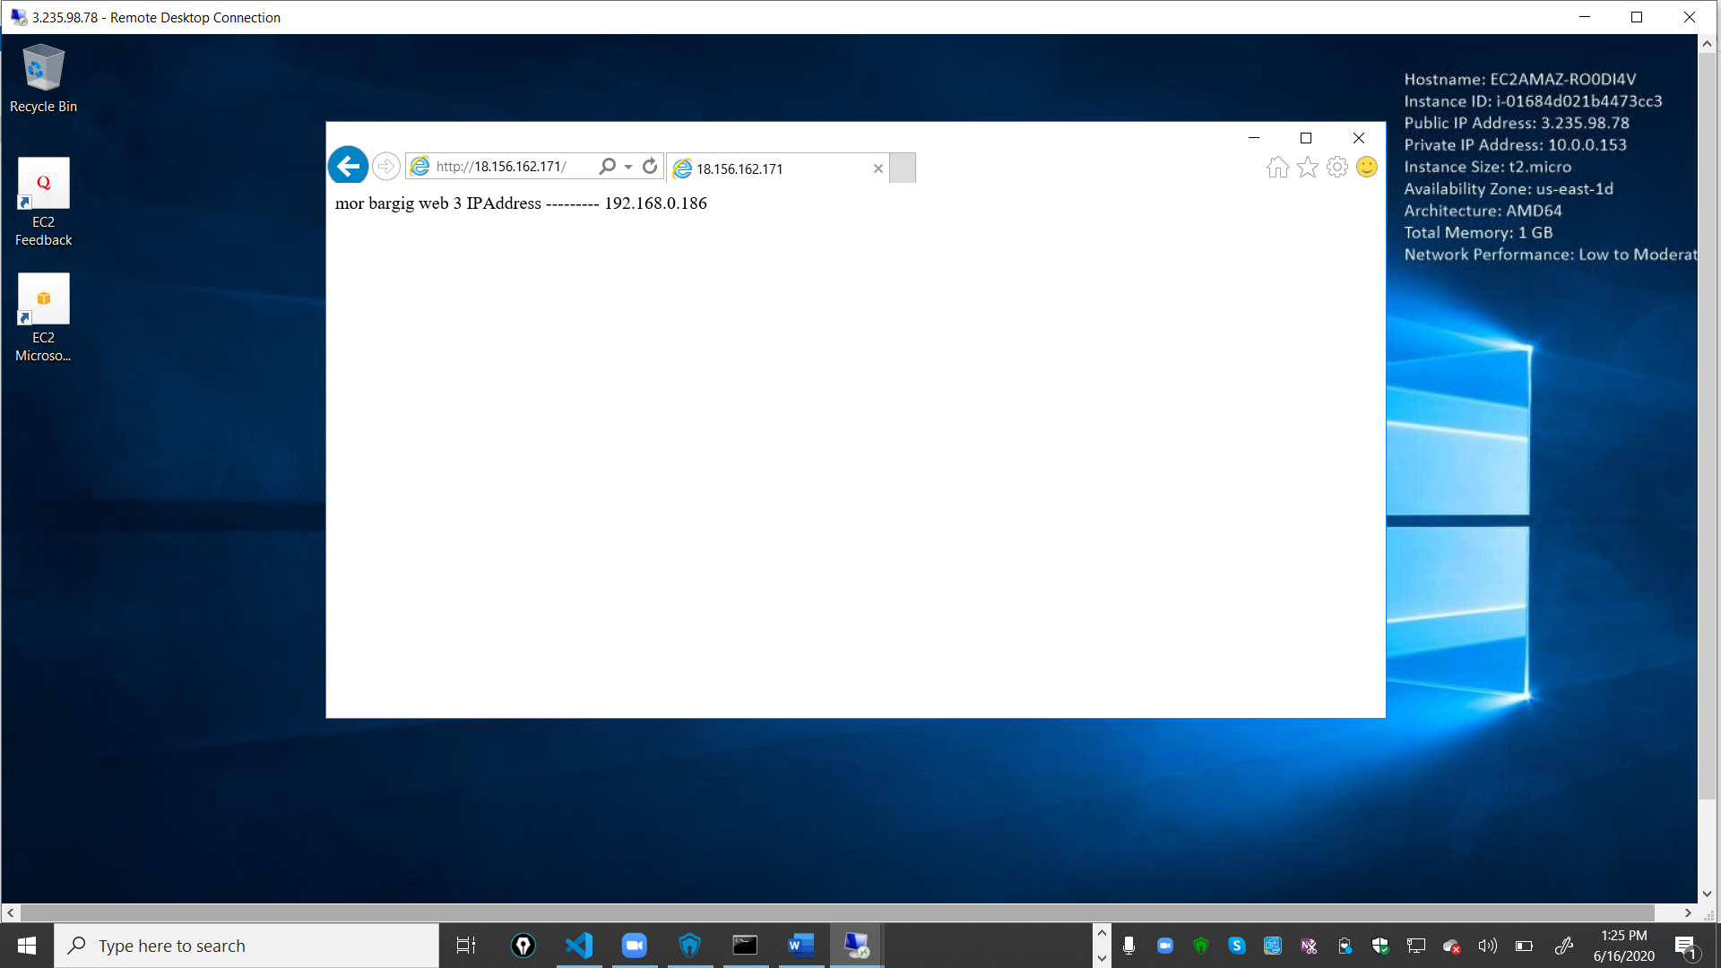­­

1. Connecting from wm3 to web1: ­­­­­ d) Connecting from wm2 to web4:

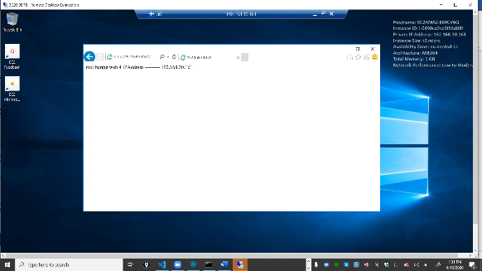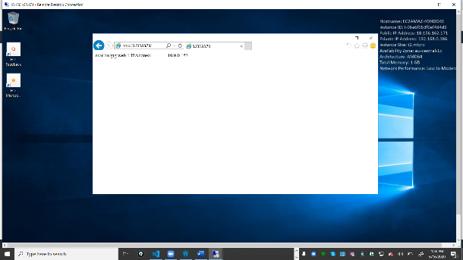

Part 2 Linux Web NLB And Azure Review

RedHat Linux Amazon VMs Web NLB

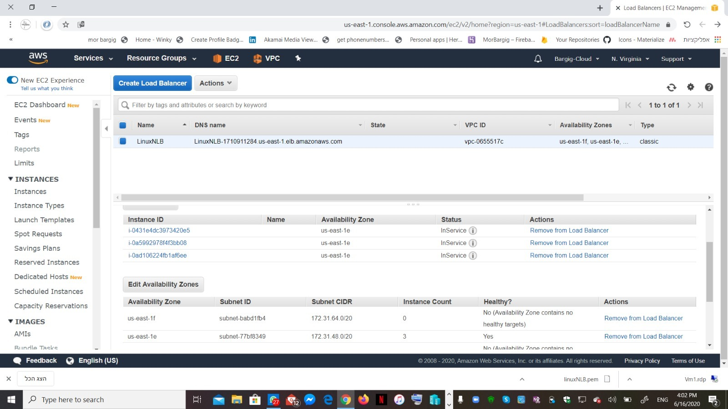

Azure Two VMs

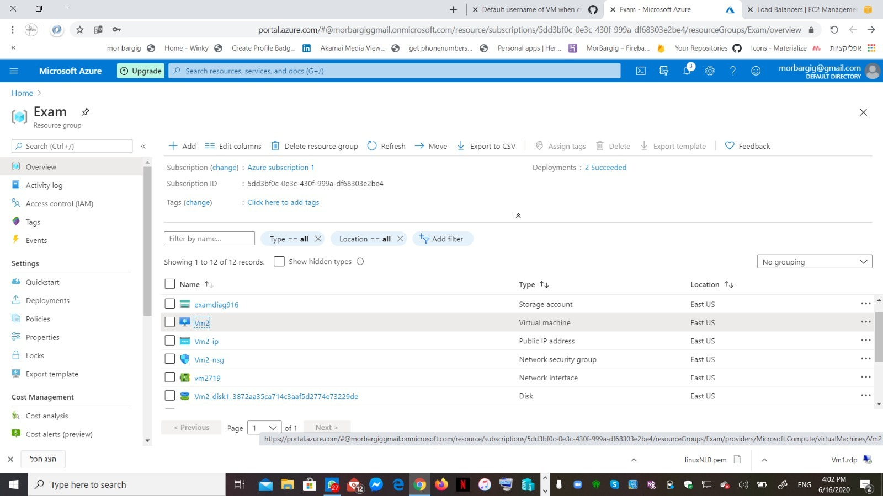

All Web Server & NLB In Progress

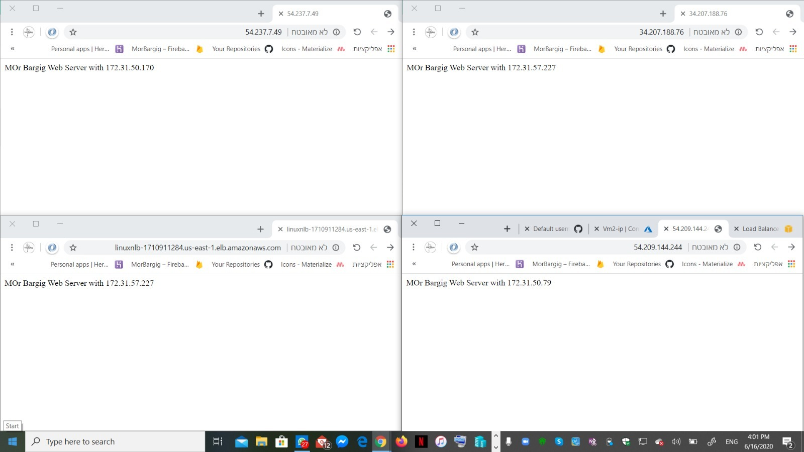

Review The NLB in Progress From Two Azure VMs Remote Desktop 🖥

