Q1. Design a circuit that can Add two one-bit numbers using a 4:1 MUX.

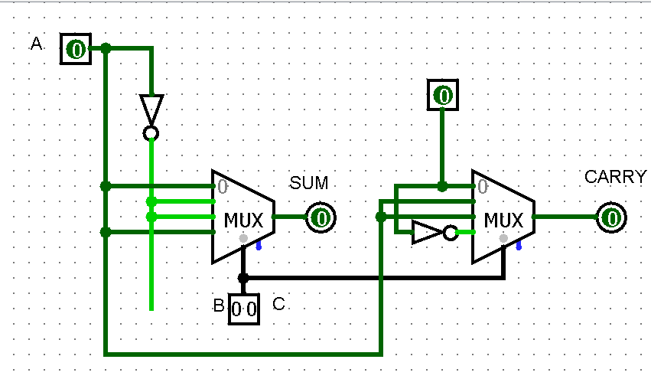

Q2. Design a circuit that can perform 1 Bit and 2 Bit Addition, Subtraction, Multiplication and Division using logisim.

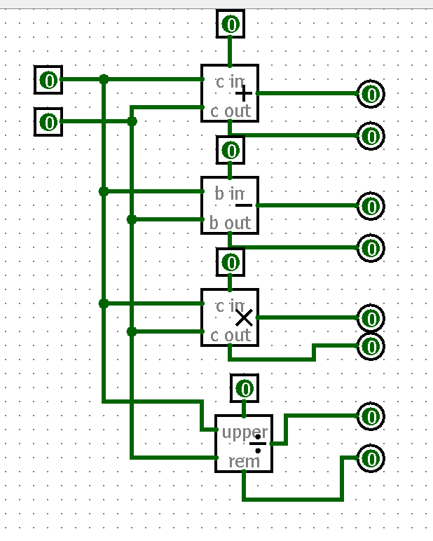

Q3. Create a 4-bit ALU in logisim that can compute AND, OR, and SUM of two 4-bit numbers. This ALU should use the adder/subtractor, multiplexer. For reference, the sample diagram of 1-bit ALU is given below.

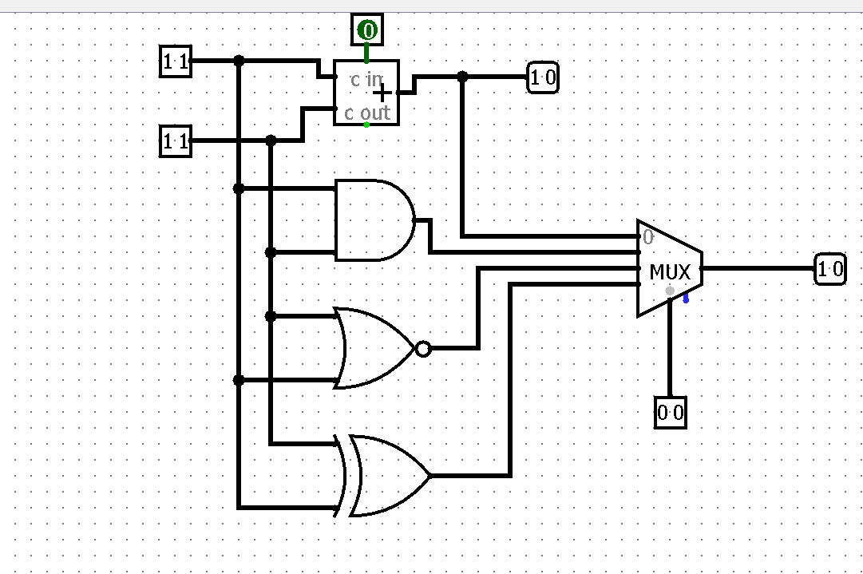

Q4. Design a J-K flipflop using SR flip-flop in logisim.

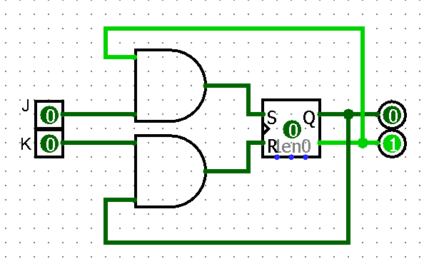

Q5. Consider a logic unit with four inputs A, B, C, and D and one output X. The output X will be high if majority inputs are low, otherwise it will be zero. Write the Boolean expression corresponding to the above logic and design the same in the logisim.

