Name:- Aashutosh singh

Enrolment number = e22cseu1732

Batch 52

Questions: 1. Create a database named as PizzaShop.

Ans.

Create database PizzaShop;

Use PizzaShop;

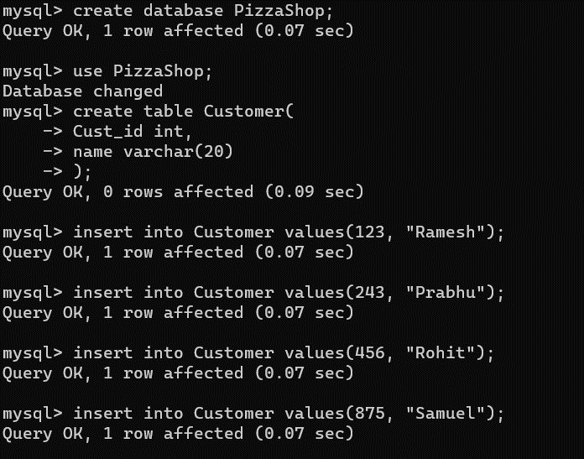

2. Create three tables named as Customer, Item, and Sale and insert 8 records each.

Ans. CREATE TABLE Customer (

Cust_Id INT PRIMARY KEY,

Cust_name VARCHAR(255)

);

INSERT INTO Customer (Cust_Id, Cust_name)

VALUES

(123, 'Ramesh'),

(243, 'Prabhu'),

(456, 'Rohit'),

(875, 'Samuel'),

(978, 'Urvashi'),

(544, 'Vandana'),

(867, 'Sarvesh'),

(837, 'Mohit');

CREATE TABLE Item (

item_id INT PRIMARY KEY,

item_name VARCHAR(255),

price INT

);

INSERT INTO Item (item_id, item_name, price)

VALUES

(13, 'Neapolitan Pizza', 1200),

(24, 'Chicago Pizza', 1300),

(36, 'New York-Style Pizza', 1000),

(35, 'Sicilian Pizza', 2000),

(78, 'Detroit Pizza', 799),

(74, 'St. Louis Pizza', 899),

(57, 'California Pizza', 2199),

(99, 'Greek Pizza', 1300);

-- Create the Customer table

CREATE TABLE Customer (

Cust_Id INT PRIMARY KEY,

Cust_name VARCHAR(255)

);

-- Insert records into the Customer table

INSERT INTO Customer (Cust_Id, Cust_name)

VALUES

(123, 'Ramesh'),

(243, 'Prabhu'),

(456, 'Rohit'),

(875, 'Samuel'),

(978, 'Urvashi'),

(544, 'Vandana'),

(867, 'Sarvesh'),

(837, 'Mohit');

-- Create the Item table

CREATE TABLE Item (

item_id INT PRIMARY KEY,

item_name VARCHAR(255),

price INT

);

-- Insert records into the Item table

INSERT INTO Item (item_id, item_name, price)

VALUES

(13, 'Neapolitan Pizza', 1200),

(24, 'Chicago Pizza', 1300),

(36, 'New York-Style Pizza', 1000),

(35, 'Sicilian Pizza', 2000),

(78, 'Detroit Pizza', 799),

(74, 'St. Louis Pizza', 899),

(57, 'California Pizza', 2199),

(99, 'Greek Pizza', 1300);

-- Create the Sale table

CREATE TABLE Sale (

sale_id INT AUTO_INCREMENT PRIMARY KEY,

bill_no INT,

bill_date DATE,

cust_id INT,

item_id INT,

qty_sold INT,

UNIQUE (bill_no) -- Make sure bill_no is unique

);

-- Insert records into the Sale table

INSERT INTO Sale (bill_no, bill_date, cust_id, item_id, qty_sold)

VALUES

(457568, '2022-08-01', 123, 99, 2),

(324235, '2022-08-03', 243, 57, 3),

(967643, '2022-08-05', 456, 74, 1),

(767879, '2022-08-08', 875, 78, 3),

(767880, '2022-08-08', 978, 35, 4), -- Corrected duplicate bill_no

(234325, '2022-08-09', 544, 36, 1),

(656878, '2022-08-10', 867, 24, 2),

(789780, '2022-08-16', 837, 13, 3);

3. Display all columns of all table.

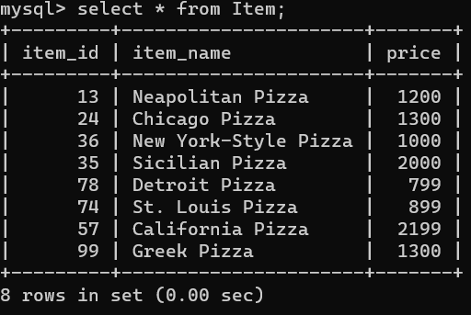

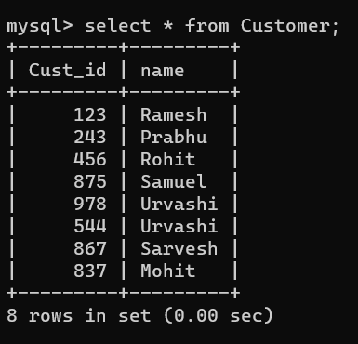

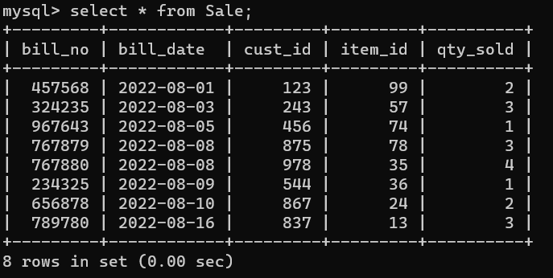

4. Display CustID of Customers table.

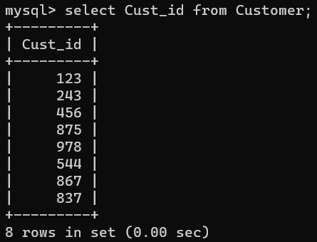

5. Display ItemID and Price of Item table.

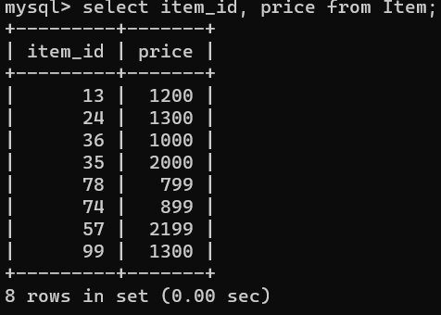

6. Display ItemName with Price whose Price is greater than 1500.

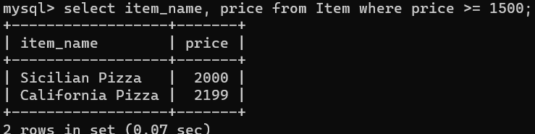

7. Find all the Sale records whose QtySold is either 2 or 1.

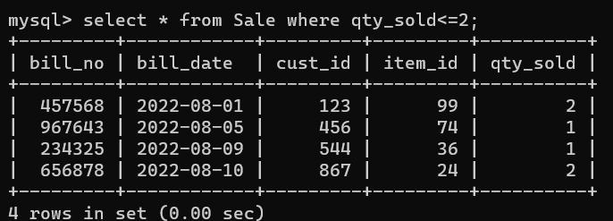

8. Find BillNo whose QtySold is 2.

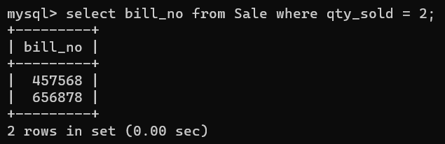

9. Add a column name as Cust_Gender in Customers table.

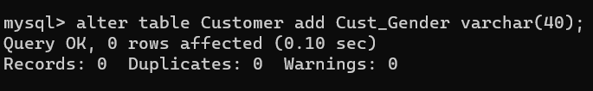

10. Delete the recently added column in the Customers table.

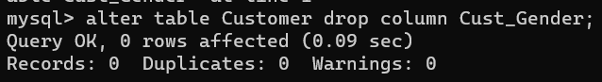

11. Change datatype of any Price from int to varchar.

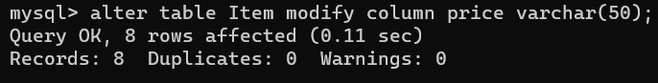

12.. Change the column name from Price to PriceTag of Item table.

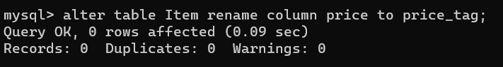

13. Delete all the records from Sale table where QtySold is greater than 30.

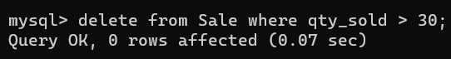

14. Change the Cust_ID of Mohit to 100.

