SchemaFieldUnit

SettingsUsr

SettingsMgr

SettingsApp

SchemaBase

RevitSettingBase

RevitSettingsMgr

RevitSettingsUnit

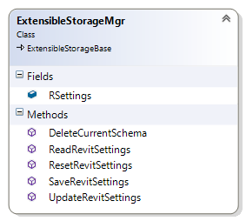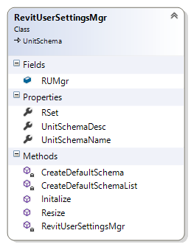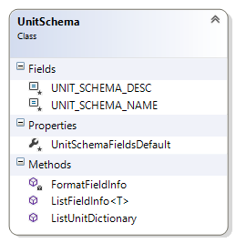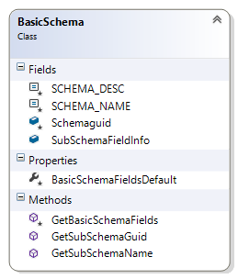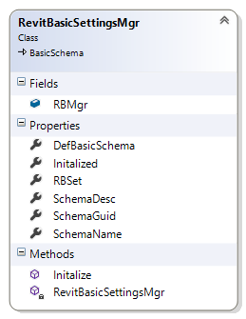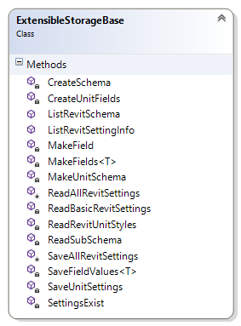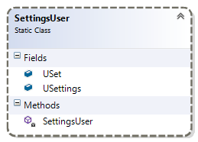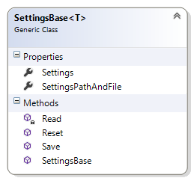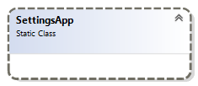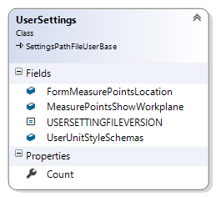

SettingsApp

# RevitSettingsUnitApp

# RevitSettingsUnitUsr

# SettingsUsr

# SettingsApp

# RevitSettingsMgr

# RsuApp

# RsMgr

# RsuUsr

# RevitSettingsBase

# SchemaFieldUnit

# SettingsMgr

# SettingsApp

# SettingsUsr

# RsuUsrSetg

# SchemaUnitApp

**SmUsr**

**SmUsrSetg**

**SmApp**

**SmAppSetg**

# RsuAppSetg

# SchemaUnitUsr

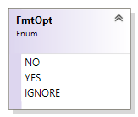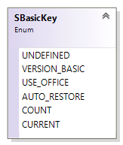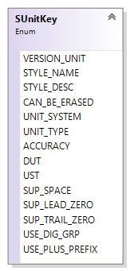

**Settings**

**SettingsPathAndFileName**

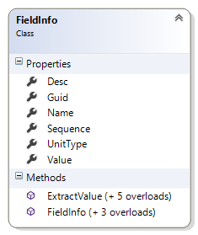

# SchemaBoolOpts

# SchemaUsrKey

# SchemaUnitAppDefault

# SchemaUnitUsrDefault

# SchemaAppKey

ChkDelRtnCode.

# RevitSettingsMgr: Read()

# RevitSettingsBase: ReadAllRevitSettings()

# true

# false

# return: true

# return: false

# RevitSettingsMgr: Update()

# RevitSettingsBase: DeleteAllSchemas()

# RevitSettingsMgr: Save2()

DUPLICATE

GOOD

Other

# return: false

# return: true

# RevitSettingsMgr: Save(false)

DUPLICATE

GOOD

Other

# return: DUPLICATE

# return: Other

# return: GOOD

# Initialized = true

# Initialized = false

# RevitSettingsMgr: Save1(override?)

# Initialized?

# yes

# no

# RevitSettingsBase: SaveAllRevitSettings()

# return:

# NOT-INIT

# Initialized?

# yes

# no

# return:

# false

NOT-INIT

# override?

# no

# yes

# RevitSettingsMgr: DeleteSchema()

# RevitSettingsBase: DeleteAllSchemas()

# RevitSettingsMgr:

# Read()→bool

# RevitSettingsMgr:

# Save(?)→SaveRtnCodes

# RevitSettingsMgr:

# Save()→bool

# RevitSettingsMgr:

# Update()→bool

# RevitSettingsMgr:

# DeleteSchema()→bool

# RevitSettingsMgr:

# Initalize()→bool

# RevitSettingsMgr: Initalize ()

# RevitSettingsBase: DeleteAllSchemas()

# return: false

# RsuUsr.Initalize()

# Save2()

# false

# Initialized = true

# return: true

# true

TOO MANY DOCUMENTS

WORKED

return: false

return: true

# return: false

# return: true

ChkDelRtnCode.

NOT FOUND

TOO MANY DOCUMENTS

WORKED

return: false

return: true

# RevitSettingsMgr: Save2()

# return: false

# return: true

# true

# false

ChkDelRtnCode.

NOT FOUND

TOO MANY DOCUMENTS

WORKED

return: false

return: true

NOT FOUND

User keeps their personal unit styles in this file which is help in their AppData area. This will hold this machines settings for all users – each style has a name associated with the style.

# Datafile:

# ConfigSettings

# Model has some user settings

# Model has no user settings

# User opens a model

# Config setting exist

# Config setting app: use unit styles?

# true

# false

# return: false

# _UnitStyleSystem= false

# true

# false

# Use unit styles?

# true

# false

# Set config file:

# use unit styles = false

# 🡪 read

# Set config file:

# use unit styles = true

# _UnitStyleSystem= true

# false

# true

ConfigSettingsExist

# Check: does the app settings file exist?

# false

# true

AskUseUnitStyleSystem

# Dialog: Use unit styles?

# false

# true

# config file: use unit styles = true

# config file: use unit styles = false

# true

# false

ConfigUseUnitStyleSystem

# 🡪 read App Settings

# App config setting: use unit styles?

# false

# true

AskUseUnitStyleSystem?

# false

# true

ConfigSettingsExist?

# false

# true

ConfigUseUnitStyleSystem

# false

# true

ConfigUseUnitStyleSystem

# false

# true

SuspendUnitStyleSystem

# Return: false

SuspendUnitStyleSystem

# Set config file:

# use unit styles = false

# return: false