Frequently Asked Questions

# About the Lecture Notes and Videos

1. Most of the videos come from YouTube. What about those who cannot use VPN?

***Response***: For studying, you should buy a VPN. Also, you have another choice: read the slides *carefully*.

1. I have a VPN, but why I cannot access YouTube?

***Response***: Just try Chrome Browser.

# Responses to Aicha (艾莎)

1. For Q. 6 and 7, I don't understand which assert functions do you mean, because there are more than 2. There are assertFalse, assertTrue, assertNotNull, assertEquals and etc.

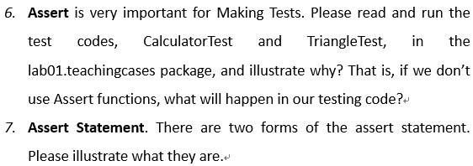

***Response***:

**For Q. 6**: Assert functions are not limited to some specific ones. To answer this question, you should write your own checking code to replace some assert functions used in your code.

**For Q. 7**: Have you read the slides “02_junit.pdf” carefully?

1. The first question laoshi is about this question, I don't know how we're supposed to make the test (the test case in Table 1) fail, they all came out successfully for me but the table says it should fail.

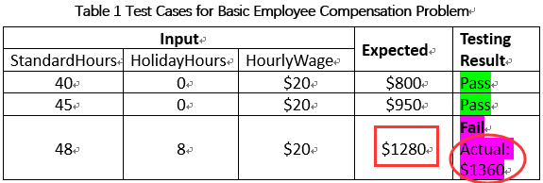

***Response***: I’m sorry. I made a mistake here. The 3rd test case has been revised as shown above.