How to Submit Your Labwork

# .Rename “Labwork.docx”

Please rename the file “Labwork.docx” to “Your Name-Your Student ID.docx”, e.g., Tamraoui Oussama- L201726630108.docx.

# How to Do the Labwork?

During the whole course procedure, you’ll receive several labworks, such as “Lab01”, “Lab02”, and etc. Note that we use “labwork”, instead of “homework”, to emphasize that our assignments are experiment-oriented and you should write codes for most of the assignments. Thus, for each labwork, you should do 2 things as follows:

* 1. report your answer in your own “Labwork.docx”;
  2. provide the corresponding source codes.

Note that your answer in your “Labwork.docx” is much more important than your source codes. Please do it as follows

* 1. **You should report the problem you met and the solving methods you got during the whole procedure.**
  2. **You should snapshot the important result of your running results and give your analyzing about the experimental result.**
  3. **You do not need to paste your code into your “Labwork.docx” unless it’s really necessary to illustrate your answer.**
* **Attention: Do NOT copy** the labwork report from others. You should do it yourself. Once 2 Labwork reports are found to be similar, the authors of the 2 reports will punished with **0 score**.

# Labwork Submission

Please submit your “Labwork.docx” as well as the corresponding Source Codes to Chaoxing System. Note that although you have several labworks, you only submit **one** Labwork report (.docx) and **one** source code package (.zip). Also, note that each labwork has its own deadline. To this end, you should submit your labwork as follows:

1. For the 1st labwork, you only need to submit your “Labwork.docx”**, which only contains your labwork report for** “**Lab01**”.



1. For the 2nd labwork, you need to submit your “Labwork.docx”**, which contains your labwork reports for** “**Lab01**” & “**Lab0**2”.



1. For the 3rd labwork, you need to submit your “Labwork.docx”**, which contains your labwork report**s **for** “**Lab01**” & “**Lab0**2” & “**Lab0**3”.



1. For the 3rd labwork, you need to submit your “Labwork.docx”**, which contains your labwork reports for** “**Lab01**” & “**Lab0**2” & “**Lab0**3” & “**Lab0**4”.



1. For the *N*-th labwork, you need to submit your “Labwork.docx”**, which contains your labwork reports for** “**Lab01**” & “**Lab0**2” & “**Lab0**3” & “**Lab0**4” & … & “**Lab0***N*”.
2. For the *final* labwork, you need to submit your “Labwork.docx”**, which contains** *all* of **your labwork reports**, as well as *all* of your source codes.



# How to add a new labwork into your own “Labwork.docx”?

According to the submission rule described in Section 3, you should *continuously* add new labworks into your own “**Labwork.docx**” in an *incremental* way. So, it’s very important to know how to *efficiently* add a new labwork to your own “**Labwork.docx**”. Here, I suppose you use *Microsoft Word* to edit your labwork report. You can do as follows

1. Open the latest “**Labwork.docx**” released by the teacher;
2. Check the checkbox of the *Navigation Pane* (导航窗格) in the *View* (视图) menu (Sorry for my Chinese GUI)



1. You’ll see the *Navigation Pane* appears on the left of your Word editor. In the Navigation Pane, you can see all of the labworks, including their subtasks, as follows

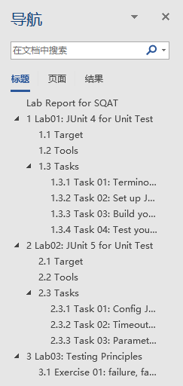

1. Select a new labwork, e.g., Lab02, to your own “Labwork.docx” as follows



Then, you’ll find the whole contents in “Lab02” are selected, as shown in the following figure.

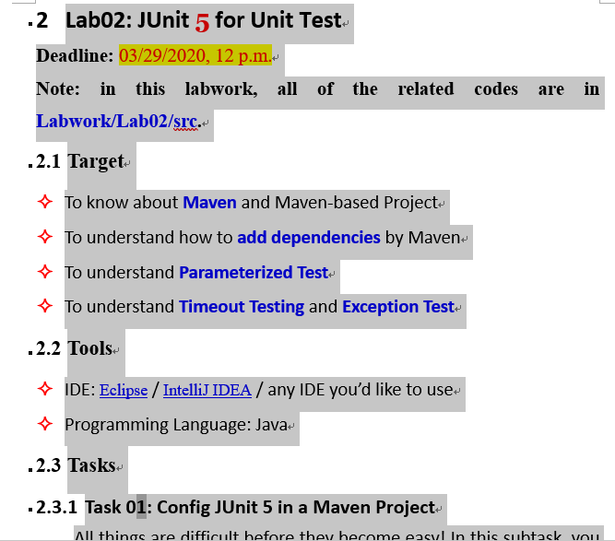

1. Copy the whole contents in Lab02 by using “Ctrl + C”.
2. Paste the copied contents into your own Labwork.docx.