CS231n: Convolutional Neural Networks for Visual Recognition

[B站教学视频](https://www.bilibili.com/video/BV19K4y1v7TK?p=3&share_medium=android&share_plat=android&share_source=WEIXIN&share_tag=s_i&timestamp=1624795633&unique_k=IQo8Cw), [教材主页](https://cs231n.github.io/)

# 学习方法

什么比较重要？

1. 教材中的图、方法（公式）、代码、数据集的描述等；
2. 代码实战：
   1. 从 NN 分类器的demo（类似于 HelloWorld 程序）开始学习；
   2. 使用PyCharm（开发环境：调试功能强大、编写代码） + SSH远程环境；
   3. 使用Jupyter Notebook（更直观，但不方便调试）：代码、文本（笔记）、运行结果；
   4. PyCharm中的错误纠正，快捷键：Alt + Enter

**TODO:**

1. 准备数据集：CIFAR-10；
2. 学习GPU服务器的使用（随后有GPU服务器使用说明给大家）；
3. 下载CS231n课程的代码；
4. 学习教材：<https://cs231n.github.io/>；
5. 高效学习方法：
6. 拷贝教材的Web页面到Word中（大家都统一使用Word，不要使用WPS）；
7. 使用Word提供的样式，建立目录索引（（怎么在word中使用样式，需要大家认真学习）。

Module 1: Neural Networks

# Image Classification: Data-driven Approach, *k*-Nearest Neighbor, train/val/test splits

**Key words:** L1/L2 distances, hyperparameter search, cross-validation

**Motivation**. In this section we will introduce the Image Classification problem, which is the task of assigning an input image one label from a fixed set of categories. This is one of the core problems in Computer Vision that, despite its simplicity, has a large variety of practical applications. Moreover, as we will see later in the course, many other seemingly distinct Computer Vision tasks (such as object detection, segmentation) can be reduced to image classification.

**Example**. For example, in the image below an image classification model takes a single image and assigns probabilities to 4 labels, *{cat, dog, hat, mug}*. As shown in the image, keep in mind that to a computer an image is represented as one large 3-dimensional array of numbers. In this example, the cat image is 248 pixels wide, 400 pixels tall, and has three color channels Red,Green,Blue (or RGB for short). Therefore, the image consists of 248 x 400 x 3 numbers, or a total of 297,600 numbers. Each number is an integer that ranges from 0 (black) to 255 (white). Our task is to turn this quarter of a million numbers into a single label, such as *“cat”*.

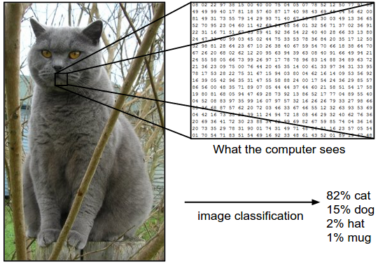

The task in Image Classification is to predict a single label (or a distribution over labels as shown here to indicate our confidence) for a given image. Images are 3-dimensional arrays of integers from 0 to 255, of size Width x Height x 3. The 3 represents the three color channels Red, Green, Blue.

**Challenges**. Since this task of recognizing a visual concept (e.g. cat) is relatively trivial for a human to perform, it is worth considering the challenges involved from the perspective of a Computer Vision algorithm. As we present (an inexhaustive) list of challenges below, keep in mind the raw representation of images as a 3-D array of brightness values:

* **Viewpoint variation**. A single instance of an object can be oriented in many ways with respect to the camera.
* **Scale variation**. Visual classes often exhibit variation in their size (size in the real world, not only in terms of their extent in the image).
* **Deformation**. Many objects of interest are not rigid bodies and can be deformed in extreme ways.
* **Occlusion**. The objects of interest can be occluded. Sometimes only a small portion of an object (as little as few pixels) could be visible.
* **Illumination conditions**. The effects of illumination are drastic on the pixel level.
* **Background clutter**. The objects of interest may *blend* into their environment, making them hard to identify.
* **Intra-class variation**. The classes of interest can often be relatively broad, such as *chair*. There are many different types of these objects, each with their own appearance.

A good image classification model must be invariant to the cross product of all these variations, while simultaneously retaining sensitivity to the inter-class variations.

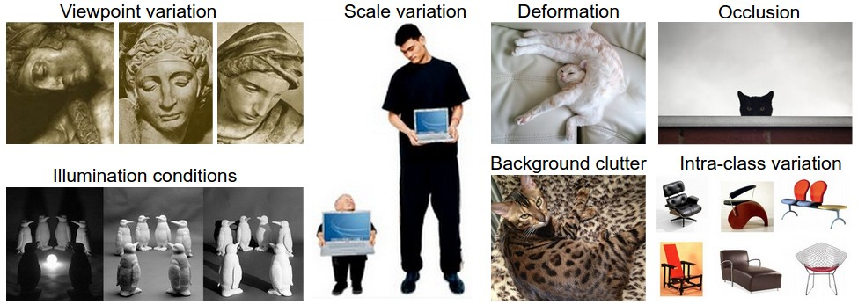

**Data-driven approach**. How might we go about writing an algorithm that can classify images into distinct categories? Unlike writing an algorithm for, for example, sorting a list of numbers, it is not obvious how one might write an algorithm for identifying cats in images. Therefore, instead of trying to specify what every one of the categories of interest look like directly in code, the approach that we will take is not unlike one you would take with a child: we’re going to provide the computer with many examples of each class and then develop learning algorithms that look at these examples and learn about the visual appearance of each class. This approach is referred to as a *data-driven approach*, since it relies on first accumulating a *training dataset* of labeled images. Here is an example of what such a dataset might look like:

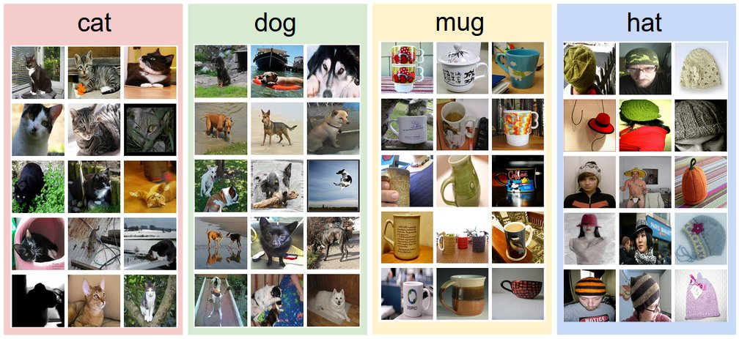

An example training set for four visual categories. In practice we may have thousands of categories and hundreds of thousands of images for each category.

**The image classification pipeline**. We’ve seen that the task in Image Classification is to take an array of pixels that represents a single image and assign a label to it. Our complete pipeline can be formalized as follows:

* **Input:** Our input consists of a set of *N* images, each labeled with one of *K* different classes. We refer to this data as the *training set*.
* **Learning:** Our task is to use the training set to learn what every one of the classes looks like. We refer to this step as *training a classifier*, or *learning a model*.
* **Evaluation:** In the end, we evaluate the quality of the classifier by asking it to predict labels for a new set of images that it has never seen before. We will then compare the true labels of these images to the ones predicted by the classifier. Intuitively, we’re hoping that a lot of the predictions match up with the true answers (which we call the *ground truth*).

## Nearest Neighbor Classifier

As our first approach, we will develop what we call a **Nearest Neighbor Classifier**. This classifier has nothing to do with Convolutional Neural Networks and it is very rarely used in practice, but it will allow us to get an idea about the basic approach to an image classification problem.

### ! [CIFAR-10 dataset](https://www.cs.toronto.edu/~kriz/cifar.html)

**Example image classification dataset: CIFAR-10.** One popular toy image classification dataset is the [CIFAR-10 dataset](https://www.cs.toronto.edu/~kriz/cifar.html). This dataset consists of 60,000 tiny images that are 32 pixels high and wide. Each image is labeled with one of 10 classes (for example *“airplane, automobile, bird, etc”*). These 60,000 images are partitioned into a training set of 50,000 images and a test set of 10,000 images. In the image below you can see 10 random example images from each one of the 10 classes:

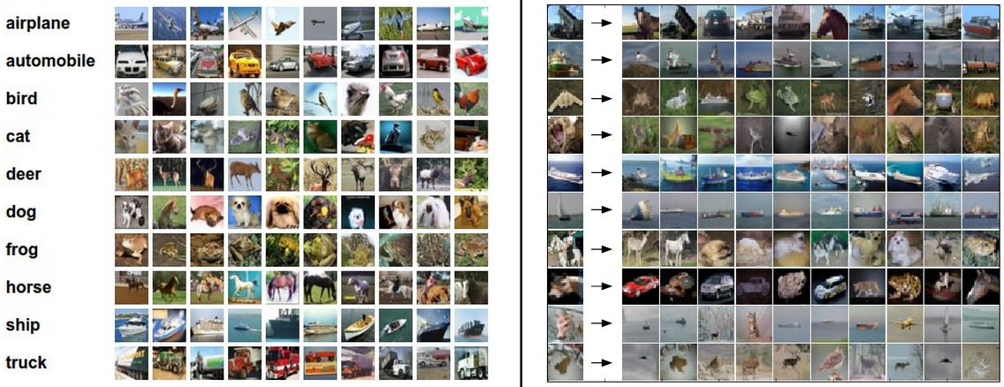

Left: Example images from the [CIFAR-10 dataset](https://www.cs.toronto.edu/~kriz/cifar.html). Right: first column shows a few test images and next to each we show the top 10 nearest neighbors in the training set according to pixel-wise difference.

Suppose now that we are given the CIFAR-10 training set of 50,000 images (5,000 images for every one of the labels), and we wish to label the remaining 10,000. The nearest neighbor classifier will take a test image, compare it to every single one of the training images, and predict the label of the closest training image. In the image above and on the right you can see an example result of such a procedure for 10 example test images. Notice that in only about 3 out of 10 examples an image of the same class is retrieved, while in the other 7 examples this is not the case. For example, in the 8th row the nearest training image to the horse head is a red car, presumably due to the strong black background. As a result, this image of a horse would in this case be mislabeled as a car.

You may have noticed that we left unspecified the details of exactly how we compare two images, which in this case are just two blocks of 32 x 32 x 3. One of the simplest possibilities is to compare the images pixel by pixel and add up all the differences. In other words, given two images and representing them as vectors I1,I2I1,I2 , a reasonable choice for comparing them might be the **L1 distance**:

Where the sum is taken over all pixels. Here is the procedure visualized:

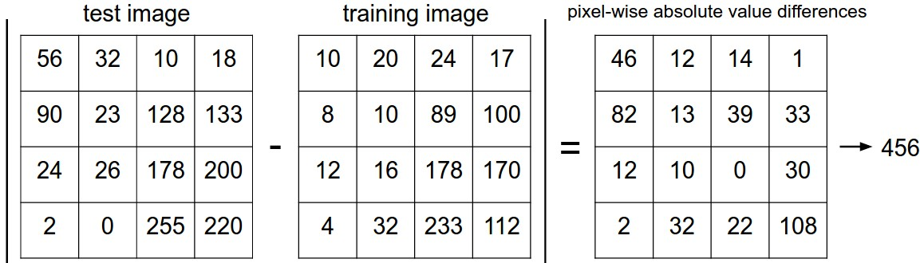

An example of using pixel-wise differences to compare two images with L1 distance (for one color channel in this example). Two images are subtracted elementwise and then all differences are added up to a single number. If two images are identical the result will be zero. But if the images are very different the result will be large.

Let’s also look at how we might implement the classifier in code. First, let’s load the CIFAR-10 data into memory as 4 arrays: the training data/labels and the test data/labels. In the code below, Xtr (of size 50,000 x 32 x 32 x 3) holds all the images in the training set, and a corresponding 1-dimensional array Ytr (of length 50,000) holds the training labels (from 0 to 9):

Xtr, Ytr, Xte, Yte **=** load_CIFAR10('data/cifar10/') *# a magic function we provide*

*# flatten out all images to be one-dimensional*

Xtr_rows **=** Xtr.reshape(Xtr.shape[0], 32 **\*** 32 **\*** 3) *# Xtr_rows becomes 50000 x 3072*

Xte_rows **=** Xte.reshape(Xte.shape[0], 32 **\*** 32 **\*** 3) *# Xte_rows becomes 10000 x 3072*

Now that we have all images stretched out as rows, here is how we could train and evaluate a classifier:

nn **=** NearestNeighbor() *# create a Nearest Neighbor classifier class*

nn.train(Xtr_rows, Ytr) *# train the classifier on the training images and labels*

Yte_predict **=** nn.predict(Xte_rows) *# predict labels on the test images*

*# and now print the classification accuracy, which is the average number*

*# of examples that are correctly predicted (i.e. label matches)*

**print** 'accuracy: %f' **%** ( np.mean(Yte_predict **==** Yte) )

Notice that as an evaluation criterion, it is common to use the **accuracy**, which measures the fraction of predictions that were correct. Notice that all classifiers we will build satisfy this one common API: they have a train(X,y) function that takes the data and the labels to learn from. Internally, the class should build some kind of model of the labels and how they can be predicted from the data. And then there is a predict(X) function, which takes new data and predicts the labels. Of course, we’ve left out the meat of things - the actual classifier itself. Here is an implementation of a simple Nearest Neighbor classifier with the L1 distance that satisfies this template:

import numpy **as** np

**class** **NearestNeighbor**(object):

**def** **__init__**(self):

**pass**

**def** **train**(self, X, y):

""" X is N x D where each row is an example. Y is 1-dimension of size N """

*# the nearest neighbor classifier simply remembers all the training data*

self.Xtr **=** X

self.ytr **=** y

**def** **predict**(self, X):

""" X is N x D where each row is an example we wish to predict label for """

num_test **=** X.shape[0]

*# lets make sure that the output type matches the input type*

Ypred **=** np.zeros(num_test, dtype **=** self.ytr.dtype)

*# loop over all test rows*

**for** i **in** range(num_test):

*# find the nearest training image to the i'th test image*

*# using the L1 distance (sum of absolute value differences)*

distances **=** np.sum(np.abs(self.Xtr **-** X[i,:]), axis **=** 1)

min_index **=** np.argmin(distances) *# get the index with smallest distance*

Ypred[i] **=** self.ytr[min_index] *# predict the label of the nearest example*

**return** Ypred

If you ran this code, you would see that this classifier only achieves **38.6%** on CIFAR-10. That’s more impressive than guessing at random (which would give 10% accuracy since there are 10 classes), but nowhere near human performance (which is [estimated at about 94%](https://karpathy.github.io/2011/04/27/manually-classifying-cifar10/)) or near state-of-the-art Convolutional Neural Networks that achieve about 95%, matching human accuracy (see the [leaderboard](https://www.kaggle.com/c/cifar-10/leaderboard) of a recent Kaggle competition on CIFAR-10).

**The choice of distance.** There are many other ways of computing distances between vectors. Another common choice could be to instead use the **L2 distance**, which has the geometric interpretation of computing the euclidean distance between two vectors. The distance takes the form:

In other words we would be computing the pixelwise difference as before, but this time we square all of them, add them up and finally take the square root. In numpy, using the code from above we would need to only replace a single line of code. The line that computes the distances:

distances **=** np.sqrt(np.sum(np.square(self.Xtr **-** X[i,:]), axis **=** 1))

Note that I included the np.sqrt call above, but in a practical nearest neighbor application we could leave out the square root operation because square root is a *monotonic function*. That is, it scales the absolute sizes of the distances but it preserves the ordering, so the nearest neighbors with or without it are identical. If you ran the Nearest Neighbor classifier on CIFAR-10 with this distance, you would obtain **35.4%** accuracy (slightly lower than our L1 distance result).

**L1 vs. L2.** It is interesting to consider differences between the two metrics. In particular, the L2 distance is much more unforgiving than the L1 distance when it comes to differences between two vectors. That is, the L2 distance prefers many medium disagreements to one big one. L1 and L2 distances (or equivalently the L1/L2 norms of the differences between a pair of images) are the most commonly used special cases of a [p-norm](https://planetmath.org/vectorpnorm).

## k - Nearest Neighbor Classifier

You may have noticed that it is strange to only use the label of the nearest image when we wish to make a prediction. Indeed, it is almost always the case that one can do better by using what’s called a **k-Nearest Neighbor Classifier**. The idea is very simple: instead of finding the single closest image in the training set, we will find the top **k** closest images, and have them vote on the label of the test image. In particular, when *k = 1*, we recover the Nearest Neighbor classifier. Intuitively, higher values of **k** have a smoothing effect that makes the classifier more resistant to outliers:

### ? Visualization of NN, *k*NN decision boundaries

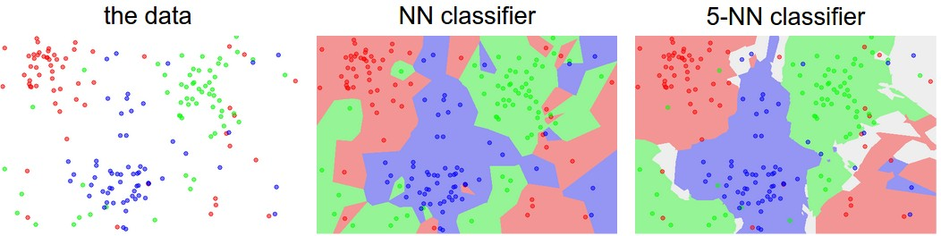

An example of the difference between Nearest Neighbor and a 5-Nearest Neighbor classifier, using 2-dimensional points and 3 classes (red, blue, green). The colored regions show the **decision boundaries** induced by the classifier with an L2 distance. The white regions show points that are ambiguously classified (i.e. class votes are tied for at least two classes). Notice that in the case of a NN classifier, outlier datapoints (e.g. green point in the middle of a cloud of blue points) create small islands of likely incorrect predictions, while the 5-NN classifier smooths over these irregularities, likely leading to better **generalization** on the test data (not shown). Also note that the gray regions in the 5-NN image are caused by ties in the votes among the nearest neighbors (e.g. 2 neighbors are red, next two neighbors are blue, last neighbor is green).

In practice, you will almost always want to use k-Nearest Neighbor. But what value of *k* should you use? We turn to this problem next.

## Validation sets for Hyperparameter tuning

The k-nearest neighbor classifier requires a setting for *k*. But what number works best? Additionally, we saw that there are many different distance functions we could have used: L1 norm, L2 norm, there are many other choices we didn’t even consider (e.g. dot products). These choices are called **hyperparameters** and they come up very often in the design of many Machine Learning algorithms that learn from data. It’s often not obvious what values/settings one should choose.

You might be tempted to suggest that we should try out many different values and see what works best. That is a fine idea and that’s indeed what we will do, but this must be done very carefully. In particular, **we cannot use the test set for the purpose of tweaking hyperparameters**. Whenever you’re designing Machine Learning algorithms, you should think of the test set as a very precious resource that should ideally never be touched until one time at the very end. Otherwise, the very real danger is that you may tune your hyperparameters to work well on the test set, but if you were to deploy your model you could see a significantly reduced performance. In practice, we would say that you **overfit** to the test set. Another way of looking at it is that if you tune your hyperparameters on the test set, you are effectively using the test set as the training set, and therefore the performance you achieve on it will be too optimistic with respect to what you might actually observe when you deploy your model. But if you only use the test set once at end, it remains a good proxy for measuring the **generalization** of your classifier (we will see much more discussion surrounding generalization later in the class).

*Evaluate on the test set only a single time, at the very end.*

Luckily, there is a correct way of tuning the hyperparameters and it does not touch the test set at all. The idea is to split our training set in two: a slightly smaller training set, and what we call a **validation set**. Using CIFAR-10 as an example, we could for example use 49,000 of the training images for training, and leave 1,000 aside for validation. This validation set is essentially used as a fake test set to tune the hyper-parameters.

Here is what this might look like in the case of CIFAR-10:

*# assume we have Xtr_rows, Ytr, Xte_rows, Yte as before*

*# recall Xtr_rows is 50,000 x 3072 matrix*

Xval_rows **=** Xtr_rows[:1000, :] *# take first 1000 for validation*

Yval **=** Ytr[:1000]

Xtr_rows **=** Xtr_rows[1000:, :] *# keep last 49,000 for train*

Ytr **=** Ytr[1000:]

*# find hyperparameters that work best on the validation set*

validation_accuracies **=** []

**for** k **in** [1, 3, 5, 10, 20, 50, 100]:

*# use a particular value of k and evaluation on validation data*

nn **=** NearestNeighbor()

nn.train(Xtr_rows, Ytr)

*# here we assume a modified NearestNeighbor class that can take a k as input*

Yval_predict **=** nn.predict(Xval_rows, k **=** k)

acc **=** np.mean(Yval_predict **==** Yval)

**print** 'accuracy: %f' **%** (acc,)

*# keep track of what works on the validation set*

validation_accuracies.append((k, acc))

By the end of this procedure, we could plot a graph that shows which values of *k* work best. We would then stick with this value and evaluate once on the actual test set.

*Split your training set into training set and a validation set. Use validation set to tune all hyperparameters. At the end run a single time on the test set and report performance.*

**Cross-validation**. In cases where the size of your training data (and therefore also the validation data) might be small, people sometimes use a more sophisticated technique for hyperparameter tuning called **cross-validation**. Working with our previous example, the idea is that instead of arbitrarily picking the first 1000 datapoints to be the validation set and rest training set, you can get a better and less noisy estimate of how well a certain value of *k* works by iterating over different validation sets and averaging the performance across these. For example, in 5-fold cross-validation, we would split the training data into 5 equal folds, use 4 of them for training, and 1 for validation. We would then iterate over which fold is the validation fold, evaluate the performance, and finally average the performance across the different folds.

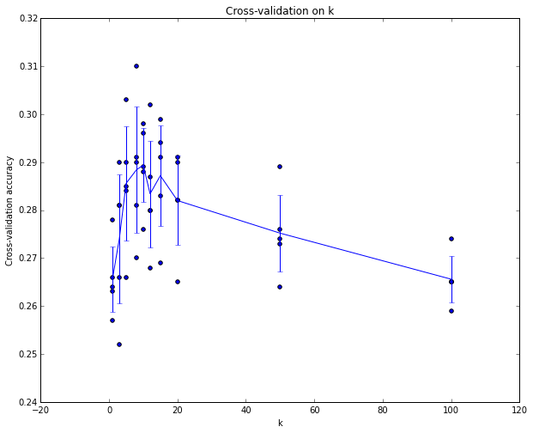

Example of a 5-fold cross-validation run for the parameter **k**. For each value of **k** we train on 4 folds and evaluate on the 5th. Hence, for each **k** we receive 5 accuracies on the validation fold (accuracy is the y-axis, each result is a point). The trend line is drawn through the average of the results for each **k** and the error bars indicate the standard deviation. Note that in this particular case, the cross-validation suggests that a value of about **k** = 7 works best on this particular dataset (corresponding to the peak in the plot). If we used more than 5 folds, we might expect to see a smoother (i.e. less noisy) curve.

**In practice**. In practice, people prefer to avoid cross-validation in favor of having a single validation split, since cross-validation can be computationally expensive. The splits people tend to use is between 50%-90% of the training data for training and rest for validation. However, this depends on multiple factors: For example if the number of hyperparameters is large you may prefer to use bigger validation splits. If the number of examples in the validation set is small (perhaps only a few hundred or so), it is safer to use cross-validation. Typical number of folds you can see in practice would be 3-fold, 5-fold or 10-fold cross-validation.

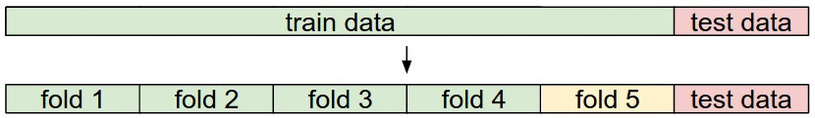

Common data splits. A training and test set is given. The training set is split into folds (for example 5 folds here). The folds 1-4 become the training set. One fold (e.g. fold 5 here in yellow) is denoted as the Validation fold and is used to tune the hyperparameters. Cross-validation goes a step further and iterates over the choice of which fold is the validation fold, separately from 1-5. This would be referred to as 5-fold cross-validation. In the very end once the model is trained and all the best hyperparameters were determined, the model is evaluated a single time on the test data (red).

**Pros and Cons of Nearest Neighbor classifier.**

It is worth considering some advantages and drawbacks of the Nearest Neighbor classifier. Clearly, one advantage is that it is very simple to implement and understand. Additionally, the classifier takes no time to train, since all that is required is to store and possibly index the training data. However, we pay that computational cost at test time, since classifying a test example requires a comparison to every single training example. This is backwards, since in practice we often care about the test time efficiency much more than the efficiency at training time. In fact, the deep neural networks we will develop later in this class shift this tradeoff to the other extreme: They are very expensive to train, but once the training is finished it is very cheap to classify a new test example. This mode of operation is much more desirable in practice.

As an aside, the computational complexity of the Nearest Neighbor classifier is an active area of research, and several **Approximate Nearest Neighbor** (ANN) algorithms and libraries exist that can accelerate the nearest neighbor lookup in a dataset (e.g. [FLANN](https://github.com/mariusmuja/flann)). These algorithms allow one to trade off the correctness of the nearest neighbor retrieval with its space/time complexity during retrieval, and usually rely on a pre-processing/indexing stage that involves building a kdtree, or running the k-means algorithm.

The Nearest Neighbor Classifier may sometimes be a good choice in some settings (especially if the data is low-dimensional), but it is rarely appropriate for use in practical image classification settings. One problem is that images are high-dimensional objects (i.e. they often contain many pixels), and distances over high-dimensional spaces can be very counter-intuitive. The image below illustrates the point that the pixel-based L2 similarities we developed above are very different from perceptual similarities:

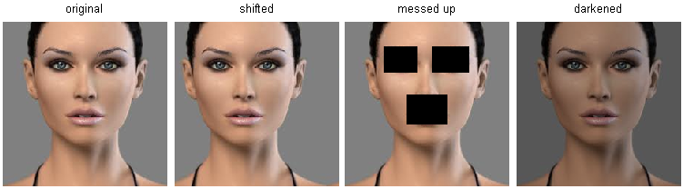

Pixel-based distances on high-dimensional data (and images especially) can be very unintuitive. An original image (left) and three other images next to it that are all equally far away from it based on L2 pixel distance. Clearly, the pixel-wise distance does not correspond at all to perceptual or semantic similarity.

Here is one more visualization to convince you that using pixel differences to compare images is inadequate. We can use a visualization technique called [t-SNE](https://lvdmaaten.github.io/tsne/) to take the CIFAR-10 images and embed them in two dimensions so that their (local) pairwise distances are best preserved. In this visualization, images that are shown nearby are considered to be very near according to the L2 pixelwise distance we developed above:

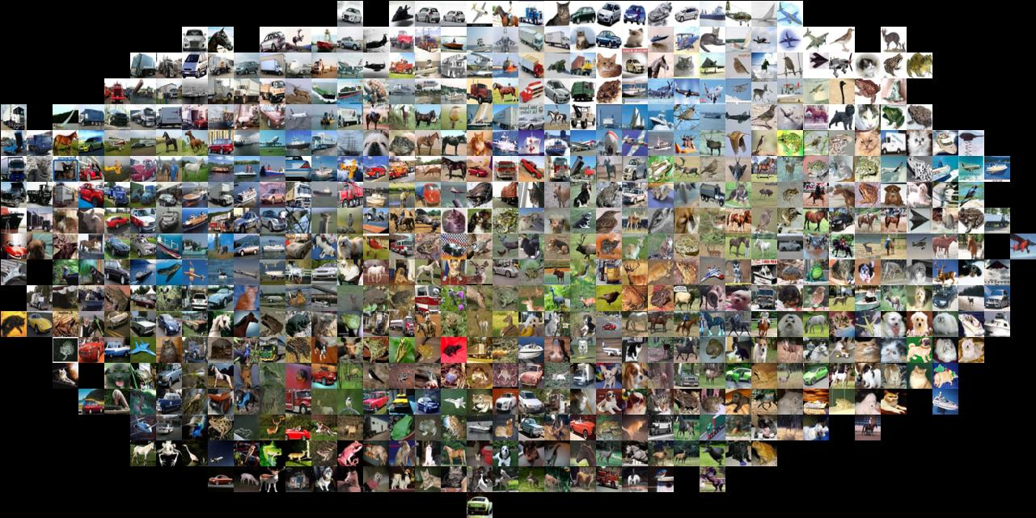

CIFAR-10 images embedded in two dimensions with t-SNE. Images that are nearby on this image are considered to be close based on the L2 pixel distance. Notice the strong effect of background rather than semantic class differences. Click [here](https://cs231n.github.io/assets/pixels_embed_cifar10_big.jpg) for a bigger version of this visualization.

In particular, note that images that are nearby each other are much more a function of the general color distribution of the images, or the type of background rather than their semantic identity. For example, a dog can be seen very near a frog since both happen to be on white background. Ideally we would like images of all of the 10 classes to form their own clusters, so that images of the same class are nearby to each other regardless of irrelevant characteristics and variations (such as the background). However, to get this property we will have to go beyond raw pixels.

## Summary

In summary:

* We introduced the problem of **Image Classification**, in which we are given a set of images that are all labeled with a single category. We are then asked to predict these categories for a novel set of test images and measure the accuracy of the predictions.
* We introduced a simple classifier called the **Nearest Neighbor classifier**. We saw that there are multiple hyper-parameters (such as value of k, or the type of distance used to compare examples) that are associated with this classifier and that there was no obvious way of choosing them.
* We saw that the correct way to set these hyperparameters is to split your training data into two: a training set and a fake test set, which we call **validation set**. We try different hyperparameter values and keep the values that lead to the best performance on the validation set.
* If the lack of training data is a concern, we discussed a procedure called **cross-validation**, which can help reduce noise in estimating which hyperparameters work best.
* Once the best hyperparameters are found, we fix them and perform a single **evaluation** on the actual test set.
* We saw that Nearest Neighbor can get us about 40% accuracy on CIFAR-10. It is simple to implement but requires us to store the entire training set and it is expensive to evaluate on a test image.
* Finally, we saw that the use of L1 or L2 distances on raw pixel values is not adequate since the distances correlate more strongly with backgrounds and color distributions of images than with their semantic content.

In next lectures we will embark on addressing these challenges and eventually arrive at solutions that give 90% accuracies, allow us to completely discard the training set once learning is complete, and they will allow us to evaluate a test image in less than a millisecond.

### Summary: Applying kNN in practice

If you wish to apply kNN in practice (hopefully not on images, or perhaps as only a baseline) proceed as follows:

1. Preprocess your data: Normalize the features in your data (e.g. one pixel in images) to have zero mean and unit variance. We will cover this in more detail in later sections, and chose not to cover data normalization in this section because pixels in images are usually homogeneous and do not exhibit widely different distributions, alleviating the need for data normalization.
2. If your data is very high-dimensional, consider using a dimensionality reduction technique such as PCA ([wiki ref](https://en.wikipedia.org/wiki/Principal_component_analysis), [CS229ref](http://cs229.stanford.edu/notes/cs229-notes10.pdf), [blog ref](https://web.archive.org/web/20150503165118/http:/www.bigdataexaminer.com:80/understanding-dimensionality-reduction-principal-component-analysis-and-singular-value-decomposition/)), NCA ([wiki ref](https://en.wikipedia.org/wiki/Neighbourhood_components_analysis), [blog ref](https://kevinzakka.github.io/2020/02/10/nca/)), or even [Random Projections](https://scikit-learn.org/stable/modules/random_projection.html).
3. Split your training data randomly into train/val splits. As a rule of thumb, between 70-90% of your data usually goes to the train split. This setting depends on how many hyperparameters you have and how much of an influence you expect them to have. If there are many hyperparameters to estimate, you should err on the side of having larger validation set to estimate them effectively. If you are concerned about the size of your validation data, it is best to split the training data into folds and perform cross-validation. If you can afford the computational budget it is always safer to go with cross-validation (the more folds the better, but more expensive).
4. Train and evaluate the kNN classifier on the validation data (for all folds, if doing cross-validation) for many choices of **k** (e.g. the more the better) and across different distance types (L1 and L2 are good candidates)
5. If your kNN classifier is running too long, consider using an Approximate Nearest Neighbor library (e.g. [FLANN](https://github.com/mariusmuja/flann)) to accelerate the retrieval (at cost of some accuracy).
6. Take note of the hyperparameters that gave the best results. There is a question of whether you should use the full training set with the best hyperparameters, since the optimal hyperparameters might change if you were to fold the validation data into your training set (since the size of the data would be larger). In practice it is cleaner to not use the validation data in the final classifier and consider it to be *burned* on estimating the hyperparameters. Evaluate the best model on the test set. Report the test set accuracy and declare the result to be the performance of the kNN classifier on your data.

## Further Reading

Here are some (optional) links you may find interesting for further reading:

* [A Few Useful Things to Know about Machine Learning](https://homes.cs.washington.edu/~pedrod/papers/cacm12.pdf), where especially section 6 is related but the whole paper is a warmly recommended reading.
* [Recognizing and Learning Object Categories](https://people.csail.mit.edu/torralba/shortCourseRLOC/index.html), a short course of object categorization at ICCV 2005.

# Python Numpy Tutorial (with Jupyter and Colab)

Weblink: <https://cs231n.github.io/python-numpy-tutorial/>

# [Linear classification: Support Vector Machine, Softmax](https://cs231n.github.io/linear-classify/)

parameteric approach, bias trick, hinge loss, cross-entropy loss, L2 regularization, web demo

# [Optimization: Stochastic Gradient Descent](https://cs231n.github.io/optimization-1/)

optimization landscapes, local search, learning rate, analytic/numerical gradient

# [Backpropagation, Intuitions](https://cs231n.github.io/optimization-2/)

chain rule interpretation, real-valued circuits, patterns in gradient flow

# [Convolutional Networks](http://cs231n.github.io/convolutional-networks)

# [Neural Networks Part 1: Setting up the Architecture](https://cs231n.github.io/neural-networks-1/)

model of a biological neuron, activation functions, neural net architecture, representational power

# [Neural Networks Part 2: Setting up the Data and the Loss](https://cs231n.github.io/neural-networks-2/)

preprocessing, weight initialization, batch normalization, regularization (L2/dropout), loss functions

# [Neural Networks Part 3: Learning and Evaluation](https://cs231n.github.io/neural-networks-3/)

gradient checks, sanity checks, babysitting the learning process, momentum (+nesterov), second-order methods, Adagrad/RMSprop, hyperparameter optimization, model ensembles

# [Putting it together: Minimal Neural Network Case Study](https://cs231n.github.io/neural-networks-case-study/)

minimal 2D toy data example

Module 2: Convolutional Neural Networks

# [Convolutional Neural Networks: Architectures, Convolution / Pooling Layers](https://cs231n.github.io/convolutional-networks/)

layers, spatial arrangement, layer patterns, layer sizing patterns, AlexNet/ZFNet/VGGNet case studies, computational considerations

# [Understanding and Visualizing Convolutional Neural Networks](https://cs231n.github.io/understanding-cnn/)

tSNE embeddings, deconvnets, data gradients, fooling ConvNets, human comparisons

# [Transfer Learning and Fine-tuning Convolutional Neural Networks](https://cs231n.github.io/transfer-learning/)