

**本科生毕业论文（设计）**

题目：Design and Implementation of Mobile Phone Album Management System

**学 院：_计算机科学与技术学院、软件学院**

**专 业： 软件工程（中外合作办学）**

**班 级： 2019软件工程（中外合作办学）03**

**学 号： 201906150319**

**学生姓名： 卫晨超**

**指导老师： 李小薪**

**提交日期： 2023年6月**

# 摘 要

近年来，随着智能手机的普及，人们已习惯于用手机拍摄照片和录制视频来记录和管理自己的学习、工作和生活。为了对照片和视频进行有效管理、备份和检索，开发了一款手机相册管理系统，该系统具有如下功能：

（1）相册无线备份功能。系统基于B/S架构，使用Web服务来连接手机端与电脑端，达成端与端之间的数据同步。前端使用JSP开发，为用户上传手机相册到电脑端提供便捷的用户图形界面；后端使用Java语言来编写，并使用MySQL来存储用户相册相关信息。

（2）相册备注功能。提供了用户图形界面，便于用户在Web端游览存储在系统中的相片与相关信息，并添加备注信息。用户可以对相片进行添加与修改备注操作，修改后的备注信息将保存在MySQL数据库中，使用数据库语句即可实现对备注的添加与修改。

（3）记录相册的全息信息。相册的全息信息主要包括：相片/视频的序列、名称、相片/视频本身的数据、拍摄时间、拍摄地点与及相关的备注信息等。使用Metadata-extractor与百度地图API来获得相片的拍摄地点与拍摄时间信息并将其保存在数据库中；。除了可以通过相册备注信息对相册进行检索，还能够根据拍摄时间、拍摄地点等信息对相册进行检索。

（4）并根据相册的全信息对相册进行检索。本系统除了可以通过相册备注信息对相册进行检索外，还能够根据拍摄时间、拍摄地点等信息对相册进行检索。使用GQL语句对相片进行检索和查询，当用户输入关键词时调用GQL语句来判断相片相册的拍摄时间、拍摄地点与备注信息等是否包含这个相关的关键词，如果包含，则将符合要求对应的相片或视频筛选出来并展示给用户。

本系统的核心功能在于实现用户的手机端与电脑端的相册数据同步，能够让用户更为方便地保存拍摄的相片与相关信息。系统还实现了用户获取相片拍摄时间地点信息、对相片进行备注操作、检索与删除相片功能。这些功能的实现能够在一定程度上方便便于用户管理数量日益增多的手机相片相册信息，具有具有较强一定的使用实用价值。

**关键词：** 手机相册，B/S结构，数据同步，相册备注，相册检索

**DESIGN AND IMPLEMENTATION OF MOBILE PHONE ALBUM MANAGEMENT SYSTEM**

# ABSTRACT

In recent years, with the popularity of smart phones, people have been accustomed to using mobile phones to take photos and record videos to record and manage their study, work and life. In order to effectively manage, backup and retrieve photos and videos, a mobile phone album management system is developed, which has the following functions:

1. Album wireless backup function. Based on B/S architecture, the system uses Web services to connect the mobile phone and the computer to achieve data synchronization between the end and end. The front end uses JSP development to provide a convenient user graphical interface for users to upload mobile phone albums to the computer side; The back end is written in Java language and uses MySQL to store information about user albums.

(2) Album remarks function. Provides a user graphical interface, which is convenient for users to visit the photos and related information stored in the system on the Web side, and add remarks information. Users can add and modify remarks to photos. The modified remarks are saved in the MySQL database and can be added and modified using database statements.

(3) Record the holographic information of the album. The holographic information of the album mainly includes: photo/video sequence, name, data of the photo/video itself, shooting time, shooting location and related remarks information. Use Metadata-extractor and Baidu map API to obtain the location and time of photo shooting information and save it in the database. In addition to retrieving albums through album remarks, albums can also be retrieved according to shooting time, shooting location and other information.

(4) The album is retrieved according to the full information of the album. This system can not only retrieve the album through the remarks information of the album, but also retrieve the album according to the shooting time, shooting location and other information. GQL statements are used to retrieve and query photos. When users enter keywords, GQL statements are called to determine whether the photo album shooting time, shooting location and remarks information contain this related keyword. If yes, the photos or videos that meet the requirements are screened out and displayed to users.

The core function of this system is to realize the synchronization of the photo album data between the user's mobile phone and the computer, which can make the user more convenient to save the photos and related information. The system also implements the functions of obtaining the information of the time and place when the photo was taken, making remarks to the photo, retrieving and deleting the photo. The realization of these functions can be convenient for users to manage the increasing number of mobile phone photo album information to a certain extent, and has a strong practical value.

**Keywords**: Mobile album, B/S structure, Data synchronization, Album remarks, Album retrieval

**Content**

摘 要 I

ABSTRACT II

CHAPTER 1: INTRODUCTION 1

1.1 Background 1

1.2 The Research Purpose and Significance of the Project 2

1.3 Research Status at Home and Abroad 3

1.3.1 Visual Tour of Photos with Notes 4

1.3.2 The Development of Smartphone Photo Album Software 4

1.3.3 Sync and Back up Photos 5

1.3.4 Categorize Photos According to Specific Information 5

1.3.5 Photo Retrieval Techniques 6

1.4 About System 6

1.5 The Organization of This Article 7

1.6 Chapter Summary 7

CHAPTER 2: RELATED WORK 8

2.1 B/S Architecture 8

2.2 Android Technology 9

2.3 Java Web Technology 10

2.4 Servlet Technology 11

2.5 JSP Technology 12

2.6 MySQL Database 13

2.7 Chapter Summary 14

CHAPTER 3: SYSTEM ANALYSIS 15

3.1 Demand Analysis 15

3.1.1 Functional Requirement 15

3.1.2 User Demand Analysis 15

3.2 System Feasibility Analysis 15

3.2.1 Technical Feasibility Analysis 15

3.2.2 Economic Feasibility Analysis 16

3.2.3 Operational Feasibility Analysis 17

3.2.4 Safety Feasibility Analysis 17

3.3 Functional Requirements Analysis 18

3.4 Database Analysis 19

3.5 Chapter Summary 19

CHAPTER 4: SYSTEM DESIGN 20

4.1 System Function Design 20

4.1.1 System President Design 20

4.1.2 Main Interface Module 20

4.1.3 Upload Photo Module 21

4.1.4 Modify Remarks Module 22

4.1.5 Delete Photo Module 23

4.1.6 Search Module 23

4.2 System Database Design 24

4.2.1 Database E-R Diagram 24

4.2.2 Database Field 25

4.3 Chapter Summary 25

CHAPTER 5: SYSTEM IMPLEMENTATION 27

5.1 Main Interface Implementation 27

5.2 Upload Function Implementation 28

5.3 Modified Remarks Function Implemented 30

5.4 Deletion Function Implementation 31

5.5 Retrieval Function Realization 32

5.6 Chapter Summary 32

CHAPTER 6: SYSTEM TEST 33

6.1 Test Method 33

6.2 Test Case 34

6.3 Chapter Summary 34

CHAPTER 7: CONCLUSION AND FEATURE WORK 36

7.1 Conclusion 36

7.2 Feature Work 36

Reference 38

Acknowledgment 40

# 

# CHAPTER 1: INTRODUCTION

## Background

As an open mobile phone development platform[1], Android has been highly valued by the industry since its official release in 2009. The Open Handset Alliance brings together a number of major players and manufacturers to break the handset industry monopoly, and it also brings about more hardware products. Android platform is for programmers, it provides developers with a large number of code resources, greatly promotes the development of Android platform, and brings users more convenient experience[2]. Worldwide, everyone has a mobile phone, and the proportion of smartphones has increased dramatically in recent years. According to the latest data from the Research Institute of the Ministry of Industry and Information Technology, Android is the most popular smartphone operating system at present, accounting for 86.4% of the national market share in 2012[3].

Taking photos of your life through an Android smartphone is the most important photo resource on the Internet. Effective image management can bring users a better application experience. With the rapid development of mobile Internet technology, intelligent photo album software based on image classification, cloud storage and other technologies came into being. With its powerful function and quality service, it provides a good picture management service for many smart phone users. However, these smartphone photo apps are still not perfect. As users continue to take more photos and enjoy these smartphone photo album software services, more demand is generated. People increasingly want to record and record photos on their mobile phones, and easily categorize and retrieve photos based on where and when they were taken. And it can realize real-time synchronization between smart phones and computers.

With the rapid development of smart phones, various applications based on smart phones have also achieved fruitful results. Back in 2012, software market research firm DistimoInc reported[4] that there were more than 400,000 apps available in the Android market. In China, according to the latest "2012 China Mobile App Market Quarterly Monitoring Report" released by iMedia Research, pictures and pictures occupy the first and second place respectively in the category of Android mobile app downloads in China, accounting for 12.2% of the first place. At the same time, it also shows that under the Android system, the development of video, audio, video and other applications is a very valuable direction [Guo Jing 2010 analysis of China's mobile Internet application market[5]. In the past decade, there are more and more pictures and pictures on the Internet. Tencent announced in 2012 that Qzone would have 150 billion images by August this year; Microsoft said last October that the cloud on its SkyDrive stored 11 billion images; and Facebook announced this month that it had more than 220 billion images and was growing by 3 million a day[6]. The growth of Android applications and the growth of the total amount of pictures on the Internet will also provide a huge space for the picture software market, which remains the main sales channel of China's mobile application market in the first half of 2013, accounting for 87.2 percent of the market share. At present, the most popular Android app distribution and download platforms in China include Android Mall, Anzhi, Baidu, Wandao, app, etc. Taking Baidu App as an example, according to its website statistics, more than 350 apps similar to mobile photo albums have been downloaded 110 million times[7].

Under the Android system, the development of mobile photo album application has a very good prospect. Mobile photography has only really caught the public's attention since Sharp's J-PHONE introduced its first built-in camera, the J-SH04, in late September 2000. Today, almost every Android phone has a photo and photo management feature. People gradually take photos and view photos as the basic functions of smart phones[8]. Android users account for more than 70 percent of China's IT netizens, and more than 90 percent of them use mobile phones to take photos in their daily lives, according to the 2013 Survey Report of Chinese IT Netizens. The biggest reasons are the ease of taking photos, the timeliness of sharing and the ease of operation. Therefore, for the Android system, how to better provide users with image management services has become an urgent problem to be solved[9].

## The Research Purpose and Significance of the Project

Today, smartphones are more widely used and their photographic capabilities are becoming more powerful, even surpassing those of digital and professional cameras. Image quality in smartphones has improved a lot in recent years, and terms such as IOS, white balance, scene mode, aperture and other formerly professional cameras are common on mobile phones. As a result, for many photography enthusiasts, the most popular shooting tool is no longer the SLR. Smartphones are light enough to fit in a pocket. It's easy to use, you don't need to adjust too many parameters, and you can get good samples at the click of the shutter. It's easy to share and easy to post-process. There are many applications that make it easy to post-process digital photos[10].

According to the survey result of social network application of China Internet Network Information Center (CNNIC)[11], 52.7% of mobile social network users upload pictures and photos. At the same time, the number of photos sent to social networks from mobile phones continues to grow, and the need for photo sharing has become widely recognized. Meanwhile, 33.4 percent of netizens post their GPS locations to the Internet, and more than 60 percent of respondents use the Internet to store photos or plan to back up some photos online, the study showed. The development of a mobile phone album[12] that integrates safe storage, fast sharing and GPS information will have great market prospects.

However, taking pictures is a simple matter, but dealing with so many is not. According to statistics, the average number of digital photos stored in each user's smartphone exceeds 1000, and with the development of The Times and the improvement of mobile photography technology, this number is still growing[13]. From thousands of photos, finding those beautiful journeys, those memories became a big problem. Therefore, it is of great significance to develop a set of photo management system for customers to carry out intelligent protection of photo information in intelligent devices[14].

The research purpose and significance of this topic is to develop a smart phone album management software based on Android, so as to improve users' experience of photo management application. Through the album management software, users can find exactly the photos they need and comment on their photos anytime and anywhere. At the same time, users can synchronize the photos saved on their smart phones to their designated computer or other servers in real time, to ensure that the information of the photos taken is not lost, but also can classify the photos according to the time and place of the photos, so that users can better access their favorite photos.

## Research Status at Home and Abroad

After reading and learning relevant materials and books, I also conducted in-depth use and research on several well-known mobile photo processing and album sharing software at home and abroad, and learned related Android technology. In the end, I came to the following conclusions:

### Visual Tour of Photos with Notes

Digital images and video clips are becoming increasingly popular, thanks to a growing number of smartphone devices capable of capturing them. Digital images on the Internet are also growing. With the increase in digital images, user-friendly tools are needed to navigate the vast amount of digital material with photos. Krischnamachari(1999) proposed a cluster-based browsing algorithm. The hierarchical clustering algorithm is used to automatically cluster the photos taken by users. Then users can browse the photos taken by themselves by navigating the tree-like structure generated by clustering[15]. In 2017, Jiao Minghui developed a method to conveniently add annotation information related to object photos[16]. The mobile terminal determines knock information according to the knock command. If the knock message meets the predetermined condition, the mobile terminal receives the first comment message as the user's photo editing message of the object; The mobile terminal displays the first note information on the target photo.

### The Development of Smartphone Photo Album Software

Based on the "cloud map" platform on the Internet and the company's existing core technology and architecture, Wang Huaxu (2014) designed and implemented an Android-based smartphone photo album system by using Android development, face recognition, image classification and other technologies[17]. On this basis, this paper also completed the design and development of intelligent photo album system based on Android platform. The system provides Android phone users with baby growth records, one-click arrangement of life and travel albums, network synchronization backup, photo sharing to social networks and other services. It is a comprehensive Android photo management application that integrates baby face detection, geographic information classification, cloud storage, rapid sharing and other functions. The main research contents of this paper are as follows:

(1) Combining AdaBoost face detection[18], C1-S feature extraction and support vector machine classification[19], the infant face detection research is carried out to achieve accurate extraction of infant faces in complex image sets.

(2) Study the "grid" type scalable space segmentation method, divide the photos in life, tourism and other scenes according to a specific proportion, and put the photos in adjacent scenes into the same photo group, so that the number of photos in the photo group is relatively the same. At present, the various modules of the smartphone album system have realized all the functions and have been used in the Android store. Users can use the photo management function provided by the system on the Android client. The first user survey confirms that this is a useful Android software.

### Sync and Back up Photos

Pei Lei (2019) applies for the disclosure of a data entry and photo synchronous acquisition method and system, wherein the data input end obtains the first control item of the image input end, and communicates with the photo acquisition terminal according to the second control item of the data input terminal and the first control item of the person of the picture acquisition terminal. When the data entry terminal inputs the first data, the first control sends the shooting command to the image collection terminal; The data input end uploads the input data to the server, and the server associates the first data with the first image on the image collecting end based on the unique identifier. When the data entry terminal upload the input data to the server, it only needs to send the input data and the unique identifier corresponding to the input data to the photo acquisition terminal. The photo acquisition end only needs to upload the collected photos with a unique identifier to the server, and the server automatically constructs the connection between the input data and the collected photos according to the unique identifier, thus improving the accuracy of the association between the input data and the corresponding collected photos[20].

### Categorize Photos According to Specific Information

At present, due to the increasing personalized requirements of mobile photo album users, the traditional photo album software can not fully meet the personalized requirements of users. In the smartphone album, how to properly classify photos is an important job. The purpose of image classification is to make users more effective search and visual browsing, so as to provide convenience for users to add, delete and share pictures. According to the actual situation, Android phones can be divided into six types: according to the storage address of the film, shooting time, browsing times, people classification, geographical location classification.

In terms of classifying the photo set according to the location and time of shooting for users' retrieval, currently, researchers have applied the photo classification technology to the mobile phone photo album to classify the pictures according to the location and time of shooting. But so far, There is no equivalent app for Android Market mobile albums[21]. In the understanding of relevant literature, Nguyen (2008) et al. proposed to classify pictures based on visual similarity[22], and L Cao (2009) et al. also proposed to classify and calibrate mobile phone photo sets in context by combining GPS geographic information and scene classification technology[23]. And a better classification effect was obtained. However, they also found that such methods have high requirements on smart phones, and the processing on mobile terminals consumes huge manpower and material resources, especially on large picture collections, and the time consumed is beyond the range of ordinary users. In addition, the rationality, practicability and accuracy of this classification method are also its limitations in practice.

### Photo Retrieval Techniques

With the wide use of digital cameras and the increasing number of photos, it is necessary to manage and query photos effectively. In this context, neither keyword-based search nor content-based search can fully meet the requirements of users. Therefore, semantic based search has become a research hotspot. Liang Tingting (2013) made an in-depth analysis of the ontology-based semantic search of images, studied the semantic search of images, applied it to the semantic search of images, and formed three practical and efficient image search and management tools. After testing, this system can better realize the semantic query of users[24].

In short, with the increasing demand of users for cameras and image processing, there is no dominant situation at present, and it can be done technically, and the requirements for developers are moderate. Therefore, this project is to develop a more comprehensive and more in line with users' needs of electronic photo album software by combining the actual needs of users and different development technologies.

## About System

Back-end Language: Java

Back-end Framework: MyBatis

Front-end Framework: jsp

Database: MySQL

IDE: Idea, Android Studio

GPU: GeForce GTX 1060Ti

## The Organization of This Article

Chapter 1: Mainly introduces the background and research significance of this system, as well as various technologies and unsolved problems used in the research status at home and abroad. Finally, the development environment of this system is introduced.

Chapter 2: Mainly introduces the research status and related technologies of the system, and summarizes other methods. Finally, some of the technologies used in the system are listed in order to give the reader a better understanding of the project.

Chapter 3: The requirements of users, the feasibility of the system and the database used in the detailed analysis and summary, in order to carry out the next work.

Chapter 4: Mainly introduces how to design the system.

Chapter 5: Mainly introduces how to achieve the function required by this system.

Chapter 6: Mainly introduces the test of the system, to ensure that the system can run normally without errors.

Chapter 7: Summary of work done and plan for future work.

## Chapter Summary

This chapter mainly introduces the background, purpose and significance of the project, also introduces the current research status and achievements of mobile album management system at home and abroad, analyzes the existing mobile album management system on the market and the relevant use and research situation, and has a preliminary and fuller understanding of this kind of system, which is conducive to the design and implementation of this mobile album management system project. In addition, this chapter also introduces the development environment of this system and the organizational structure of this article.

# CHAPTER 2: RELATED WORK

## 2.1 B/S Architecture

In this system, the use of B/S architecture for development, the user's Android phone as the client, the user's Windows11 computer as the server, using the web way to connect the client and server, to achieve the purpose of data synchronization. B/S architecture refers to browser/server architecture, also known as Web Architecture. It divides the application into two parts: client side and server side. In the B/S architecture, the client is the browser, which usually uses HTML, CSS, JavaScript and other technologies to provide interactive services to users through the web. The server side handles various business logic and data operations, usually using low-level programming languages such as Java, C++, Python, etc[25].

The advantages of the B/S architecture include: Easy maintenance: Since the business logic and data processing of the application are done on the server side, only the server-side code needs to be maintained, and data can be backed up and restored through the server side. Cross-platform: Applications developed using the B/S architecture can run on any browser-enabled computer, avoiding the problem of developing for different platforms. High security: Because the core logic of the application is on the server side, the client cannot directly access the database and application code, greatly reducing the possibility of security problems. Easy to scale: Because the business logic of the application is on the server side, the processing power of the system can be increased by increasing the number of servers or through distributed deployment. Easy upgrade: When an application needs to be upgraded, you only need to complete the corresponding upgrade on the server. No operation is required on the client. Low resource utilization: The browser displays only the page and processes user input, reducing the usage of system resources and improving the system response speed. Easy deployment: Applications developed using the B/S architecture can be easily deployed to remote servers through cloud services or virtualization technologies for easy management and maintenance[26].

As shown in Figure 2-1, the B/S architecture is divided into three layers:

The first presentation layer: it mainly completes the interaction between the user and the background and the output of the final query results.

The second logical layer: The server is used to complete the application logic function of the client.

The third layer of data layer: mainly after receiving client requests, independent operations.

B/S architecture has become one of the mainstream architecture modes of modern Internet applications, widely used in e-commerce, social networking, online education and other fields.

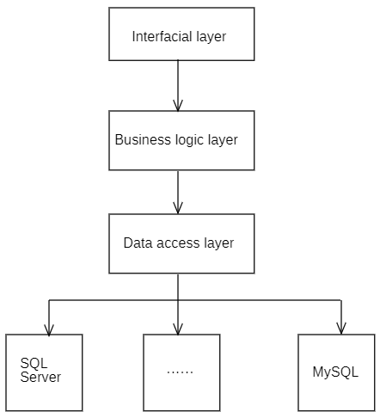

Figure 2-1: B/S Three-layer Architecture

## 2.2 Android Technology

As the client of this system, the user's Android mobile phone uses Android technology for research and development[27].

Android technology is a mobile operating system technology, it is developed by Google company. Android technology is mainly used in smart devices such as smartphones and tablets. Android technology is based on the Linux kernel and supports more hardware devices and resource management. Android technology applications are mainly written in Java language. Android technology provides a rich set of apis, frameworks, and tools that allow developers to develop high-quality Android applications quickly and easily. The most important components are activities, services, broadcast receivers, content providers, and so on. Android technology also includes Internet related components, such as WebView, HTTP communication, and multimedia related components, such as Camera, MediaPlayer, OpenGL ES, etc. In addition, Android technology also provides support for user interface design, storage and database, security, and more. In short, Android technology is a very powerful mobile operating system technology, it provides developers with a wealth of tools and components, so that developers can more convenient, efficient development of high quality Android applications.

## 2.3 Java Web Technology

In this project, the mobile album management system uses java web technology to develop the server program of this system on Windows11. Through this program, the user's Android phone is the client, and the computer is the server to realize the data synchronization and backup of the album information on the Android phone. In addition, as a server-side pc program can also display the user has saved the photo, and the user can know all the relevant information data and change data of the photo.

Java Web is a method of using Java technology to develop Web applications[28]. It is a technology based on the Java EE (Enterprise Edition) platform that can be used to develop enterprise applications and large Web applications. The most commonly used technologies in the Java Web include servlets, JSP, JavaBean, EJB, JDBC, and so on. Servlet is one of the core technologies of Java Web. It is a Java class that runs on a Web server and can process client requests and return responses. JSP (JavaServer Pages) is a dynamic web technology that allows Java code to be embedded in HTML pages and compiled to run as servlets. Java Web also provides rich apis and tools to simplify Web application development and deployment, such as JNDI, JMS, JAAS, and more. In addition, Java Web supports a variety of Web servers, such as Tomcat, Jetty, GlassFish, and more. Java Web is a widely used Web application development framework, which provides safe, reliable and efficient enterprise solutions and is widely used in the development of various Web applications[29].

In addition to the core technologies and tools mentioned above, Java Web has several other features and advantages, including:

(1) Platform independence :Java is a cross-platform programming language. Java Web applications can run on different operating systems and hardware platforms.

(2) Rich development tool support :Java Web applications can be developed using a variety of Java IDE(integrated development environment) development tools, such as Eclipse, IntelliJ IDEA, etc. These development tools provide many convenient features, such as code completion, debuggers, testing tools, and more.

(3) Strong security :Java Web provides a variety of security mechanisms, such as SSL/TLS based encrypted transmission, digital certificate authentication, permission control, etc., to ensure the security of Web applications.

(4) Strong scalability :Java Web applications can extend their capabilities by adding new components and plug-ins, such as new servlets, JSP tag libraries, filters, listeners, and so on.

(5) Efficient performance :Java Web applications can take advantage of JVM (Java Virtual Machine) optimization to improve performance, and can also take advantage of configuration tuning and cache optimization to further improve performance.

To sum up, Java Web technology is a mature, stable and reliable enterprise application development solution, it is widely used in all kinds of Web application development, has rich characteristics and advantages.

## 2.4 Servlet Technology

The earliest support for Servlet technology is JavaSoft's Java Web Server. Since then, several other Java-based Web servers have begun to support the standard Servlet API. The main function of Servlet is to interactively browse and modify data, and generate dynamic Web content[30]. The process is:

(1) The client sends a request to the server;

(2) The server sends request information to the Servlet;

(3) Servlet generates the response content and passes it to the server. The response content is usually dynamically generated based on the client's request;

(4) The server returns the response to the client.

Servlets look like regular Java programs. A Servlet imports a specific package that belongs to the Java Servlet API. Because they are object bytecode and can be loaded dynamically from the network, servlets can be said to act like applets to client to server, but because servlets run in servers, they do not require a graphical user interface. For this reason, servlets are also called FacelessObject.

A Servlet is a class in the Java programming language that extends the performance of a server hosting applications that can be accessed through a request-response programming model. While servlets can respond to any type of request, they are typically only used for applications that extend Web servers[31].

Figure 2-2 shows a typical Servlet cycle.

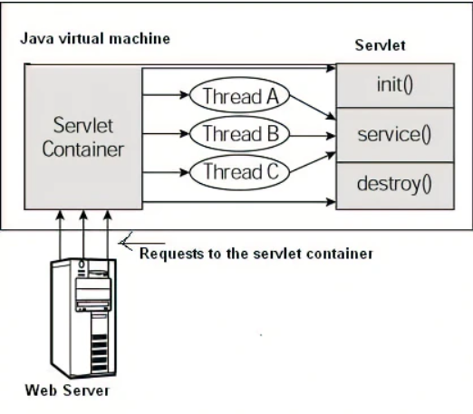

Figure 2-2: Servlet Cycle

## 2.5 JSP Technology

JSP (Java Server Pages) is a Java technology used to create dynamic Web pages[32]. It allows developers to embed Java code in HTML pages to generate dynamic content. Unlike static pages, JSPS can be processed on the server side, taking advantage of the power and ease of maintenance of the Java language to enable richer, more complex Web applications. JSPS can often be used in conjunction with servlets for more flexible Web application development.

JSP files typically contain HTML tags and Java code. At run time, the server compiles the JSPS into servlets and converts them into executable Java code. By inserting Java code into a JSP page, developers can output dynamic data on the page, retrieve data from a database, execute business logic, and more. In addition to Java code, JSP also supports the use of Tag libraries to extend its functionality. Tag library is a collection of user-defined tags, which can be easily reused and managed to further improve development efficiency[33].

In addition, in order to further improve the efficiency and maintainability of JSP development, Expression Language (EL) is introduced into the JSP 2.0 specification. EL expressions allow developers to access application data and objects in JSP pages using a simple, easy-to-read expression language. In this way, developers can avoid over-embedding Java code and HTML tags, making JSP pages easier to maintain and debug. In addition, JSP supports the use of JSTL (JSP Standard tag Library) tag libraries. JSTL is a standard set of custom tags used to perform common Web tasks such as traversing collections, formatting dates, handling conditional logic, and so on. By using the JSTL tag library, developers can significantly reduce the amount of duplicate code they need to write and improve the usability and maintainability of their code.

In short, JSP technology is an important part of Java Web application development, can easily generate dynamic Web pages, and provide rich functions and extension mechanism.

## 2.6 MySQL Database

The server side of the system uses MySQL to store all the information of the album on the client side, namely the smart phone used by the user, including the data of the photo, the user's comments on the photo, the location and time of the photo, etc.

MySQL is a relational database management system (RDBMS). It is one of the most popular open source databases in the world. MySQL uses standard SQL language to manage data and supports concurrent access by multiple users, multiple threads and multiple clients[34]. In MySQL, data is stored in tables, each consisting of several fields. MySQL supports multiple data types, including integers, floating-point numbers, dates and times, and more. Developers can create, modify, and query data in tables through SQL statements.

MySQL also provides some advanced features, such as transaction processing, stored procedures, triggers, views, etc[35]. Transaction processing can ensure data integrity and consistency, avoid data corruption and error. Stored procedures allow developers to encapsulate commonly used code snippets into functions for easy reuse and maintenance. Triggers allow developers to automatically insert, update, or delete data when a specific event occurs. Views allow developers to view portions of data according to specific criteria without the need for complex SQL statements. MySQL is also highly scalable and high-performance, running on a variety of operating systems and hardware architectures. At the same time, MySQL's open source code and large community support make it easy for developers to obtain documentation and technical support, which speeds up application development and deployment.

MySQL, as a powerful, flexible, scalable, high-performance, easy-to-use relational database management system, is widely used in Web applications, enterprise software and other data-intensive applications.

## 2.7 Chapter Summary

This chapter mainly introduces the various technologies and architectures needed in the development process of this project. Using relevant technologies of Android, develop a simple Android phone photo album application on the user's Android phone as the client of this system, and use Servlet, JSP, MySQL and other technologies to develop Windows programs as the server of this system. Then connect the two ends of the system through the web. To achieve the Android phone and Windows computer data synchronization purpose.

# CHAPTER 3: SYSTEM ANALYSIS

## 3.1 Demand Analysis

### 3.1.1 Functional Requirement

This mobile phone album management system mainly realizes the synchronization of the photo information data on the user's Android phone to the user's Windows computer through web services, and also saves the photo information data to the local folder on the computer. In addition to this main function, the system can also record the user's remarks on the photos taken and the data of the shooting time and location of the photos, which will be displayed to the user together with the photos themselves in the Android phone terminal and Windows PC terminal, and provide photo search function.

### 3.1.2 User Demand Analysis

(1) Users can make remarks on the photos taken by themselves, so as to record the relevant information of the photos taken by users.

(2) Users can use specific keywords to search for the photos they want.

(3) Users can wirelessly back up photos and videos and sync photos from their phone to a PC or server of their choice.

(4) The user can know when and where the photo was taken, so he can recall the moment when the photo was taken.

## 3.2 System Feasibility Analysis

### 3.2.1 Technical Feasibility Analysis

In terms of data storage, the mobile phone album management system needs to store and manage a large number of photos. These photos may involve different formats and resolutions that need to be compressed and stored efficiently. At the same time, in order to ensure the security and reliability of data, the system also needs to implement the data backup and recovery mechanism. In terms of image processing, the mobile phone album management system needs to achieve basic image processing functions, such as scaling, rotation, cropping, filter, etc. These features need to be implemented using computer vision technology and need to consider the limitations of the phone's hardware. In terms of user interface, the user interface of the mobile album management system needs to be concise and easy to operate. Therefore, the system needs to improve user experience through reasonable interface design and interaction, including the use of dropdown menus, wheel cast graphs, tabs and other ways to increase user interaction. Mobile terminal development needs to take into account the differences between different devices, such as screen size, operating system version, etc. Therefore, the development process requires compliance with relevant standards and specifications, and the use of responsive layouts to accommodate different screen sizes.

The technical feasibility of mobile photo album management system is very high. However, in the design and development process, attention should be paid to data security, user experience, mobile terminal compatibility and other issues. At the same time, it is necessary to combine the actual demand and carry out the gradually iterative development mode according to different functional modules.

### 3.2.2 Economic Feasibility Analysis

In terms of cost analysis, the cost of mobile album management system mainly includes development, maintenance, promotion and so on. Among them, the development cost involves the salary of technical personnel and the input of related equipment; Maintenance costs include server rental, data backup, etc. Promotion costs include advertising expenses, social media publicity, etc. According to the market survey, the price of this kind of application in the market usually ranges from a few yuan to more than ten yuan, so the cost can be controlled within a reasonable range. In terms of income analysis, the income of mobile album management system mainly comes from two aspects: software sales and advertising income. They can be downloaded through App stores such as the App Store or Google Play, which will take a 30 per cent commission on each transaction. In addition, developers can make money by showing ads to users. According to market research, the monthly advertising revenue of such apps can reach tens of thousands of yuan. At present, with the popularity of smart phones and the change of people's lifestyle, mobile phone album management system has become a habit of more and more people. According to the market survey, this kind of application is in great demand in the market, and users have high requirements for its functions and use experience.

The mobile photo album management system has good economic feasibility, and more and more popular users, so the project is worth investment and development.

### 3.2.3 Operational Feasibility Analysis

The operational feasibility of the mobile photo album management system refers to whether the user can easily and quickly complete the corresponding operation when using the application. In terms of operation interface design, the mobile album management system needs to improve user experience through reasonable interface design and interaction methods, including the use of drop-down menus, wheel casting, tabs and other ways to increase user interaction, and support gesture operation and multi-touch and other functions. In terms of image import and export, when using the mobile album management system, users can import photos from the mobile album into the application for management, and also export the managed photos to the mobile album. The import and export operations must be easy to understand, stable, and compatible. In terms of image processing, the mobile phone album management system needs to achieve basic image processing functions, such as scaling, rotation, cropping, filter, etc. These features need to be easy to understand and responsive to user needs. In terms of classification management, the mobile album management system needs to support users to classify and manage photos, and provide search and sorting functions to facilitate users to quickly find the photos they need. These actions need to be straightforward and provide a good user experience.

The operation feasibility of mobile album management system is very high, and can improve the user experience through reasonable design and development, to bring users a convenient and quick operation experience. At the same time, the application can also be continuously improved and optimized according to user feedback after launching, so as to better meet user needs.

### 3.2.4 Safety Feasibility Analysis

Security feasibility refers to whether users' photos and personal information are adequately protected when using the app. In terms of data encryption, mobile album management system needs to adopt advanced data encryption technology to protect users' photos and personal information from unauthorized visitors. These schemes include encrypting data files and using SSL/TLS protocol to protect data transmission. In terms of permission management, the mobile album management system needs to ensure the privacy of users' photos through permission management mechanism. For example, after a user has registered, the system could ask the user to set a login password and only be able to view and manage the user's photos if the correct password is provided. In terms of security backup, the mobile album management system needs to establish a sound data backup and recovery mechanism to avoid the loss of user data due to software failure or hardware failure. In addition, applications need to support cloud storage capabilities to ensure that users' photos and data are stored and backed up in multiple locations. To prevent attacks, mobile phone album management system needs to adopt advanced security measures to prevent hacking and attacks. These measures include the use of firewalls, anti-virus software and network security equipment.

The security feasibility of mobile phone album management system is very high. Comprehensive security measures should be adopted to protect users' photos and data from unauthorized visitors, and continuous monitoring and improvement should be carried out after the application is launched to improve system security and stability.

## 3.3 Functional Requirements Analysis

(1) The whole mobile album management system should be simple and convenient, so that every user can easily get started, without any difficulty.

(2) The interface of the mobile album management system is simple and clear, with strong interaction, and users can respond to each operating system.

(3) Users' mobile phone photos belong to their personal privacy and have high security requirements. The user's photo information should be securely stored in a local database.

(4) The whole mobile phone album management system does not involve any professional knowledge in the use of the system. Users can use the management system without computer and Android related knowledge.

(5) The expansion ability is the mobile phone album management system should have.

(6) Technology is indispensable to this system.

(7) In order to facilitate the later service and expansion, the entire system architecture should be divided according to business modules.

## 3.4 Database Analysis

The mobile photo album management system is an application designed to help users easily browse, manage and share photos in mobile photo albums. To achieve this goal, the system needs a reliable database to store all the photos uploaded by users and the associated metadata.

When designing a database, we need to consider the following factors:

(1) Database structure: The database should include the album table to save the relevant information of each photo. Each photo should have a unique photo ID, the name of the photo, the time and place when the photo was taken, as well as the user's remarks on the photo.

(2) Database performance: Since users may upload a large number of photos, the database must be able to process a large amount of data quickly. To do this, we can use indexes to speed up query operations and optimize query statements to improve database performance.

(3) Database security: Since photos are sensitive information, the database must be equipped with good security measures, such as access control, encryption, backup and recovery, to ensure the security of user data.

(4) Database scalability: With the increase of the number of users and photos, the database must have good scalability, so that the server and storage capacity can be easily increased[36].

The database of mobile album management system should have good data structure, high performance, high security and scalability to support users to browse, manage and share photos.

## 3.5 Chapter Summary

This chapter analyzes the needs of users and the feasibility of the system for the management system of mobile phone album, summarizes the purpose of users in the use of the system and the satisfaction of their own needs, and also carries out the feasibility analysis of the system in terms of technology, economy, operation, security and so on. Finally, the functional system analysis of this system, and the database used in this system were analyzed and summarized.

# CHAPTER 4: SYSTEM DESIGN

## 4.1 System Function Design

### 4.1.1 System President Design

The overall design of the mobile album management system is shown in Figure 4-1 below. The system is mainly divided into 5 modules. The following will be a detailed design overview of each module in the mobile album management system.

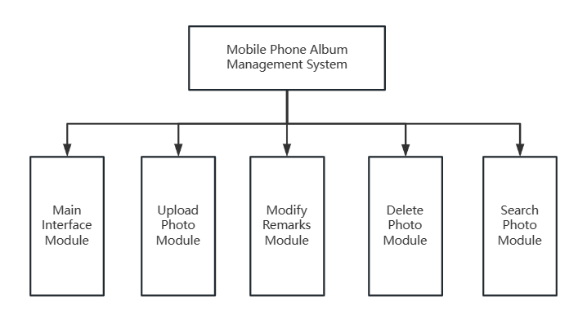

Figure 4-1: Mobile Phone Album Management System Overall Design Function Chart

### 4.1.2 Main Interface Module

This module displays the photo information uploaded and saved by the user in the photo album management system of the mobile phone, including the photo itself, the place and time when the photo was taken, and the user's remarks on the photo. In addition, the interface of this module also has the upload local photo button, modify photo remarks button and delete photo function button.

The core function of this system is to realize the information data synchronization between the user's mobile phone terminal and the computer terminal through the web server, that is, the user can take photos on the mobile phone through the system to realize the photo tour on the computer terminal. In using the system, the user first needs to enter the IPv4 address of the computer on the mobile terminal to access the web server, enter the initial interface of the system for photo query and search, and click the query button to enter the main interface module of the system, where the user can visit the photos uploaded to the album management system. And the relevant information of these photos were modified accordingly. Figure 4-2 Timing diagram of the main interface module.

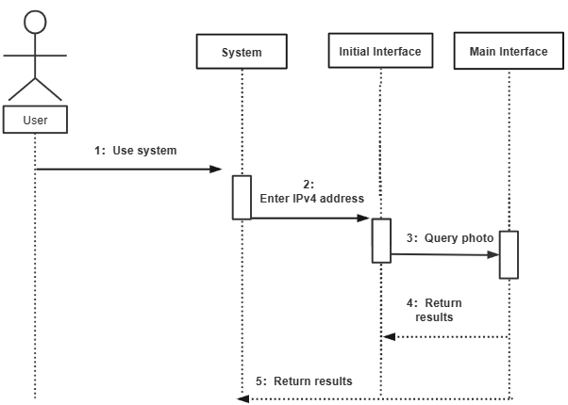

Figure 4-2: Main Interface Module Timing Diagram

### 4.1.3 Upload Photo Module

At the top of the main interface module, the user can upload the photos taken by the mobile phone to the system by uploading the local photos. Meanwhile, the system can obtain the information of the shooting time and location of the photos by using the metadata-extractor technology[37] and show the information to the user. Finally, the system will save the photo itself and related information on the computer to realize data synchronization and backup at both ends of the user's photo.

After uploading photos taken or saved on the mobile phone, users can view these photos and related information on the computer at any time, and make further changes to the photo information. Figure 4-3 shows the timing diagram of the module.

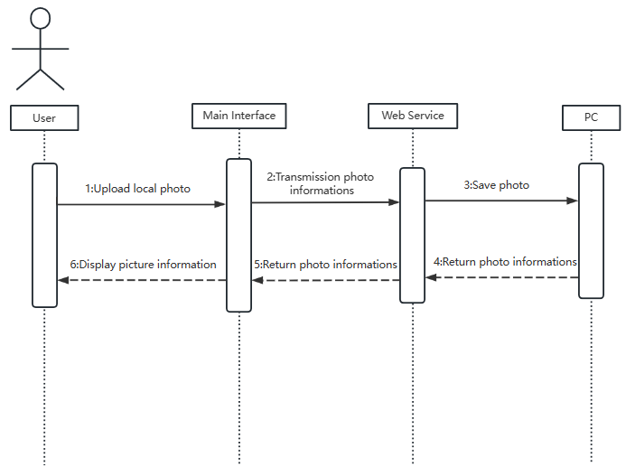

Figure 4-3: Upload Photo Module Sequence Diagram

### 4.1.4 Modify Remarks Module

In this module, users can add comments to a photo and modify them. After users upload the photos taken on the mobile phone to the system, connect the mobile phone and computer through the Web server, and save the photo information to the computer, the remarks information of the photo will be empty by default. Users can modify the remarks information to be empty, and these remarks information will be saved to MySQL. The modified photo remarks will be displayed to the user through the main interface module. Users can modify the remarks of photos they do not like at any time by modifying the remarks button. You can integrate the function of modifying remarks into remarks. That is, users can directly click the remarks text to modify the remarks without clicking the Modify Remarks button to go to the new interface to modify the remarks. Figure 4-4 shows the timing diagram of modifying the remarks module.

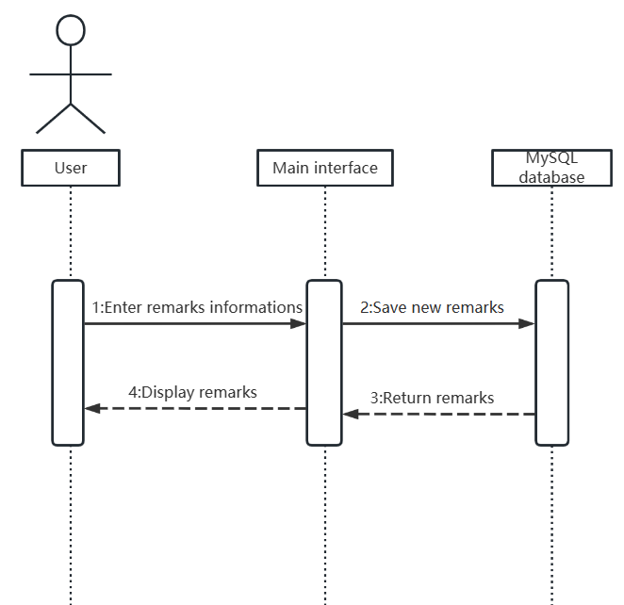

Figure 4-4: Modify The Remarks Module Timing Diagram

### 4.1.5 Delete Photo Module

Users can choose to delete unnecessary photos from the system, and the system will not show the photos and related information to users. In the operation process, the user only needs to click the designated photo delete button, the photo can be deleted from the system. However, this function is only effective in this system. The local photos of the user's mobile phone will not be deleted together. When the user needs to view this photo again, he can view it again through the upload photo module. Because the process of this function is simple and easy to understand, no sequence diagram is drawn.

### 4.1.6 Search Module

In order to facilitate users to find the required photos, the system provides users with convenient retrieval function. Users can fill in the relevant information of photos, such as shooting time, shooting location and remarks information, and do not need to fill in the information completely. Users can also find the photos they need through this search function. The main interface module will only show the photos that meet the search criteria to the user, and the user can edit these photos accordingly. Figure 4-5 shows the timing diagram of the search module.

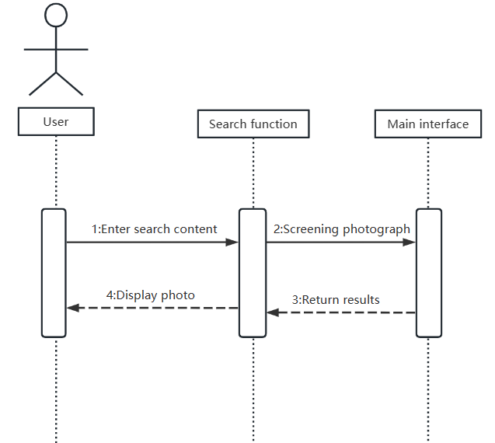

Figure 4-5: Search for Module Timing Diagrams

## 4.2 System Database Design

### 4.2.1 Database E-R Diagram

This system uses MySQL database to store the related information of photos, which will be saved on the user's computer, and present the information to the user on the user's mobile phone and computer. When a user uploads a local photo, the photo's name, time, location, remarks and other data are automatically saved in the database. When the user modifies or deletes the information, the content in the database is also changed. The E-R diagram of the database used in this system is shown in Figure 4-6.

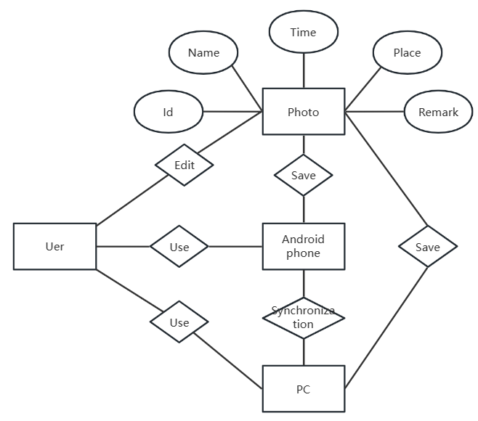

Figure 4-6: Database E-R Diagram

### 4.2.2 Database Field

A photo data table is included in the database to store the information related to the photo. This database is used to store the serial number of the photo, non-duplicate name, shooting time, shooting place, user's remarks and other data. Table 4-1 is used to represent the photo data table to record the data related to the photo.

Table 4-1 Album Data Table

|  |  |  |  |  |  |  |  |  |
| --- | --- | --- | --- | --- | --- | --- | --- | --- |
| Serial number | Data field | Data type | Data length | Decimal place | Identification | Primary key or not | Empty or not | Default value |
| 1 | Id | INT | 10 |  | Y | Y | N | auto_increment |
| 2 | Name | VARCH | 20 |  | N | N | N | null |
| 3 | Time | DATE | 20 |  | N | N | N | null |
| 4 | Place | VARCH | 20 |  | N | N | N | null |
| 5 | Remark | VARCH | 100 |  | N | N | N | null |

## 4.3 Chapter Summary

This chapter mainly introduces the design point of view of the system, divides the functions of the whole system into five modules, and analyzes these modules one by one and draws corresponding sequence diagram. After that, the database used in the system was designed, the E-R diagram of the database was drawn and the database fields were presented.

# CHAPTER 5: SYSTEM IMPLEMENTATION

## 5.1 Main Interface Implementation

The main interface displays all photos saved in the system and their related information. Figure 5-1 shows the interface of the main interface module.

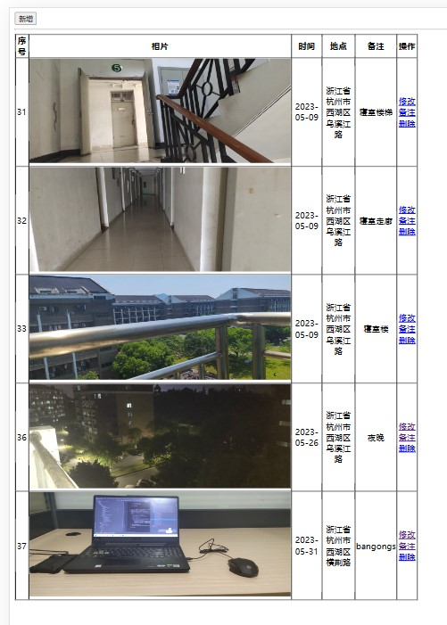

Figure 5-1: Main Interface Implementation Diagram

The main interface is implemented to query all the photo information from the MySQL database. This part of the code simply calls a SelectAll() method to display the contents of the database.MySQL database only saves the name of the photo, shooting time, shooting location, remarks and other information, but does not save the photo itself, in order to realize the photo display in the main interface, the system will access the relative path of the photo storage according to the unique name of the photo, to realize the photo display to the user.

## 5.2 Upload Function Implementation

The user uploads the local photo of the mobile phone and saves the photo to the computer. The key of this operation is to add a new photo record to the MySQL database, and transfer and save the new photo to the computer through the Web server. When the user uploads a local photo, the system also uses the metadata-extractor API to obtain the time and location of the photo, which is added to the corresponding database fields, and the time and location information along with the photo itself is displayed to the user on the main screen. Metadata-extractor this API can only obtain the photo shooting time and location of the longitude and latitude information, in order to achieve the photo shooting location access function, also need to obtain the longitude and latitude information of the photo through metadata-extractor, the use of Baidu map API to obtain the specific location of the photo shooting. Figure 5-2 shows the interface of uploading photos. Figure 5-3 shows the changes of the main interface after uploading a new photo.

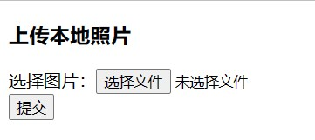

Figure 5-2: Upload Module Diagram

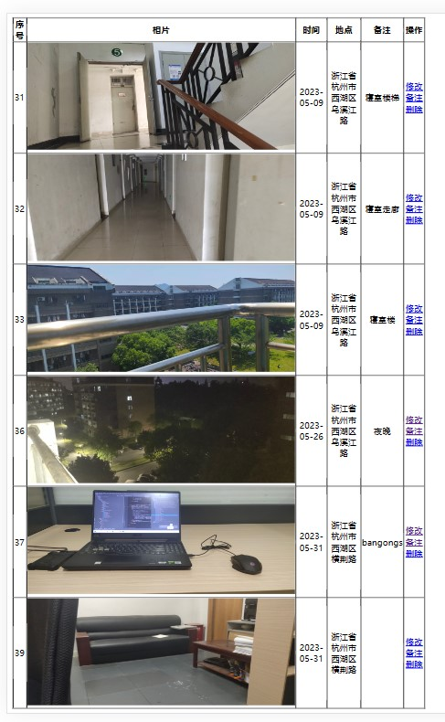

Figure 5-3: Upload New Photo Main Screen Changes

## 5.3 Modified Remarks Function Implemented

The initial comment value of a photo is empty. You need to add a new comment to the photo. You can also modify the comment information at any time. When the user changes the remarks information of the photo, the system will find the specified photo record in MySQL according to the serial number of the photo specified by the user, and then modify the remarks field content in this record. Finally, the modified remarks information will be displayed to the user in the main interface. Figure 5-4 shows the page for modifying Remarks.Figure 5-5 shows how the home screen changes after the user modifies the remarks of the last photo.



Figure 5-4: Modify The Remarks Module Diagram

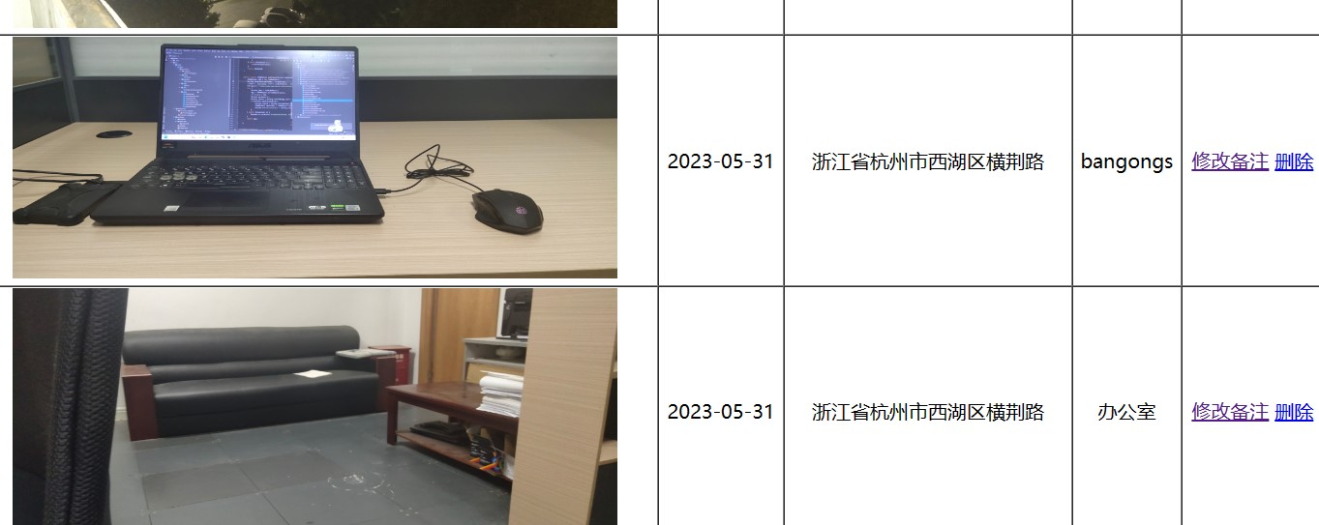

Figure 5-5: The Main Screen Changes after Remarks are Modified

## 5.4 Deletion Function Implementation

Users can delete photos they don't like by directly clicking the designated photo delete button on the main interface to complete the operation. The key to achieve this function is to delete a record in MySQL. The system can achieve this function as long as it calls a DeleteById() method. After a photo record is deleted by the user, the main interface will not display the deleted photo and its related information to the user. Figure 5-6 shows how the home screen changes after a user deletes a photo.

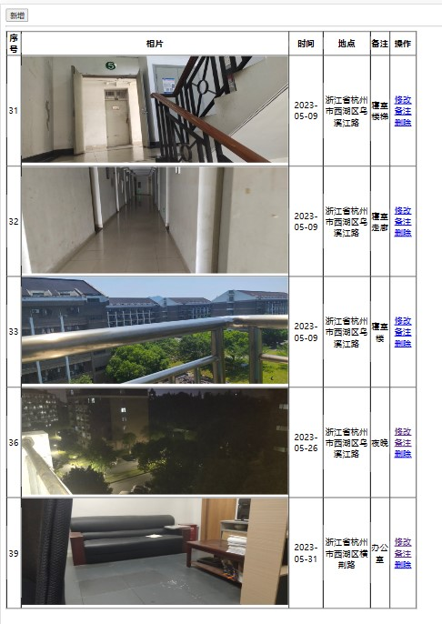

Figure 5-6: Delete Photo Main Screen Changes

## 5.5 Retrieval Function Realization

The key to realize this function lies in the query operation of MySQL database. The user enters a specific string in the search box and the system calls the function to query in the database. If the time, place and remarks of the photo record contain the string input by the user, The main screen will display the filtered photos. Figure 5-7 shows how the main screen changes after the user enters a string and searches for it.

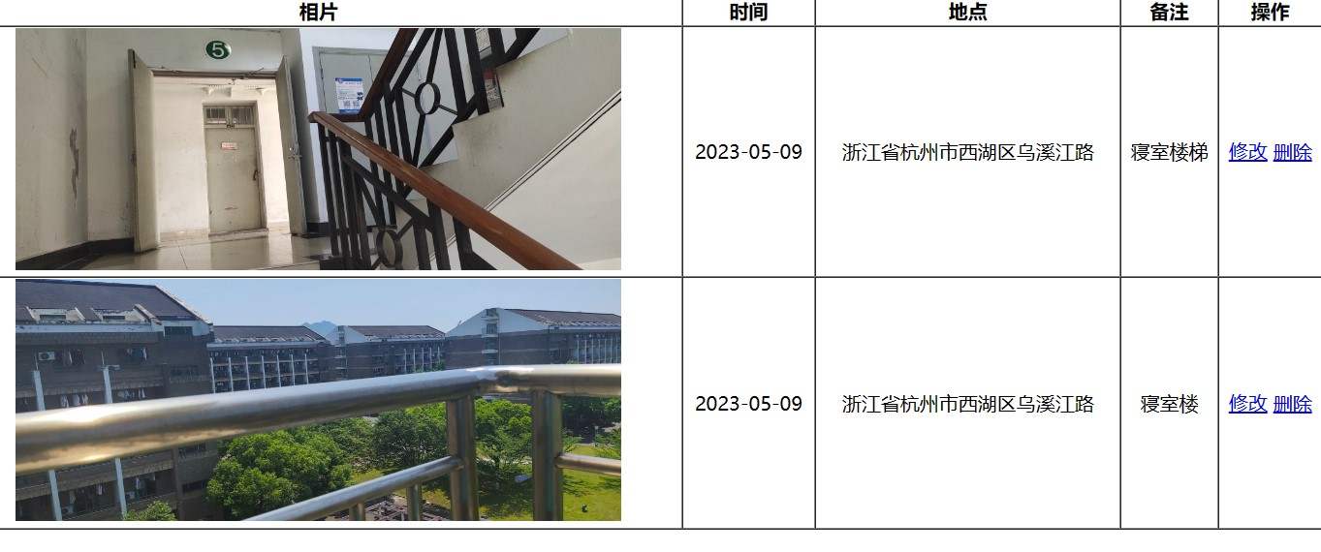

Figure 5-7: Search Photo Main Screen Changes

## 5.6 Chapter Summary

This chapter mainly shows the realization results of the main functions of the system and screen shots.

# CHAPTER 6: SYSTEM TEST

## 6.1 Test Method

The test methods mainly used in this paper include functional test, performance test and interface test[38].

Functional testing: A common software testing method whose primary purpose is to verify that a system meets expected functional requirements. During functional testing, testers usually determine test cases based on requirements documents, user manuals or other relevant documents and test each function of the system one by one. During functional testing, testers should strictly follow test plans and test cases, follow test procedures and specifications, and record test results in a timely manner. Through the function test, the functional defects of the system can be found, and the system function can meet the needs of users, with good stability and reliability.

Performance test: The main purpose is to test the performance of the system under different load conditions, including response time, throughput, concurrency and other indicators. Through performance tests, you can evaluate the utilization efficiency and scalability of system resources, and determine the load limit of the system. When performing performance tests, testers need to test according to the test plan and load model, record test data and analyze it. Through performance testing, you can discover system performance defects and bottlenecks, determine system load limits and stability, and improve system performance and user experience.

Interface test: Interface is the most direct layer between the system and the user, its quality determines the user's first impression of the system. Interface testing aims to ensure that the user interface of an application meets design specifications and user expectations. It typically involves testing the layout, appearance, and interactive performance of user interface elements. Interface testing can help you find problems with UI elements that don't display correctly or arrange as expected, users who can't easily interact with UI elements, UI elements that are slow or unstable to respond to, and more. The main goal of interface testing is to ensure that the application provides a quality user experience and that all UI elements in the application work properly. Ensuring that your application provides a great user experience is an important part of improving your application's usability and stability, and ensuring that your application attracts and retains users.

## 6.2 Test Case

On the premise of using the above mentioned test methods, several functional modules of the system are tested. Table 6-1 shows the test of uploading local photos, Table 6-2 shows the test of modifying photo remarks, and Table 6-3 shows the test process and results of deleting photos in the test system.

Table 6-1 Test Cases of Uploading Photos

|  |  |
| --- | --- |
| Title | User upload mobile phone local photo function test |
| Condition | Photos are normally uploaded to the computer and saved |
| Test procedure | 1. Click the New button to jump to the Supremacist photo interface  2. Select the photo you want to upload  3. Confirm to upload the selected photo |
| Expected result | Photo information is displayed on the main screen |
| Test result | pass |

Table 6-2 Modifying Remarks Function Test Cases

|  |  |
| --- | --- |
| Title | Users modify the comment function of a photo test |
| Condition | The remarks of the photo were modified successfully |
| Test procedure | 1. Select a photo and click the corresponding Modify button  2. The page for modifying photo remarks is displayed  3. Enter the content and confirm the modification |
| Expected result | The modified remarks can be displayed to users on the home screen |
| Test result | pass |

Table 6-3 Test Cases of Deleting Photos

|  |  |
| --- | --- |
| Title | User delete photo function test |
| Condition | The photo selected by the user was successfully deleted |
| Test procedure | 1. Choose a photo  2. Confirm the deletion  3. Refresh the page |
| Expected result | The deleted photo will not be displayed to the user on the main screen |
| Test result | pass |

## 6.3 Chapter Summary

This chapter introduces several software testing methods used in the process of testing the mobile photo album management system, and shows several system test examples, in these test examples, the functions to be tested have passed the system test.

# 

# CHAPTER 7: CONCLUSION AND FEATURE WORK

## 7.1 Conclusion

In this paper, the background and research significance of the mobile album management system are firstly analyzed, and the research status of the mobile album software at home and abroad is briefly introduced. Then, the technology and development platform needed for the development of the mobile album management system are studied and analyzed. After the preliminary technical selection, the market demand analysis of the mobile photo album system was carried out, and the overall functional structure of the mobile photo album was researched and designed. Then on the previous design of several sub-modules, their functions and implementation of key technologies are elaborated, which is also a key part of this paper.

However, it has to be said that in the photo album application of this mobile phone, there are still many functional modules to be further improved and secondary development, so that this mobile phone photo can bring good experience to users. First of all, the app does not support bulk uploading and downloading of photos. In addition, if the pictures are too large or too many, the app will not be smooth. A lot of work needs to be done to get it into the hands of users in the future.

Due to the limitation of my time and the technology I have mastered, this mobile photo album system has only realized some of its basic functions. There is still a lot of work to be done to make this mobile photo album system really online and accepted by more users. First, the system's features need to be perfected, and second, he has to consider whether the mobile album system will work with Android and other mobile platforms. All in all, the subsequent development was fraught with difficulties.

## 7.2 Feature Work

At present, the main problem is that the functions can not fully meet the requirements of users. In the future, more functions will be gradually added to the software. A perfect smart phone photo management system includes a variety of image classification methods for users to choose. For example, the scene recognition technology based on image content has gradually entered the field of view of mobile photo album research. The broad smart phone photo album system also covers many aspects, including multifunctional photography, editing, beautifying and interactive sharing of images, and can realize the effective and orderly management of mobile phone photos. More and stronger functions will provide users with higher quality photo management services.

In addition, since the system is not always able to meet the requirements of users in practical use, further improvement and in-depth research will be carried out in the following three aspects:

(1) Interface optimization: due to the limitations of my time and technology, only take into account the realization of the main functions of the system, but ignore the layout and beauty of the interface resulting in the mobile phone album management system interface slightly rough, in order to make users use the system more comfortable and beautiful, should be the front-end interface of the system for further development and optimization.

(2) Improvement of user information: In the process of developing this mobile phone album management system, user information has not been sufficiently complete. As long as any user using this system can change the content filled in by the previous user and the photo information taken by the previous user. In the aspect of protecting users' personal information, the system needs to be improved and optimized.

(3) Photo editing: After photos are uploaded to the mobile phone album management system by users from the local, users can only visit the uploaded photos and learn the relevant information content of the photos. In the further research and development of this system, photo editing functions such as cropping, rotation and beautification can be added to the system.

Strengthen system visualization: The mobile phone album management system has high requirements for image visualization. For example, some scholars have proposed visualization technologies such as hexagon crystal map hierarchical browsing[39], which can be used for the subsequent development of smartphone album, so as to improve users' experience. In addition, Android phones come with built-in sensors, such as gyroscopic sensors, that can be used to view images, making them more intuitive and intuitive.

# Reference

1. MarkoGargenta, 加尔根塔, 李亚舟,等. Learning Android[M]. 电子工业出版社, 2012:4.
2. Nauman M , Zhang X . Apex: Extending Android Permission Model and Enforcement with User-defined Runtime Constraints. 2010:24.
3. 汪永松. Android平台开发之旅[M]. 机械工业出版社, 2010:21.
4. Rodden K , Wood K R . How do people manage their digital photographs? In CHI 2003:12.
5. 郭靖, 郭晨峰. 中国移动互联网应用市场分析[J]. 信息网络, 2010(7):6.
6. Shi Z , Sun X , Wu F . Photo Album Compression for Cloud Storage Using Local Features[J]. IEEE Journal on Emerging and Selected Topics in Circuits and Systems, 2014, 4(1):17-28.
7. 靳岩.eoeMarket本土化的第三方Android应用软件发布平台[J].程序员,2009,(09):97-98.
8. 张姗. 智能手机拍照功能对于社会的影响研究[J]. 旅游与摄影, 2021(006):000.
9. 吴志强. 图片管理探索[J]. 图书馆建设, 2003:212.
10. 孙家贺. 面向Android平台的智慧相册的设计与实现[D]. 北京交通大学,2017:13
11. 张紫.第33次中国互联网络发展状况统计报告[J].计算机与络,2014,40(02):5.
12. 李征航. GPS测量与数据处理[M]. 武汉大学出版社, 2013:87
13. 杜万平. 机关数码照片归档现状与对策[J]. 山西档案, 2011(1):2.
14. 程涛, 陈慧琴, 孙萍. 基于Android的手机相册分享软件的设计与实现[J]. 微型机与应用, 2014, 33(13):2.
15. Krishnamachari S , Abdelmottaleb M . Image browsing using hierarchical clustering[C]// 1999:31.
16. 焦明慧. 一种照片备注的方法以及移动终端:, 2017:154.
17. 王华旭. 基于Android平台的智能手机相册的设计与实现[D]. 中山大学:23.
18. Viola P A , Jones M J . Rapid Object Detection using a Boosted Cascade of Simple Features[C]// Computer Vision and Pattern Recognition, 2001. CVPR 2001. Proceedings of the 2001 IEEE Computer Society Conference on. IEEE, 2001:212.
19. Serre T , Wolf L , Poggio T . Object Recognition with Features Inspired by Visual Cortex[C]// Computer Vision and Pattern Recognition, 2005. CVPR 2005. IEEE Computer Society Conference on. IEEE, 2005:325.
20. 裴磊, 高文荣. 一种数据录入与照片同步采集方法及系统:, CN110535917A[P]. 2019:30.
21. 刘铁锋. 深入探析Android Market大势[J]. 程序员, 2011(3):3.
22. Nguyen G P , Worring M . Interactive access to large image collections using similarity-based visualization[J]. Journal of Visual Languages & Computing, 2008, 19(2):203-224.
23. Cao L , Luo J , Kautz H , et al. Image Annotation Within the Context of Personal Photo Collections Using Hierarchical Event and Scene Models[J]. IEEE Transactions on Multimedia, 2009, 11(2):208-219.
24. 梁婷婷. 基于语义的相片检索研究与系统实现[J]. 信息技术与信息化, 2013, 000(006):95-100.
25. 蔡长安, 王盈瑛, CAIChang-an,等. C/S和B/S的模式的比较和选择[J]. 渭南师范学院学报, 2006, 21(2):47-50.
26. 吴毅杰, 张志明. C/S与B/S的比较及其数据库访问技术[J]. 舰船电子工程, 2003(2):4.
27. 张军朝. Android技术及应用[M]. 电子工业出版社, 2016:49.
28. 孙卫琴, 李洪成. Tomcat与Java Web开发技术详解[M]. 电子工业出版社, 2004:76.
29. 孙鑫. Java Web开发详解[M]. 电子工业出版社, 2012:320.
30. 池亚平, 方勇. Servlet技术与应用方法[J]. 北京邮电大学学报, 2003(z1):4.
31. 吴晨清, 荣震华. 用JSP/Servlet技术构建Web应用[J]. 计算机工程, 2001, 027(001):170-172.
32. 张波, 张福炎. 基于JSP技术的Web应用程序的开发[J]. 计算机应用研究, 2001, 18(005):99-101.
33. Phil Hanna. JSP技术大全[M]. 机械工业出版社, 2002:125.
34. 兰旭辉, 熊家军, 邓刚. 基于MySQL的应用程序设计[J]. 计算机工程与设计, 2004, 25(3):3.
35. Widenius M , Axmark D , Dubois P . Mysql Reference Manual[M]. O'Reilly & Associates, Inc. 2002:14.
36. 霍列基威茨, I.T. 数据库分析与设计[M]. 南京工学院出版社, 1987:44.
37. Eassa F E , Al-Barhamtoshy H , Almenbri A , et al. An Architecture for Metadata Extractor of Big Data in Cloud Systems[J]. International Journal of Scientific & Engineering Research, 2014, 5(1):2187-2191.
38. 宋俊雅, 王鹏彪, 黄俊爽,等. B/S结构软件的系统测试技术[J]. 科技信息, 2010(10):2.
39. Schaefer G . Interactive Exploration of Image Collections[M]. 1970:22.

# Acknowledgment

At the end of this article, I would like to thank the people who helped me in the process of completing this paper.

First of all, I would like to express my heartfelt thanks to Prof. Li Xiaoxin for his care and careful instruction. Although Professor Li is very busy with teaching and research, he still spare valuable time from topic selection to report writing, to demonstration, to final revision, and finally to the final draft. Mr. Li's profound knowledge, profound academic attainments, rigorous academic attitude, meticulous work attitude, let me benefit for life, I would like to extend my heartfelt thanks to him.

In addition, I would like to express my gratitude to the leaders and teachers of Zhejiang University of Technology. In the past four years, your academic attainments, dedication, personality charm, as well as your guidance and care for me, all of these are the power to make continuous progress for me. Thank you for giving me a lot of knowledge and help during my study.

At the same time, I would like to express my heartfelt thanks to my family and classmates for their dedication to my study. I sincerely wish them all happiness.

Finally, I would like to express my heartfelt thanks to all the teachers who took time out of their busy schedule to review and give valuable comments on this paper.

# Appendix

**附录1 毕业设计文献综述**

**附录2 毕业设计开题报告**

**附录3 毕业设计外文翻译（中文译文与外文原文）**