Question/Assignment 1

1. Kill all processes/zombie processes of service called “gunicorn” in a single command.
Ans :- pkill -9 gunicorn

2. MySQL shell command to show the unique IPs from where MySQL connections are being made to the Database.
Ans :- SELECT DISTINCT host FROM mysql.processlist

3. Bash command to get value of version number of 3 decimal points (first occurrence) from a file containing the JSON: {
"name": "abc",
"version": "1.0",
"version": "1.0.57",
"description": "Testing",
"main": "src/server/index.js",
"version": "1.1"
}

Ans :- grep -oP '"version":\s*"\d+\.\d+\.\d+"' file.json | head -1 | awk -F'"' '{print $4}'
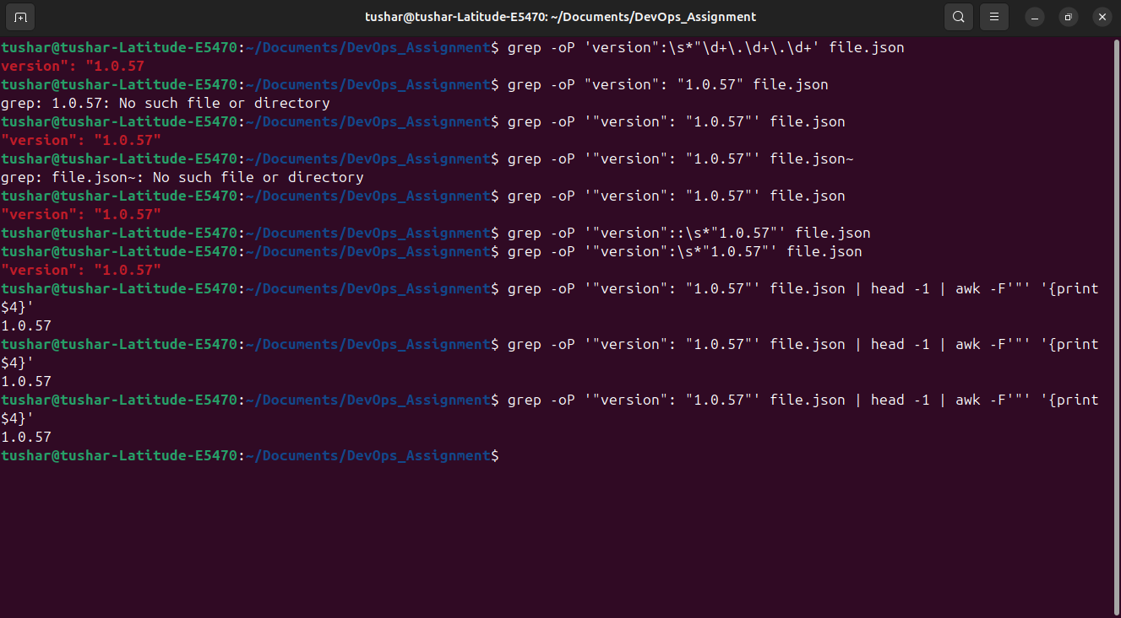

4. Bash command to add these numbers from a file and find average upto 2 decimal points: 0.0238063905753
0.0308368914424
0.0230014918637
0.0274232220275
0.0184563749986
Ans :-

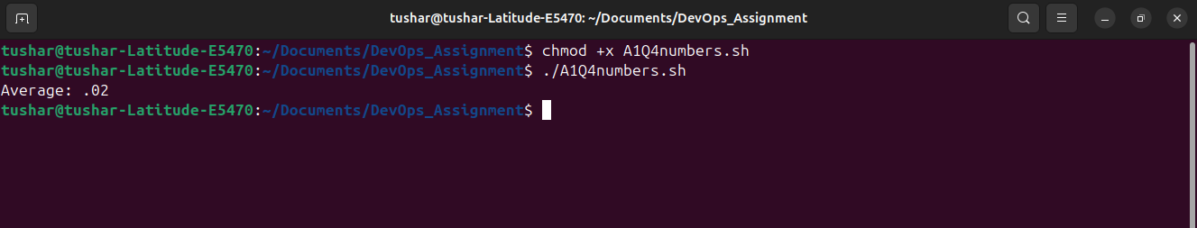

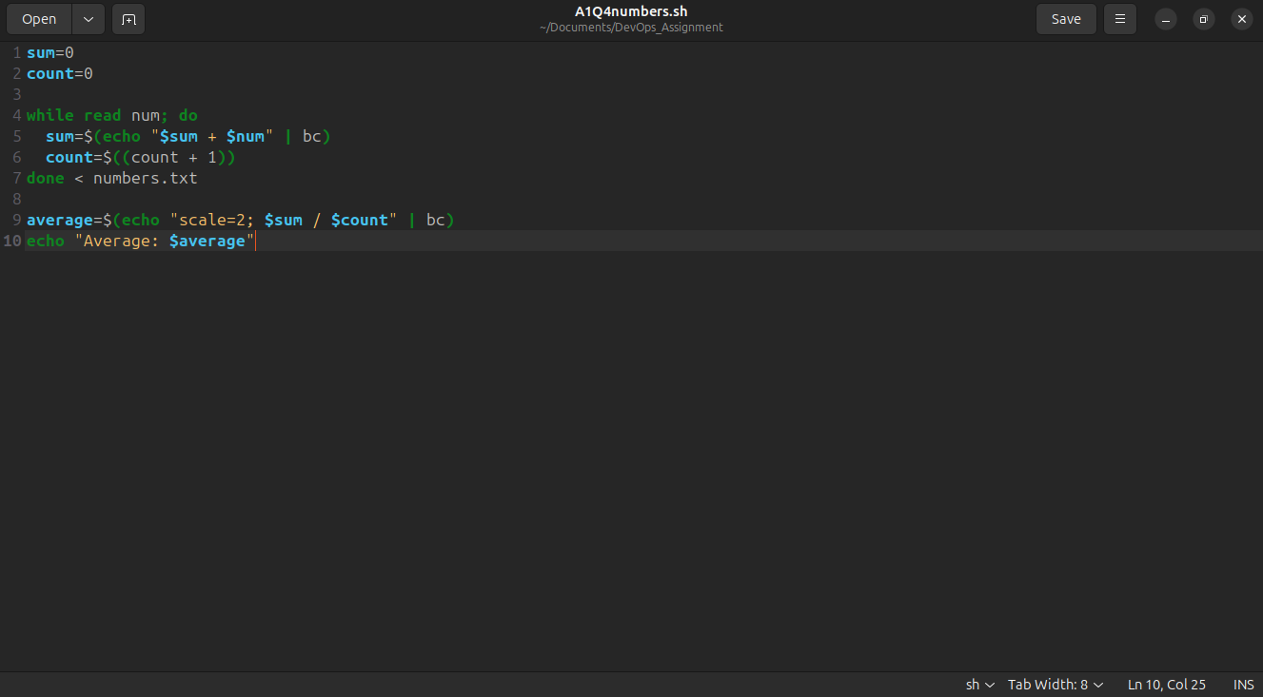

Question/Assignment 2

Create a Virtual Machine: Set up a VM using AWS
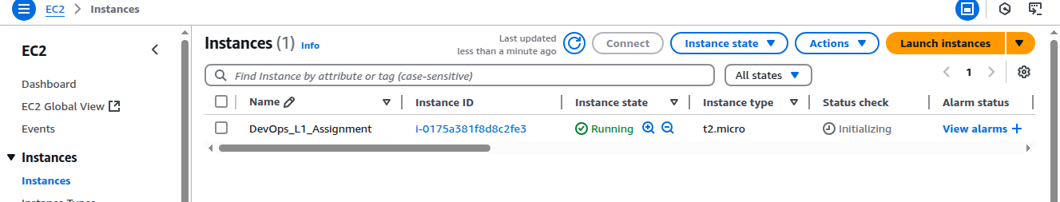
1)ip route show (done)
2)ping google.com (done)
3)ping 192.168.1.108 (done)
4)curl http://192.168.1.108 and curl http://52.66.208.130 (This is not done)
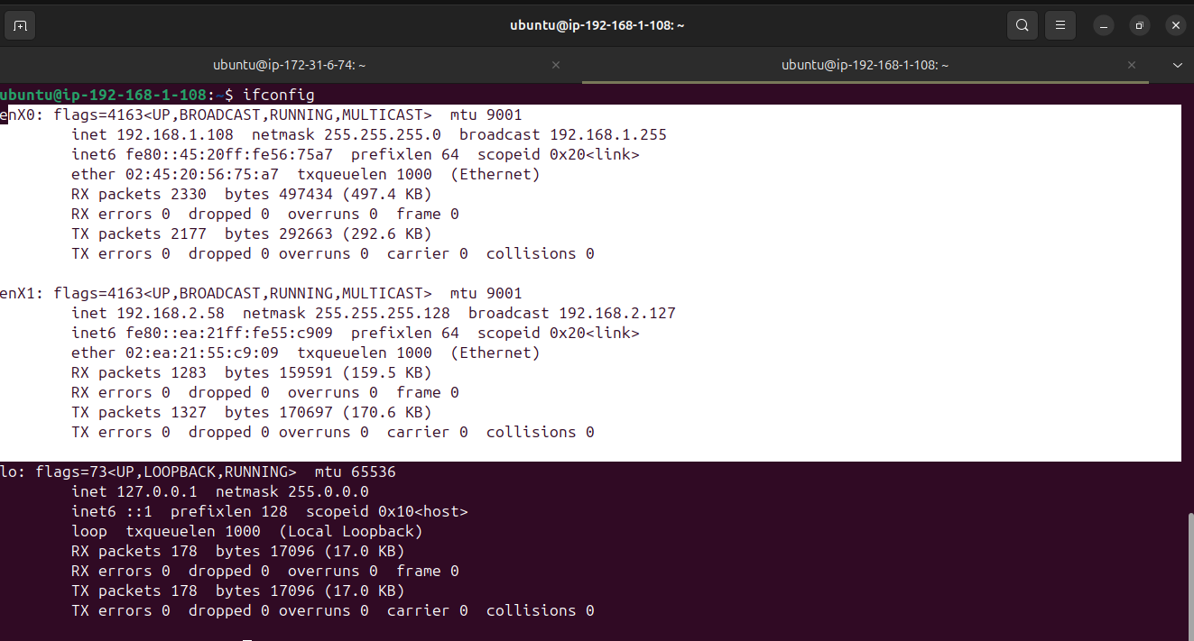
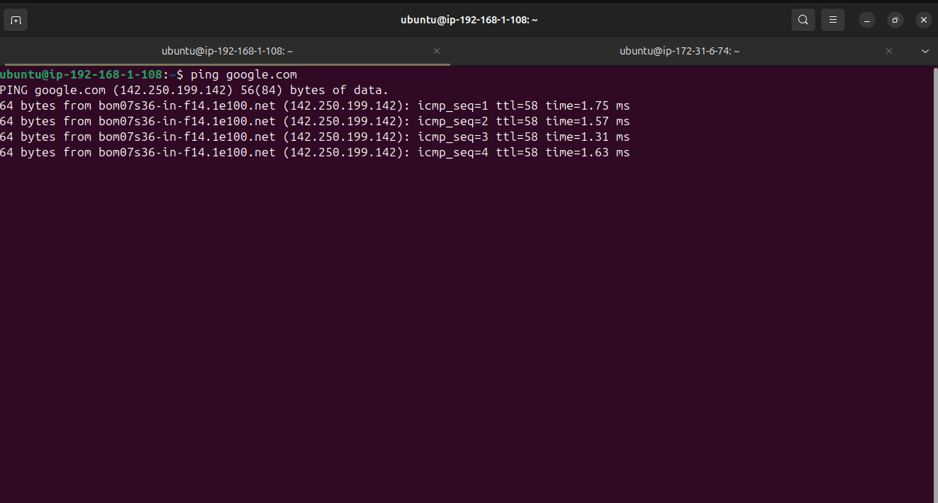

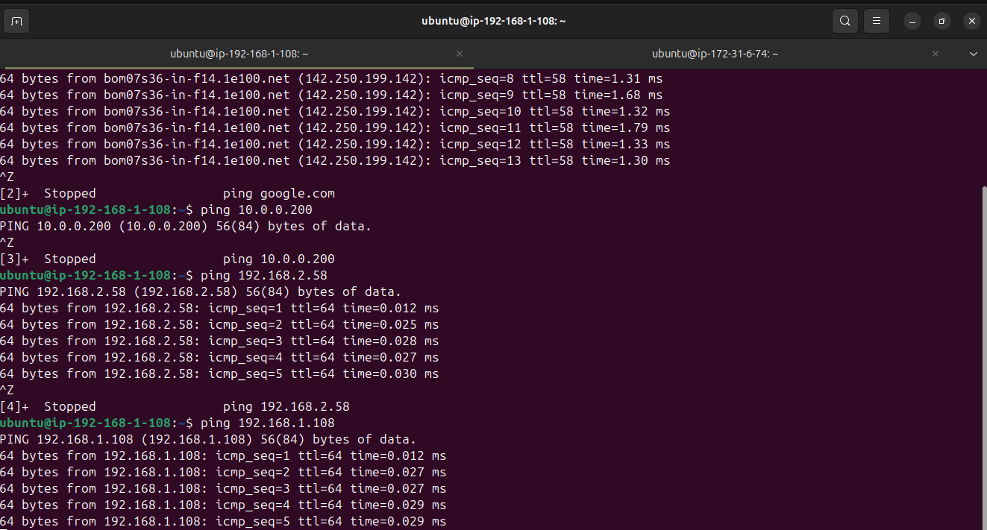
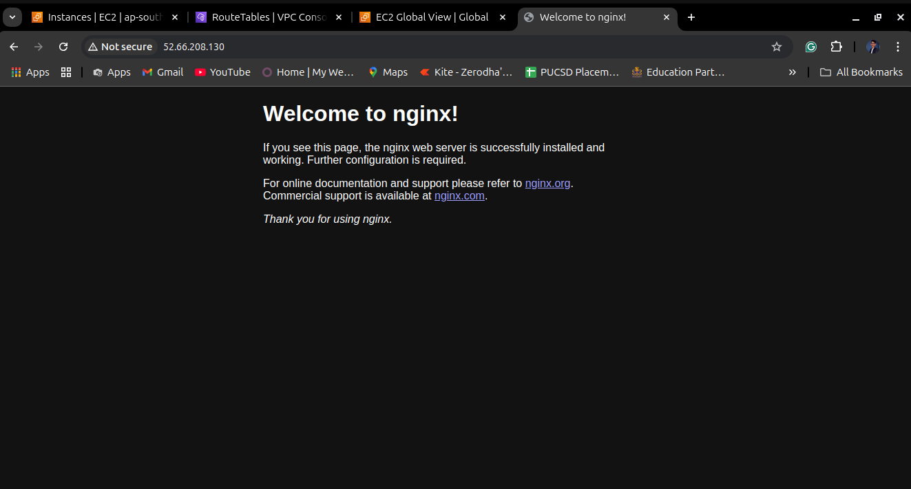

Question/Assignment 3
Q) Write an executable bash script to set up a whole LAMP stack, PHP app can be Wordpress and DB can be MySQL.
Ans:-
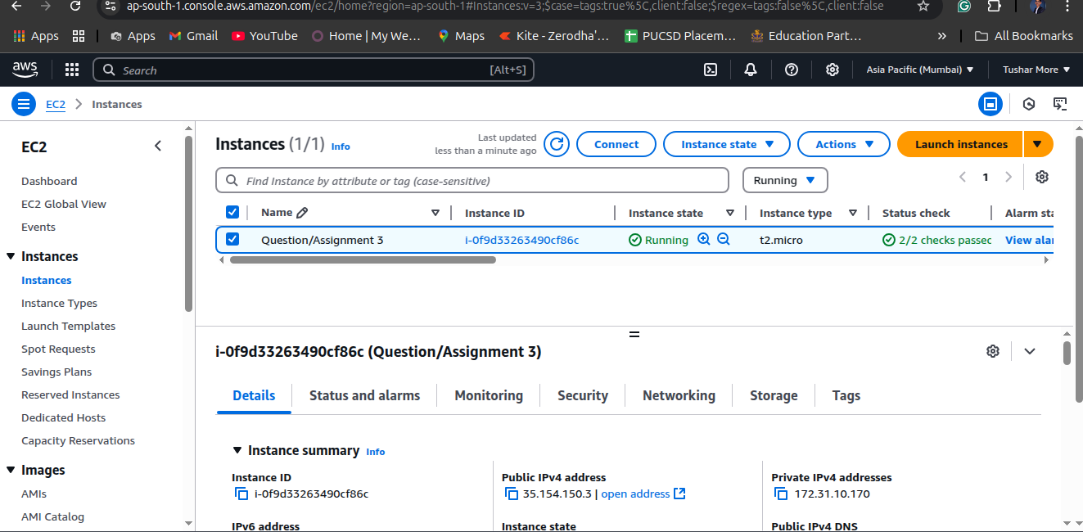
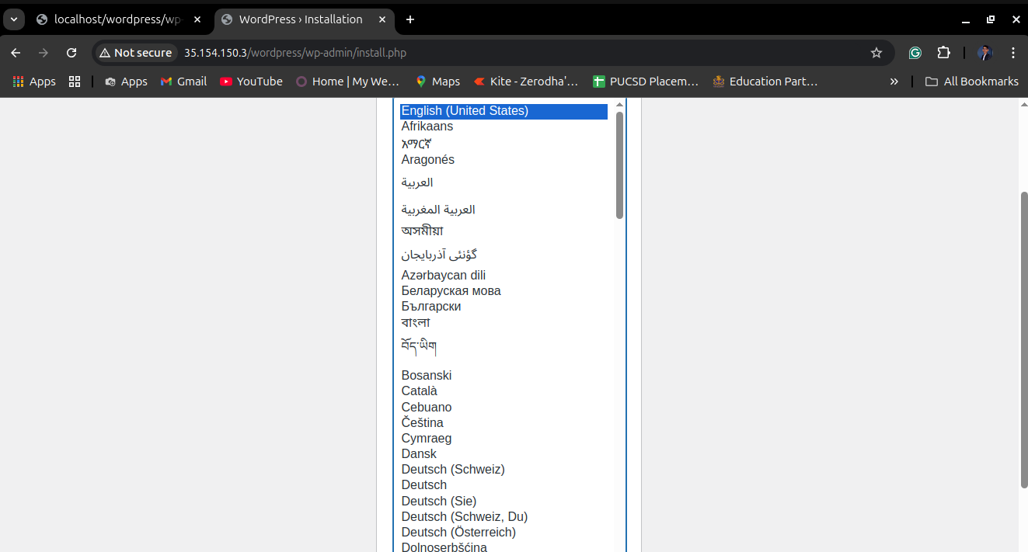

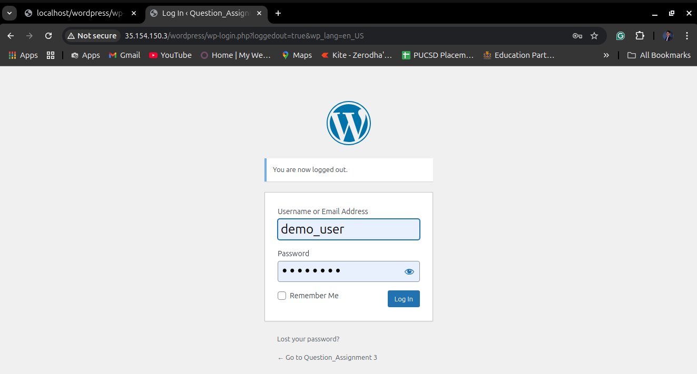
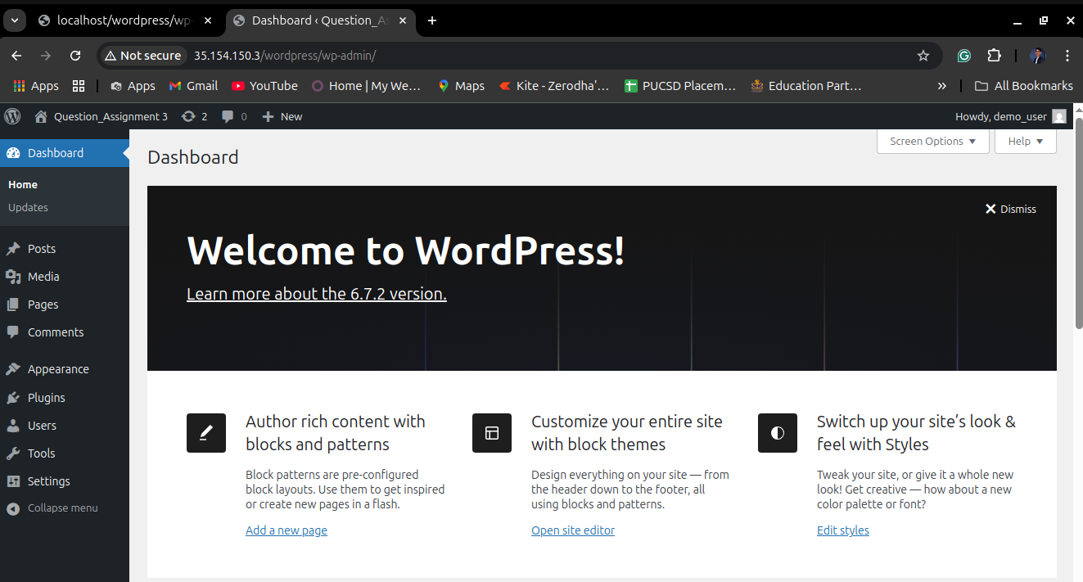

How to Run lamp_setup.sh
#!/bin/bash
# Define variables
WEB_ROOT="/var/www/html"
DB_NAME="demo_db"
DB_USER="demo_user"
DB_PASS="Root@123"

# Update and install dependencies
echo "Updating system and installing required packages..."
sudo apt-get update
sudo apt install -y apache2 php libapache2-mod-php php-mysql php-curl php-gd php-mbstring php-xml php-xmlrpc php-soap php-intl php-zip wget unzip mysql-server

# Enable and start Apache
echo "Starting and enabling Apache..."
sudo systemctl enable --now apache2

# Secure MySQL installation (Non-interactive)
echo "Securing MySQL..."
sudo mysql -e "ALTER USER 'root'@'localhost' IDENTIFIED BY '$DB_PASS'; FLUSH PRIVILEGES;"

# Create MySQL database and user
echo "Creating MySQL database and user for WordPress..."
sudo mysql -u root -e "
CREATE DATABASE $DB_NAME;
CREATE USER '$DB_USER'@'localhost' IDENTIFIED WITH caching_sha2_password BY '$DB_PASS';
GRANT ALL PRIVILEGES ON $DB_NAME.* TO '$DB_USER'@'localhost';
FLUSH PRIVILEGES;"

# Download and configure WordPress
echo "Downloading WordPress..."
cd $WEB_ROOT
sudo wget -q https://wordpress.org/latest.tar.gz
sudo tar -xzf latest.tar.gz
sudo rm latest.tar.gz
sudo chown -R www-data:www-data $WEB_ROOT/wordpress
sudo chmod -R 755 $WEB_ROOT/wordpress

# Configure wp-config.php
echo "Configuring WordPress..."
sudo cp $WEB_ROOT/wordpress/wp-config-sample.php $WEB_ROOT/wordpress/wp-config.php
sudo sed -i "s/database_name_here/$DB_NAME/" $WEB_ROOT/wordpress/wp-config.php
sudo sed -i "s/username_here/$DB_USER/" $WEB_ROOT/wordpress/wp-config.php
sudo sed -i "s/password_here/$DB_PASS/" $WEB_ROOT/wordpress/wp-config.php

# Restart Apache
echo "Restarting Apache..."
sudo systemctl restart apache2

# Display completion message
echo "WordPress installation completed!"

Make the Script Executable
chmod +x lamp_setup.sh
Run the Script
sudo ./lamp_setup.sh

Question/Assignment 4
Q)Let’s say you are working on an application which is hosted on AWS or Azure. Draw an architecture diagram for a PHP/JAVA/Python-based application to be hosted on AWS with all mentions like VPC, AWS/any other cloud platform services, well-defined network segregation. Any more details that you think are necessary please do include them.
Ans:-
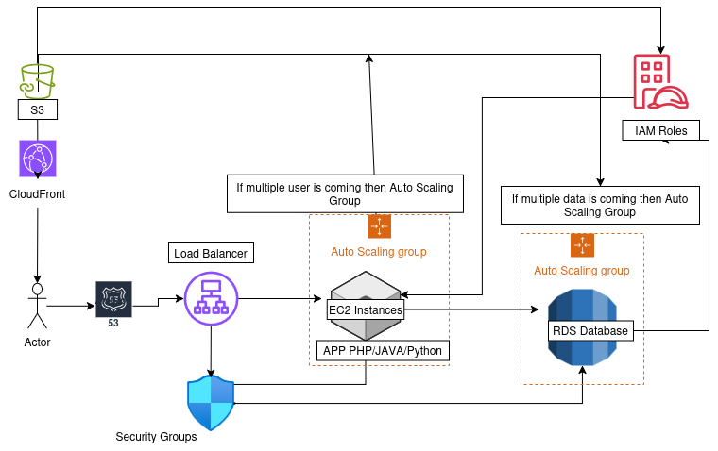
1)Adding CloudFront for Fast Content Delivery
I am adding CloudFront between the user and S3 because CloudFront caches static assets from S3 and serves them to users quickly.
2)Improving Security with Security Groups
I am adding Security Groups for the Load Balancer, EC2 Instances, and RDS Database.
The reason is that the Load Balancer communicates with EC2, and EC2 communicates with RDS, ensuring controlled access.
3) Assigning IAM Roles for Secure Access
I am assigning IAM Roles to EC2, RDS, and S3 for security reasons.
This ensures that instances can access required AWS services without hardcoded credentials.
4)Adding a VPC for Network Segmentation
In the Public Subnet, I have added the Load Balancer.
In the Private Subnet, I have added EC2 Instances and RDS for security reasons.

Flow of the Architecture:
Users → Route 53 → Load Balancer → Auto Scaling EC2 Instances (App) → RDS Database (Auto Scaling, based on load)
Storage:
- S3 for storing files, backups of RDS, large images, and log files.
Security:
- Security Groups for controlled network access.
- IAM Roles for managing secure access to AWS resources.
BONUS QUESTIONS
Q1)

Q2)Write a Terraform/Cloud Formation template for the LAMP stack in Question
ans:- This script:
Provisions an EC2 instance (Ubuntu)
Installs Apache, MySQL, and PHP
Configures a security group for HTTP, HTTPS, and SSH access
after that Save this as main.tf
Run:
terraform init
terraform apply

I have Not Create CloudFormation Template

