Assignment-1.

● Write a Java program named Car

● The Car class should have the following attributes: make (String), model (String) , year (short) , and price(int) .

● The car class should have a constructor that takes all the attributes.

● Add a main method to instantiate car objects.

● The program should allow the user to create and display objects of each Car Class.

SOURCE CODE :

import java.util.Scanner;

public class car {

    String make;

    String model;

    short year;

    int price;

    public car(String make, String model, short year, int price) {

*this*.make = make;

*this*.model = model;

*this*.year = year;

*this*.price = price;

    }

    public void displayInfo() {

        System.out.println("Make  : " + make);

        System.out.println("Model : " + model);

        System.out.println("Year  : " + year);

        System.out.println("Price : " + price);

    }

    public static void main(String[] args) {

        Scanner sc = new Scanner(System.in);

        System.out.print("How many cars do you want to enter? ");

        int count = sc.nextInt();

        sc.nextLine();

        car[] cars = new car[count];

        for (int i = 0; i < count; i++) {

            System.out.println("\nEnter details for Car #" + (i + 1));

            System.out.print("Enter Make: ");

            String make = sc.nextLine();

            System.out.print("Enter Model: ");

            String model = sc.nextLine();

            System.out.print("Enter Year: ");

            short year = sc.nextShort();

            System.out.print("Enter Price: ₹");

            int price = sc.nextInt();

            sc.nextLine();

            cars[i] = new car(make, model, year, price);

        }

        System.out.println("\nCAR DETAILS");

        for (car c : cars) {

            c.displayInfo();

        }

        sc.close();

    }

}

OUTPUT :

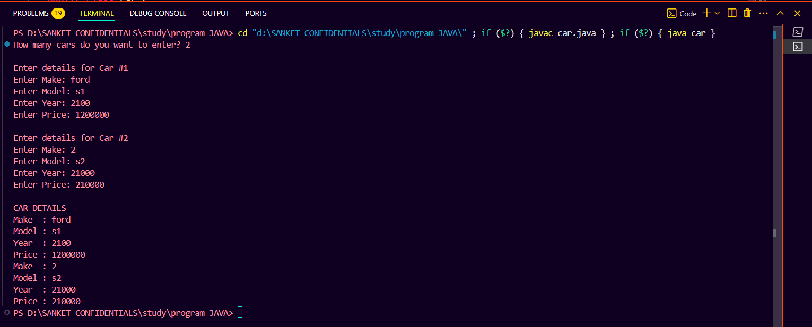

Assignment-2.

● Write a Java program that demonstrates method overloading by creating a class called Calculator.

● Add three methods called add().

● The first add() method should take two int variables as arguments and return their sum as int.

● The second add() method should take three int variables as arguments and return their sum as int.

● The third add() method should take two doubles as arguments and return their sum as double.

● The program should allow the user to display the results of each method.

SOURCE CODE :

import java.util.Scanner;

public class Calculator {

    public int add(int a, int b) {

        return a + b;

    }

    public int add(int a, int b, int c) {

        return a + b + c;

    }

    public double add(double a, double b) {

        return a + b;

    }

    public static void main(String[] args) {

        Scanner sc = new Scanner(System.in);

        Calculator calc = new Calculator();

        System.out.println("Choose type of addition :");

        System.out.println("1. Add two int");

        System.out.println("2. Add three int");

        System.out.println("3. Add two doubles");

        System.out.print("Enter choice (1-3): ");

        int choice = sc.nextInt();

        switch (choice) {

            case 1:

                System.out.print("Enter first int: ");

                int a = sc.nextInt();

                System.out.print("Enter second int: ");

                int b = sc.nextInt();

                System.out.println("Sum: " + calc.add(a, b));

                break;

            case 2:

                System.out.print("Enter first int: ");

                int x = sc.nextInt();

                System.out.print("Enter second int: ");

                int y = sc.nextInt();

                System.out.print("Enter third int: ");

                int z = sc.nextInt();

                System.out.println("Sum: " + calc.add(x, y, z));

                break;

            case 3:

                System.out.print("Enter first double: ");

                double p = sc.nextDouble();

                System.out.print("Enter second double: ");

                double q = sc.nextDouble();

                System.out.println("Sum: " + calc.add(p, q));

                break;

            default:

                System.out.println("Invalid choice.");

        }

        sc.close();

    }

}

OUTPUT CASE 1:

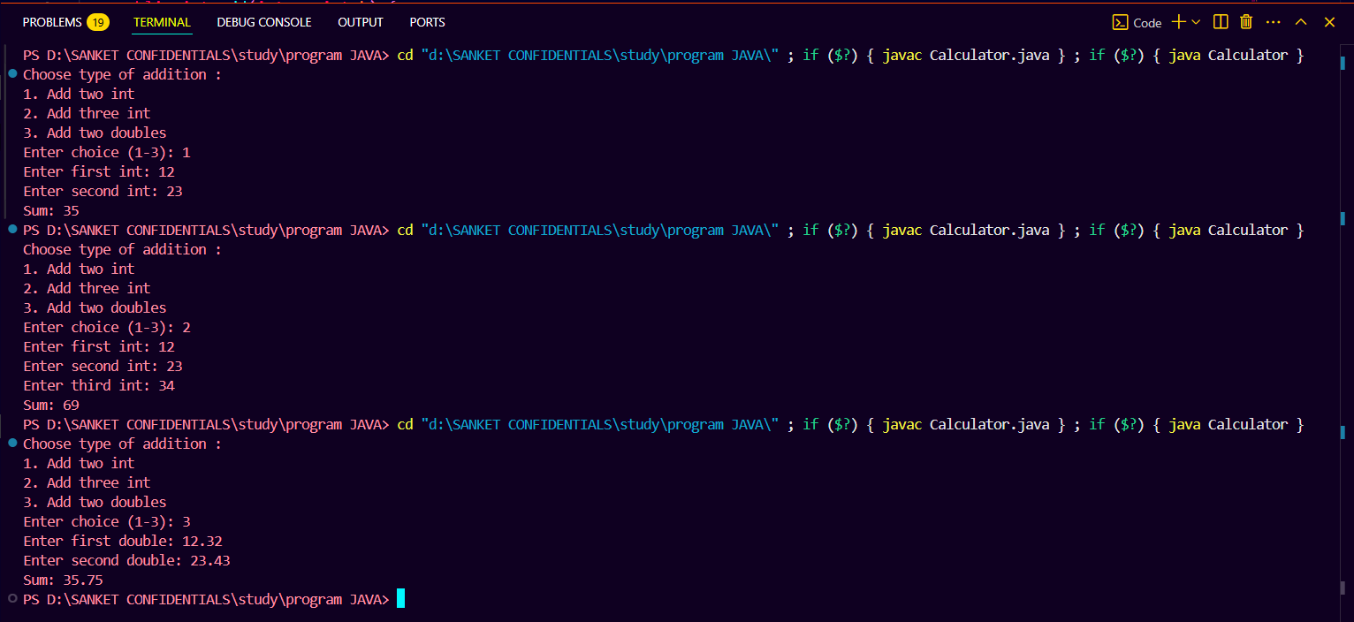

OUTPUT CASE 2 :



OUTPUT CASE 3:



 Assignment-3.

● Create a Java Bean Class Student.

● Add three attributes ○ private String name; ○ private int age; ○ private String department;

● Add a constructor that takes all three attributes as parameters. ● Add setter and getter methods

● Compile the program

SOURCE CODE :

public class Student1 {

    private String name;

    private int age;

    private String department;

    public Student1(String name, int age, String department) {

*this*.name = name;

*this*.age = age;

*this*.department = department;

    }

    public String getName() {

        return name;

    }

    public void setName(String name) {

*this*.name = name;

    }

    public int getAge() {

        return age;

    }

    public void setAge(int age) {

*this*.age = age;

    }

    public String getDepartment() {

        return department;

    }

    public void setDepartment(String department) {

*this*.department = department;

    }

    public static void main(String[] args) {

        Student1 student = new Student1("sanket ", 21, "computer engineering");

        System.out.println("name : "+student.getName());

        System.out.println("age : "+student.getAge());

        System.out.println("dept : "+student.getDepartment());

    }

}

OUTPUT :

