Assignment-1.

Write a Java program that uses a method to calculate the area of a rectangle and compare them using Relational Operator Steps:

● Create a class Rectangle.

● The Rectangle class should have two attributes length and width of type int.

● Create a constructor that accepts length and width as parameters.

● Area should be calculated as length\*area.

● Instantiate two Rectangle classes with random values.

● Compare the areas of the two rectangles using the Relational Operator.

● If the first one is bigger than the second one, print “Rectangle1 > Rectangle2”.

● If the first one is smaller print “Rectangle1 < Rectangle2”.

● Otherwise print “They are equal”.

SOURCE CODE :

import java.util.Random;

class rectangle {

private int length;

private int width;

public rectangle(int length,int width) {

this.length=length;

this.width=width;

}

public int area(){

return length\*width;

}

}

public class rectanglecomparisons{

public static void main(String[] args) {

Random r=new Random();

rectangle rectangle1 = new rectangle(r.nextInt(33) + 1, r.nextInt(8) + 1);

rectangle rectangle2 = new rectangle(r.nextInt(46) + 1, r.nextInt(8) + 1);

int area1 = rectangle1.area();

int area2 = rectangle2.area();

System.out.println("Area of Rectangle 1: " + area1);

System.out.println("Area of Rectangle 2: " + area2);

if (area1 > area2) {

System.out.println("Rectangle1 > Rectangle2");

} else if (area1 < area2) {

System.out.println("Rectangle1 < Rectangle2");

} else {

System.out.println("They are equal");

}

}

}

OUTPUT :

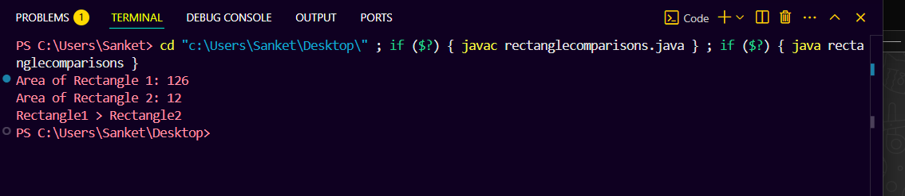

Assignment-2.

 Write a Java program that allows the user to create a bank account and perform transactions such as deposit, withdrawal, and balance inquiry. Using a conditional operator (ternary operator ), display the message whether minimum balance is maintained or not. Steps:

● Create a class BankAccount

● Add three member variables: String accountHolderName , int accountNumber and int balance;

● Add a constructors using all three members

● Add getters and setters.

● Add method deposit (int), withdraw(int)

● Implement the methods by increasing or decreasing the balance

● In the main method create a bank account

● Withdraw money from this account and/or deposit into this account

● Get the balance

● Create a string variable “status” inside the main method

● Assign values to status as “Minimum Balance Maintained” if balance is above or equal to 5000. Otherwise values of status will be “Minimum Balance not Maintained”. Use conditional operator (ternary operator ) to assign the values of the status.

● Display the status

SOURCE CODE :

import java.util.Scanner;

class BankAccount {

private String accountHolderName;

private int accountNumber;

private int balance;

public BankAccount(String accountHolderName,int accountNumber,int balance) {

this.accountHolderName = accountHolderName;

this.accountNumber = accountNumber;

this.balance = balance;

}

public String getAccountHolderName() {

return accountHolderName;

}

public void setAccountHolderName(String accountHolderName) {

this.accountHolderName = accountHolderName;

}

public int getAccountNumber() {

return accountNumber;

}

public void setAccountNumber(int accountNumber) {

this.accountNumber = accountNumber;

}

public int getBalance() {

return balance;

}

public void setBalance(int balance) {

this.balance = balance;

}

public void deposit(int amount) {

if (amount > 0) {

balance += amount;

System.out.println("Deposited: " + amount);

} else {

System.out.println("Invalid deposit amount.");

}

}

public void withdraw(int amount) {

if (amount > 0 && amount <= balance) {

balance -= amount;

System.out.println("Withdrawn: " + amount);

} else {

System.out.println("Invalid withdrawal amount or insufficient balance.");

}

}

}

public class bankdetails {

public static void main(String[] args) {

Scanner scanner = new Scanner(System.in);

System.out.print("Enter Account Holder Name: ");

String name = scanner.nextLine();

System.out.print("Enter Account Number: ");

int accNo = scanner.nextInt();

System.out.print("Enter Initial Balance: ");

int initialBalance = scanner.nextInt();

BankAccount account = new BankAccount(name, accNo, initialBalance);

System.out.print("Enter amount to deposit: ");

int depositAmount = scanner.nextInt();

account.deposit(depositAmount);

System.out.print("Enter amount to withdraw: ");

int withdrawAmount = scanner.nextInt();

account.withdraw(withdrawAmount);

int currentBalance = account.getBalance();

System.out.println("Current Balance: " + currentBalance);

String status = (currentBalance >= 5000) ?"Minimum Balance Maintained" : "Minimum Balance not Maintained";

System.out.println("Status: " + status);

scanner.close();

}

}

OUTPUT:

