ASSIGNMENT 1

1. Write a program to find out all the armstrong numbers within a given range using a method named printArmstrongNumber( int start, int end) by taking input from the user. The program should print the Armstrong number in a given range starting from “start” and ending with “end”. Armstrong Number Example: 153 1 3+5 3+3 3 =153 (Number which is equal to the sum of the cubes of its digits) Note: input should be taken from the keyboard. Use a loop to calculate the Armstrong number from “start” to “end”. Also use loops to calculate the cube of a number. Do not use the Math.pow() function.

SOURCE CODE :

import java.util.Scanner;

public class Lab4_question1 {

    public static void main(String[] args) {

        Scanner sc = new Scanner(System.in);

        System.out.print("Enter start of range: ");

        int start = sc.nextInt();

        System.out.print("Enter end of range: ");

        int end = sc.nextInt();

        printArmstrongNumber(start, end);

        sc.close();

    }

    static void printArmstrongNumber(int start, int end) {

        System.out.println("Armstrong numbers in the range:");

        for (int num = start; num <= end; num++) {

            int original = num;

            int sum = 0;

            int temp = num;

            int digits = 0;

            while (temp > 0) {

                digits++;

                temp /= 10;

            }

            temp = num;

            while (temp > 0) {

                int digit = temp % 10;

                int cube = 1;

                for (int i = 0; i < digits; i++) {

                    cube *= digit;

                }

                sum += cube;

                temp /= 10;

            }

            if (sum == original) {

                System.out.println(original);

            }

        }

    }

}

OUTPUT:

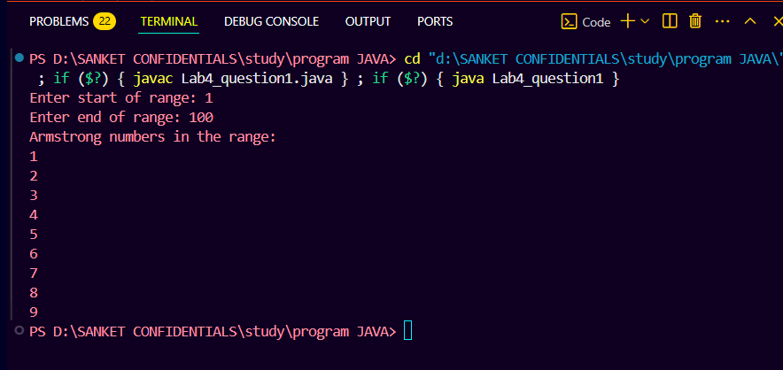

ASSIGNMENT 2

 2. Write a program to calculate the gross salary of a group of employees. Basic salary should be taken from the user. If the basic salary is greater than 15000 ,HRA=20% and DA=60% will be given, else HRA=3000 and DA 70% will be given to the employee. Note:Input of basic salary will be taken from the keyboard. After calculating the salary of one employee, the program will ask for the user's choice as int. If “-1” is entered then the loop will continue and the loop will exit for other int inputs.

SOURCE CODE :

import java.util.Scanner;

public class lab4_question2 {

    public static void main(String[] args) {

        Scanner sc = new Scanner(System.in);

        while (true) {

            System.out.print("Enter basic salary: ");

            double basic = sc.nextDouble();

            double hra, da, gross;

            if (basic > 15000) {

                hra = 0.20 * basic;

                da = 0.60 * basic;

            } else {

                hra = 3000;

                da = 0.70 * basic;

            }

            gross = basic + hra + da;

            System.out.println("Gross Salary: " + gross);

            System.out.print("Enter -1 to continue or any other number to exit: ");

            int choice = sc.nextInt();

            if (choice != -1) {

                break;

            }

        }

        sc.close();

    }

}

OUTPUT:

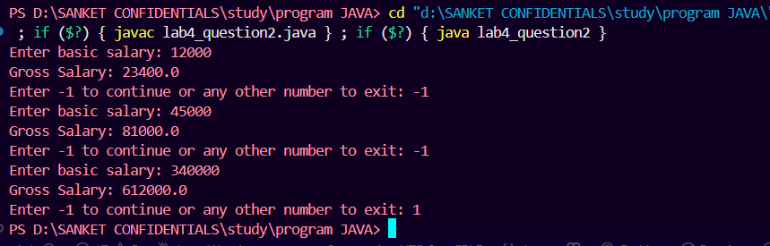

ASSIGNMENT 3

3. Write a program to count and print the total number of odd and even numbers from user inputs. Program will ask for user inputs in a loop. Loop will terminate if -1 is entered as input.

SOURCE CODE:

import java.util.Scanner;

public class lab4_question3 {

    public static void main(String[] args) {

        Scanner sc = new Scanner(System.in);

        int evenCount = 0, oddCount = 0;

        while (true) {

            System.out.print("Enter a number (-1 to stop): ");

            int num = sc.nextInt();

            if (num == -1) {

                break;

            }

            if (num % 2 == 0) {

                evenCount++;

            } else {

                oddCount++;

            }

        }

        System.out.println("Total even numbers: " + evenCount);

        System.out.println("Total odd numbers: " + oddCount);

    }

}

OUTPUT:

