Lab Assignment -3
Write a Java program that reads an input file from the file system and outputs the content of the file character by character. Use FileReader.read() method to read characters from the file. At the end, print the total number of characters present in the file.

Source code :
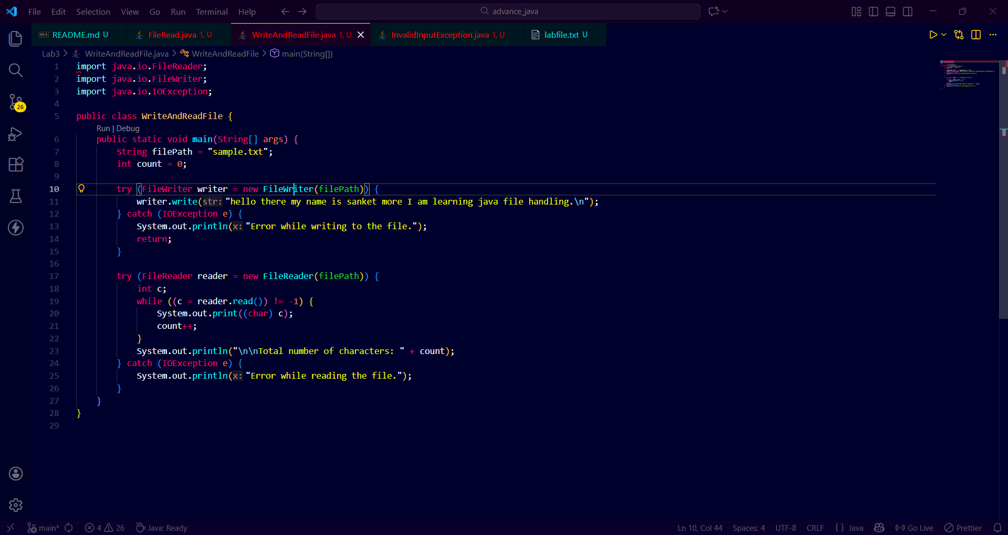
Output:
