Lab Assignment -4
1. Write a Java program that reads a file and throws an exception if the file is empty.
Source code :
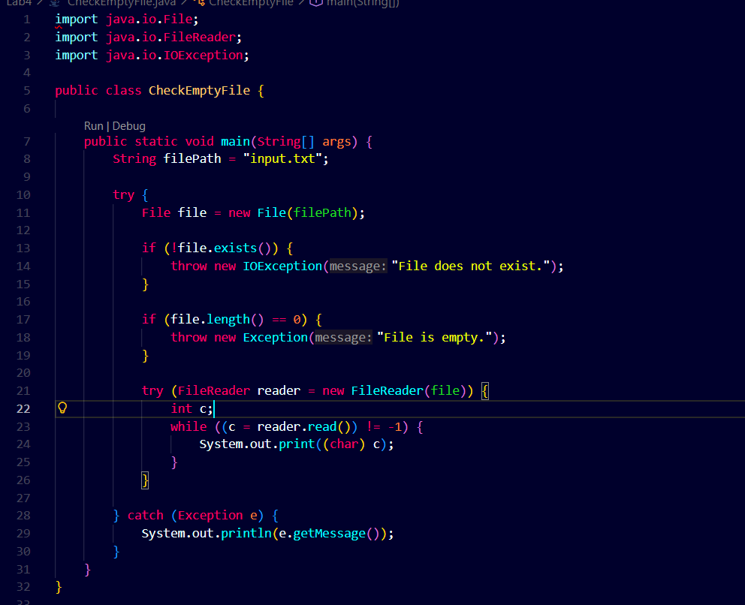
Output:
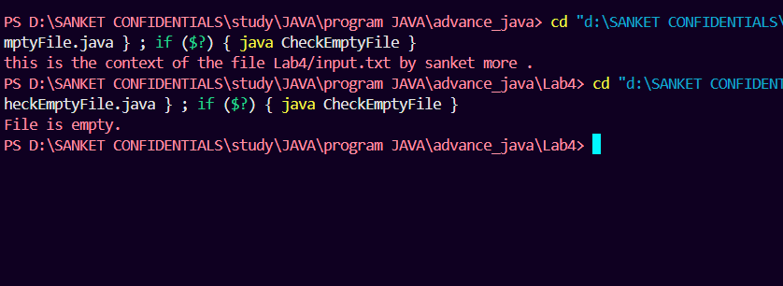
Lab Assignment – 4
2.
Design and implement a Java program that simulates two real-world validation scenarios using custom exceptions:
- Banking System Validation: Create a checked exception named InsufficientFundsException. Write a BankAccount class with a withdraw(double amount) method that throws this exception if the withdrawal amount exceeds the current balance. The exception should display the current balance and the deficit amount.
- Age Eligibility Validation: Create an unchecked exception named InvalidAgeException. Write a VoterRegistration class with a method validateAge(int age) that throws this exception if the provided age is less than 18, preventing the user from completing the registration.

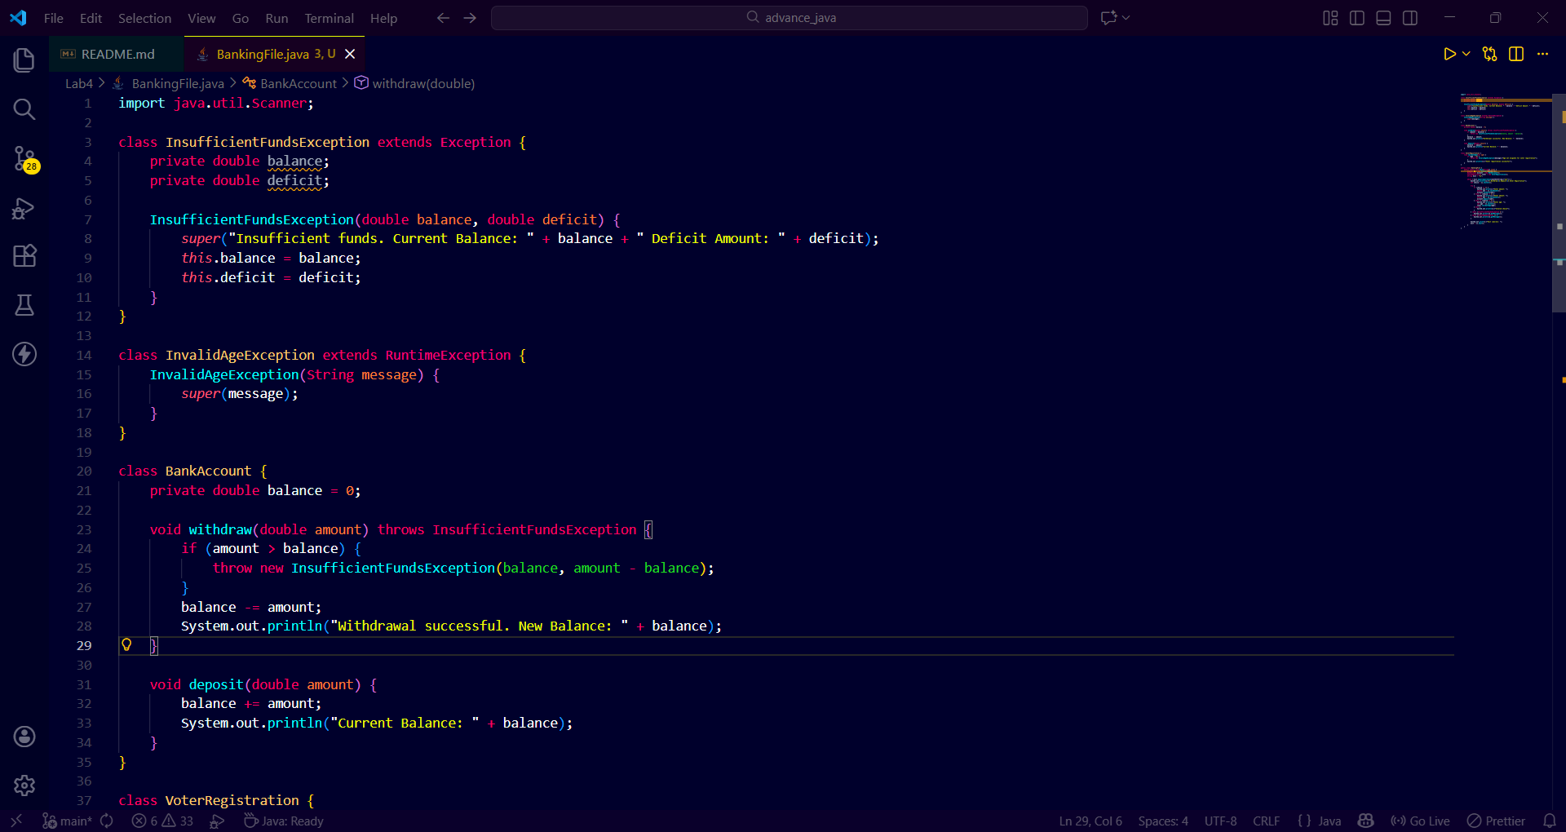
Source code :

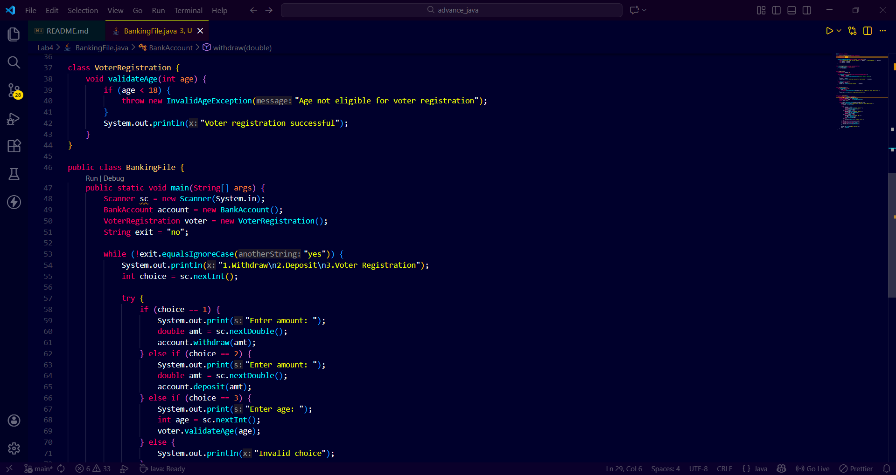

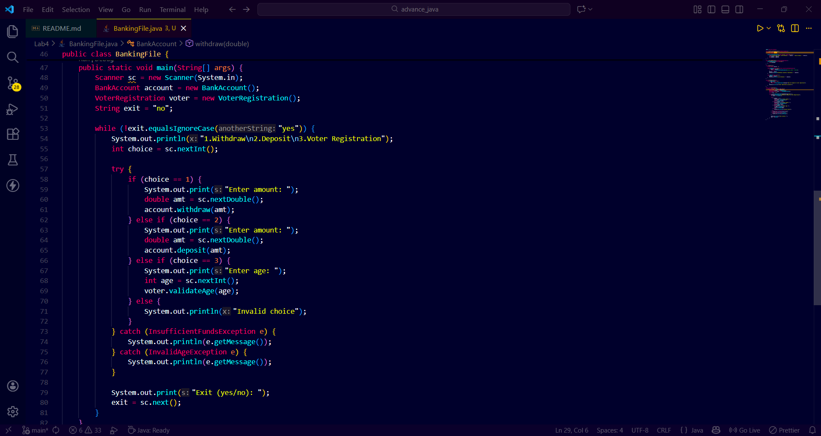

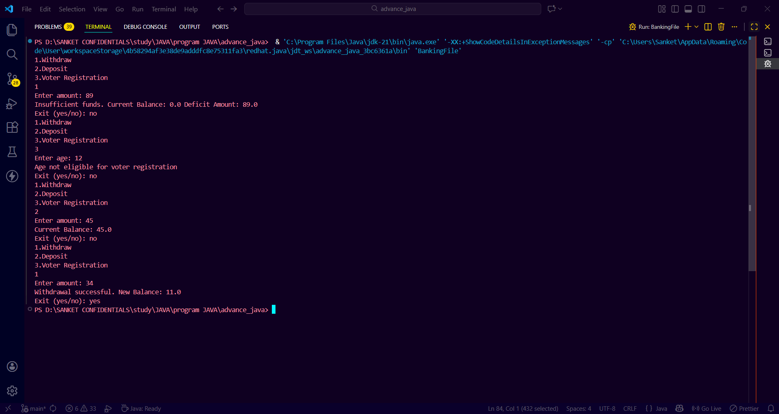
Output:

