Lab Assignment -1
1.Create a Java program that acts as a simple calculator.
● The program should prompt the user to enter two numbers and an operator (+, -, *, /).
● Perform the corresponding calculation based on the operator.
● Handle potential exceptions, such as division by zero or invalid operator input.
● Display the result or an appropriate error message.

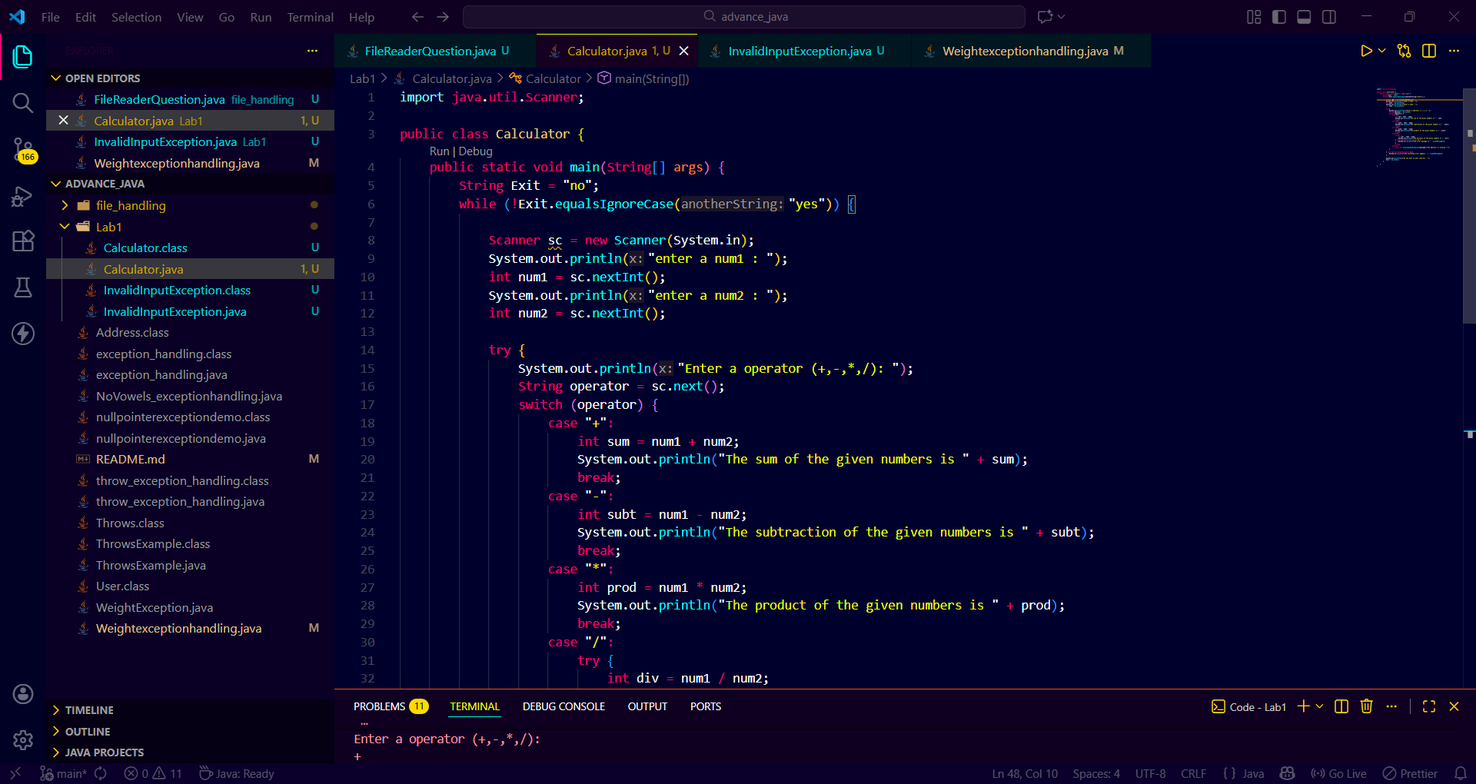
Source code :

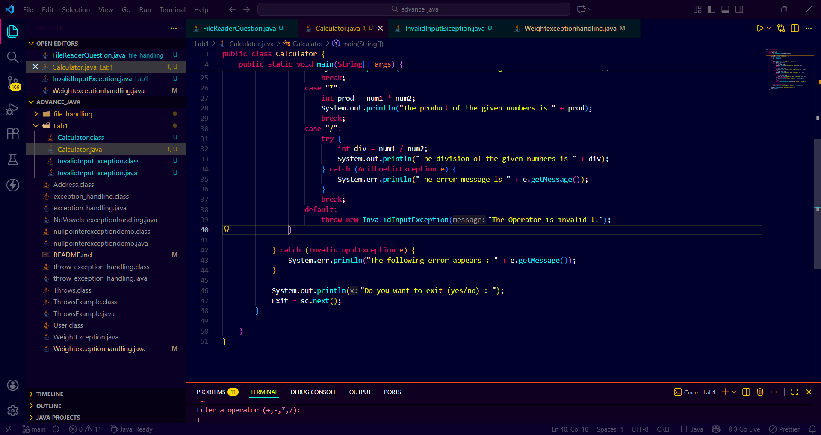

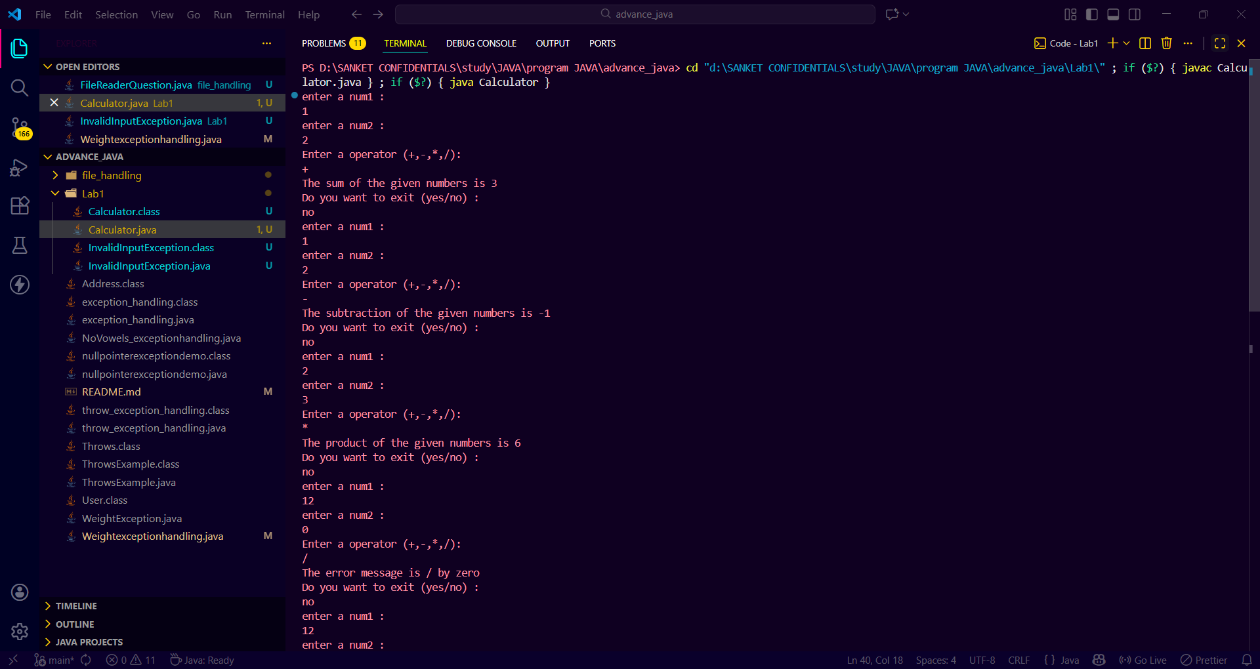
Output:

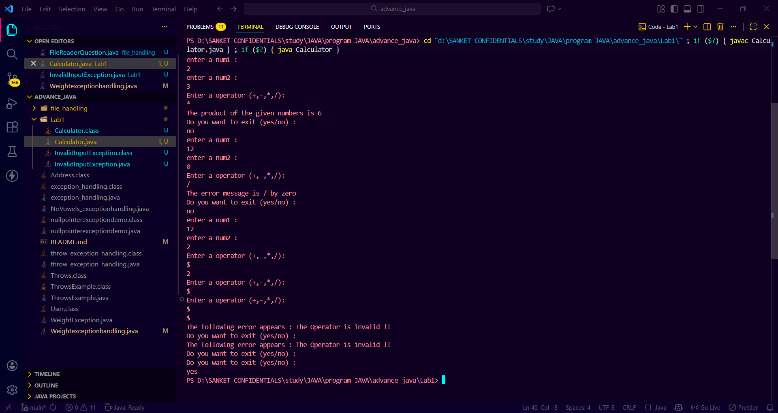

Lab Assignment 1
2.Write a Java program to simulate a simple banking application.
● Create a class BankAccount with a balance and methods for deposit and withdrawal.
● Implement exception handling for withdrawal operations to prevent overdrawing.
● Handle the scenario when the withdrawal amount is greater than the balance.

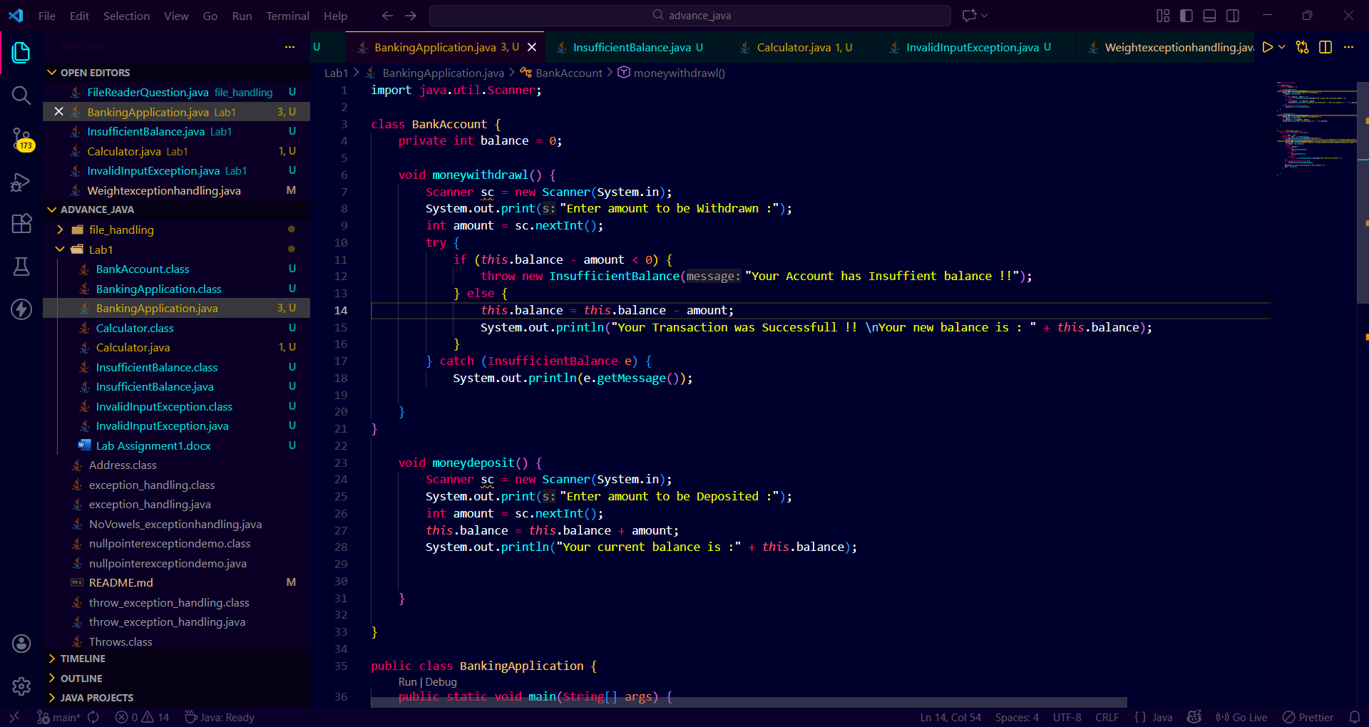
Source code :

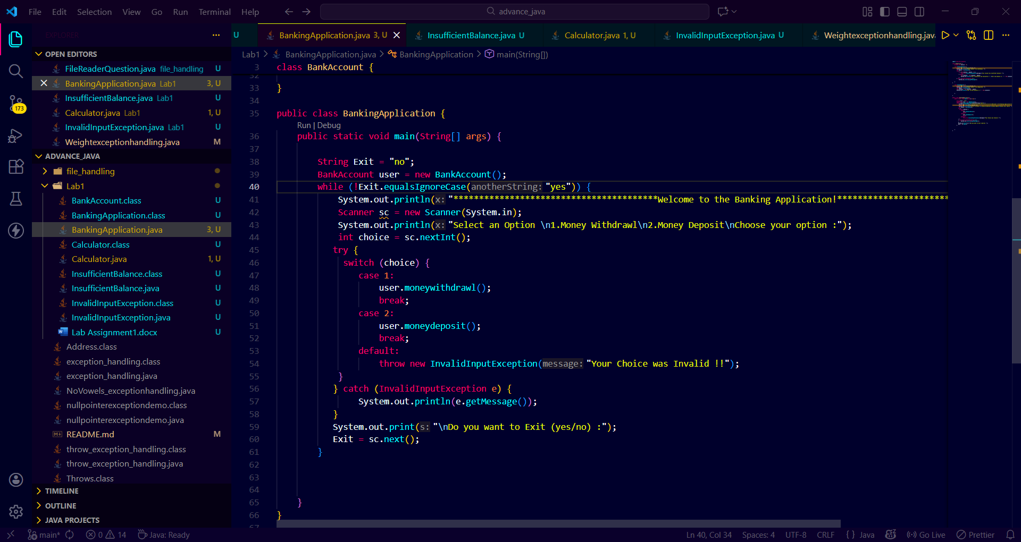

Output :
