ASSIGNMENT 1:
Write a Java program that demonstrates various operations on a 3D array: 1. Initializing the 3D array with random values. 2. Finding the maximum value in the array. 3. Calculating the average of all elements. 4. Displaying the array.

SOURCE CODE :
import java.util.Random;

public class lab6_Q1 {
public static void main(String[] args) {
int[][][] array = new int[3][3][3];

ThreeDArrayHelper helper = new ThreeDArrayHelper(array);
helper.initializeRandom();
helper.displayArray();
System.out.println("Maximum value: " + helper.findMax());
System.out.printf("Average of all elements: %.2f\n", helper.calculateAverage());
}
}

class ThreeDArrayHelper {
private int[][][] array;
private Random rand;

public ThreeDArrayHelper(int[][][] array) {
this.array = array;
this.rand = new Random();
}

public void initializeRandom() {
for (int i = 0; i < array.length; i++) {
for (int j = 0; j < array[i].length; j++) {
for (int k = 0; k < array[i][j].length; k++) {
array[i][j][k] = rand.nextInt(100);
}
}
}
}

public void displayArray() {
System.out.println("3D Array Elements:");
for (int i = 0; i < array.length; i++) {
System.out.println("Layer " + (i + 1) + ":"); // Each top-level index is a layer
for (int j = 0; j < array[i].length; j++) {
for (int k = 0; k < array[i][j].length; k++) {
System.out.print(array[i][j][k] + "\t");
}
System.out.println();
}
System.out.println();
}
}

public int findMax() {
int max = Integer.MIN_VALUE;
for (int[][] layer : array) {
for (int[] row : layer) {
for (int val : row) {
if (val > max) {
max = val;
}
}
}
}
return max;
}

public double calculateAverage() {
int sum = 0;
int count = 0;
for (int[][] layer : array) {
for (int[] row : layer) {
for (int val : row) {
sum += val;
count++;
}
}
}
return (double) sum / count;
}
}

OUTPUT:
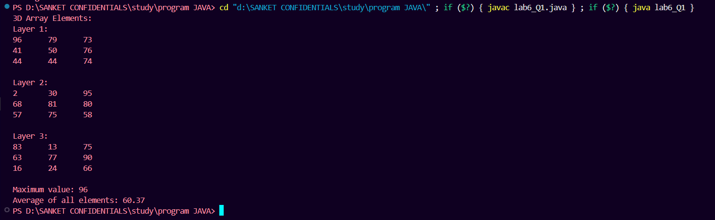

ASSIGNMENT 2 :
Write a Java program that performs addition of two matrices. The program should use a 2D array of wrapper class objects (e.g., Integer) for the matrix elements. Take two matrices as input, perform the addition operation, and display the resulting matrix

SOURCE CODE :
import java.util.Scanner;

public class lab6_Q2 {
public static void main(String[] args) {
Scanner scanner = new Scanner(System.in);

System.out.print("Enter number of rows: ");
int rows = scanner.nextInt();

System.out.print("Enter number of columns: ");
int cols = scanner.nextInt();

Integer[][] matrix1 = new Integer[rows][cols];
Integer[][] matrix2 = new Integer[rows][cols];
Integer[][] result = new Integer[rows][cols];

System.out.println("\nEnter elements of Matrix 1:");
for (int i = 0; i < rows; i++) {
for (int j = 0; j < cols; j++) {
System.out.print("Element [" + i + "][" + j + "]: ");
matrix1[i][j] = scanner.nextInt();
}
}

System.out.println("\nEnter elements of Matrix 2:");
for (int i = 0; i < rows; i++) {
for (int j = 0; j < cols; j++) {
System.out.print("Element [" + i + "][" + j + "]: ");
matrix2[i][j] = scanner.nextInt();
}
}

// Matrix Addition
for (int i = 0; i < rows; i++) {
for (int j = 0; j < cols; j++) {
result[i][j] = matrix1[i][j] + matrix2[i][j];
}
}

System.out.println("\nResultant Matrix after Addition:");
for (int i = 0; i < rows; i++) {
for (int j = 0; j < cols; j++) {
System.out.print(result[i][j] + "\t");
}
System.out.println();
}

scanner.close();
}
}

OUTPUT:
