ASSIGNMENT 1 :
● Write a Java program to create a class called Vehicle with a method called drive(). ● Vehicle should have attributes such as make (String), model (String) , year (int) and maximumSpeed (int). ● Create a constructor in Vehicle with all fields as constructor parameters. ● Create a subclass called Car and override constructor. Call super(). ● Write a function that overrides the drive() method to print (make + “ ” + model + " Car is driving". ) ● Also create another subclass Bike extending the vehicle class. ● Override the drive() method to print (make + “ ” + model + " Bike is driving". ) ● Instantiate both Bike and Car class. Print their attributes.
SOURCE CODE :
class Vehicle {
String make;
String model;
int year;
int maximumSpeed;

public Vehicle(String make, String model, int year, int maximumSpeed) {
this.make = make;
this.model = model;
this.year = year;
this.maximumSpeed = maximumSpeed;
}

public void drive() {
System.out.println("Vehicle is driving.");
}
}

class Car extends Vehicle {
public Car(String make, String model, int year, int maximumSpeed) {
super(make, model, year, maximumSpeed);
}

@Override
public void drive() {
System.out.println(make + " " + model + " Car is driving.");
}
}

class Bike extends Vehicle {
public Bike(String make, String model, int year, int maximumSpeed) {
super(make, model, year, maximumSpeed);
}

@Override
public void drive() {
System.out.println(make + " " + model + " Bike is driving.");
}
}

public class lab7_Q1 {
public static void main(String[] args) {
Car car = new Car("Honda", "Civic", 2023, 200);
Bike bike = new Bike("Yamaha", "FZ", 2021, 150);

System.out.println("Car Attributes:");
System.out.println("Make: " + car.make);
System.out.println("Model: " + car.model);
System.out.println("Year: " + car.year);
System.out.println("Max Speed: " + car.maximumSpeed);
car.drive();

System.out.println("\nBike Attributes:");
System.out.println("Make: " + bike.make);
System.out.println("Model: " + bike.model);
System.out.println("Year: " + bike.year);
System.out.println("Max Speed: " + bike.maximumSpeed);
bike.drive();
}
}

OUTPUT:
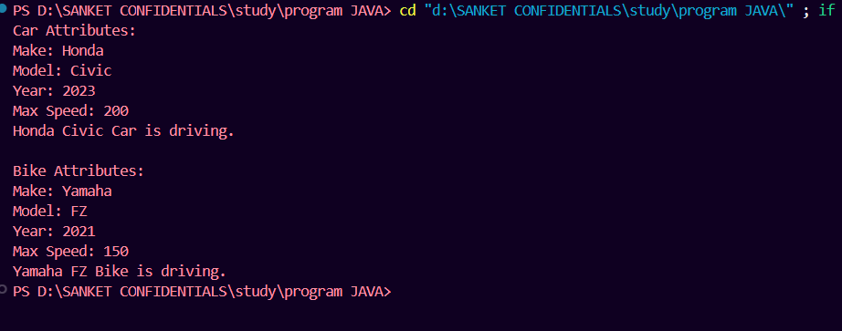

ASSIGNMENT 2:
● Write a Java program to create a class called Shape with a method called getArea(). ● Create a subclass called Circle and create a constructor that takes the value of radius(int) as input parameter. ● Override the getArea() method. ● Create a class called square that takes an attribute length. Create a constructor that takes length as input. ● Override the getArea() method. ● Create a subclass of Shape called Rectangle that takes width and height as input to the constructor. ● Override the getArea() method to calculate the area of a rectangle. Instantiate and call getArea() method.
SOURCE CODE :
abstract class Shape {
public abstract double getArea();
}

class Circle extends Shape {
private int radius;

public Circle(int radius) {
this.radius = radius;
}

@Override
public double getArea() {
return Math.PI * radius * radius;
}
}

class Square extends Shape {
private int length;

public Square(int length) {
this.length = length;
}

@Override
public double getArea() {
return length * length;
}
}

class Rectangle extends Shape {
private int width;
private int height;

public Rectangle(int width, int height) {
this.width = width;
this.height = height;
}

@Override
public double getArea() {
return width * height;
}
}

public class lab7_Q2 {
public static void main(String[] args) {
Circle circle = new Circle(5);
Square square = new Square(4);
Rectangle rectangle = new Rectangle(3, 6);

System.out.println("Area of Circle: " + circle.getArea());
System.out.println("Area of Square: " + square.getArea());
System.out.println("Area of Rectangle: " + rectangle.getArea());
}
}

OUTPUT:
