ASSIGNMENT 1
1.Create an abstract class Shape with an abstract method calculateArea(). Implement two subclasses, Circle and Rectangle, which inherit from Shape and provide their own implementations of calculateArea(). Write a program to calculate and print the areas of a circle and a rectangle
SOURCE CODE :
abstract class Shape {
abstract double calculateArea();
}

class Circle extends Shape {
double r;
Circle(double r) {
this.r = r;
}
double calculateArea() {
return 3.14159 * r * r;
}
}

class Rectangle extends Shape {
double l, w;
Rectangle(double l, double w) {
this.l = l;
this.w = w;
}
double calculateArea() {
return l * w;
}
}

public class lab8_Q1 {
public static void main(String[] args) {
Shape c = new Circle(7);
Shape r = new Rectangle(5, 10);
System.out.println("Circle Area: " + c.calculateArea());
System.out.println("Rectangle Area: " + r.calculateArea());
}
}

OUTPUT:
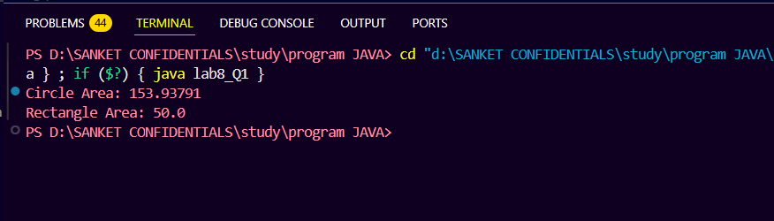

ASSIGNMENT 2 :
2. Write a Java program that demonstrates method overriding by creating a superclass called Animal and two subclasses called Dog and Cat. ● TheAnimal class should have a method called makeSound(), which simply prints "The animal makes a sound." ● TheDogandCatclasses should override this method to print "TheCat/The dog meows/barks" respectively. ● Theprogram should allow the user to create and display objects of each class. [Hint:Use multilevel inheritance

SOURCE CODE :
import java.util.Scanner;

class Animal {
void makeSound() {
System.out.println("The animal makes a sound.");
}
}

class Dog extends Animal {
void makeSound() {
System.out.println("The dog barks.");
}
}

class Cat extends Dog {
void makeSound() {
System.out.println("The cat meows.");
}
}

public class Main {
public static void main(String[] args) {
Scanner sc = new Scanner(System.in);
System.out.println("Enter animal type (animal/dog/cat): ");
String input = sc.nextLine().toLowerCase();

Animal obj;

if (input.equals("dog")) {
obj = new Dog();
} else if (input.equals("cat")) {
obj = new Cat();
} else {
obj = new Animal();
}

obj.makeSound();
sc.close();
}
}

OUTPUT :
