OUR SCHOOL
My timetable
MONDAY | TUESDAY | WEDNESDAY | THURSDAY | FRIDAY
English | Russian | Geography | Kazakh | English
Maths | ICT | Russian | PE | Maths
PE | Kazakh | History | Music | ICT
Art and Design | Maths | Kazakh | Russian | Kazakh
Music | History | Biology | English
Kazakh | PE | Maths
My school uniform
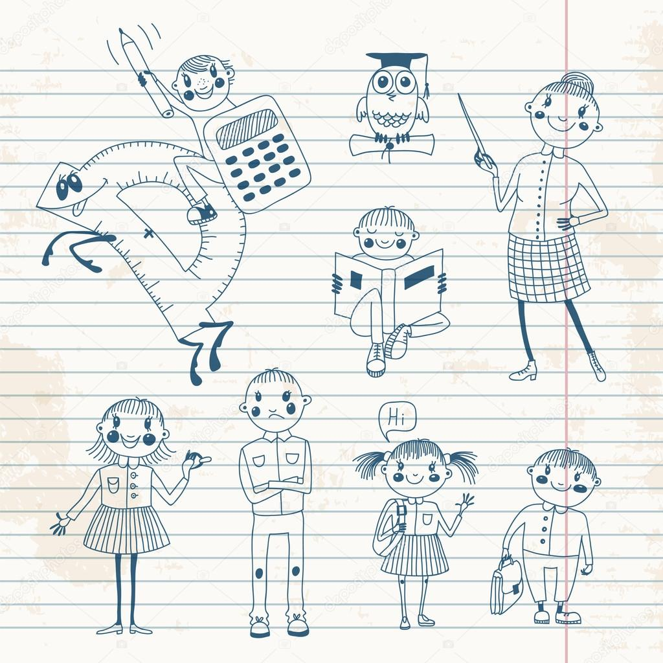

My teachers
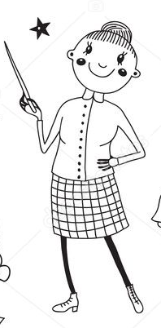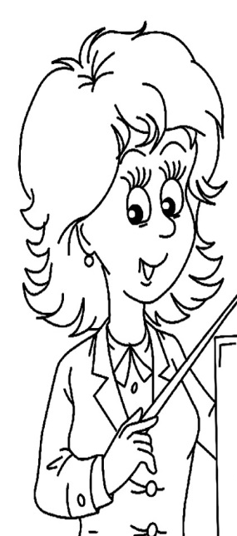
This is my Russian teacher. This is my PE teacher. This is my Maths teacher.
Her name is Victoria His name is Sergei Her name is Aigul Nikolaevna. Vladimirovich Serikovna

My favourite subject
My favourite subject is English. I have two English lessons in a week. My English teacher’s name is Natalia Sergeevna. She is very nice and kind.

