OUR SCHOOL
_________________
MONDAY | TUESDAY | WEDNESDAY | THURSDAY | FRIDAY
__________________
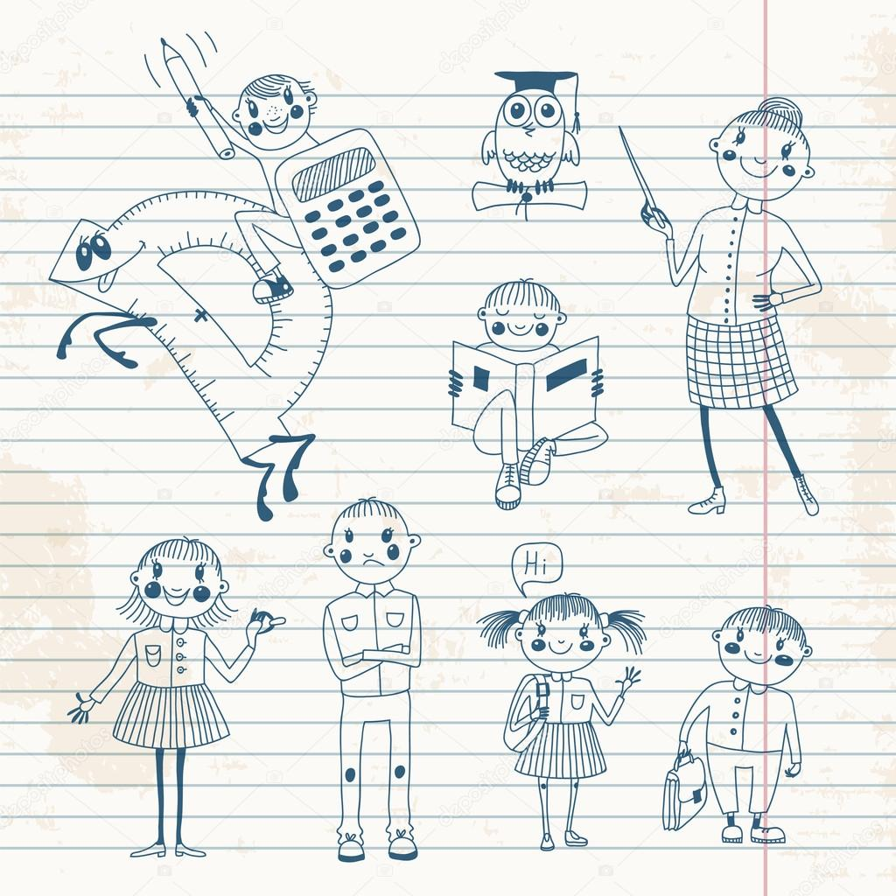
OUR SCHOOL
_________________
MONDAY | TUESDAY | WEDNESDAY | THURSDAY | FRIDAY
__________________
___________________
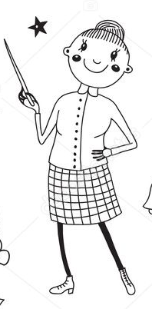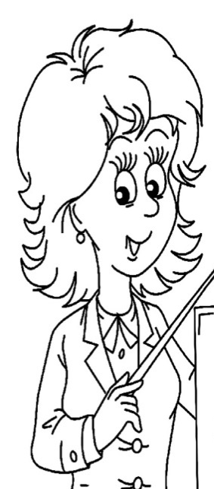
This is my This is my This is my
_____________teacher. _________teacher. ____________teacher.
Her name is His name is Her name is
________________________ ______________________ _______________________
________________________ ______________________ _______________________

_______________________
____________________________________________________________________________________________________________________________________________________

___________________
This is my This is my This is my
_____________teacher. _________teacher. ____________teacher.
Her name is His name is Her name is
________________________ ______________________ _______________________
________________________ ______________________ _______________________

_______________________
____________________________________________________________________________________________________________________________________________________

