Building a Domain-Specific Retrieval-Augmented Generation System for Australian Building Deconstruction
M. Reza Hosseiniand K.A.D.M.Natasha
ABSTRACT
Australian policy and regulatory documents related to building deconstruction and the circular economy are widely dispersed across federal, state, and local government and regional sources, creating a large, fragmented body of knowledge that is difficult for practitioners and users to navigate. To address this, this study aims to develop and validate a Retrieval-Augmented Generation (RAG) system that transforms the fragmented landscape of Australian building deconstruction and circular economy policy documents into an accessible, queryable computational knowledge infrastructure, by addressing three critical challenges: dispersed regulatory information, limited semantic search capabilities for policy intelligence, and the absence of scalable frameworks for cross-jurisdictional policy comparison. By combining document extraction, semantic filtering, vector-based retrieval, and large language model generation, the platform enables evidence-based policy analysis, practitioner guidance, and comparative governance research across Australian jurisdictions with extensibility to international contexts.
Keywords: Building Deconstruction, Circular Economy, Large language models, Retrieval-Augmented Generation, Policy Intelligence, Semantic Search

INTRODUCTION
In Australia, the architecture, engineering, and construction (AEC) industry is a significant contributor to the nation's economy(Shooshtarian et al., 2022). However, the growth in AEC has resulted in increased construction and demolition (C&D) waste generation and resource utilization(Shooshtarian et al., 2022). Australia has one of the highest per-capita material footprints among developed nations, underscoring the construction sector’s urgent need to improve material efficiency and transition towards a circular economy (Arehart et al., 2024). Additionally, the C&D waste stream is the main source of solid waste in Australia, producing between 26.8 and 29 million tonnes a year, or around 38% to 44% of all waste. In 2022-23, an estimated 26.8 Mt of building and demolition materials waste was reported(DCCEEW, 2025). Despite recovery and recycling rates of approximately 76–77%, substantial waste persists in the sector, with the value of discarded resources projected to reach up to AUD 64 billion by 2030(Green Building Council of Australia, 2025).
An important role in buildings’ circularity is played by deconstruction, which is the ability to dismantle the building part by part, avoiding damage, in anticipation of maintaining the value by reuse in different contexts, as an alternative to the classic demolition, which tends to be an arbitrary and destructive process(Bertino et al., 2021). Policy and regulatory leadership can enable and support grounding circular economy practices at the national and state levels(Iyer-Raniga et al., 2023). Australian policy and regulatory frameworks relevant to building deconstruction and circular economy comprise national waste policies, state and territory waste and circular economy strategies, landfill levy regimes, and industry-led sustainability frameworks(Iyer-Raniga et al., 2023). The current policy environment can be broadly characterised as fragmented, as different facets of the circular economy are covered by various policies(Senaratne et al., 2025). This disorganised approach makes compliance difficult and complicates regulations(Senaratne et al., 2025). Given the fragmented nature of the body of knowledge, at present, building deconstruction and circular economy-related policies, regulations, and procedures are accessed manually through keyword-based search engine retrievals, government portals, document reviewing, and expert consultation, with limited support for semantic, cross-jurisdictional policy intelligence or integrated AI-assisted retrieval. As a result, at present, practitioners face issues such as regulatory information scattered across federal, state, and local government documents, a lack of semantic search capabilities for policy intelligence, and the absence of scalable frameworks for cross-jurisdictional policy comparison, for which RAG systems are designed to address through semantic retrieval, document consolidation, and scalable, source-grounded policy analysis(Lewis et al., 2020).
Advances in Large Language Models (LLMs) and Retrieval-Augmented Generation (RAG) techniques offer a potential solution by enabling AI systems to generate grounded, context-aware guidance (Athulathmudali, 2025). Similar systems are currently being studied to be implemented in many domains. Furthermore, prior studies rarely address the challenges of constructing curated, provenance-rich policy corpora or systematically validating RAG performance in regulatory contexts. This study aims to develop and validate a RAG system that transforms the fragmented landscape of Australian building deconstruction and circular economy policy documents into an accessible, queryable computational knowledge infrastructure. This approach allows for rigorous processing of diverse PDF documents, overcoming limitations of traditional manual policy analysis, such as document volume constraints, analyst fatigue, and lack of replicability, while providing complete audit trails linking answers to specific policy clauses and page numbers.
By combining document extraction, semantic filtering, vector-based retrieval, and large language model generation, the platform enables evidence-based policy analysis, practitioner guidance, and comparative governance research across Australian jurisdictions with potential for application in international contexts.
Accordingly, this study aims to achieve 4 objectives. First, to systematically assemble and quality validate the Australian deconstruction policy corpus by collecting a minimum of 80 source documents with balanced jurisdictional coverage across all eight states and territories, yielding over 300 high-quality chunks with 100% provenance metadata. Second, to design and implement a ChromaDB-based RAG architecture by establishing an operational database collection with a minimum of 300 indexed chunks, under 3 seconds of query response time with retrieval Precision@5 exceeding 80%, jurisdictional filter accuracy above 90%, and 100% source citation traceability. Thirdly, to systematically validate RAG System’s performance and answer quality by ensuring more than 80% accuracy in the top 5 answers and more than 85% of expert-rated answer accuracy and usefulness, with proven 100% citation accuracy and demonstrated superiority over keyword search. Finally, to demonstrate cross-jurisdictional scalability through UK policy integration, with at least 10 UK policy documents successfully processed, chunks indexed using the jurisdiction = ‘UK’ tag, successful execution of a minimum of 3 comparative Australia–UK queries, and documented schema mapping to support future Canadian expansion.

The contributions of this study extend to both practice and research. Practically, it demonstrates how AI systems can provide accurate, low-cost guidance for practitioners to implement policies and regulations relevant to building deconstruction and the circular economy in Australia and comparable international contexts. Academically, it explores the application of RAG for the domain of building studies while bridging policy studies and AI.

Literature review

Retrieval-Augmented Generation (RAG)
Retrieval-Augmented Generation (RAG), introduced by Lewis et al. (2020), is an AI framework that combines LLMs with external document retrieval systems to generate responses that draw on both the model’s internal knowledge (parametric memory) and relevant information retrieved from external data sources (Lewis et al., 2020). It retrieves relevant information from external knowledge bases before answering questions with LLMs by demonstrating significant enhancements in answer accuracy, reducing model hallucination, particularly for knowledge-intensive tasks (Gao et al., 2023). RAG systems' increased adaptability and advantages over conventional LLMs have created new use cases and sparked a lot of interest in business applications (Ammann et al., 2025).
The basic architecture of RAG mainly consists of 3 stages, including data pre-processing, a retrieval component, and a text-generating language model (Polan, 2025). First, data from external sources is divided into smaller text chunks, which are then converted into vector embeddings and indexed for efficient retrieval(Polan, 2025). When a user query is received, it is converted into a vector using the same embedding model, where the most similar vectors and the top relevant text chunks are retrieved(Polan, 2025). In the generation stage, the original user query and the retrieved relevant text chunks are combined and fed into the language model to generate a response(Polan, 2025).

Applications of RAG
RAG models are widely used in domains requiring factual accuracy and contextual understanding, particularly in open-domain question answering (Gupta et al., 2024)Recent studies also highlight RAG’s potential for knowledge-intensive tasks and for a broad range of language-based applications, enabling more accurate and up-to-date outputs (Fan et al., 2024). RAG systems are widely used in Natural Language Processing (NLP) applications such as Question Answer (QA) Systems, Chatbots, and Fact Verification(Fan et al., 2024). The same author discusses the application in both finance and software engineering. Similar systems are currently being studied to be implemented in many domains, such as healthcare applications, which can retrieve and integrate the most recent research findings or patient-specific data to produce precise diagnostic recommendations, the legal and regulatory sector, where the model can retrieve pertinent case law or statutes to offer legally sound advice, the enterprise knowledge management sector, and the building sectors(Abo El-Enen et al., 2025; Balaji et al., 2026; Gupta et al., 2024; Karakurt and Akbulut, 2026; Keisha et al., 2025). Recently, the potential of RAG has extended beyond natural language processing, with emerging methods integrating retrieval-augmented strategies into the computer vision (CV) domain on visual understanding and visual content generation(Zheng et al., 2025). Also, studies are done on the use of RAG in embodied AI applications such as planning, task execution, multimodal perception, interaction with environments, and other specialized domains(Zheng et al., 2025).

RESEARCH METHODOLOGY
This study applies a reproducible seven-stage computational workflow to transform fragmented Australian policy documents into a queryable RAG system with end-to-end source traceability. The pipeline combines multi-engine PDF extraction, semantic chunking, LLM-assisted filtering, vector indexing, and source-grounded answer generation. Implementation was completed in Python within Google Colab and packaged in a public repository to support transparent replication and reuse in other policy domains.
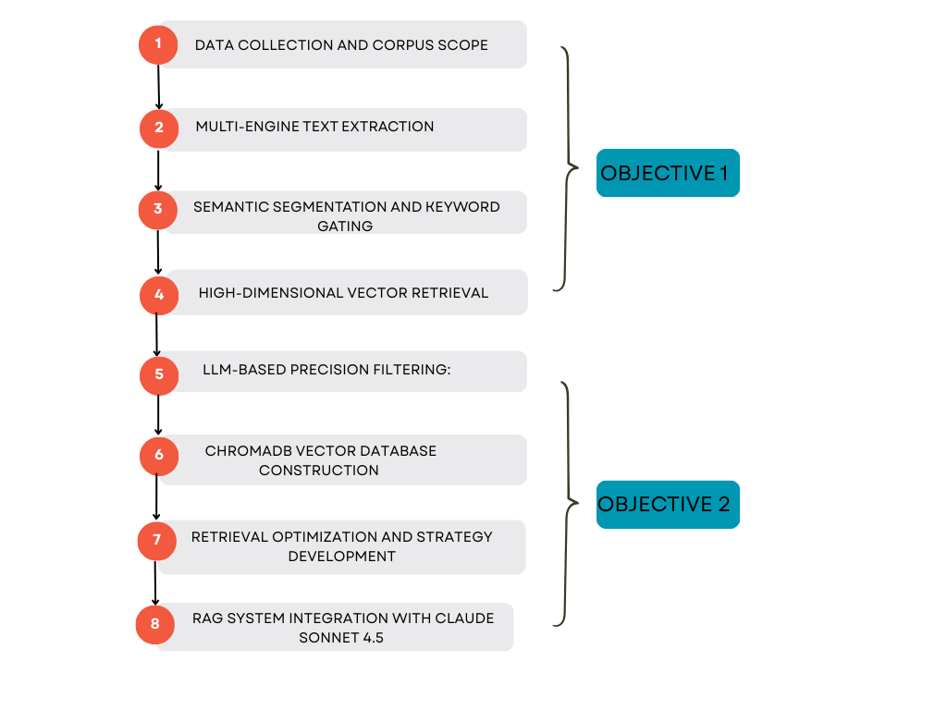
Figure 1-Seven-Stage Pipeline Architecture

Stage 1 - Data Collection and Corpus Scope
The corpus was assembled through systematic collection from Australian federal, state, and territory government portals, statutory sources, and official regulatory repositories. Inclusion criteria retained authoritative documents (2015-2024) covering deconstruction, selective demolition, reuse, circular economy policy, and construction and demolition waste governance. The final corpus includes 95 documents. To handle heterogeneous layouts and scanned pages, text extraction used a tiered process with pdfplumber, PyMuPDF, and OCR fallback where required.

Stage 2 - Semantic Segmentation and Keyword Gating
Extracted text was segmented into metadata-preserving chunks using a recursive character-based splitting strategy. Chunking parameters were tuned to preserve semantic continuity while maintaining retrieval efficiency. Domain keyword gating was then applied to retain segments relevant to deconstruction, circular economy, material reuse, and policy implementation, creating a focused candidate pool for downstream retrieval.
This stage produced a provenance-rich candidate set for semantic retrieval and precision filtering.

Stage 3 - High-Dimensional Vector Retrieval
Candidate chunks were embedded into dense vectors and evaluated through semantic similarity retrieval. During development, FAISS-based retrieval was used to test recall behavior under policy-focused prompt sets. This retrieval stage established initial relevance ranking for each query and generated candidates for LLM-based precision assessment.

Stage 4 - LLM-Based Precision Filtering (LLM Judge)
GPT-4.1 was used as a deterministic LLM Judge to classify retrieved chunks as Keep, Maybe, or Drop against policy-relevance criteria. Human verification was used to calibrate confidence and check agreement on edge cases. The retained set formed the final high-quality corpus (364 chunks across 95 source files), with each record preserving explicit provenance metadata for traceable downstream use.

Stage 5 - ChromaDB Vector Database Construction
The retained corpus (95 source files, 364 validated chunks) was indexed in a persistent ChromaDB collection. Chunks were embedded with OpenAI text-embedding-3-small and stored with chunk_id, source_file, page metadata, and chunk index. For reproducibility, the vector store is rebuilt from scratch at each run before batch insertion, ensuring a clean and auditable index state.

Stage 6 - Retrieval Optimization and Strategy Development
Operational retrieval uses deterministic semantic top-k search over ChromaDB, with metadata returned alongside content for transparent evidence tracing. Retrieval settings were tuned for stable, repeatable behavior in policy question-answering tasks, prioritizing citation fidelity and source verifiability over aggressive post-retrieval reranking.

Stage 7- RAG System Integration with OpenAI LLM
The retrieval module was integrated with an OpenAI generation model (gpt-4.1-mini) in a Google Colab implementation. For each user query, the system retrieves the most relevant chunks, composes a constrained context window, and instructs the model to answer strictly from retrieved evidence. A lightweight Gradio interface operationalizes the workflow and outputs citations (chunk_id and source metadata) with every response.

Implementation Procedure for Public Reproducibility
To enable public validation and reuse, the complete implementation was packaged in a repository structure containing source chunk data, notebook code, and runtime folders (data/, notebooks/, chroma_db/). A Colab-ready notebook documents each step (dependency setup, secret loading, corpus ingestion, index construction, retrieval testing, and interactive deployment via Gradio). The final interface supports question-answering over the indexed corpus and returns source-grounded citations for each response, providing an end-to-end, reproducible reference workflow for future domain adaptation.

RAG in action
This section demonstrates the deployed RAG interface in operation. Users submit natural-language policy questions, the system retrieves semantically relevant chunks from the indexed corpus, and the LLM returns grounded answers with explicit source citations. The screenshots below illustrate representative question-answer interactions and citation transparency in the working interface.
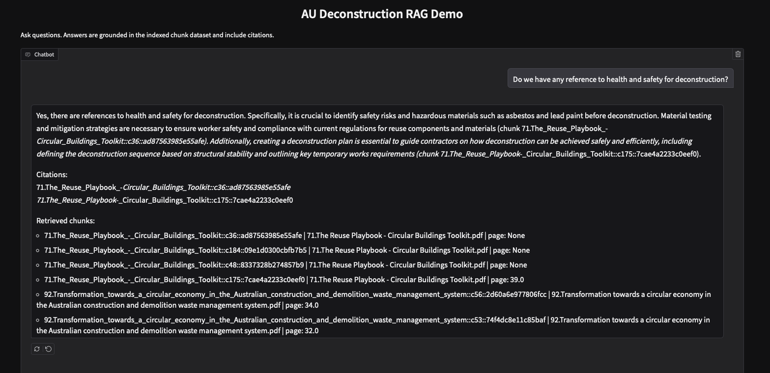
Figure 2. RAG demo screenshot showing user query, grounded response, and chunk-level citations.
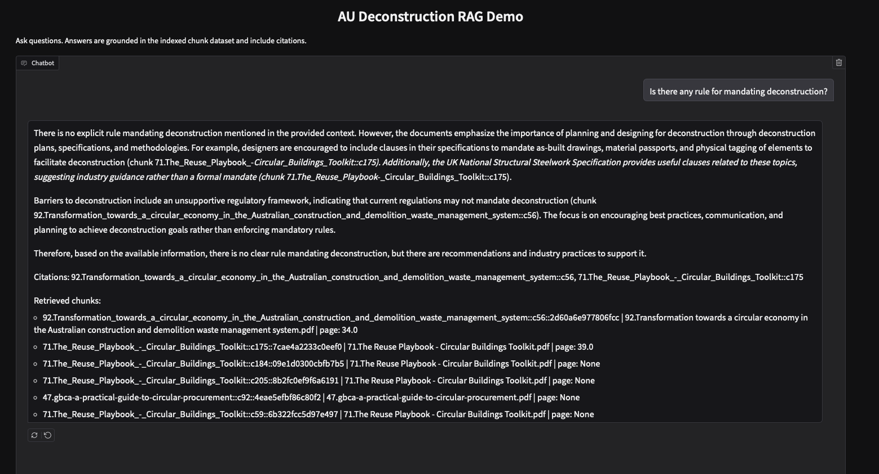
Figure 3. RAG demo screenshot showing user query, grounded response, and chunk-level citations.

CONCLUSIONS
This RAG system provides practical value for practitioners by reducing search time across fragmented policy sources and delivering source-grounded answers that can be audited at chunk level. For built-environment professionals, regulators, and consultants, the workflow supports faster interpretation of deconstruction and circular economy requirements while preserving evidentiary traceability for decision support.
From a research perspective, assembling and validating 364 high-quality chunks across 95 official documents advances the domain knowledge base by consolidating dispersed regulatory content into a computable, queryable corpus. This structured evidence layer strengthens theory development in policy implementation and cross-jurisdictional comparison, while also establishing a reliable educational resource for teaching policy intelligence, RAG design, and evidence-based AI workflows in higher education and professional training contexts.

REFERENCES
Abo El-Enen, M., Saad, S. and Nazmy, T. (2025), “A survey on retrieval-augmentation generation (RAG) models for healthcare applications”, Neural Computing and Applications 2025 37:33, Springer, Vol. 37 No. 33, pp. 28191–28267, doi: 10.1007/s00521-025-11666-9.
Ammann, L., Ott, S., Landolt, C.R. and Lehmann, M.P. (2025), “Securing Rag: A Risk Assessment and Mitigation Framework”, Proceedings - Swiss Conference on Data Science, SDS, Institute of Electrical and Electronics Engineers Inc., pp. 127–134, doi: 10.1109/SDS66131.2025.00024.
Arehart, J.H., Pomponi, F., D’Amico, B. and Srubar, W. V. (2024), “A material stock and flow analysis for Australian detached residential houses: Insights and challenges”, Resources, Conservation and Recycling, Elsevier, Vol. 200, p. 107289, doi: 10.1016/j.resconrec.2022.106583.
Athulathmudali, A. (2025), “AI for Legal Domain Identification and Guidance in Sri Lankan Law”, International Journal of Innovative Science and Research Technology, International Journal of Innovative Science and Research Technology, p. 609, doi: 10.38124/ijisrt/25dec441.
Balaji, B., Bhattacharya, A., Fierro, G., Gao, J., Gluck, J., Hong, D., Johansen, A., et al. (2026), “BuildingGPT: Query building semantic data using large language models and vector-graph retrieval-augmented generation”, Building and Environment, Pergamon, Vol. 287, p. 113855, doi: 10.1016/j.apenergy.2018.02.091.
Bertino, G., Kisser, J., Zeilinger, J., Langergraber, G., Fischer, T. and Österreicher, D. (2021), “Fundamentals of Building Deconstruction as a Circular Economy Strategy for the Reuse of Construction Materials”, Applied Sciences 2021, Vol. 11, Page 939, Multidisciplinary Digital Publishing Institute, Vol. 11 No. 3, p. 939, doi: 10.3390/app11030939.
DCCEEW. (2025), “At a glance - DCCEEW”, 6 January, available at: https://www.dcceew.gov.au/environment/protection/waste/publications/national-waste-resource-recovery-reporting/glance-2024 (accessed 18 February 2026).
Gao, Y., Xiong, Y., Gao, X., Jia, K., Pan, J., Bi, Y., Dai, Y., et al. (2023), “Retrieval-Augmented Generation for Large Language Models: A Survey”, p. 32, doi: https://doi.org/10.48550/arXiv.2312.10997.
Green Building Council of Australia. (2025), “$64 billion in building materials at risk of going to waste, new report reveals”, 26 June, available at: https://new.gbca.org.au/news/gbca-media-releases/64-billion-in-building-materials-at-risk-of-going-to-waste-new-report-reveals/ (accessed 18 February 2026).
Iyer-Raniga, U., Gajanayake, A. and Ho, O.T.K. (2023), “The Transition to a Circular Built Environment in Australia: An Analysis of the Jurisdictional Policy Framework”, Environmental Policy and Law, SAGE PublicationsSage UK: London, England, Vol. 53 No. 4, pp. 233–246, doi: 10.3233/EPL-220073.
Karakurt, E. and Akbulut, A. (2026), “Retrieval-Augmented Generation (RAG) and Large Language Models (LLMs) for Enterprise Knowledge Management and Document Automation: A Systematic Literature Review”, Applied Sciences (Switzerland), Multidisciplinary Digital Publishing Institute (MDPI), Vol. 16 No. 1, p. 368, doi: 10.3390/app16010368.
Keisha, F., Singh, P., Pallavi, Fernandes, D., Manivannan, A., Wicaksono, I., Ahmad, F., et al. (2025), “All for law and law for all: Adaptive RAG Pipeline for Legal Research”, arXiv.org (Cornell University), pp. 1–14.
Lewis, P., Perez, E., Piktus, A., Petroni, F., Karpukhin, V., Goyal, N., Küttler, H., et al. (2020), “Retrieval-Augmented Generation for Knowledge-Intensive NLP Tasks”, Advances in Neural Information Processing Systems, Vol. 33, pp. 9459–9474.
Senaratne, S., Jayakodi, S. and Perera, S. (2025), “Closing the loop: towards an Australian circular economy policy for the built environment”, The Policymaker, James Martin Institute for Public Policy, Vol. 14 May 2025.
Shooshtarian, S., Maqsood, T., Caldera, S. and Ryley, T. (2022), “Transformation towards a circular economy in the Australian construction and demolition waste management system”, Sustainable Production and Consumption, Elsevier, Vol. 30, pp. 89–106, doi: 10.1016/j.spc.2021.11.032.

Designation, Department, University or Company, Country, E-mail
Designation, Department, University or Company, Country, E-mail

