Unsupervised evaluation with care score…….
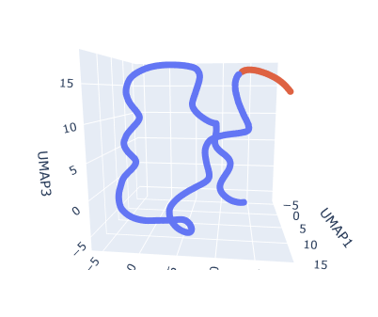
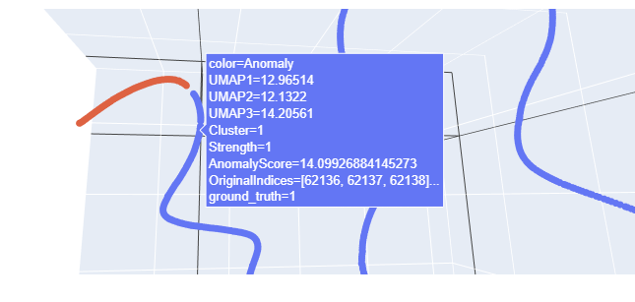
For dataset 44
📍 Coverage Fβ: 0.9709
✅ Accuracy (Normal): 0.6467
📦 Reliability Fβ: 1.0000
⏱️ Earliness Score: 0.2906
🎯 Final CARE Score: 0.6397

For Dataset 81
📍 Coverage Fβ: 0.7961
✅ Accuracy (Normal): 0.0000
📦 Reliability Fβ: 1.0000
⏱️ Earliness Score: 0.1670
🎯 Final CARE Score: 0.0000
For dataset 47

📍 Coverage Fβ: 0.5576
✅ Accuracy (Normal): 0.1748
📦 Reliability Fβ: 1.0000
⏱️ Earliness Score: 0.6429
🎯 Final CARE Score: 0.1748

For Dataset 79
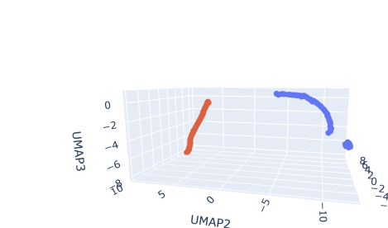
📍 Coverage Fβ: 0.6991
✅ Accuracy (Normal): 0.6620
📦 Reliability Fβ: 0.0000
⏱️ Earliness Score: 0.0000
🎯 Final CARE Score: 0.2722

For Dataset 76
📍 Coverage Fβ: 0.5013
✅ Accuracy (Normal): 0.5000
📦 Reliability Fβ: 0.0000
⏱️ Earliness Score: 0.0000
🎯 Final CARE Score: 0.2003

FOR DATASET 5(WORST)
📍 Coverage Fβ: 0.8192
✅ Accuracy (Normal): 0.0000
📦 Reliability Fβ: 1.0000
⏱️ Earliness Score: 0.7226
🎯 Final CARE Score: 0.0000

FOR DATASET 31
📍 Coverage Fβ: 0.3382
✅ Accuracy (Normal): 0.2874
📦 Reliability Fβ: 1.0000
⏱️ Earliness Score: 0.0956
🎯 Final CARE Score: 0.2874

FOR DATASET 90

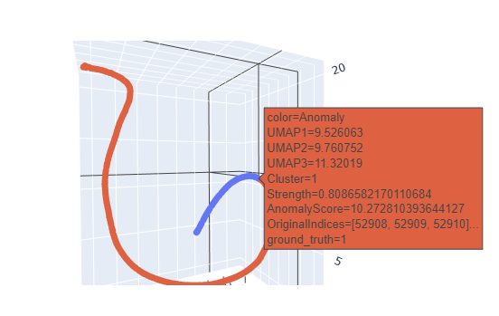
📍 Coverage Fβ: 0.8765
✅ Accuracy (Normal): 0.5053
📦 Reliability Fβ: 1.0000
⏱️ Earliness Score: 0.1093
🎯 Final CARE Score: 0.5201

For Supervised Learning

For dataset 44(benchmark)
{'gt_start': '2023-08-03 14:00:00', 'pred_start': '2023-08-03 09:30:00', 'lead_time_steps': 27, 'lead_time_minutes': 270, 'lead_time_readable': '0d 4h 30m', 'peak_confidence': 0.6135766798743759}

📍 Coverage Fβ: 0.22170411191182704
✅ Accuracy (Normal): 0.933531746031746
📦 Reliability Fβ: 0.07692307692307693
⏱️ Earliness Score: 0.045036822973635676
🎯 Final CARE Score: 0.26444651616278425

For Dataset 49
{'gt_start': '2023-04-01 00:00:00', 'pred_start': '2023-03-30 05:10:00', 'lead_time_steps': 257, 'lead_time_minutes': 2570, 'lead_time_readable': '1d 18h 50m', 'peak_confidence': 0.661474425739999}
📍 Coverage Fβ: 0.1455
✅ Accuracy (Normal): 0.9375
📦 Reliability Fβ: 0.0877
⏱️ Earliness Score: 0.0807
🎯 Final CARE Score: 0.2664

For Dataset 55
{'gt_start': '2023-10-29 11:30:00', 'pred_start': '2023-10-27 11:30:00', 'lead_time_steps': 288, 'lead_time_minutes': 2880, 'lead_time_readable': '2d 0h 0m', 'peak_confidence': 0.9645079784937108}
📍 Coverage Fβ: 0.3424
✅ Accuracy (Normal): 0.2056
📦 Reliability Fβ: 0.0562
⏱️ Earliness Score: 0.2753
🎯 Final CARE Score: 0.2056

For Dataset 81
{'gt_start': '2023-11-16 01:30:00', 'pred_start': '2023-11-15 21:50:00', 'lead_time_steps': 22, 'lead_time_minutes': 220, 'lead_time_readable': '0d 3h 40m', 'peak_confidence': 0.5007802318629536}
📍 Coverage Fβ: 0.7769
✅ Accuracy (Normal): 0.9157
📦 Reliability Fβ: 0.1220
⏱️ Earliness Score: 0.6717
🎯 Final CARE Score: 0.6316

For Dataset 47(Not enough early points in predicition frame)
{'gt_start': '2023-12-22 15:00:00', 'pred_start': '2023-12-26 06:10:00', 'lead_time_steps': 0, 'lead_time_minutes': 0, 'lead_time_readable': '0d 0h 0m', 'peak_confidence': 0.0}
📍 Coverage Fβ: 0.1476
✅ Accuracy (Normal): 0.4803
📦 Reliability Fβ: 0.0459
⏱️ Earliness Score: 0.0399
🎯 Final CARE Score: 0.4803

For datastet 12 (Not enough starting points)
{'gt_start': '2023-12-22 15:00:00', 'pred_start': '2023-12-26 07:30:00', 'lead_time_steps': 0, 'lead_time_minutes': 0, 'lead_time_readable': '0d 0h 0m', 'peak_confidence': 0.0}
📍 Coverage Fβ: 0.1064
✅ Accuracy (Normal): 0.5347
📦 Reliability Fβ: 0.0413
⏱️ Earliness Score: 0.0252
🎯 Final CARE Score: 0.1466

For Dataset 4
{'gt_start': '2023-07-31 10:00:00', 'pred_start': '2023-07-28 18:20:00', 'lead_time_steps': 382, 'lead_time_minutes': 3820, 'lead_time_readable': '2d 15h 40m', 'peak_confidence': 0.928981908805792}
📍 Coverage Fβ: 0.0097
✅ Accuracy (Normal): 0.8160
📦 Reliability Fβ: 0.0376
⏱️ Earliness Score: 0.0018
🎯 Final CARE Score: 0.1734

For dataset 18
{'gt_start': '2023-09-13 00:00:00', 'pred_start': '2023-09-16 04:10:00', 'lead_time_steps': 0, 'lead_time_minutes': 0, 'lead_time_readable': '0d 0h 0m', 'peak_confidence': 0.0}
📍 Coverage Fβ: 0.1622
✅ Accuracy (Normal): 0.9852
📦 Reliability Fβ: 0.1220
⏱️ Earliness Score: 0.0082
🎯 Final CARE Score: 0.2572
For Dataset 28
{'gt_start': '2023-05-28 13:00:00', 'pred_start': '2023-05-28 04:20:00', 'lead_time_steps': 52, 'lead_time_minutes': 520, 'lead_time_readable': '0d 8h 40m', 'peak_confidence': 0.4500525527836449}
📍 Coverage Fβ: 0.2917
✅ Accuracy (Normal): 0.9977
📦 Reliability Fβ: 0.5556
⏱️ Earliness Score: 0.0913
🎯 Final CARE Score: 0.4055

For Dataset 39
{'gt_start': '2023-10-19 13:00:00', 'pred_start': '2023-10-22 14:50:00', 'lead_time_steps': 0, 'lead_time_minutes': 0, 'lead_time_readable': '0d 0h 0m', 'peak_confidence': 0.0}
📍 Coverage Fβ: 0.5179
✅ Accuracy (Normal): 1.0000
📦 Reliability Fβ: 1.0000
⏱️ Earliness Score: 0.0991
🎯 Final CARE Score: 0.5432

For dataset 66
{'gt_start': '2023-01-17 00:00:00', 'pred_start': '2023-01-17 05:00:00', 'lead_time_steps': 0, 'lead_time_minutes': 0, 'lead_time_readable': '0d 0h 0m', 'peak_confidence': 0.0}
📍 Coverage Fβ: 0.4615
✅ Accuracy (Normal): 1.0000
📦 Reliability Fβ: 1.0000
⏱️ Earliness Score: 0.2098
🎯 Final CARE Score: 0.5762

For Dataset 15
{'gt_start': '2023-02-06 00:00:00', 'pred_start': '2023-02-05 05:00:00', 'lead_time_steps': 114, 'lead_time_minutes': 1140, 'lead_time_readable': '0d 19h 0m', 'peak_confidence': 0.9343736084802986}
📍 Coverage Fβ: 0.4825
✅ Accuracy (Normal): 0.7951
📦 Reliability Fβ: 0.2000
⏱️ Earliness Score: 0.1402
🎯 Final CARE Score: 0.3516
For Dataset 78
{'gt_start': '2023-07-30 13:00:00', 'pred_start': '2023-07-31 00:10:00', 'lead_time_steps': 0, 'lead_time_minutes': 0, 'lead_time_readable': '0d 0h 0m', 'peak_confidence': 0.0}
📍 Coverage Fβ: 0.0327
✅ Accuracy (Normal): 1.0000
📦 Reliability Fβ: 1.0000
⏱️ Earliness Score: 0.0104
🎯 Final CARE Score: 0.4107

For Dataste 79
{'gt_start': '2023-07-26 09:00:00', 'pred_start': '2023-07-28 19:30:00', 'lead_time_steps': 0, 'lead_time_minutes': 0, 'lead_time_readable': '0d 0h 0m', 'peak_confidence': 0.0}
📍 Coverage Fβ: 0.0000
✅ Accuracy (Normal): 0.9653
📦 Reliability Fβ: 0.0000
⏱️ Earliness Score: 0.0000
🎯 Final CARE Score: 0.0000

For dataset 30
{'gt_start': '2023-12-15 00:00:00', 'pred_start': '2023-12-30 11:00:00', 'lead_time_steps': 0, 'lead_time_minutes': 0, 'lead_time_readable': '0d 0h 0m', 'peak_confidence': 0.0}
📍 Coverage Fβ: 0.0015
✅ Accuracy (Normal): 1.0000
📦 Reliability Fβ: 1.0000
⏱️ Earliness Score: 0.0002
🎯 Final CARE Score: 0.4004

For Dataset 33
{'gt_start': '2023-08-26 13:00:00', 'pred_start': '2023-08-26 23:50:00', 'lead_time_steps': 0, 'lead_time_minutes': 0, 'lead_time_readable': '0d 0h 0m', 'peak_confidence': 0.0}
📍 Coverage Fβ: 0.3701
✅ Accuracy (Normal): 1.0000
📦 Reliability Fβ: 1.0000
⏱️ Earliness Score: 0.1139
🎯 Final CARE Score: 0.5196

For Datatset 11
{'gt_start': '2023-10-17 12:30:00', 'pred_start': '2023-10-22 16:10:00', 'lead_time_steps': 0, 'lead_time_minutes': 0, 'lead_time_readable': '0d 0h 0m', 'peak_confidence': 0.0}
📍 Coverage Fβ: 0.4965
✅ Accuracy (Normal): 0.9896
📦 Reliability Fβ: 0.2000
⏱️ Earliness Score: 0.1134
🎯 Final CARE Score: 0.3826

For dataset 31
{'gt_start': '2023-01-18 00:00:00', 'pred_start': '2023-01-17 10:00:00', 'lead_time_steps': 84, 'lead_time_minutes': 840, 'lead_time_readable': '0d 14h 0m', 'peak_confidence': 0.4886518821705387}
📍 Coverage Fβ: 0.3306
✅ Accuracy (Normal): 0.9028
📦 Reliability Fβ: 0.2000
⏱️ Earliness Score: 0.2139
🎯 Final CARE Score: 0.3722

For dataset 67
{'gt_start': '2023-02-02 00:00:00', 'pred_start': '2023-02-01 01:50:00', 'lead_time_steps': 133, 'lead_time_minutes': 1330, 'lead_time_readable': '0d 22h 10m', 'peak_confidence': 0.9576281130902545}
📍 Coverage Fβ: 0.5769
✅ Accuracy (Normal): 0.6892
📦 Reliability Fβ: 0.1351
⏱️ Earliness Score: 0.2090
🎯 Final CARE Score: 0.3638

For dataset 9
{'gt_start': '2023-08-05 07:30:00', 'pred_start': '2023-08-04 04:50:00', 'lead_time_steps': 160, 'lead_time_minutes': 1600, 'lead_time_readable': '1d 2h 40m', 'peak_confidence': 0.44641179739837206}
📍 Coverage Fβ: 0.2773
✅ Accuracy (Normal): 0.9954
📦 Reliability Fβ: 0.3846
⏱️ Earliness Score: 0.0561
🎯 Final CARE Score: 0.3539

For dataset 91
{'gt_start': '2023-10-12 09:30:00', 'pred_start': '2023-10-12 01:00:00', 'lead_time_steps': 51, 'lead_time_minutes': 510, 'lead_time_readable': '0d 8h 30m', 'peak_confidence': 0.6913791469843859}
📍 Coverage Fβ: 0.2898
✅ Accuracy (Normal): 0.7283
📦 Reliability Fβ: 0.0820
⏱️ Earliness Score: 0.0637
🎯 Final CARE Score: 0.2455

For dataset 5
{'gt_start': '2023-02-02 00:00:00', 'pred_start': '2023-02-01 13:40:00', 'lead_time_steps': 62, 'lead_time_minutes': 620, 'lead_time_readable': '0d 10h 20m', 'peak_confidence': 0.6175150585767674}
📍 Coverage Fβ: 0.1535
✅ Accuracy (Normal): 0.9653
📦 Reliability Fβ: 0.2941
⏱️ Earliness Score: 0.0389
🎯 Final CARE Score: 0.2981

For Dataset 90
{'gt_start': '2023-08-10 15:00:00', 'pred_start': '2023-08-12 12:50:00', 'lead_time_steps': 0, 'lead_time_minutes': 0, 'lead_time_readable': '0d 0h 0m', 'peak_confidence': 0.0}
📍 Coverage Fβ: 0.0833
✅ Accuracy (Normal): 0.9306
📦 Reliability Fβ: 0.0820
⏱️ Earliness Score: 0.0204
🎯 Final CARE Score: 0.2273

For Dataset 70
{'gt_start': '2023-11-10 14:00:00', 'pred_start': '2023-11-15 22:30:00', 'lead_time_steps': 0, 'lead_time_minutes': 0, 'lead_time_readable': '0d 0h 0m', 'peak_confidence': 0.0}
📍 Coverage Fβ: 0.6009
✅ Accuracy (Normal): 0.9878
📦 Reliability Fβ: 0.3846
⏱️ Earliness Score: 0.2461
🎯 Final CARE Score: 0.4931
For Dataset 35
{'gt_start': '2023-09-24 00:00:00', 'pred_start': '2023-09-23 03:30:00', 'lead_time_steps': 123, 'lead_time_minutes': 1230, 'lead_time_readable': '0d 20h 30m', 'peak_confidence': 0.5102656923396062}
📍 Coverage Fβ: 0.2218
✅ Accuracy (Normal): 0.9931
📦 Reliability Fβ: 0.5556
⏱️ Earliness Score: 0.0721
🎯 Final CARE Score: 0.3829

For Dataset 16
{'gt_start': '2023-12-23 00:00:00', 'pred_start': '2023-12-28 00:20:00', 'lead_time_steps': 0, 'lead_time_minutes': 0, 'lead_time_readable': '0d 0h 0m', 'peak_confidence': 0.0}
📍 Coverage Fβ: 0.0023
✅ Accuracy (Normal): 1.0000
📦 Reliability Fβ: 1.0000
⏱️ Earliness Score: 0.0006
🎯 Final CARE Score: 0.4007

For Dataset 76
{'gt_start': '2023-01-08 00:00:00', 'pred_start': '2023-01-06 02:10:00', 'lead_time_steps': 275, 'lead_time_minutes': 2750, 'lead_time_readable': '1d 21h 50m', 'peak_confidence': 0.826719078611855}
📍 Coverage Fβ: 0.0442
✅ Accuracy (Normal): 0.8229
📦 Reliability Fβ: 0.0877
⏱️ Earliness Score: 0.0483
🎯 Final CARE Score: 0.2103

