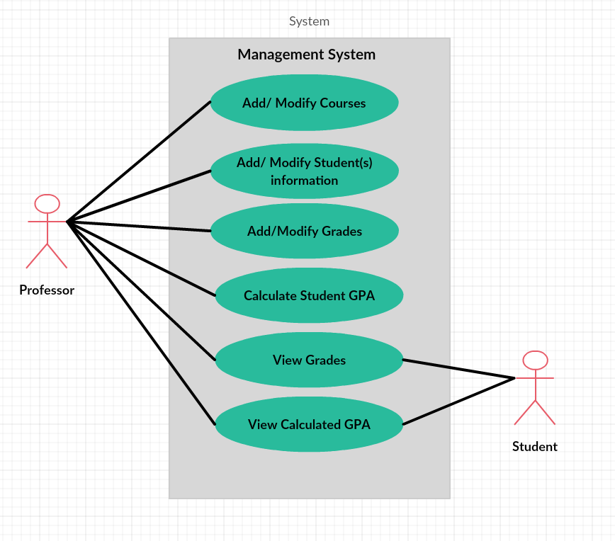

1. Professor wishes to add a new course.
2. Professor presses the add course(s) button.
3. New window appears.
4. Professor types course id number.
5. Course information unsaved until confirmation.
6. Professor wishes to delete an existing course.

2. Professor presses the delete course(s) button.

3. New window appears.

4. Professor makes selection of course to delete.

5. Course information unsaved until confirmation.

1. Professor wishes to add new student into a course.

2. Professor presses the add student(s) button.

3. New window appears.

4. Professor enters student information.

1. Student information unsaved until confirmation.
2. Professor wishes to delete student from course.
3. Professor presses the delete student(s) button.

3. New window appears.

4. Professor makes selection of student to delete.

5. Student information unsaved until confirmation.

1. Professor wishes to modify student(s) information.

2. Professor presses the modify student button.

3. New window appears.

4. Professor makes changes to student information.

1. Student information unsaved until confirmation.

1. Professor wishes to modify exam score.

2. Professor presses the edit exam button.

3. New window appears.

4. Professor enters new exam score.

1. Score information unsaved until confirmation.

1. Professor wishes to add exam score.

2. Professor presses the edit exam button.

3. New window appears.

4. Professor enters exam score.

1. Score information unsaved until confirmation.

1. User wishes to see calculated GPA.

2. Use presses the course button in which GPA is desired.

3. New window appears.

4. GPA score appears in GPA box.

1. User wishes to see exam score.

2. User presses the course button in which exam score is desired.

3. New window appears.

4. Exam score appears next to the corresponding exam.

1. Professor wishes to see the calculated GPA.

2. Professor presses the course in which student is in.

3. New window appears.

4. Professor selects the student.

1. New window appears.
2. Professor clicks the calculate GPA button.
3. Calculated GPA score appears in GPA box.